Chapter Study Guide – Rocks & Minerals

What is a MINERAL?
A mineral is a Naturally occurring, Inorganic Solid that has a Crystal structure and has a definite Chemical Compositon. (NISCCC)

For a substance to be classified a mineral it must have all of the five characteristics: (NISCCC)
- It must occur Naturally.
- It must be Inorganic.
- It must be a Solid with a definite volume and shape.
- It must have a Crystal structure.
- It must have a definite Chemical Composition.

Identifying Minerals: Each mineral has its own specific properties that can be used to identify it.
- Hardness is measured by seeing how easy it is to scratch a mineral (Mohs Hardness Scale)
- Color is NOT always a good way to identify a mineral. Many minerals are found in several colors. Only a few minerals have their own characteristic color.
- Luster is the way a mineral reflects light. Minerals can be described as metallic, pearly, glassy, silky, or dull
- Streak is the color of the streak made by rubbing a mineral across a hard, rough surface like a bathroom tile (color of its powder). Even though the color of a mineral may vary, its streak does not.
- Density is the mass of the mineral.
- Crystal System is the structure of the mineral based on the number of angles and faces.
- Cleavage and Fracture is the way a mineral breaks apart.
More about Identifying Minerals
●During the California Gold Rush of 1849, thousands of people headed west to find gold. Some found gold, but most found pyrite (fool’s gold).
●Pyrite and gold looks the same.
●Both are the color yellow.
●Both have a metallic luster.
●Both have a similar density and hardness.
●The STREAK test is used to identify gold and pyrite. Pyrite has a greenish streak and gold has a yellow streak.
●Pyrite is called fool’s gold because people thought it was real gold.
How Do Minerals Form?
Minerals can form in two ways:
- Crystallization of melted materials
●Minerals form as hot magma cools inside the crust, or as lava hardens on the surface. When these liquids cool to the solid state, they form crystals.
- Crystallization of materials dissolved in water (Rock Candy)
●If you have a hot water solution (sugar and hot water), when the water cools the atom(s) leave the solution and crystallize as minerals.
●A SOLUTION is a mixture in which one substance dissolves in another. (Sugar dissolved in water makes a solution).

- Minerals form by Evaporation
●If you stir salt crystals into a cup of water, the salt dissolves in the water. When the water evaporates, it will leave salt crystals.
What Determines the Size of a Crystal?
The size of a crystal depends on several factors:
- The rate at which the magma cools
●When magma remains deep below the Earth’s surface, it cools slowly over many thousands of years. Slow cooling forms LARGE crystals.
●Magma closer to the surface cools faster. Fast cooling forms small crystals.
- The amount of gas the magma contains
- Chemical composition of the magma
Rocks
The three types of rocks are: (Grouped by how they formed)
- Igneous Rock also known as Volcanic Rock.
●Form when hot, liquid magma or lava cools and hardens.
●Igneous rocks that form from lava ON earth’s surface are EXTRUSIVE ROCK.
●Igneous rocks that form BENEATH earth’s surface are INTRUSIVE ROCK.
- Sedimentary Rock
●Form from sediments that are pressed (compacted) and cemented together.
●Sedimentary rock formed by the remains of living things pressed and cemented together are called ORGANIC ROCKS.
●Erosion plays a role in the formation of sedimentary rock because wind and water breakup and wear away the rock.
- Metamorphic Rock
●Form by heat and pressure that takes place beneath the surface.

Rock Cycle
The series of processes on and beneath Earth’s surface that change rocks from one type of rock to another is called the rock cycle.
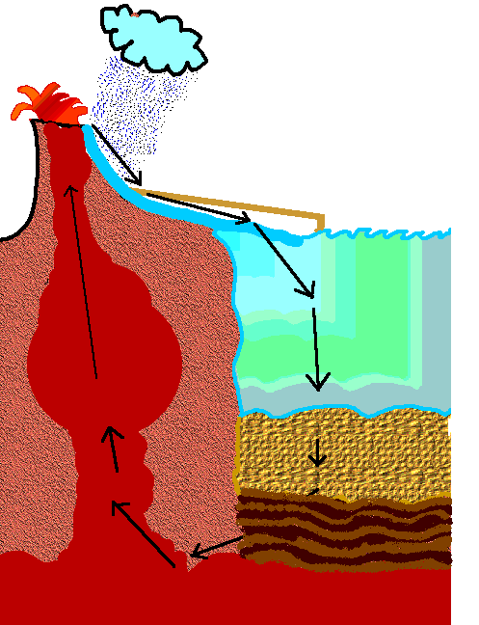
IGNEOUS ROCK
SEDIMENTARY ROCK
METAMORPHIC ROCK
EROSION (WEATHERING)
When magma cools and hardens.
Sediments are carried by wind and water.
(Rock is pressed together)
(Heat and pressure from inside Earth change the rock)

