Inside Earth Chapter 1 Study Guide (pages 16 – 47)

Geology is the study of planet Earth. Geologists are the scientists who study forces that make and shape planet Earth.

Geologists divide forces that change the surface into two groups:
- Constructive forces – shape the surface by building up mountains and landmasses

- Destructive forces – slowly wear away mountains. Example: Ocean waves that wear away shorelines.

Three main layers make up Earth’s interior:
- Crust – layer of rock that forms Earths OUTER surface.
- It includes both dry land and the ocean floor.
- The crust beneath the ocean is called oceanic crust.
- The oceanic crust consists mostly of dense rock called basalt.
- The continental crust (crust that forms the continents) consists mainly of a less dense rock called granite.

- Mantle – layer of hot, solid rock between the crust and core.

- Core – consists of two parts:
- The outer core is a layer of molten metal (iron, nickel) that surrounds the inner core. (Like a thick liquid)
- The inner core is a dense ball of solid metal (iron, nickel).

Earth’s Interior
CRUST (Granite – found in continental crust; Basalt – found in oceanic crust)
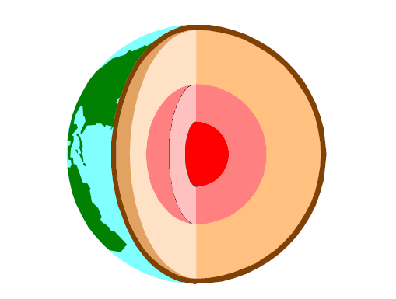
Inner Core (Solid)
(Highest Temperature & Highest Pressure)
Outer Core (Liquid)
(Molten Iron and Nickel)
C
O
R
E
MANTLE (Hot, Solid)
(Contains lithosphere & athensophere)
There are three types of heat transfer:
- Radiation – The transfer of energy through empty space. Sunlight is radiation that warms Earth’s surface. Other familiar forms of radiation are the heat you feel around a flame or fire.
- Conduction – Heat transfer by direct contact of particles of matter. Think about what happens as a spoon heats up in a pot of soup. Heat is transferred from the hot soup and pot to the spoon. If you touch the spoon, conduction transfers heat from the spoon directly to your skin.

- Convection –The transfer of heat by movements of a heated fluid.

Convection in Earth’s Mantle

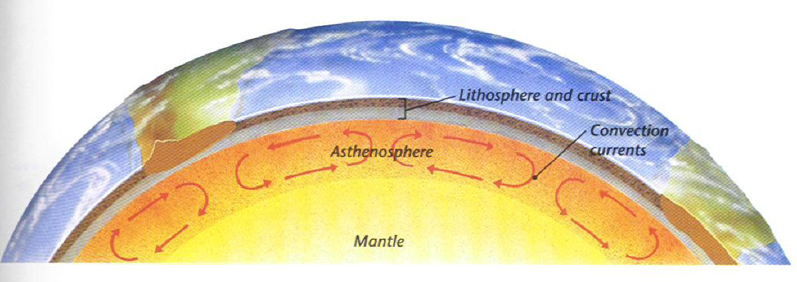

Drifting Continents
Alfred Wegener
- Hypothesized that all the continents had once been joined together in a single landmass and have since drifted apart.
- Wegener named this supercontinent Pangaea
- According to Wegener, Pangaea existed 300 million years ago.
- Over tens of millions of years, Pangaea began to break apart. The pieces of Pangaea slowly moved toward their present-day locations becoming the continents they are today.
- Wegener’s idea that the continents slowly moved over Earth’s surface became known as continental drift.

Evidence to support Continental Drift
  - Landforms
  - Fossils
  - Climate

Sea-floor spreading
- Harry Hess said that the ocean floors move like conveyor belts beginning at the mid-ocean ridge.
- He said that at the mid-ocean ridge, molten materials rise from the mantle and erupt. The molten material then spreads out pushing older rock to both sides of the ridge.
- Hess called the process that continually adds new material to the ocean floor sea-floor spreading.

Evidence to support Sea-floor spreading
- molten material
- magnetic stripes
- drilling samples

The Theory of Plate Tectonics
- Plate tectonics is the geological theory that pieces of Earth’s lithosphere are in constant, slow motion, driven by convection currents in the mantle.

Three types of Plate Boundaries
- Transform boundaries
- Place where two plates slip past each other moving in opposite directions. Earthquakes occur frequently along these boundaries.
- Divergent Boundaries
- Place where to plates move apart
- Sea-floor Spreading happens here! As the two plates move away from each other, magma wells up from the Earth's interior. It then hardens into rock as it is cooled creating new ocean floor.
- Convergent Boundaries
- Place where two plates come together

