Stress Force | Type of Fault | Plate Boundary | Diagram
Shearing | Strike-Slip | Transform | 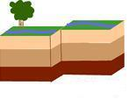
Tension | Normal | Divergent | 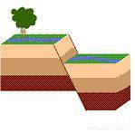
Compression | Reverse | Convergent | 