Scientific Method (7 Steps)

Step 1: State the Problem

What do you want to find out? State the issues in your own words.

Step 2: Hypothesize or Predict
What do you think may happen? Why?

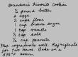
Step 3: Plan the Investigation
Write a step by step procedure that anyone can follow and repeat.
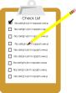
Step 4: Gather Data
Collect information by observing, estimating, or measuring.
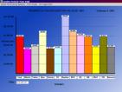
Step 5: Record and organize Data
Use tables, graphs, or drawings to organize and display the information.
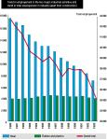
Step 6: Analyze Data
Do you see any trends or patterns?
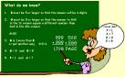
Step 7: Draw a Conclusion
State your conclusion based on your data

Important Vocabulary Terms:
Hypothesis – something you predict
Control – something you compare experiment to
Variable - action you take or things you change
Infer – suggest an explanation

