Science Study Guide: Chapter 2 Earthquakes

Three types of Stress: TENSION, COMPRESSION, SHEARING (Study Figure 2 on page 55 of your textbook!)

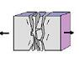  TENSION  STRETCHES rock in opposite directions. | 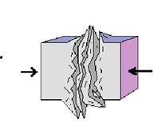  COMPRESSION  SQUEEZES rock until it folds/ breaks. | 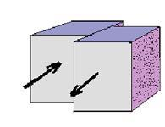  SHEARING  PUSHES rock in two opposite directions.

- ANY change in the shape of Earth’s crust is called DEFORMATION.
- When STRESS builds up in a rock, the rock breaks creating a FAULT.
- A FAULT is a break in the crust where slabs of crust slip past each other.
- Faults usually occur along plate boundaries where plates PULL APART (TENSION), PUSH TOGETHER (COMPRESSION), or SLIP PAST EACH OTHER (SHEARING).

Three types of faults: NORMAL FAULT, REVERSE FAULT, STRIKE-SLIP FAULT (Study Figures 3, 4, and 5 on pages 56 and 57 of your textbook!)
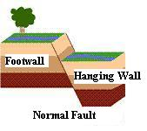  - Hanging Wall slides DOWN the footwall.  - Type of stress: TENSION | 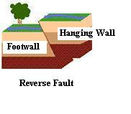  - Hanging Wall slides UP over the footwall.  - Type of Stress: COMPRESSION | 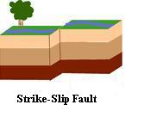  - Rocks slip past each other with little up-or-down motion.  - Type of Stress: SHEARING

You need to be able to identify these faults and the type of stress that causes it!!!!!

Be able to identify and label these two terms on a diagram for the test: (Study Figure 9 on page 60 of your textbook!)

- ANTICLINE – Folds that bend UPWARD into an arch (think of an ANT hill).

- SYNCLINE – Folds that bend downward (It sags)

Be able to identify and label these two terms on a diagram for the test: Study Figure 12 on page 65 in your textbook!)

- P Waves – waves that COMPRESS and EXPAND the ground like an accordion or slinky.

- S Waves – waves that vibrate SIDE to SIDE as well as UP and DOWN (like wiggling a rope).

Be able to identify these two terms:

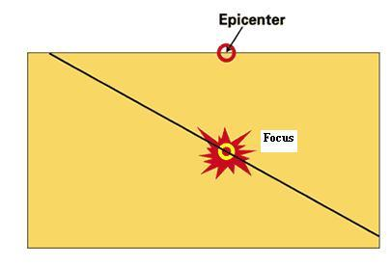
Epicenter – Point ON the surface directly ABOVE the focus.
Focus – Point BENEATH the Earth’s surface where the crust breaks and triggers an earthquake.

Study Figure 17 on page 69 of your textbook to locate an earthquake’s epicenter using data from a seismograph. You will be given a map and asked to identify the epicenter on the test! (The epicenter is the point where the three circles INTERSECT!)

Scales Used To Measure Earthquakes:

1. Mercalli Scale
- Rates an earthquakes INTENSITY

2. Richter Scale
- Rates SIZE OF SEISMIC WAVES
3. Moment Magnitude Scale
- Rates TOTAL ENERGY released by an earthquake

More Vocabulary:

Tsunami – large wave produced by an earthquake on the ocean floor.

Aftershock – Earthquake that occurs AFTER a larger earthquake in the same area.

Liquefaction – Occurs when an earthquake’s violent shaking suddenly turns loose, soft soil into liquid mud.

Seismograph - instrument used to measure seismic waves.

Protecting Yourself During an Earthquake
- The best way to protect yourself is to drop, cover, and hold.
- Crouch beneath a sturdy table or desk and hold on to it.
- The desk will provide a barrier against falling objects.
- If no table is available, crouch against an inner wall, away from the outside of a building, and cover your head and neck with your arms.
- Avoid windows, mirrors, wall hangings, and furniture that might topple.
- If outdoors move to an open area such as a playground.
- Put together an earthquake kit with canned food, water, and first aid supplies.

Applying what you know – Understanding it!!!
On the test you will be given a made-up scenario about an earthquake (news report) to read. Based on the paragraph, you will be asked questions about what you know about earthquakes. Be prepared to answer questions about protecting yourself during an earthquake, scales used to measure earthquakes, and type of stress and faults.

Study your vocabulary! You need to know your vocabulary but more importantly understand it! Be able to label diagrams, answer questions about the diagrams using your vocabulary words!

Study to UNDERSTAND - and not to just memorize facts!
Ask questions until you know you GOT IT!
If there is something that doesn’t make sense, ASK!
Chances are HUGE that you’re not the ONLY one with that question!!!

