Reflex Arc Lab title of investigation- at top of page & in table of contents- lab notebook = +1
Purpose: To study the simplest functional unit of the nervous system: the reflex arc- apply and THINK about the models made Friday- and to THINK about what is happening when you have a reflex and WHY

Background: +1 title of this background section from notes- PPT for this lab is on Quia if you missed Friday or Monday’s lessons- → Sketch of components discussed/modeled in a 3-neuron arc reflex + NTs + synapses – from stimuli to response→ +6 (must have my signature to earn 5 additional points in this section--these points were recorded in Skyward after Friday’s modeling activity)

In class you were asked to record in your own wording-- your opinion on a definition for a reflex is ⁺¹…then we added in different ink- or highlighted or underline- a textbook definition = Reflexes are rapid, involuntary responses to stimuli which occur over simple nerve pathways called reflex arcs.” ⁺² AND today- record in your own wording and interpretation of the reason for doctors’ testing of patients’ reflexes = important diagnostic tool for assessing the condition of the nervous system. Distorted, exaggerated, or absent reflex responses may indicate degeneration or pathology of portions of the nervous system, often before other signs are apparent. ⁺³

FYI: Involuntary reflexes are very fast, traveling in milliseconds. The fastest impulses can reach 320 miles per hour. Record of the milliseconds response times to sound, touch, sight. +3
THE IMPORTANCE OF REFLEX TESTING continued…– WHY?
If the spinal cord is damaged, then reflex tests can help determine the area of injury. For example, motor nerves above an injured area may be unaffected, whereas motor nerves at or below the damaged area may be unable to perform the usual reflex activities. Closed head injuries, such as bleeding in or around the brain, may be diagnosed by reflex testing. Remember that the oculomotor nerve stimulates the muscles in and around the eyes. If pressure increases in the cranium (such as from an increase in blood volume due to the brain bleeding), then the pressure exerted on CN III (Cranial Nerve 3) may cause variations in the eye reflex responses.
SPINAL REFLEXES: The spinal cord provides a major pathway for ascending and descending neural tracts. In addition to this function, the spinal cord functions as the integration center for many reflexes. These are called spinal reflexes because their arcs pass through the spinal cord.
THE CEREBELLUM: The cerebellum functions as a reflex center that integrates sensory information concerning the position of the body, and coordinates complex skeletal muscle movements. The cerebellum also helps to maintain posture. The cerebellum communicates with other parts of the CNS by means of nerve tracts called cerebellar peduncles. Damage to the cerebellum or to the cerebellar peduncles can result in tremors and inaccurate movement of skeletal muscles. THE MIDBRAIN: The midbrain functions as the integration center for multiple reflexes. One reflex that you should have tested on your partner was the visual reflex. The integration centers for the visual reflexes are located in the superior colliculi.
Most reflexes are polysynaptic (involving more than two neurons) and involve the activity of interneurons (or association neurons) in the integration center. Some reflexes; however, are monosynaptic ("one synapse") and only involve two neurons, one sensory and one motor. Since there is some delay in neural transmission at the synapses, the more synapses that are encountered in a reflex pathway, the more time that is required to effect the reflex

+3 points for reflex titles- please circle each- then observations should be below title
Patellar (knee-jerk) Reflex The patellar tendon reflex ("knee-jerk" reflex) is a monosynaptic (one
synapse, therefore two neuron) stretch reflex that assesses the nervous tissue between (and including)
the L2 and L4 segments (L=lumbar) Procedure followed for the Patellar Reflex: Have your partner sit on the lab table with legs hanging freely. Sharply tap the patellar tendon of one leg with the blunt side of the reflex mallet and note the response. Be sure to stand to one side. Compare responses in the right and left knees.
Record the results: Your lab should contain a chart OR diagram for a minimum of 3 reflexes tested on your partner. Label each diagram or fill in the chart with specific information on the

For each reflex tested – include a labeled diagram or chart with each of the following components
+1 Stimulus- was this a pen light, Taylor’s hammer, nerf gun, wooden stick...etc.
+1 Receptor- what kind of receptor received the signal- pressure receptor? Pain receptor? Stretch receptor? Photoreceptor? Touch receptor?
+1 Sensory neuron- Afferent- bonus if you find which sensory neuron it is specifically- CN4? SN8?
+1 Spinal cord or region in brain- grey matter (bonus- if you know dorsal or ventral; or which part of brain the message goes to)
+1 Motor neuron- which neuron? - efferent
+2 Effector- be specific- what muscles contracted and relaxed- RESEARCH- iris? Biceps brachii? Rectus femoris?

THE PATELLAR TENDON REFLEX
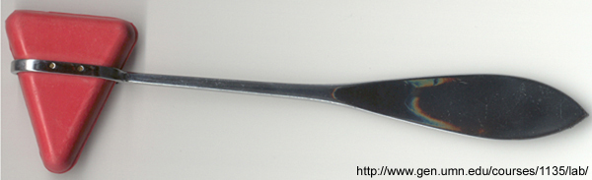
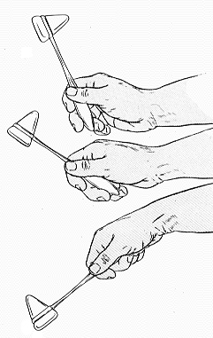
Stretch reflexes are a special type of muscle reflex which protect the muscle against increases in length which may tear or damage muscle fibers. Stretch reflexes are very important in maintaining your upright posture in humans.

***Some evidence suggests the magnitude of these stretch reflexes can be increased when the contractile tone of the muscle is increased. Mental activity, which increases muscle tone, may increase the magnitude of the response. Decreased mental activity (sleep, restfulness) can decrease the magnitude of the reflex while physical activity and mental stress may make the reflex less sensitive.
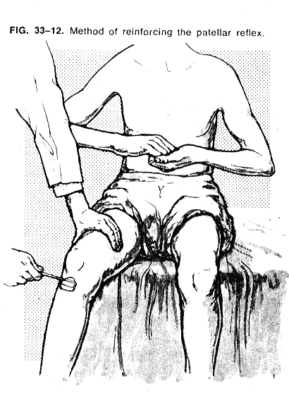
The primary tool that we should be using to test reflex activity is the Taylor Reflex Hammer. Care must be taken to use the proper hammer technique during our lab activities. Improper techniques will not elicit the desired reflexes.
The patellar tendon reflex ("knee-jerk" reflex) is a monosynaptic stretch reflex that assesses the nervous tissue between (and including) the L2 and L4 segments. It can be elicited by sharply tapping the patellar ligament (just below the knee) with the base of a Taylor hammer.
- Have the subject sit on the edge of a table with one leg dangling freely. Have your partner look away from the tester. Strike the tendon just below the knee-cap with the edge of your hand or the Taylor’s hammer..

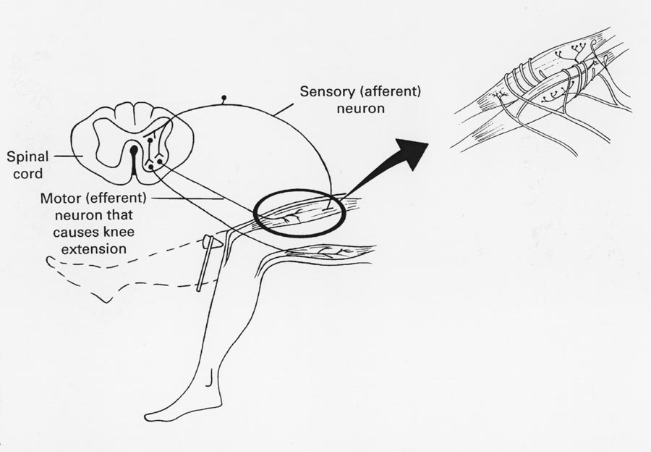
Record the results.
Repeat the above, but have your partner perform Jendrassik's maneuver; that is, clasping his or her
hands at chest level in front of your body with fingers locked, have him or her try vigorously to pull the hands apart while you tap the patellar tendon as before
Record Observations
***read math problems to your subject to solve in their head- while testing reflex→record observations

THE PUPILLARY REFLEX
The pupillary reflexes are autonomic reflexes that can be used to assess multiple conditions, such as deterioration of vital brain tissue and severe head trauma. The pupillary reflexes can be elicited by covering one eye and shining a light into the other.
The photopupillary reflex will be our example reflex arc. The components of this reflex arc are as follow:
  - The retina of the eye contains the receptors.
  - The optic nerve and tract contain the afferent (sensory) fibers.
  - The CNS contains the integration centers (remember the parts of the brain stem).
  - The oculomotor nerve and tract contain the efferent (motor) fibers.
  - The smooth muscle of the iris is the effector.
While assessing the photopupillary reflex response in lab, you may notice that the pupil of the covered eye responds when you shine light into the uncovered eye. This is called a consensual response. The consensual response, or any reflex observed on one side of the body when the other side has been stimulated, is a contralateral response. If only the uncovered pupil responds to the light, then this is an ipsilateral (same side)

PROCEDURE:

1-Have the subject close his/her eyes for 2 minutes

2-Hold a filing card along the bridge of the nose so the right eye is shielded from the left.

3-Shine a bright light into the right eye as soon as the subject opens his eyes.

4-Observe the pupils of both eyes and record the response.

5-Explain the results. What could happen if this reflex did NOT exist?

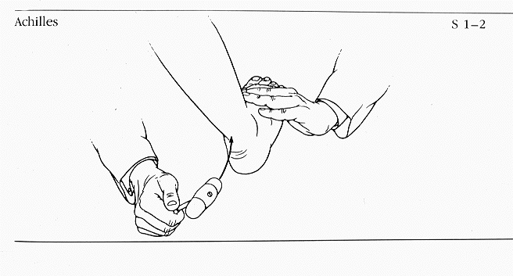
THE CALCANEAL REFLEX
The calcaneal reflex ("Achilles" or "ankle-jerk" reflex) is a stretch reflex that assesses the nervous tissue between (and including) the first two sacral segments. It can be elicited by sharply tapping the calcaneal tendon (just above the ankle) with the base of a Taylor hammer.
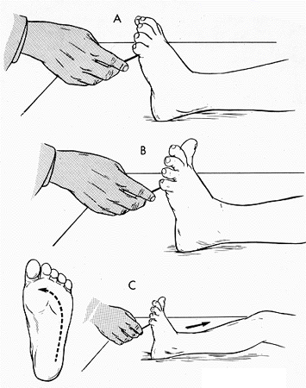
THE PLANTAR REFLEX
The plantar reflex is a superficial spinal reflex that depends both on functional upper-level motor pathways and on the cord-level reflex arc. It can be elicited by firmly drawing the handle of a Taylor hammer along the lateral border of the subject's sole, starting at the heel and continuing toward the big toe (across the ball of the foot).
In adults, stimulation of cutaneous receptors in the sole of the foot (as when testing the plantar reflex) usually causes the toes to flex and move together.
Damage to the corticospinal tract (or incomplete myelination of the nervous system, as is the case with infants) produces Babinski's sign, an abnormal response in which the toes flare and the great toe moves in an upward direction.
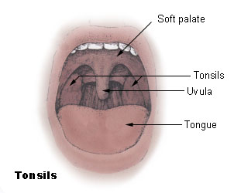
Uvular Reflex
- Have the subject open his/her mouth widely and touch the uvula with a clean Q-tip
- Record the results
- Of what value is this response to humans?
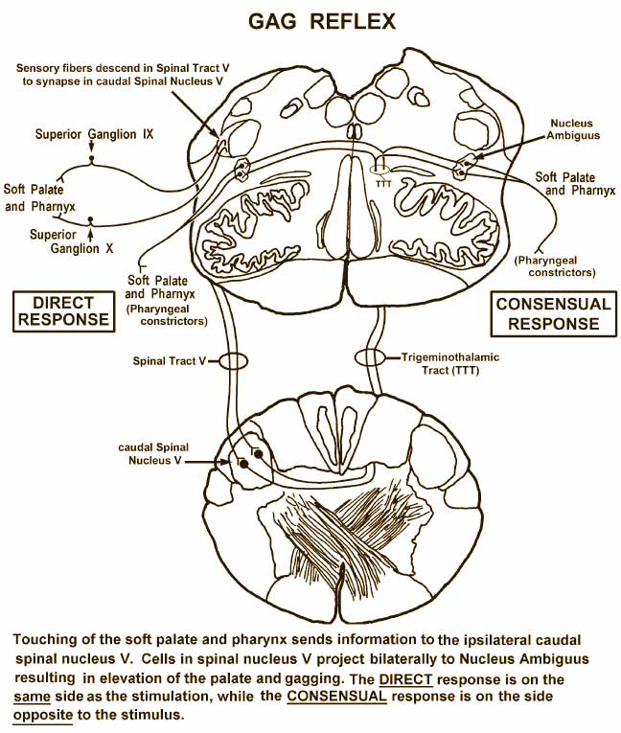

Accomodation Reflex--Focus both eyes on the tip of a pencil held at eye level and at arm's length. While focusing on the pencil tip, indicate whether or not the objects in the background are in focus.
- Keeping the same line of sight, focus on the objects in the background. What happens to the image of the pencil tip. The distance from the eye to the nearest object that can be focused on clearly is called the near point of vision. To find the near point: Cover one eye, and focus on a piece of newspaper. Gradually bring the newspaper closer and closer to your eye until the letters just go out of focus.
- Have your partner measure the distance (in cm) between the newspaper and your eye.
- Repeat steps 4 and 5 for the other eye.
- Record the near point for both eyes.
- Give a physiological explanation for what has occurred in both parts of this experiment.
- Why can a person not see objects clearly when they are positioned closer to the eye than the near point?
- What happens to the near point as a person ages? Why does this occur?
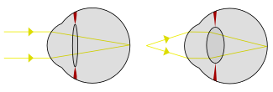
Station Title: How Fast Are Your Reflexes?
Get a ruler (or a meterstick). Hold the ruler near the end (highest number) and let it hang down. Have another person put his or her hand at the bottom of the ruler and have them ready to grab the ruler (however, they should not be touching the ruler). Tell the other person that you will drop the ruler sometime within the next 5 seconds and that they are supposed to catch the ruler as fast as they can after it is dropped. Record the level (inches or centimeters) at which they catch the ruler (you can convert the distance into reaction time with the chart below). Test the same person 3 to 5 times (vary the time of dropping the ruler within the 5 second "drop-zone" so the other person cannot guess when you will drop the ruler). Here is a table to convert the distance on the ruler to reaction time. For example, if you caught the ruler at the 8 inch mark, then your reaction time is equal to 0.20 seconds (200 ms). Remember that there are 1,000 milliseconds (ms) in 1 second.

Distance of catch Reaction Time (in seconds)

2 in (~5 cm) 0.10 sec (100 ms)

4 in (~10 cm) 0.14 sec (140 ms)

6 in (~15 cm) 0.17 sec (170 ms)

8 in (~20 cm) 0.20 sec (200 ms)

10 in (~25.5 cm) 0.23 sec (230 ms)

12 in (~30.5 cm) 0.25 sec (250 ms)

This reaction time experiment required visual information (the movement of the ruler) to travel to your brain. Then your brain sent a motor command ("grab that falling ruler") to the muscles of your arm and hand. If all went well, you caught the ruler!!

Try the experiment in dim light. Does your reaction time increase, decrease or stay the same? Can you explain your results?

Compare the scores after practice. Does reaction time improve with practice?

Αναλψσισ Θυεστιονσ:
1. What is a nerve pathway?
2. What is a monosynaptic reflex?
3. What type of neurons conduct nerve impulses along an efferent pathway?
4. What is the effector in the photopupillary reflex arc?
5. What is a consensual response?
6. What would you call a reflex that is observed on the same side of the body that has been stimulated ?

Today’s Station: Reflexes on the Computer

If you finish early- then try out these sites and record your results. Explore all links associated with the sites- find the tranquilizing sheep!
http://reflextest.net/
http://www.brainmetrix.com/reflex3.html

