## Primer on Hypothesis Testing

At the most recent Assessment Academy, faculty members reviewed and coded a questionnaire focused on the basics of writing an hypothesis, identifying an independent and dependent variable, choosing a research method and identifying ethical concerns. We found that students struggled with writing hypotheses, identifying an independent variable and clearly articulating ethical considerations.

As a result, we have complied some materials which we hope will be helpful to you to both assess and teach this portion of our departmental competency in scientific inquiry. You can find these resources on SharePoint and on Quia. These resources include this primer, assessments of student understanding of these concepts, and a classroom exercise you may want to use (or adapt) as an introduction to the topic.

Please see these sites in order to evaluate these materials:

Share Point: <https://myway.mccneb.edu/depts/sociology/default.aspx>

Quia: <https://www.quia.com/pages/jfauchier/scimethods>

From the Textbook Lecture Notes:

* + 1. Experiments have been used by sociologists to investigate the relationship between media and real world violence. An **experiment** is a carefully controlled artificial situation that allows researchers to isolate hypothesized causes and measure their effects precisely. Experiments involve **randomization** (assigning individuals to one of two groups by chance processes) to create two similar groups for comparison.
    2. Sociologists investigating the effects of violence on television on children’s behavior randomly assign children to a **control group** (the group that is not exposed to the independent variable) and an **experimental group** that will be exposed to the independent variable (in this case viewing an hour-long program containing many acts of violence).
    3. Children’s initial aggression score is the **dependent variable** (the presumed effect in a cause-and-effect relationship). The experimental group is exposed to some form of media violence, which is the **independent variable** or the presumed cause of any change in a cause-and-effect relationship).
    4. Experiments allow researchers to isolate the single cause of theoretical interest and measure its effect with high **reliability**, the degree to which a measurement procedure yields consistent results.
    5. Many sociologists argue that experiments are highly artificial situations. They believe that removing people from their natural social settings lowers the **validity** of experimental results, or the degree to which a measure actually measures what it is intended to measure.

# **Independent vs. Dependent Variables in Sociology**

by Shane Hall

http://peopleof.oureverydaylife.com/independent-vs-dependent-variables-sociology-7788.html

## Sociology applies scientific methods to the study and understanding of human society. Social units ranging from the family to modern industrial society attract the interest of sociologists. Like all scientific research, sociological studies search for a cause-and-effect relationship between two phenomena. Sociologists classify social phenomena being studied as independent and dependent variables.

## **Dependent Variables**

A dependent variable in sociology and other social sciences is the effect, the phenomenon affected or changed by other actions or phenomena. Examples of dependent variables in sociology include levels of crime or poverty in neighborhoods, racist attitudes or order within a civil society. Sociologists often study the ways in which numerous programs, activities and other phenomena impact these and other dependent variables. For example, sociologists interested in crime may ask how certain factors affect urban crime rates. In this example, urban crime rate is the dependent variable. Sociologists often represent the dependent variable mathematically by using the letter "Y."

**Independent Variables**

Independent variables are those factors, activities and other phenomena that change or affect the value or level of a dependent variable. Sociologists often represent independent variables mathematically with the letter "X." A typical sociological research question may ask the manner and extent to which X influences dependent variable Y. A sociologist who studies criminal behavior may ask how lack of economic opportunity affects urban crime rates. For such a study, lack of economic opportunity represents the independent variable, while urban crime rate is the dependent.

**Considerations**

Many independent and dependent variables in sociology and other social sciences do not lend themselves to easy measurement, meaning that researchers must carefully think about one or more measures to investigate the phenomena they wish to study. For example, they may need to design questionnaires to measure subject attitudes about race or use government-collected data on economic or criminal activity to measure levels of wealth or crime across social classes.

**Warning**

In addition to measurement issues, the lack of laboratory controls available to researchers in the natural sciences further complicate sociological research. Social research occurs in the real world of social interactions, meaning that sociologists cannot randomly assign subjects to experimental and control groups for research purposes. This makes it difficult to attribute changes in a dependent variable to the independent variable. This means sociologists must often conduct complex statistical analysis to control other factors besides the independent variables of interest that may affect the dependent variable.

Understanding social research requires knowledge of the difference between these classes of variables.

_______________________________________

As a way to remind students that “correlation is not the same as causation.” These examples are fun:

<http://www.tylervigen.com/spurious-correlations>

Here’s a few examples of what is on this site:

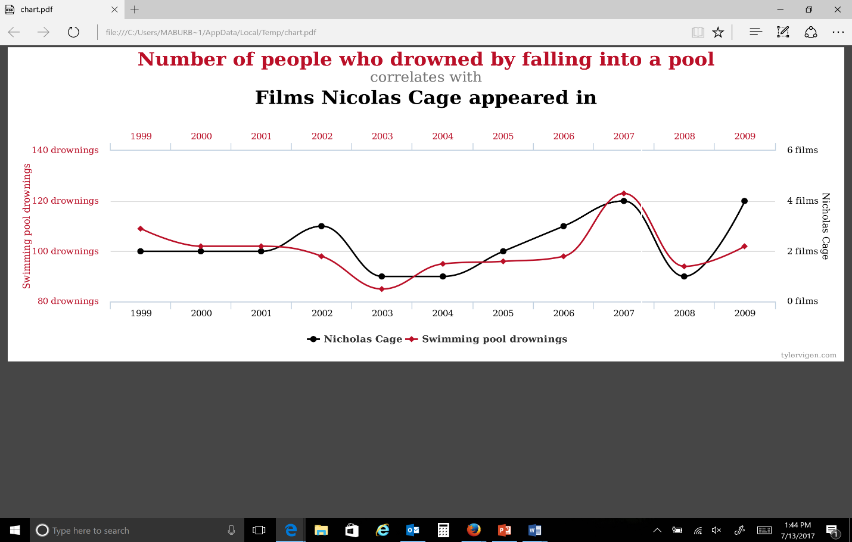

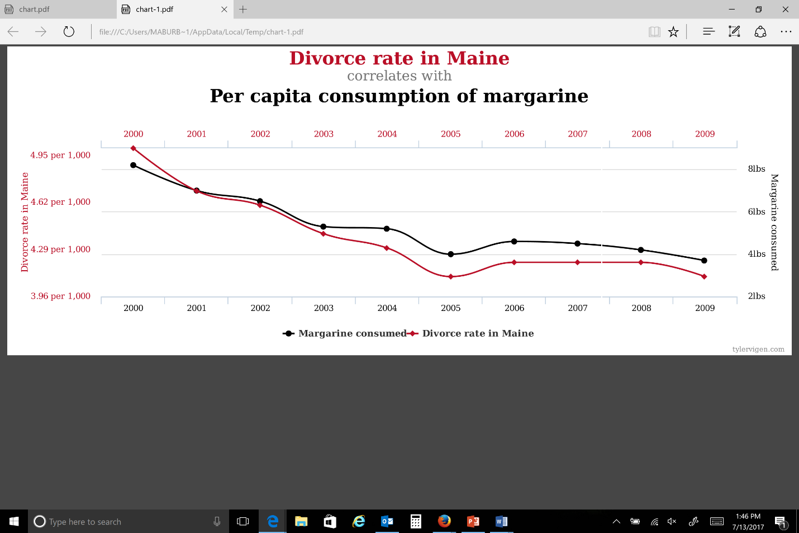

Here’s another way to explain the concept of “spuriousness” from the work of Sheldon Goldenberg in his text *Thinking Methodologically*, (1992. Harper Collins):

*Scientists have found that there is an association between the number of fire fighters who respond to a call and the amount of damage done by the fire. From this association it is possible to make a nasty inference that it is the fire fighters who account for the damage, since as their numbers increase, so does the damage. After all, they have fire axes, heavy hoses, and dirty boots! Put a lot of them in your living room and you might well have damage done. Talk about a bull in a china shop! Fortunately for the fire departments, some people were skeptical of the causal interpretation of this association and suggested that it could be spurious or accidental and a function of a third variable that would explain it away. They suggested that this third variable could be the severity of the fire. The logic of their argument is that more severe fires require the presence of more fire fighters and tend to do more damage. In other words, in less severe fires there will be few fire fighters and little damage, whereas in severe fires there will be many fire fighters and lots of damage. It is therefore the case that when you move from less severe to more severe fires you simultaneously move from few fire fighters and little damage to many fire fighters and much damage, thereby producing an association between these two variables (p. 123).*

***Ethics in Social Research***

***From the Textbook Lecture Notes:***

* 1. Ethics in Sociological Research
     1. Researchers must be mindful of and have respect for their *subjects' rights*:
        1. Right to safety
        2. Right to privacy
        3. Right to confidentiality
        4. Right to informed consent
     2. Ethics also govern how the treatment of research results. Plagiarism has increased as a result of widespread access to materials via the Internet.

***ASA Code of Ethics:***

**GENERAL PRINCIPLES**

The following General Principles are aspirational and serve as a guide for sociologists in determining ethical courses of action in various contexts. They exemplify the highest ideals of professional conduct.

Principle A: Professional Competence

Sociologists strive to maintain the highest levels of competence in their work; they recognize the limitations of their expertise; and they undertake only those tasks for which they are qualified by education, training, or experience. They recognize the need for ongoing education in order to remain professionally competent; and they utilize the appropriate scientific, professional, technical, and administrative resources needed to ensure competence in their professional activities. They consult with other professionals when necessary for the benefit of their students, research participants, and clients.

Principle B: Integrity

Sociologists are honest, fair, and respectful of others in their professional activities—in research, teaching, practice, and service. Sociologists do not knowingly act in ways that jeopardize either their own or others' professional welfare. Sociologists conduct their affairs in ways that inspire trust and confidence; they do not knowingly make statements that are false, misleading, or deceptive.

Principle C: Professional and Scientific Responsibility

Sociologists adhere to the highest scientific and professional standards and accept responsibility for their work. Sociologists understand that they form a community and show respect for other sociologists even when they disagree on theoretical, methodological, or personal approaches to professional activities. Sociologists value the public trust in sociology and are concerned about their ethical behavior and that of other sociologists that might compromise that trust. While endeavoring always to be collegial, sociologists must never let the desire to be collegial outweigh their shared responsibility for ethical behavior. When appropriate, they consult with colleagues in order to prevent or avoid unethical conduct.

Principle D: Respect for People's Rights, Dignity, and Diversity

Sociologists respect the rights, dignity, and worth of all people. They strive to eliminate bias in their professional activities, and they do not tolerate any forms of discrimination based on age; gender; race; ethnicity; national origin; religion; sexual orientation; disability; health conditions; or marital, domestic, or parental status. They are sensitive to cultural, individual, and role differences in serving, teaching, and studying groups of people with distinctive characteristics. In all of their work-related activities, sociologists acknowledge the rights of others to hold values, attitudes, and opinions that differ from their own.

Principle E: Social Responsibility

Sociologists are aware of their professional and scientific responsibility to the communities and societies in which they live and work. They apply and make public their knowledge in order to contribute to the public good. When undertaking research, they strive to advance the science of sociology and to serve the public good.