Imperialism Organizer
Use Ch 27 Sec 1 to Complete
Why Imperialism?

- Note three motives behind the European race for colonies. Be sure to explain each!! Do not simply state.

- Note two technological advantages Europeans had over the Africans and explain why they are advantageous.

- Note two factors within Africa that made it vulnerable to European conquest. Explain.

Positive and Negative Aspects of Imperialism

How did Africans benefit from colonial rule (Create a list of positive effects)?

What were the negative consequences of colonial rule for the African continent?

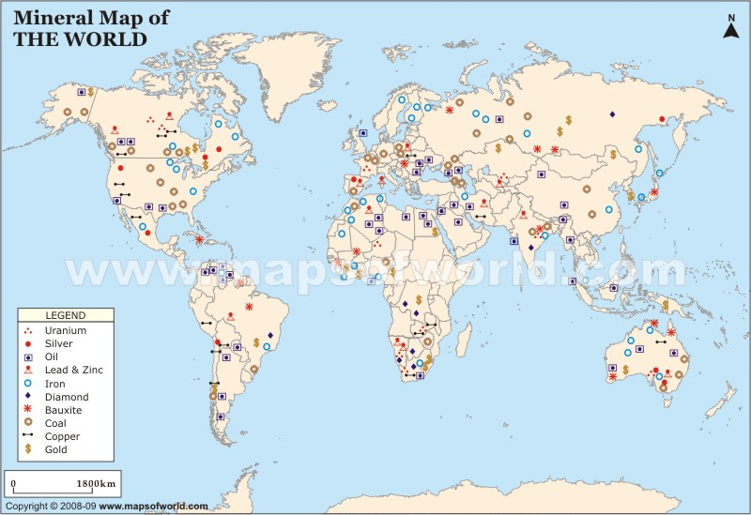

1. What mineral(s) were most abundant in Europe?

2. Why would Africa be desirable to Europeans? What minerals did Africa have an ample supply of (Hint: this can be used to answer question 1 on the other side)?

