Name: _____________________
Date: ______________________
Introduction:
There are many career opportunities in welding. In this lesson we will
- explore the welding trade
- discuss some of the duties of a welder
- learn and practice some vocabulary related to welding
- get some information about the welding training programs, including the program at RTC
- watch a video and practice listening for important information
- practice asking questions when you don’t understand something
- use the Internet to get more information

Part 1: Brainstorm and Discussion Questions
- Do you know anyone that can weld? What kinds of things can they weld?

- Look around the room. What products are welded? What other kinds of products have welded joints? Give some examples.

One good example is the welded joints on most chairs in the classroom. Turn a chair over and you’ll see them.

- Think of transportation. What kinds of vehicles have welded joints?

Cars, buses, trucks, trains, ships, airplanes, etc.

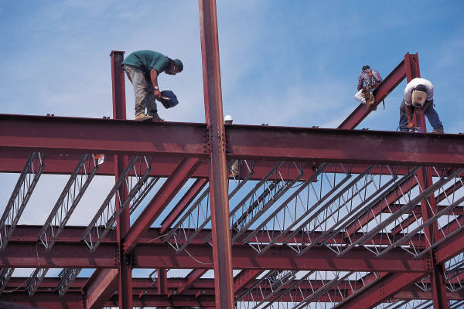
- Think about structures (buildings). What kind of buildings have welded joints? (For example, does a house usually have welded joints? Does a high rise usually have welded joints?)

Most houses (at least in this area) are made of wood, so they aren’t welded. Most commercial and industrial buildings have steel structures and other components that are welded.

Part 2: Watch the Video: listen for the main ideas

Directions: Watch the RTC training video about the Welding program at RTC. It’s a short video, so you can easily watch it several times if you need to. Take notes. Then answer and discuss the following questions.

Introduction

- How long has Renton Technical College been preparing students for work?
For over 65 years
Excuse me.
What does open entry mean?

- How many programs are available at RTC?

More than 72 – full and part-time
Questions about the Welding program

- How long does it take to complete the Welding program?

5 quarters

- When can a new student begin this program?

It’s open entry, so students can begin anytime (as long as there is an opening)

- The video mentioed some products that welders help create. Which ones did you hear mentioned?

Coast Guard patrol boats, Mariner’s Safeco Field, 2009 ferry fleet, titanium aerospace pipe

- How many arc welding processes do students learn in this program?

They learn and can be certified in five arc welding processes.

- In the video you can see someone measuring something on a paper or plan. Do you know what that plan is called?
It’s called a blueprint. The video says, “Learn bluepring reading . ..”

Part 3: Watch the video again: focus on specific details and vocabulary

Directions: Watch the video again. This time you can also read the script as you watch. Listen carefully and fill in the missing words.

Welding

Welcome to Renton Technical College. For over 65 years we have been preparing a diverse student population for work. With more than 72 full and part-time programs to choose from, we have one for you. Check this out.

Welding is a five quarter program with open entry. Depending on available space you can start today. Would you like to create these products: Coast Guard patrol boats, Mariner’s Safeco Field, 2009 ferry fleet, or titanium aerospace pipe? Come join us at RTC’s welding program. Certify in five arc welding processes. Learn blueprint reading, how to cut metal by torch and plasma cutter. Become financially stable doing work you enjoy.

Ready to enroll? Let us help you get started. Call now for an appointment to talk with one of our counselors at 425-235-5840. Renton Technical College: education for life.

[Text on screen]: Day, evening, and Saturday classes available to fit your schedule.

Part 4: Research: getting more information
Directions: Open your web browser. Type the following addressinto the address bar: www.RTC.edu. Then following these links: Library àOnline Databases à WOIS.

- After you open WOIS, look on the left side for the Search box. Type “Welding” in the box. Then click on Search.
  - How many search results did you find?
There are 83. (May need to explain “1-20 of 83”)

  - What are the four types of results?
    - program – describes a typical training program
    - school – information about a specific school
    - occupation – describes an occupation
    - military – describes the occupation in military
- Click on the first link, Welding Technology (a program)
  - If you get a degree in welding technology, what are some industries that you could work in?
    - construction, food production, drilling, and manufacturing
  - What organization builds spacecraft?
    - NASA
  - What do students usually study in a welding technology program?
    - welding techniques, such as gas, arc, Mig, Tig, and pipe welding
    - cutting techniques, including plasma and gas cutting
    - testing and fabrication methods
    - welding safety
    - how to set up welding tools and machines
    - metallurgy
  - What does “metallurgy” mean? (You may use a dictionary or the Internet to find the answer.)
    - Metallurgy is the science/study of metals (including properties such as strength) and how they are used.
- If you finish answering the questions before the rest of the class, or if you are really interested in this occupation, take some time to explore WOIS for more information about it. Some questions you may wish to explore are:
  - What are some of the working conditions for this occupation?
  - What are some of the physical demands for this occupation?
  - What are the hiring practices for this occupation?
  - How much do welders earn? (What are their wages?)
  - Where can you get training for this occupation?
  - What are some related occupations?

Additional Resources

Heavy Metal: Hot Careers in Welding (video)

Construction & Building Technology Careers, RTC brochure

Also see the Resources section in WOIS

NOTES

In addition to welding program, RTC has a Basic Welding program. Many ESL students have been very successful in both of these welding programs.

