SERVICE CONTRACTS – GENERAL INFORMATION
REVISED 3/13/03

SALES - Contracts are sold by ServiceOne Sales Reps, Telemarketers, Employees & Real Estate
Agents.
- Customer agrees to a 12-month commitment.
- Sales are effective immediately except Inspected Home Warranty agreements
  - Which are effective following an inspection.
  - Non-inspected HW sales subject to tech determination of “chargeable” during first 30 days.
- If customer moves, they can transfer the plan to their new residence or leave for new owner
- If customer wants to CANCEL before the end of 1st year
  - They will receive refund of any unearned prepayments less administrative costs & costs of services received. HW customers receive no refund.
- TAX – is collected as follows: Iowa (100%) Nebraska (27%) of monthly plan cost.
- DISCOUNTS – 10% to Omaha Chamber of Commerce & UtiliCorp Employee, State Farm employees receive 10% off Gold, 8% off Silver, & 5% off Bronze.

PRE-
EXISTING - Conditions that exist at time coverage begins must be repaired before coverage can begin
CONDITIONS on that specific appliance.

We will repair it for 30% discount up to $50 or accept proof of repair from qualified repair
company.

NOTE: If repair is requested on an item that is not currently covered on the contract & customer adds the appliance to their contract, we will repair for 30% discount up to $50.
- To receive 30% discount, the customer must pay the 1st month installment at time of appt.
AVAILABLE - Single family homes, condominiums, apartments & townhouses (mobile homes are
covered except for Plumbing & Electric if supplied by fuses).
RENEWALS - Monthly EFT customers & those who pay quarterly/semi-annually are automatically
renewed at end of 12 months.
- A representative will contact customers who paid a year in advance to renew their coverage.
SAME DAY
EMERGENCY - No heat when temperature is expected to fall below 45 degrees.
- Total electrical failure or shock/shorting hazards.
- Uncontrolled water running inside of house causing damage.
- Only toilet out of commission.
SOFT
EMERGENCY - No hot water.
- Health emergencies will be given priority service, however, if customer requests service after hours the emergency service fee applies.
- Refrigerators not cooling if no place to put food.
- Kitchen sink drains completely clogged.
- VIP customers.
- Call Backs (depends on severity of problem, when we were out & customer’s agitation)
HW DEDUCT - One deductible per appliance or trade (i.e. one trip for washer, dryer & clogged drain
would be 3 deductibles or $195)
AFTER HRS
SERVICE FOR - C.O.D. charge $75 (Emergency Fee). H.W. deductibles & Plumbing trip fees are
NON-EMERG charged in addition to the $75 fee.
AGREEMENT
CALLS

MANUF. - If item is under warranty by others, we will do the repair if it is covered by our service contract if
WARRANTIES customer wishes. The manufacturer warranty is NOT voided.
PAYMENT
OPTIONS - Cash, check, credit cards (MC/VISA/DISCOVER/AMEX) or electronic funds transfer.
GAS LEAKS - Inform customer to call utility to stop immediate danger & to call us if repair is needed.
OTHER ODORS - Inform customer that air ducts can carry smells from room to room & if all equipment is working,
we cannot send a technician to research an odor.
DEMAND SERVICE
REVISED 3/14/03

DEFINITION - Any call that is chargeable. (Agreement cust who want uncovered repairs or cust w/o agreement)

NEW INSTALL - We will not install a new appliance unless it is sitting in place and doesn’t have to be moved.
ο When we install customer’s equipment, we warranty only the installation.
TICKET TYPE - 1-NEW
RESPONSE
TIME - Same day/Next day
FEE - Please see Diagnostic Fee script.
TRADES
APPLIANCE/
HVAC/ - $39.95 ($49.95 in Dubuque & Wichita) Diagnostic fee during business hours (maximum of 2
PLUMBING appliances, price for 3 or 4 would be $79.90 in Omaha & $99.90 in Dubuque & Wichita.)
- NO DIAGNOSTIC FEE for demand plumbing if customer has plumbing coverage.
- $75 Diagnostic fee after hours (maximum of 2 appliances)
- NOTE: The regular hours diagnostic fee is NOT collected in addition to bid.
  - The after hours diagnostic fee of $75 IS NOT collected in addition to bid for Appliance or HVAC calls, but IS COLLECTED in addition to the bid for Plumbing & Electrical bids.
  - If parts must be ordered, the diagnostic fee is collected at time of diagnosis and, if during normal working hours, will be deducted from the total cost. If during after hours, the
diagnostic fee WILL NOT be deducted from the repair price when installed.
ELECTRICAL - No Diagnostic fee for Gold customers, technician referrals or substantial work (new services, new
Construction, remodeling etc.) for other calls, quote $55 per hour labor with one-hour minimum
($75 emergency fee will be added for after hours).
PM CHECKS - (Furnace & A/C) All customers (contract or no contract) = $79.95
Second units 20% disc (furn + a/c or 2nd a/c) = $63.95
COMMERCIAL - APPLIANCES: No Demand Service
- ELECTRICAL: Inside switches/outlets etc., all electricians. Total outage or unknown problem,
Denny. NO DIAGNOSTIC FEE: $65/hour plus parts, one hr minimum (PMs included).
- HVAC: Accept 15ton or smaller units only (no boilers or chillers) send Jeremy. Quote $80/hour,
1 hr min/2 techs $120/hr* After hours $120/$180* Holiday $160/$240
- PLUMBING: (no drain cleaning) Sr. Techs Only. Quote same fee as HVAC
QUOTABLE
PRICES - Install of customer’s faucet (standard installation). With plumbing coverage $75, without $85.
- Install of ½ and ¾ HP Garbage Disposal – see appliance sheet for pricing.
- Install of water heater (Contract customers) – one month of free service.
- Leak checks: $90 to inject dye pack ($30, if already in home) & advise cust we will return in 2-3
weeks to find and repair leak. $65/hr plus parts/materials for repair.
TAX - Sales tax on the total amount of the repair is added to all repairs in NE & IA.
DISCOUNTS - 10% to Senior Citizen (over 60), UCU employ, Omaha Chamber of Commerce, State Farm empl.
- 2nd appliance repair is discounted by 50%.
- 30% discount (up to $50) given to customers purchasing a service contract at the time of an ON
DEMAND service request. Customer must pay 1st month installment to receive discount.
WARRANTY - REPAIR: Labor – 90 days, Parts – 2 years; DRAIN CLEANING: 30 days (Generally this is the
case. If there is to be no warranty because of certain circumstances, the technician will have
written that on the ticket .)
- FURNACE & A/C: Sales after 1996 5 yrs part & labor / Manufacturer may have longer warranty
on Heat Ex & Compressor / Customer should refer to their original proposal.
- WATER HEATER: Tank 6 yrs / Parts 2 yrs
QUALIFIED
EQUIPMENT - All equipment we cover on Agreements EXCEPT: Window A/C, Pools/Spas, Garage Dr Openers
REVISED 07/19/03

LINCOLN STI
CUSTOMER SCHEDULING PROCESS

HVAC

❶ Try Brian McBride-Lincoln Furnace on the NEXTEL - 1137.
If he is able to schedule, GENERATE a ticket in SASWIN for appropriate
date. Force it on AQUILA - LINCOLN as the technician.
FAX a copy of the work order to Brian with a cover letter or special
notation on the work order – ATTENTION: BRIAN – SERVICE ONE.
# 402-476-3550

❷ Brian is unable to schedule within 2 days -
GENERATE a ticket in SASWIN and force it on Kilgore Heating/Cooling.
They request to contact & schedule on their own.
FAX the work order to Kilgore @ 402-328-2915.
NOTATE in the work order that it was faxed and by whom.
If you need to CONTACT Kilgore – 402-328-2913.

APPLIANCE

GENERATE a ticket in SMS and assign to CONTRACTOR.
-SCHAEFER APPLIANCE SERVICE CENTER
-Schedule with NO TIME/NO DATE.
They will contact the customer to set it up.
-PRINT the appt & FAX to 402-464-8327,
Write SERVICEONE at top of page, no cover page needed.
-Office Hours: 8 am–5:30 pm M-F; 8:30 am–5 pm Sat (normal day)
-EMERGENCY CALLS – call them @ 402-464-8277
DO NOT SEND CALL BACKS FOR EITHER TRADE
TO AQUILA.
THE ABOVE CONTRACTORS WILL NEED TO KNOW THE HISTORY, PLEASE MAKE SUCH NOTATIONS

ON THE APPOINTMENT.
IF IT IS NOT THE SAME PROBLEM,
THE DEDUCTIBLE SHALL APPLY.
REVISED 4/17/03

WICHITA STI
CUSTOMER SCHEDULING PROCESS

APPLIANCE & HVAC

GENERATE a ticket in SMS and forward your request to the FRC via email.
ASSIGN the calls to WICHITA in SMS
ADD an event “Technician Acknowledge” and finish the ticket after the call has been forwarded to the FRC or the CONTRACTOR

NON-EMERGENCY: If the customer calls in the AM for a service request the service call will be ran the next business day in the AM. If the customer calls in the PM the service request will be ran the next business day in the PM.

EMERGENCY (No Heats, Etc.): Please call these service requests in directly to the FIELD
RESOURCE CENTER @ (800) 527-3698 and the order will be entered by the FRC. Please also follow up via e-mail (Subject Line: STI EMERGENCY - WICHITA) as hard copy for back up.

All Service order requests are to be forwarded via email to Gregory.Johnson@aquila.com and in the subject line of each email please put STI Appliance Repair - Wichita. It is very important to record the Service request also in SMS.

E-MAIL: Subject line: STI APPLIANCE REPAIR - WICHITA
Email: ADDRESS
CUSTOMER’S NAME
HOME PHONE NUMBER
ALTERNATE NUMBERS
DATE/TIME/HOURS NEEDED & EQUIPMENT
FORM OF PAYMENT
& ANY OTHER PERTAINENT INFORMATION

EMERGENCY
AFTER HOURS: 800 303 0752

CONTRACTORS:
GENERATE a ticket in SMS only, for the job types listed below.
ASSIGN to the applicable contractor from the following list.
INFORM customer of whom the contractor is and that they should receive a call within an hour to schedule an appointment, if they don’t hear from the contractor within an hour to please call back.
ADD an event “Technician Acknowledge” and “Finish” the ticket after the call has been given to the CONTRACTOR
REVISED 3/14/03

JOB TYPE | CONTRACTOR | CONTACT | TOWN | OFFICE#
BOILERS | MIKE GLENN | MIKE GLENN | WALTON | 402 782 3033
CENTRAL VACUUM | AMERICAN ELECTRONICS | DANIEL WARD | LINCOLN | 402 421 1222
ELECTRICAL | REAL LITE ELECTRICS | MIKE SLOCUM | LINCOLN | 402 430 9600
GARAGE DOOR OPENERS | DOOR DOCTOR | KATHY | LINCOLN | 402 432 0749
PLUMBING  WATER HTRS | NOHAVEC PLUMBING | BOB NOHAVEC | LINCOLN | 402 420 1552  790-5996 AFTER HOURS
Plumbing includes: garbage disposals, plumbing, and water heaters
WHIRLPOOLS AND SPAS | THE APPLIANCE DOCTOR |  | LINCOLN | 402 467 5439
SWIMMING POOLS |  | HW DEPT. | WILL SET UP

Customers outside Contractor’s service area are to contact their own contractor if repair over
$200.00. Customer needs to call for authorization of repair.

Please do not schedule any of these through FRC.
Our point of contact during the transition periods is Greg Johnson.
In his absence, Gary Staiert and Holly Hazen will serve as our point of contact.

DUBUQUE TECHS
REVISED 3/6/03

TECH | TRADE
CHUCK BANDY | LEAD TECH
TERRY LENANE | PL, HVAC, ELEC, INSTALL, SALES
KEVIN GLADWIN | APPL, WH, HVAC, SALES
MERLE HINDERMAN | EVERYTHING (per Chuck)
AL HINDERMAN | EVERYTHING (per Chuck)
RANDY WILLIAMS | PL, HVAC, ELEC, INSTALL, SALES
SCOTT ESTAL | PL, HVAC, ELEC, INSTALL, SALES
CREATE TICKET IN SMS | EXAMPLE  Please time out Chuck for 1 hr on 12/18-at 9:30 am- bid cust, Swift (last name) 2900 Jackson St. #3, Dubuque (address)
EMAIL DUBUQUE FRC (INCLUDING CHUCK & SUSAN)

FREMONT CONTRACTORS

HVAC & PLUMBING | BUCKRIDGE INC. | 402 721 2442
APPLIANCE | ALLIED APPLIANCE | 402 721 3221
ELECTRICAL | REED ELECTRIC | 402 478 4342
GARAGE DOORS | NORM’S  GARAGE DOOR | 402 331 8920

REVISED 3/29/03

OMAHA SUB-CONTRACTORS
GENERAL INFORMATION

RADIOSMITH - 331 - 4411

MAJOR
APPLIANCE - 616 - 2687

CONDITIONS - ONLY GIVE TO CONTRACT CUSTOMERS, who are going to be home & no $$ to collect.
- If customer not going to be home, MAJOR as last resort only. Must be HOME for RSMITH.
- NO HOME WARRANTIES, only MAJORS as last resort. NEVER RADIOSMITH.
- First give then REFRIGERATORS & DISHWASHERS, but they can run any appliance.
- NO GARBAGE DISPOSALS.
- NO PREVENTATIVE MAINTENANCE CHECKS ON FURNACE OR A/C
- NO RANGE HOODS/VENTS or MICROWAVES

AVAILABLE - MAJOR has a Spanish-speaking tech, ARNIE, if needed & meets all the above criteria.
- ONLY NEBRASKA CALLS, no Iowa calls.

SCHEDULING - RADIO SMITH – 6AM/6PM
- MAJOR APPLIANCE – 5AM/5PM
- Available hours for contractors will not be reflected on the dispatch board.
- Once the schedules are faxed, the tickets will be finished. You can see them by right click gray bar.
- MAJOR APPLIANCE – does not work on ASKO BRAND or BOSCHO BRAND
- RADIOSMITH – does not run calls in VALLEY, NE.

REVISED 3/29/03

HOME WARRANTY AGREEMENTS
GENERAL INFORMATION

STIPULATIONS: - is a one-year agreement
- cost for basic coverage is 395+tax.
- a $65 deductible per appliance per trade.
- available for single family homes, condos, apartments & town homes.
- only one residence during the term of the plan.
- may transfer the plan to the new owner of the residence.
- no refund given on the home warranty plan.

EVALUATED - effective following the evaluation
PLAN: - All pre-existing conditions must be repaired before coverage can begin on the specific item, if the customer requests repair of the pre existing item they will be given 30% up to $50 off the cost of the repair.

NON - non-evaluated plan is subject to a determination by technician of
EVALUATED being pre-existing & could be chargeable during the first 30 days of
contract

SELLER - seller is covered during the listing period for duration not to exceed
WARRANTY: 180 days, at closing the warranty will be transferred to the buyer for a
12-month term.

Buyer Warranty: - buyer is will be covered for a 12-month term from the date of closing.

Basic coverage - Furnace, Air Conditioner, Humidifier, Washer, Dryer, Range,
395+tax includes: Refrigerator, Freezer, Dishwasher, Garbage Disposal, Garage Door
Opener, Sump Pump, Built-In Microwave, Trash Compactor, Water
Heater, Range Hood, Plumbing and Electrical.

Multiple appliances: - Are covered at no additional charge.

Additional Coverage: - Basic coverage includes single heating & cooling equipment;
additional HVAC equipment is an $100 extra.

Optional Coverage: - Swimming Pools, Hot Tubs, Spa’s & Whirlpool Baths
can be added for an additional fee - $150 – unless on special, see Carla.

DEDUCTIBLES - charged per appliance per trade. (i.e.; furnace, dryer & humidifier would
$65(no tax): be 3 deductibles or $195, multiple electrical & plumbing problems would
be one deductible.)

After Hours Service for
Non Emergency
Agreement Calls: - C.O.D charge of $75 is collected in addition to the $65 deductible.

RENEWALS: - will contact customer to renew their coverage after the first year.
- Note: Payment options are available after the 1st year.

REVISED 3/29/03

NEW CONTRACT PRICING

OMAHA & LINCOLN | 1 YEAR | 2 YEARS (PAID @ SAME TIME) | INSTALLMENT OPTIONS FOR RENEWALS
BASIC COVERAGE | 395+tax=$402.47 | 730+tax=$845.69 | $110.04 Quarterly, $36.68 Monthly
ADDITIONAL COVERAGE | 495+tax=$503.69 | 830+tax=$947.58 | $137.55 Quarterly, $45.85 Monthly
OPTIONAL COVERAGE | 545+tax=$555.30 | 880+tax=$998.52 | $152.85 Quarterly, $50.95 Monthly
ADDITIONAL & OPTIONAL COV. | 645+tax=$657.19 | 980+tax=$1100.41 | $177.30 Quarterly, $59.10 Monthly
IOWA | 1 YEAR | 2 YEARS (PAID @ SAME TIME) | INSTALLMENT OPTIONS FOR RENEWALS
BASIC COVERAGE | 395+tax=$418.70 | 730+tax=$879.80 | $114.48 Quarterly, $38.16 Monthly
ADDITIONAL COVERAGE | 495+tax=$524.70 | 830+tax=$985.80 | $143.10 Quarterly, $47.70 Monthly
OPTIONAL COVERAGE | 545+tax=$577.70 | 880+tax=$1038.80 | $159.00 Quarterly, $53.00 Monthly
ADDITIONAL & OPTIONAL COV. | 645+tax=$683.70 | 980+tax=$1144.80 | $184.44 Quarterly, $61.48 Monthly

AIR CONDITIONER
REVISED 3/29/03

AGREEMENT: HW– GOLD – SILVER – COOLING – COMBO– PLAT II
PRIMARY TECHNICIAN: HVAC
EMERGENCY SERVICE: NO (See Health Problems Below)
DEMAND: YES (Central units only, no window)

WINDOW A/C – Omaha – 1 Unit covered if no central a/c in home (No Add-ons) schedule 2 techs
NOT
COOLING - Check furnace filter. Dirty filters are the 2nd most common a/c call (s/b changed monthly)
- Is outside condenser obstructed by vegetation? (wash out w/ garden hose)
- Is there ice on lines going to outside unit? Check filter. Run blower for 2 hrs before sending tech.
- Is outside unit running?
FURNACE OR A/C
PM CHECKS $79.95
2ND UNIT $63.95
(20% DISC)

NO ο Is t-stat turned to “cool”?
ο Is t-stat set at a temp lower than current room temp?
ο Is circuit breaker tripped?
YES ο Is air coming out of registers cool? Everything probably ok.
Possible reasons could not feel cool are:
IF STILL NOT COOL
TURN OFF UNIT
MAKE A NOTE

- A/C turned on after house was hot & it will take several hours to remove humidity & begin it will take several hours to remove humidity & begin to cool. House is harder to cool if wind is blowing. Uncovered windows facing sun will decrease efficiency of A/C
- Air blowing out of outside unit should be hotter than outside temperature. Freon line, wrapped in black foam, should be cool & sweating
WON’T - Is t-stat turned to “cool” and below room temperature?
If yes, everything is ok. It is normal for an A/C to run from 2-10 pm on very hot days.
COME ON - Is circuit breaker tripped? Also check breaker outside by unit.
- Check service switch on side of furnace & fuse beside switch
- Is the blower door on furnace closed tight?
- Dog could have chewed on outside low volt wire (would be chargeable)
WON’T
SHUT OFF - Is fan set to “auto”?
- Is t-stat set to a lower temperature than room temperature?
- Is air coming out of outside unit warmer than outside air temperature?
- Is air coming out of registers cool?
- Is freon line cool & sweating?
LEAKING
(WATER) - Disconnect drain hose, blow into hose to clear obstruction, or take it outside & use garden hose
- If still leaks, blow/push wire backwards through plastic fitting to clear obstruction in evaporator drain pan
SCHED HVAC TECH
- To eliminate further damage, tell customer to turn t-stat OFF
LEAKING
(FREON) - MINOR LEAK REPAIR (COVERED)
- Some repairs can be found easily due to Signs of Oil, Hearing Leak, Easy access or Use of Fluorescent Leak Detection and can be found within an hour
HEALTH
PROBLEMS
People w/ health
problems will
receive “priority”
service, however,
will not
necessarily be
scheduled the same day.
MAJOR LEAK REPAIR (HW ONLY, OTHER NOT COVERED, tech to provide bid)
  - = have to add 50% or more freon or charge more than once in a season or leak is not found during normal leak check
  - Can take 3-4 hours to find, cost would be $65/hour with 1 hour minimum.
  - NOTE: We can charge the system one time after we determine the system requires a leak check to get cooling until we get back out to repair/replace. We reserve the right to add freon or not based on severity of the leak.
  - 95% of leaks in evap coil not covered due to rust and corrosion
  - 10% discount w/ purchase of FULL SYSTEM ONLY
  - We can charge system for demand cust but advise them NO WARRANTY APPLIES
AIR CONDITIONER
REVISED 3/29/03

AGREEMENT: HW– GOLD – SILVER – HEATING – COOLING – COMBO– PLAT II
PRIMARY TECHNICIAN: HVAC
EMERGENCY SERVICE: NO
DEMAND: YES (Central units only, no window)

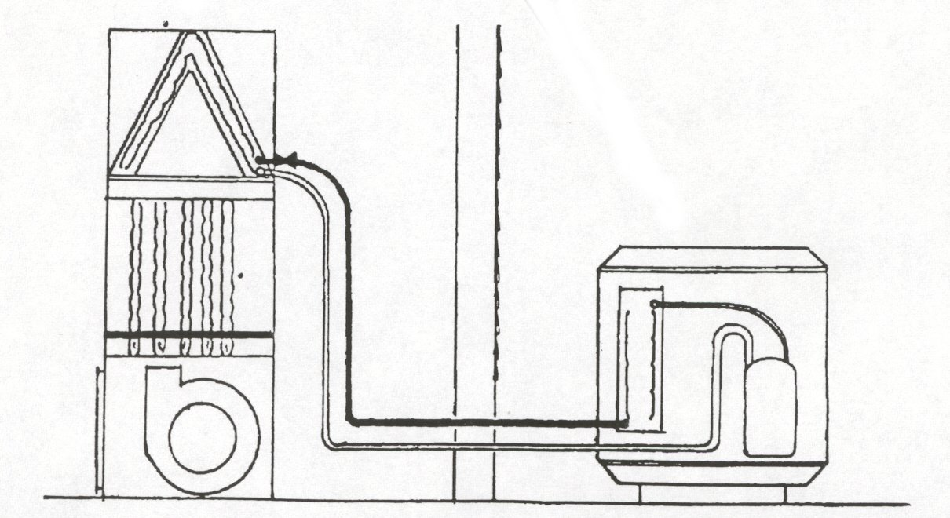
WINDOW A/C – Omaha – 1 Unit covered if no central a/c in home (No Add-ons) schedule 2 techs
COVERED COMPONENTS
Appliance cords
Bearings
Belts
Expansion valve
Pulley
Thermostat
COVERED COMPONENTS
Circuit boards
Capacitors
Compressor
(Up to 12 years of age)
Condenser fan blades
Condenser fan motors
Control-type switches
Condenser-type switches
Filter drier
Leak repair
(Minor sealed system)
Refrigerant charging
Refrigerant accumulators & receivers
(Up to 12 years of age)
Relay
Service valves
Transformer
Valve caps
EXCLUDED COMPONENTS
Any damage caused by
rust or corrosion
Any damage caused by customer
Coils (indoor & outdoor)
Scratch & cosmetic repairs
Trim
Inadequately sized line sets
Piping radiation
Coil cleaning
Condensate hoses
Replacement of
refrigerant lines
Gas air conditioning
Air filters, pads & cleaners

BENT FINS?
$60/HR & CHARGEABLE

REVISED 2/21/03
ATTIC & WHOLE HOUSE FAN

ATTIC FAN (NOT COVERED)
A fan installed in the attic to circulate air in the attic only.

WHOLE HOUSE FAN (SEE BELOW)
A fan may be installed in the attic or a hallway, but if in the attic,
will have louvers in the ceiling or wall to pull the air from the house into the attic.

AGREEMENT: HW – ONLY THOSE SOLD BEFORE 1999
NOT COVERED ON CONTRACTS AFTER 6/2001
PRIMARY TECHNICIAN: ELECTRIC
EMERGENCY SERVICE: NO
DEMAND: YES

SCHEDULE FIRST THING IN THE MORNING!!

DISHWASHER
REVISED 4/17/03

AGREEMENT: HW– GOLD– Add on to any plan
PRIMARY TECHNICIAN: APPLIANCE
EMERGENCY SERVICE: NO
DEMAND: YES

WON’T
DRAIN - If kitchen sink is also not draining, dispatch a plumber
- Check for kink in drain hose under sink
- If new garbage disposal was installed, plug may not have been taken out of disposal

LEAVING
SPOTS
OR STREAKS
ON DISHES - Determine if it is water scum on dishes or are there food particles.
ο If only water scum, you can suggest a teaspoon of Tang after the machine fills.
- Calcium buildup can be corrected by running empty dishwasher with 1 cup CLR
- Use no more than 2 tablespoons of soap (1T in each cup)
- Fill Jet-Dry dispenser once a month
  - For hard water areas (Bellevue, Papillion) use Jet Dry hanging baskets
- Run water from kitchen faucet until water is hot before starting dishwasher
- Make sure dishes are clear of spray tower that rises up in center
- User only granulated soap – no gel soap
  - Gels cause build up, going back and forth from gel to granular causes buildup
  - Clean dishwasher with Glisten, available at most grocery stores
WON’T
FILL WITH
WATER - Check for obstruction under float (located in left from bottom corner)

RUST ON
INSTALL QUESTIONS??
Please refer them to PAUL’S APPLIANCE
598-5356
DISHES - Caused from rusty racks. RACKS ARE NOT COVERED
  - Painting racks may help stop deterioration of racks.
  - Paint found at appliance part stores.
BURNING
SMELL - Plastic utensil may be stuck in bottom element

WON’T DO
ANYTHING - Check circuit breaker or fuse (only 1 fuse)
- Check for door obstruction (Door needs to be closed tight to latch)
DON’T FORGET MAJOR & RADIOSMITH
JUST REMEMBER NO CALLBACKS
NO HW
- Check child safety buttons – Lockout Option on some models

SCHEDULING GUIDELINES

No portable counter top models – Only full size portables!

BOB W. or TOM L. ONLY on the following dishwashers:
ASKO AKIE BOSCH
FISHER-PYKEL
(No Demand or warranty work except for contract customers)

DISHWASHER
REVISED 3/21/03

AGREEMENT: HW– GOLD– Add on to any plan
PRIMARY TECHNICIAN: APPLIANCE
EMERGENCY SERVICE: NO
DEMAND: YES

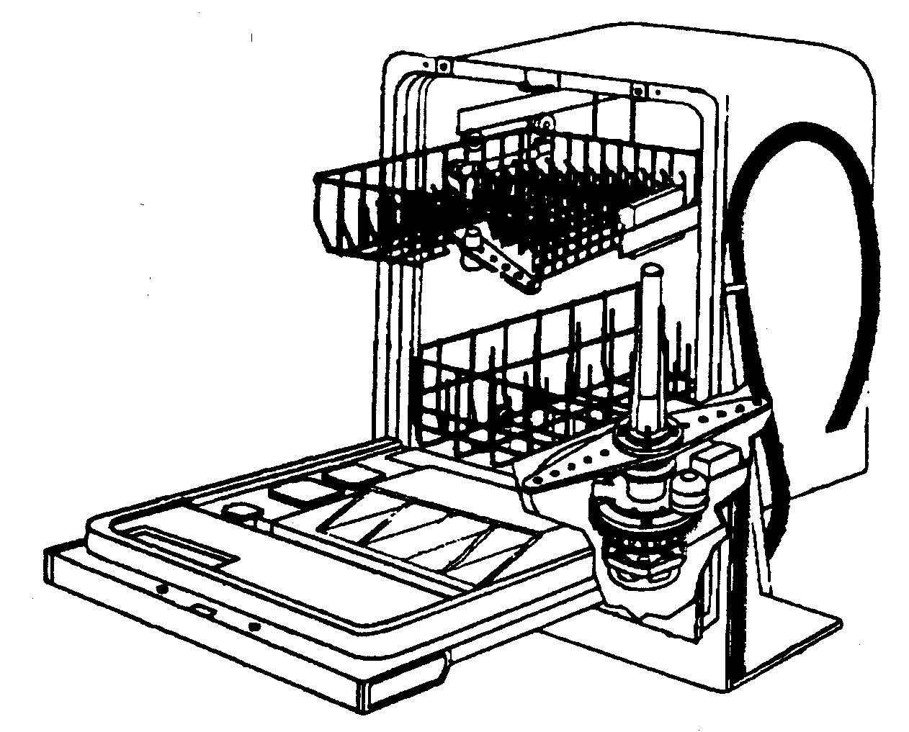
COVERED COMPONENTS
Spray arms
Spray towers

Touch pads
Timer/control
Printed circuit controls
Door switch
Door hinges
Door springs
Door gaskets
Chemicals & detergent dispensers
Knobs & handles
COVERED COMPONENTS
Tub
Motor
Motor relay
Motor seals
Pump
Impellers
Water seals
Wax motors
Fill valve
Heating element
Heat/moisture purge–
-blower & motor
Hoses
Drain solenoid
Check valve
Leveling legs

EXCLUDED COMPONENTS
Any damage caused by
rust or corrosion
Any damage caused by customer
Anti-syphon devices
Scratch & cosmetic repairs
Trim
Wheels
Rollers
Racks, Shelves & Baskets

REVISED 3/19/03
DRYER

AGREEMENT: HW– GOLD– SILVER–BRONZE– PLAT II
PRIMARY TECHNICIAN: APPLIANCE
EMERGENCY SERVICE: NONE
DEMAND: YES

NOT
RUNNING - Make sure plug is firmly inserted into outlet, check the breaker/fuses (2 fuses on electric).

NOT - Check breaker. If breaker looks OK, switch on/off/on again.
HEATING - If fuses are used (usually 2) each controlling 120 volts.
ο It is possible to have 1 fuse bad causing dryer to run but not heat.

TOO LONG - Check for clogged venting or kink in flexible vent.
TO DRY - Check outside flap to vent.
- Check for dirty lint filter.
- Is customer trying to dry too large a load?
- Is washer spinning dry?

TIMER NOT
ADVANCING
IN
AUTOMATIC - Vent restrictions can cause poor thermostat cycling.
OR - Does timer advance on minute side of timer, if not send tech.
PERMANENT
PRESS

NOISY - Check front & rear seals for coins, paper clips, jewelry – Send Tech.

LIGHT IN
TUB NOT - Replace& tighten bulb (NOT COVERED).
WORKING

SMELL GAS - Call local gas utility to isolate problem, once located call back if further assistance needed.

FURTHER SCHEDULING GUIDELINES

No EQUATOR except for CONTRACT CUSTOMERS
(per Tom L.)

DRYER
REVISED 4/17/03
AGREEMENT: HW– GOLD– SILVER–BRONZE– PLAT II
PRIMARY TECHNICIAN: APPLIANCE
EMERGENCY SERVICE: NONE
DEMAND: YES

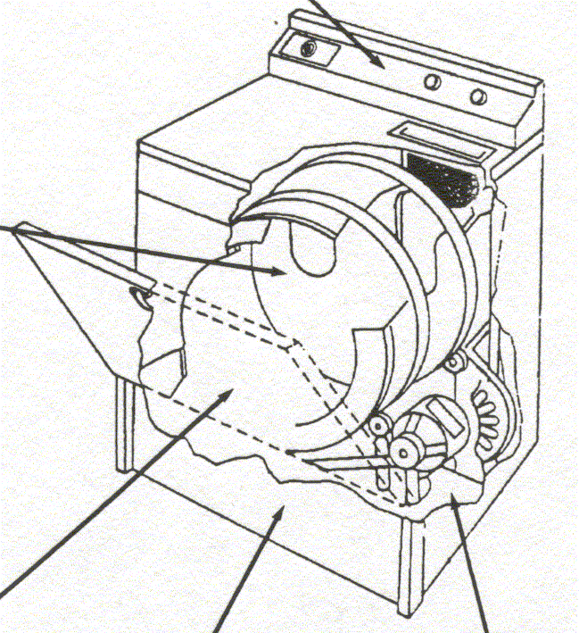
EXCLUDED COMPONENTS
Any damage caused by
rust or corrosion
Any damage caused by customer
Coin operated equipment
Scratch & cosmetic repairs
Trim
Vent
Drum
Light bulbs
Flexible gas connector
Cleaning of venting
or re-venting
Damage from
improper venting

COVERED COMPONENTS
Appliance cords
Controls timer
Fuse
Knobs & handles
Electronic dry control boards
Touch pad control
Touch pad
Selector
Switch
Printed circuit timer control
Transformer
Automatic laundry product disposal
Bearings
Belts
Cables
Capacitors
Door catch
Door switch
Drum baffles
Gasket & seals
Glides
Lint filter
Roller & shafts
Sensor (moisture/dryness)
Flame sensor
Flame spreader
Gas valve
Heating element
Heating element switch
Ignitor
Limit control
Main burner
Pilot burner
Regulator
Spark generator
COVERED COMPONENTS
Blower wheel
Leveling legs
Motor
Pulleys
Relay
Springs
Thermal fusible links
Thermistors
Thermocouple
Thermostats
REVISED 2/21/03

DUCT CLEANING

AGREEMENT: NONE
PRIMARY TECHNICIAN: CONTRACTOR
EMERGENCY SERVICE: NO
DEMAND: ONLY

OMAHA AREA

INFORMATION & SALES: JOHN SALMANS, ext 2182
JASON REEDER – BACK UP, ext 2178
LISA SOUSEK – BACK UP, ext 2108
JIM BOUKAL – BACK UP, ext 2179

PRICES: $375 for up to 12 registers & cold air returns
$10 for every opening in addition to the 1st 12
$50 for additional furnace

SCHEDULING: Call DUCTS UNLIMITED 829-3828 & give information
- They will contact the customer to make the appointment.

DUBUQUE AREA

TECHNICIAN: RUSS KRAMER, AIRTECH AIR DUCT CLEANING

PRICES: $350 for up to 12 registers & cold air returns
$375 for more than 12 registers & cold air returns

SCHEDULING: Call Russ Kramer, (319) 582-9815 or (319) 590-5722
- Give Russ the information & he will contact the customer to make appointment
- Generate a ticket and schedule under Russ Kramer

HIGHLIGHTS OF OUR PROCESS IN OMAHA:

Video inspection of the duct work before and after, if requested by the customer

ELECTRICAL
REVISED 3/7/03

AGREEMENT: HW– GOLD– PIPES & WIRES
PRIMARY TECHNICIAN: ELECTRICIAN
EMERGENCY SERVICE: NO
DEMAND: YES (HW & Gold customers will not be charged a minimum fee for a bid)

WHOLE/HALF
BATHROOM EXHAUST FAN IS CHARGE-ABLE QUOTE MIN OF 1 HR @ $55
HOUSE - Probably a problem with the power company.

LIGHT
PLUGGED - If outlet or circuit breaker has ground fault interrupter, push reset.
INTO - Replace light bulb – not covered.

OUTLET - Check circuit breaker.

WON’T - Try to turn light switches on/off around outlet, this may turn outlet on.

COME
ON

CEILING - If fan is turning, problem cannot be in the wiring. (Ceiling fans are not covered.)
FAN - Switches for Casa Blanca fans are not covered.

FLORESCENT
LIGHTS - Flickering lights are most often caused by the bulb or ballast (ballast covered on Gold and
Pipes & Wires, but not on HW. The bulb is not covered on any plan.)

SWITCHES - GFI type switches (have a “test” & “reset” button on them) “reset” by pushing the button.
- The switch for Casa Blanca ceiling fan is part of the fan & not covered.
- Appliance or HVAC techs can also look at/repair outlets or switches.
OUTLETS
F.Y.I.
LIGHT FIXTURES, CEILING FANS, BULBS & PULL CHAINS ARE NOT COVERED BY ANY PLAN.
NOT - If outlet is loose, may not be screwed into box tightly.
WORKING - Plug may not fit properly, have they tried other plugs?

OUTLETS,
SWITCHES,
BREAKERS - turn switch or breaker off until electrician arrives.
SMELL HOT
SMOKING
DISCOLORED

FUSES ALWAYS
DEMAND BIDS 1 HR MINIMUM @ $55
BLOW OUT - customer may need to upgrade service

WHOLE
HOUSE FAN
VS - Attic fan circulates air in the attic. A whole house fan pulls air out of the house into attic.
ATTIC FAN

LIGHT BULBS - Post air-conditioning season, Omaha voltage is 124-128 volts & the cheap bulbs are rated
DON’T LAST 120 volts & will last only 2-3 weeks especially when subject to vibration or left on for an
VERY LONG extended amount of time. Suggest purchase of 130 volt or longer life bulbs.
ELECTRICAL
REVISED 5/3/03

AGREEMENT: HW– GOLD– PIPES & WIRES
PRIMARY TECHNICIAN: ELECTRICIAN
EMERGENCY SERVICE: NO
DEMAND: YES (HW & Gold customers will not be charged a minimum fee for a bid)

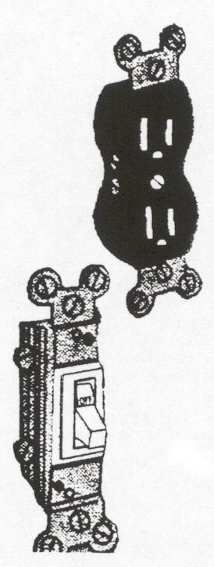
EXCLUDED COMPONENTS
Any damage caused by
rust or corrosion
Any out of code conditions
Attic fans/Whole house fan**
Bathroom vent fans
Burglar or fire alarms
Ceiling fans
Doorbell chimes
Doorbell decorative covers
Insufficient electrical service
Insufficient current due to wire size or
number of circuits
Intercoms or speaker systems
Light fixtures
Lighted switches
Low voltage electrical systems
Off-peak switching systems
& timers
Power failures, shortages
or surges
Underground outdoor
lighting systems

COVERED COMPONENTS
Components and parts within the perimeter of the main foundation
Doorbell unit:
-transformers
-push button switches
-solenoids
-plungers
Fuse holders & breakers
Main panel
Outlets
Standard switches
Wiring
Ballast on florescent light
(Not covered on HW)

Light fixtures
(Pipes & Wires only –
pre-existing customers only)
FREEZER
REVISED 2/28/03

AGREEMENT: HW– GOLD
PRIMARY TECHNICIAN: APPLIANCE
EMERGENCY SERVICE: “NOT COOLING” Soft Emerg.
DEMAND: YES

NOT
COOLING - Check to see if plug has slipped out
- Check outlet by plugging something else in.
- Check breaker
- To see if outlet is not functioning, plug appliance into extension cord & run to outlet in another room. If appliance works, NEED ELECTRICIAN.
- Freezers should not be on GFI outlets, but if so check GFI & reset.

GASKET - If seal is torn or has come off, send TECH to verify type & part to be ordered.
- If customer is insistent on preorder, then do so. (Per Tom L.)

- If seal is wedged, send tech.

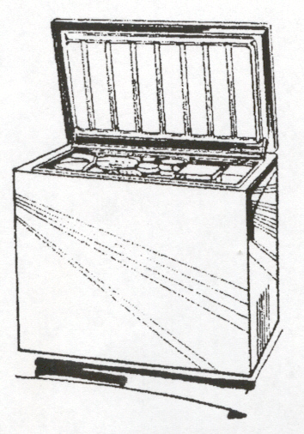
SCHEDULING GUIDELINES

No SANYO except for Contract Customers.
EXCLUDED COMPONENTS
Any damage caused by rust or corrosion
Door locks
Evaporator & condenser coils
Food spoilage
Heaters that are molded into the cabinet
Insulation panels
Light bulbs
Removable baskets & racks
Scratch & cosmetic repairs
Trim
Yoder loops

COVERED COMPONENTS
Appliance cords
Capacitors
Compressors
(up to 12 yrs of age)
Condenser fan blades
Condenser fan motor
Control-type switches
Defrost element
Defrost timer
Door seals
Drain hoses
Evaporator fan motor
Handles
Hot gas defrost valve
Knobs
Leak repair (minor sealed-system)
Mullion defrost heater
.
REVISED 3/26/03
FURNACE (FORCED AIR)
AGREEMENT: HW– GOLD – SILVER – HEATING – COMBO– PLATI/II
PRIMARY TECHNICIAN: HVAC
EMERGENCY SERVICE: NO HEAT (If temperature is expected to fall below 45 degrees.)
DEMAND: YES (Except Boilers)

NO HEAT - IS FAN RUNNING?
NO ο Make sure t-stat is set to “Heat” & set at a temp higher than room temperature.
ο Make sure t-stat is set to “Auto” or “On”.
- Make sure switch on side of furnace is “on” & fuse next to switch is good.
- Turn furnace switch off, wait 1 minute and turn back on.
- Make sure breaker is not tripped.
- Check to see if pilot is off.
- Make sure the door to the furnace is latched in place.
YES ο Make sure t-stat is set at a higher temp than room temp.

WON’T
SHUT OFF - Make sure t-stat is set to a temp lower than room temp & fan is set to “Auto”
(You might have them try setting it to “Off”).
- If temperature keeps going up, shut off furnace switch or breaker, IF BURNER STILL STAYS
ON, TURN POWER BACK ON & SEND A TECH.

WATER
AROUND - (WINTER) Is probably the humidifier. (SUMMER) Is probably a condensate leak.
BOTTOM - If humidifier, tell customer to turn water valve off to prevent further leaking until repaired.
- If air conditioner, tell customer to turn a/c off to prevent further leaking until repaired.
- See A/C condensate.
NOT
ENOUGH - Check for dirty filter (filters should be changed once a month, NOT COVERED).
AIR FLOW - Check for closed or obstructed registers (both warm & cold returns).

SHORT
CYCLING - Fan turns on and off repeatedly.
- Ask if house temperature is below 65 degrees when this happens.
SMELLS
GAS - Inform customer to call local gas supplier (Our techs are not equipped with the sophisticated
equipment the utilities use & they will not charge to locate the problem, & turn the gas off if
necessary. We will perform the corrective repair.)
- Make sure flue pipe is secure to top of furnace. Repair of flue pipe is CHARGEABLE.
- If there is a lot of gas present, inform customer leave the home to call gas company & to stay out.
LOUD
BANGING - Could be a delayed ignition which is dangerous & must be scheduled as EMERGENCY.
OR - Inform customer to turn furnace off until we get there.
EXPLODING - Duct work could be expanding and contracting.
GOT A BOILER?
DENNY & JEREMY ONLY
NOISE Correction of duct work is CHARGEABLE
WHEN
BLOWER
GOES
WARRANTY INFO.
INSTAL HUMID = 1 YR
INSTAL FURN = 5 YR PT/L
ON/OFF
FURNACE (FORCED AIR)
REVISED 3/26/03
AGREEMENT: HW– GOLD – SILVER – HEATING – COMBO– PLATI/II
PRIMARY TECHNICIAN: HVAC
EMERGENCY SERVICE: NO HEAT (If temperature is expected to fall below 45 degrees.)
DEMAND: YES (Except Boilers)

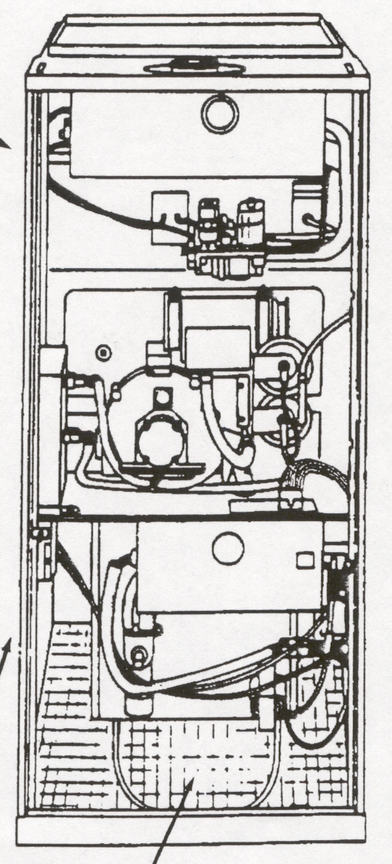
EXCLUDED COMPONENTS
Any damage caused by rust or corrosion
Air Cleaners
AMANA HTM furnaces
Auxiliary space heaters
Chimney, liners & flues
Duct systems
--cleaning
--duct boosters
--duct mounted forced draft assemblies
--forced-air zone controls & dampers
--setting airflow
--vents
--connectors
--dampers
Filters
Heat Exchangers
Humidifiers
Hydronic Systems
--Expansion Tanks
--Boiler Sections
Solar Heat
-------------------
Repairs necessitated by installation or design deficiencies, or manufacturer product updates

COVERED COMPONENTS
Flame electrode
Flame spreader
Fuel regulator
Gas valve
Ignitor
Main burner
Manifold
Pilot burner
Sensor
Vent damper (OEM)

Circuit boards
Circulation pump (motor only)
Fan plate
Fan and/or limit controls
Forced draft fan
Forced draft motor
Fuse
Heating element
Ignition control module
Inducer fan/motor assembly
Low water cut off
Thermocouple
Transformer
Wiring (other than complete wiring)
Pressure control
Pressure gauge
Pump coupler
Thermal fuse
Safety interlock switches
Sequencers
.
COVERED COMPONENTS
Belts
Blower Bearings
Blower Wheels
Blower Shaft
Capacitors
Fan motor
Furnace Service Switch
Pulleys
Radiants
Relay
Relief Valve
Sight Glass
.
REVISED 3/25/03
GARAGE DOOR OPENER
AGREEMENT: HW ONLY
PRIMARY TECHNICIAN: NORM’S GARAGE DOOR
EMERGENCY SERVICE: NO
DEMAND: NO

- GENERATE a ticket in SMS.

- ASSIGN to the NORM’S GARAGE DOOR.

- INFORM customer of whom the contractor is and that they should receive a call within an hour to
schedule an appointment, if they don’t hear from the contractor within an hour to please call back.

- CONTACT NORM’S GARAGE DOOR – 331-8920 & give ticket # for payment reference.

- ADD an event “Technician Acknowledge” and “Finish” the ticket after the call has been given to the
CONTRACTOR.

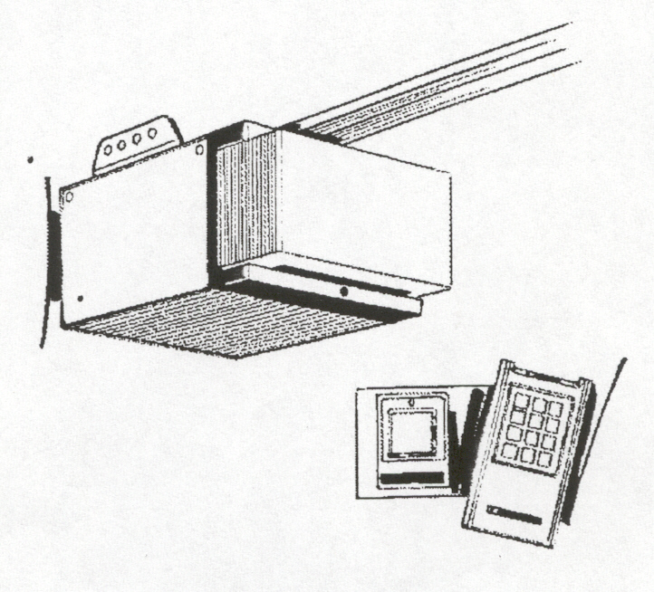
COVERED COMPONENTS

Bearings
Belt
Capacitor
Chain
Components & parts contained in the opener
External Safety Devices (electric eye)
Motor
Pulleys
Sprockets
Trolley
Upper/Lower Limit Switches

EXCLUDED COMPONENTS
Door springs, pulleys & rollers
Door Rails/Tracks
Keyless Entry
Keyed Entry Electric
Lights & light bulbs
Malfunction of opener caused by non-covered parts
Opener hangers & supports
Receivers
Transmitters
REVISED 3/25/03
GARBAGE DISPOSAL
AGREEMENT: HW– GOLD
PRIMARY TECHNICIAN: APPLIANCE
EMERGENCY SERVICE: NONE
DEMAND: YES Replacement Prices: ½ H/P* ¾ H/P*
Gold Contr (Same Trip) $175.00 $200.00
Gold Contr (2nd Trip) $215.00 $250.00
Other Contract $201.00 $260.00
No Contract $224.00 $292.00

*½ H/P = 3 yr warranty ¾ H/P = 4 yr warranty

WILL NOT
RUN - Ask if they tried the reset button. It is usually a red button found on the bottom of the
disposal or around the top. When pushed in, the disposal may start again.
- When disposal is in the off position or unplugged, insert Allen Wrench at bottom of disposal and turn to free cutting blade.

SMELLS - Instruct customer to put ½ slice lemon (remove seeds) down disposal & running cool water

A tray of ice cubes ran through the disposal (without water) will also help eliminate odors.

NOISY - Unplug disposal and check for silverware or other items jammed in disposal.

CLOGGED - Could be disposal if cutting blade rusted or missing.
- Normally this is not a disposal problem, it is a plumbing problem.

CHECK TO SEE IF THEY HAVE PLUMBING COVERAGE.
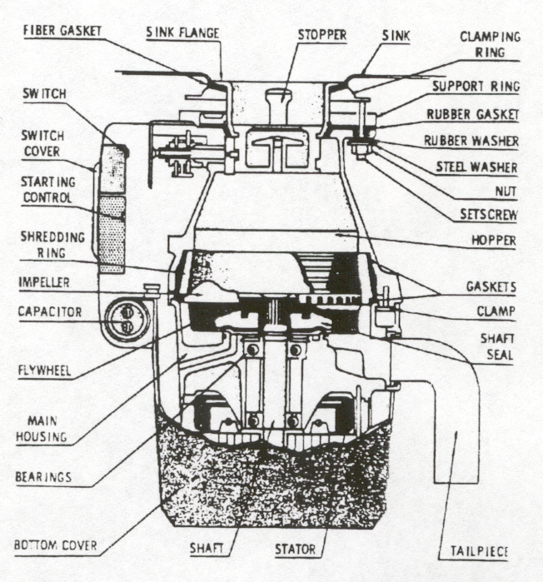
COVERED COMPONENTS
Batch switch in collar
Capacitor
Reverse switch
Rotor
Safety switches
Seals
Shredder
(stationary & rotor)
Sink flange
Sink gasket
Stator

EXCLUDED COMPONENTS
Any damage caused by rust or corrosion
End bell assemblies
Insulation
On/off wall switch
Tail pipe or connectors
Trim

SCHEDULING GUIDELINES

No SANYO except for Contract Customers.
HEAT PUMP
REVISED 3/29/03
(WINTER SEASON ONLY)

AGREEMENT: HW– GOLD – SILVER – HEATING – COMBO – PLAT II
PRIMARY TECHNICIAN: HVAC
EMERGENCY SERVICE: NO (During heating season, there is a backup furnace.)
DEMAND: YES

IS THE UNIT
FROZE UP? - A heat pump will get a thin layer of frost over the coils. This is normal. That is why
there is a defrost cycle.
- But if the ice is over a ¼” thick over the entire coil then there is defrost problem & they
will need to shut down the unit & schedule a technician.

IS IT RUNNING
OUTSIDE? - Check breakers.
- Is the temperature below the balance point set for the heat pump?
Which is usually around 25 degrees.
It means that the heat pump will not run once the temperature falls below that.
It will automatically go to its backup heat.
Reason is that a heat pump cannot keep up at that temperature.
- This is not true for ELECTRIC furnaces, heat pump will always run when electric furnace is on, for efficiency reasons.

EMERGENCY
HEAT - EVERY HEAT PUMP HAS BACK-UP HEATER, WHETHER ELECTRIC OR
WORKING? GAS.
- On every heat pump thermostat there is an emergency heat position on the system switch
where they switch from heat to cool.
COVERED COMPONENTS
Capacitors
Circuit boards
Compressor
(up to 12 yrs of age)
Condenser fan motor
Fossil fuel kits
-outdoor thermostats
& controls
Fuse
Leak repair
(minor-sealed system)
Refrigerant accumulators & receivers
(up to 12 yrs of age)
Refrigerant charging
Relay
Transformer
Reversing valve
Liquid & suction line
Valve caps

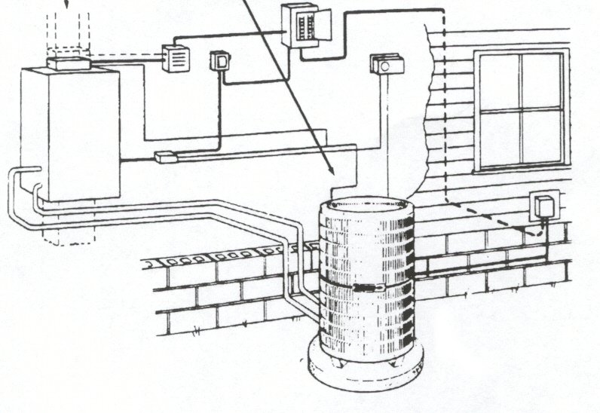
COVERED COMPONENTS
Bearings
Belts
Control type switches
Defrost heaters
Defrost control
Expansion valves
Fan blades
(indoor & outdoor)
Pulleys
Thermostat

EXCLUDED COMPONENTS
Any damage caused by rust or corrosion
End bell assemblies
Insulation
On/off wall switch
Tail pipe or connectors
Trim
REVISED 3/26/03
HUMIDIFIER
AGREEMENT: HW– GOLD– Add on to BRONZE/SILVER
PRIMARY TECHNICIAN: HVAC
EMERGENCY SERVICE: NO
DEMAND: YES

(Humidifier is used only in winter with furnace.)
NOT
ENOUGH - Humidstat, white line, may be turned below set point. Turn upper portion higher.
HUMIDITY - Humidstat should be set at 35% if outside temp is above 25 degrees, 25% if below 25 degrees.
- Check damper control; General – turn control to “high”,
other humidifiers, open damper on 5-6” pipe.

TOO MUCH
HUMIDITY - Turn humidstat control to 25% or turn damper control to “low”.

LEAKING - Remove drain hose and blow into hose to clear obstruction (a vacuum may also be used).
- Unplug humidifier or turn to lowest setting.
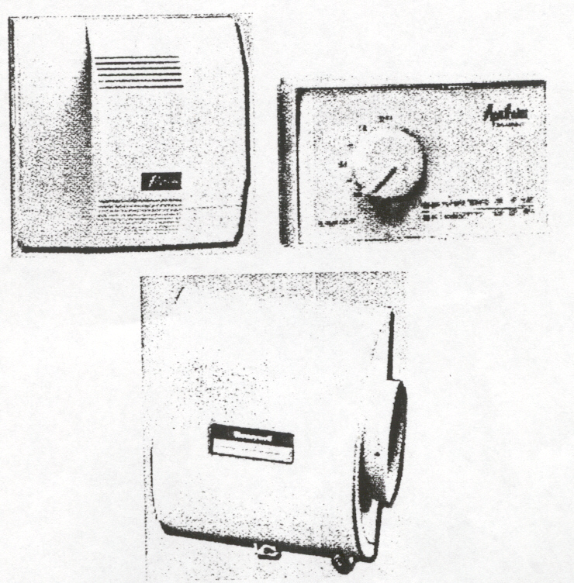
- Turn off water supply.
WARRANTY INFO.
INSTAL HUMID = 1 YR
INSTAL FURN = 5 YR PT/L
EXCLUDED COMPONENTS
Media
Any condition caused by rust or corrosion
Damage caused by leaks or overfilling
Damage due to high levels of humidity
COVERED COMPONENTS
Electric motor
Float
Float fill valve
Float valves
Humidistats
Line tap valves
Relays
Solenoid water valves
Transformers

REVISED 3/27/03
MICROWAVE (BUILT-IN ONLY)

AGREEMENT: HW– Add on to GOLD
PRIMARY TECHNICIAN: APPLIANCE (See below)
EMERGENCY SERVICE: NO
DEMAND: YES

A built-in microwave is either a part of the range or
is attached to the wall above the range, usually with an exhaust fan as a part of it.

NO COUNTERTOP MODELS AT ALL.

SCHEDULING GUIDELINES

SCHEDULE WITH TOM L. OR MARCEL ONLY

If unit is G.E. & manufactured between 1999-2001, have customer call G.E. @ 1800GE-CARES to see if under warranty – up to 5 years.
Model # is inside on the left wall.

COVERED COMPONENTS
Carousel motor
Door interlock switches
Electronic control
Glass doors
High voltage transformer
Magnetron
Stirrer
Timer
Touch pads
Voltage doubler circuit

EXCLUDED COMPONENTS
Any damage caused by rust or corrosion
Portable or stand-alone microwave units
Trays or plate
Light bulbs
REVISED 3/6/03
PIPES & WIRES

AGREEMENT: NO LONGER AVAILABLE, current PW customers still covered
PRIMARY TECHNICIAN: PIPES – PLUMBER, WIRES – ELECTRICIAN
EMERGENCY SERVICE: TOTAL ELECTRICAL OUTAGE OR BURNING/SPARKING
DEMAND: YES

WIRES - See Electrical System (Differences listed below)
COVERED: EXCLUDED:
In-Wall Wiring for: Phone Sets
Telephone Wall Jacks Computer Unit
Computer Intercom Unit
Intercom Stereo Unit
Stereo Decorative or non-functional parts
Light Fixtures of light fixture
(only down to part the bulb screws into)

PIPES - Gas pipes only.
COVERED: EXCLUDED:
All gas piping w/in perimeter of the foundation Gas meter & pipes outside the perimeter
Flexible gas connectors of the main foundation.

GAS ODOR
If customer suspects they have a significant gas leak, here are some safety rules:
- Open doors/windows
- Do not turn lights on/off, use telephone or other electricity (could spark an ignition)
- Leave home to call gas utility. After utility has secured the home & determined where the leak is, call us for repair.
PLUMBING
REVISED 3/7/03
AGREEMENT: HW– Add-on to any other plan -- $25 Trip Fee
PRIMARY TECHNICIAN: PLUMBING
EMERGENCY SERVICE: UNCONTROLLABLE RUNNING WATER
ONLY TOILET UNUSABLE
DEMAND: YES (w/ HW & PLUMBING COVERAGE, no diagnostic fee)

MOBILE HM INSIDE ONLY

Customer’s Standard Faucet Replacement: w/ Plumbing Coverage $75, w/out PL $85 MINIMUM.
DRAINS - 30 DAY WARRANTY
SIMPLE DRAIN CLEAN
$85 MINIMUM
MAIN WASTE - Not covered, however a technician needs to be
VENT STACKS dispatched to the home for verification.

UNCONTROLLED
LEAKING - If damage is being done & leak can’t be controlled at source, instruct cust. to turn water off @
at the meter.

Schedule as an emergency if whole house has to be turned off.
LEAKING
DRIPPING - Ask how long this has been occurring (if for some time, cust. shouldn’t mind if they have to wait
FAUCETS two days). To determine how badly it has been leaking, ask how long it takes to fill a glass. A very
slow leak can wait a couple of days.
OUTSIDE
FAUCET - This occurs frequently in the Spring. It is usually caused by frozen pipes because of an extremely
LEAKING cold winter or the hose being left attached to the faucet, causing water to remain in the pipe, freeze,
INTO HOUSE expand & break the pipe. This leak occurs when garden hose is turned on (is not covered).

BANGING - This is caused by air in the pipes and can usually be eliminated by turning on all faucets in house

IN PIPES at once to fill in the air pockets. (Only if water has recently been shut off to house.)

TOILET - To stop the toilet from running temporarily, the shut off valve behind the bowl can be turned off.
RUNNING - If no shut off valve, will need to shut off at meter.

SINK/TOILET
LEAKING - Instruct customer to turn off water valve under toilet/sink, SCHEDULE EMERG if ONLY toilet.

TUB/SHOWER
1 CUP CLOROX
3 DAYS/WK
LEAKING - If leaking does not occur when tub water drains, or when shower is running
(shower head directed to middle of tub), it is a tile or grout problem.

SLOW/CLOGGED
DRAINS - Ask customer if obstruction is visible, (if so, can they get to it with hand or a clothes hanger?).
- If something has been dropped in drain (a toy etc.), we will run the call, however, if this happens
regularly, it will become a chargeable call.
- If FLOOR DRAIN backing up w/ toilet waste, problem is MAIN DRAIN which can be referred to RAPID ROOTER or inform customer NOT COVERED & they can contact any drain cleaner.
ODORS - Normally do not dispatch for odors, inform customer to use bleach w/ water in the drain.
- NOTE: If we have been out recently to snake the floor drain, it’s possible we forgot to put the back-flow preventer back in place.
NO WATER
OUT OF - If weather has been extremely cold, ask if faucet is on outside wall or over garage-probably frozen.
FAUCET - Hot water freezes before cold water.

GAS ODOR If customer suspects they have a significant gas leak, here are some safety rules:
- Open doors/windows; Do not turn lights on/off, use telephone or other electricity (could spark an
ignition) Leave home to call gas utility. Once secured & leak determined, call us for repair.
RAPID ROOTER
331-1568
PLUMBING
REVISED 3/2703
AGREEMENT: HW– Add-on to any other plan -- $25 Trip Fee
PRIMARY TECHNICIAN: PLUMBING
EMERGENCY SERVICE: UNCONTROLLABLE RUNNING WATER
ONLY TOILET UNUSABLE
DEMAND: YES (w/ HW & PLUMBING COVERAGE, no diagnostic fee)

MOBILE HM INSIDE ONLY

COVERED COMPONENTS
Covers items within the perimeter of the main foundation
Drains
Faucets (repair only)
Faucet handles
Gas pipes
Pressure regulators
Sewer pipes
Shut-offs
Toilets (repair only)
Traps
Water pipes

EXCLUDED COMPONENTS
Any condition caused by rust or corrosion
Back-flow preventers
Caulking or grouting
Closed systems for non-potable water
Color or purity of the water system
Conditions caused by excessive lime deposits
Expansion tanks on potable water lines
Flexible gas connectors
Frozen pipes
& water lines
Insufficient or excessive water pressure
Jet pumps
Lead piping
Main supply line valves
Piping & plumbing outside the perimeter of the foundation
Plastic tubing or fittings
Plumbing contained in
or under the foundation
or slab

EXCLUDED COMPONENTS
*Pools, spas, hot tubs
Relief valve problems due to installation of back flow preventers, pressure reducing valves, check valves
Septic tanks & systems in or outside the residence
Sewage ejector pumps
Shower enclosures/base pans
Solar systems

*Sump pumps
Vent & waste stacks
Water filters
Water meter (inlet/outlet)

*Water softeners
Water purification systems
Wells, well pumps & storage tanks

Instant hot water dispensers

REVISED 3/2703

POOLS & SPAS

AGREEMENT: HW (Add-on Only)
PRIMARY TECHNICIAN: DENNY BENDER
EMERGENCY SERVICE: NONE
DEMAND: NO

NOT WORKING PROPERLY

- Is the filter dirty?
- Is the water level sufficient?

JET TUBS

AGREEMENT: HW (Add-on Only)
PRIMARY TECHNICIAN: BOB WEZOREK (Problems w/ Jets)
DENNY BENDER (Problems w/ Plumbing)
LISA (Technical Asst., w/ handle)
EMERGENCY SERVICE: NONE
DEMAND: NO
We have an agreement with NFM
to do their warranty work on ACQUATIC JET TUBS.

COVERED COMPONENTS
Air switches & hoses
Air mix valves & hoses
Air blower motors
Electrical circuitry
Filter system
Gas lines
Heater
Motor
Plumbing
Pool heater by-pass
Printed circuit
control boards
Pump
Thermostat
Timers
Valves

EXCLUDED COMPONENTS
Cleaning equipment
Damage caused
by chemicals
Filter cartridges
& basket-type filters
Improper installations
Jacuzzi/massage tubs
Lights
Lines or equipment
not readily accessible
Pool & tub structure
Pool or spa heater coil
or heat exchanger
Pool sweeps
Pool sweep motors
Solar equipment

RANGE
REVISED 2/28/03

AGREEMENT: HW– GOLD–SILVER–BRONZE–PLAT I/II
PRIMARY TECHNICIAN: APPLIANCE
EMERGENCY SERVICE: NONE (Soft Emerg. during holiday season
DEMAND: YES if needed for the holiday.)

WON’T
COME ON - Check the breaker, reset by turning off, on/off & on again (if fuses are used, there are 2)
OR JUST - Check to see if range is plugged in.
LIGHTS
COME ON

OVEN WON’T - Make sure automatic timer is set to “manual”, not “hold” or “auto”.
COME ON - Check the breaker
- Make sure the “Selector” and “Thermostat” knobs are not reversed
FOOD BURNS
IN OVEN - Make sure oven is allowed to preheat 15-20 minutes
- Electric range – make sure vent channel from oven under right rear burner vents through drip pan.
(Aluminum foil or burner covers will obstruct venting.)
- Using aluminum foil on bottom of oven or covering racks will cause uneven baking & can damage oven liner.
OVEN LIGHT
WON’T - Replace bulb (bulbs must be screwed in tight) NOT COVERED.
COME ON

BURNER
ELEMENTS
HAVE TO BE - Send a Tech
WIGGLED
TO WORK

ELECTRONIC
RANGE - Turn circuit breaker off/on, press cancel. Reset clock on timer & try to bake again. If code comes
INDICATES up again, send tech. (Power surges will cause these errors & will go away by resetting.)
F-1, F-2, ETC.

OVEN DOOR
WILL NOT - Even when indicator says self-clean is finished, oven may be too hot, wait an additional hour.
UNLATCH - Oven release button must be pushed to unlatch door.
AFTER
SELF-CLEAN

SELF-CLEAN INSTRUCTIONS
- If oven door has shield, to protect the glass lift up and lock.
- Set selector knob to SELF CLEAN.
- Set t-stat knob to clean or as high as it will go.
- Set start time on clock to current time. Knob should be in out position.
- Set stop time to 2-3 hours past start time.
- If range has latch release button, depress button & latch door to CLEAN position.
- To get oven out of SELF CLEAN, reverse procedures. On most ovens, the selector and thermostat must be left on “Clean” for latch deactivation.
RANGE
REVISED 3/28/03

AGREEMENT: HW– GOLD–SILVER–BRONZE–PLAT I/II
PRIMARY TECHNICIAN: APPLIANCE
EMERGENCY SERVICE: NONE (Soft Emerg. during holiday season
DEMAND: YES if needed for the holiday.)

COVERED COMPONENTS
Touch pads
Touch pad controls
Knobs & handles
Printed circuit controls
Process control switches
Process control timer
Programmable cooking –-controls
Receptacles
Transformers
Fuse
Fan control
Fan motor
Exhaust fan switches
Exhaust fan controls
Exhaust fan motors
Thermostat

EXCLUDED COMPONENTS
Any damage caused by rust or corrosion
Scratch &
cosmetic repairs
Trim
Exhaust duct & vent
Light bulbs
Flexible gas connector
Clocks or timers that are not process controls
Induction cooking
Racks
Meat probes
Rotisserie motors

COVERED COMPONENTS
Glass cooking tops
Heating elements
Ignition modules
Insulation panels
Main burner
Manifold
Pilot burner
Regulator
Relay
Door hinges
Door liners
Door springs
Gas valve
Gaskets & seals
(self-cleaning only)
Glass doors
Oven liners
Sensors
Ignitor
Leveling legs
Self-cleaning elements
Self-cleaning latches
Self-cleaning solenoids
Thermistors
Thermocouples

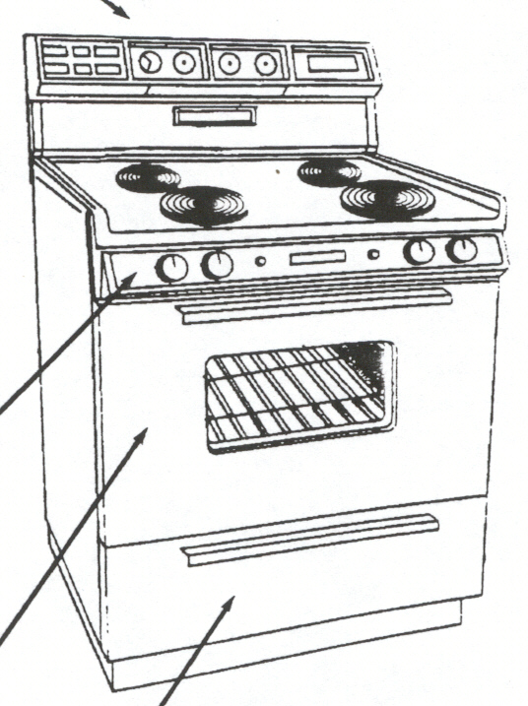
REVISED 5/15/03

RANGE HOOD

AGREEMENT: HW– GOLD
PRIMARY TECHNICIAN: APPLIANCE (see below)
EMERGENCY SERVICE: NONE
DEMAND: YES

SCHEDULING GUIDELINES

WHEN SCHEDULING, ASK BRAND & NOTE IN COMMENTS.

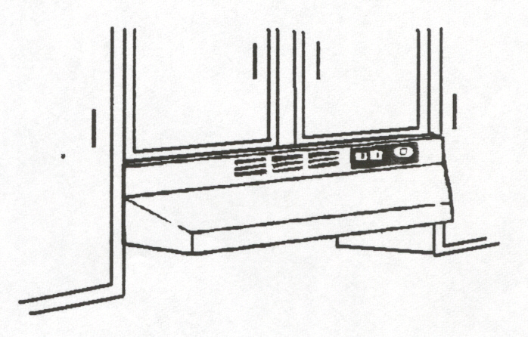
COVERED COMPONENTS
Control switches
Exhaust fan & motor
Knobs
Lights

EXCLUDED COMPONENTS
Charcoal beds
Cleaning of exhaust system
Duct dampers
Duct flappers
Duct work
Filter elements
Light bulbs
Scratch & cosmetic repairs

REVISED 3/5/03

REFRIGERATOR

AGREEMENT: HW– GOLD– SILVER– PLAT II
PRIMARY TECHNICIAN: APPLIANCE
EMERGENCY SERVICE: SOFT (if not cooling)
DEMAND: YES

NOT COOL
AT ALL - Make sure refrigerator is plugged on.
(NO LIGHTS) - Check circuit breaker or fuse. If in doubt, run extension cord to another outlet.

NOT COOL - Remove kick plate under doors and vacuum condenser coil.
VERY WELL - Paper could be stuck in condenser fan motor in back of unit (obstructing air movement).
- Was fresh food or freezer door left ajar.

LIGHT IN
REFRIG./ - Ask customer to push in the switch in the door to see if the fan comes on.
FREEZER ο If fan runs, the problem is just the light, which is not covered.
NOT WORK ο If fan does not come on, send tech
- Replace/tighten bulb. NOT COVERED

GASKET - If seal is torn or has come off, send TECH to verify type & part to be ordered.
- If customer is insistent on preorder, then do so. (Per Tom L.)
- If seal is wedged, send tech.

COMPRESSOR COVERAGE??

Compressors are only covered for up to 12 years.

Replacement techs – Bob W. and Brian A.

FURTHER SCHEDULING GUIDELINES

No SANYO except for CONTRACT CUSTOMERS
(per Tom L.)

REFRIGERATOR
REVISED 3/29/03

AGREEMENT: HW– GOLD– SILVER– PLAT II
PRIMARY TECHNICIAN: APPLIANCE
EMERGENCY SERVICE: SOFT (if not cooling)
DEMAND: YES

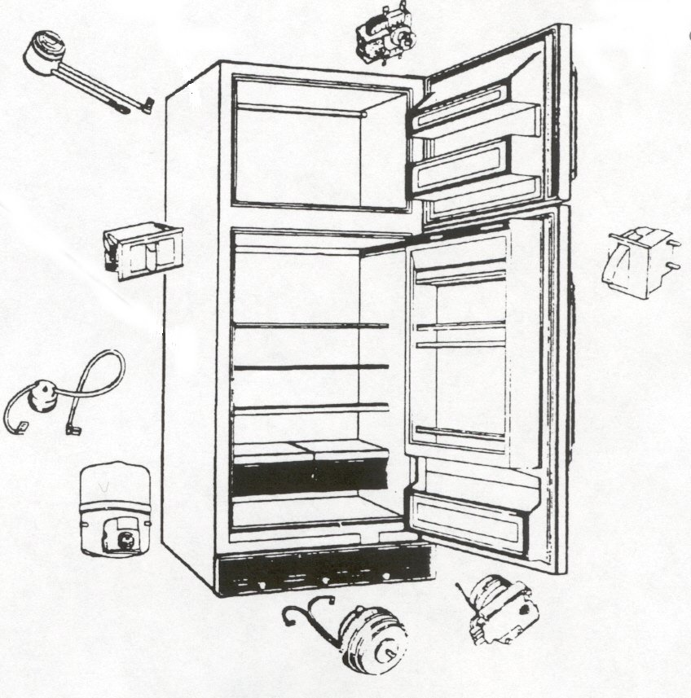
COVERED COMPONENTS
Appliance cords
Defrost elements
Defrost fan
Defrost thermostat
Defrost timer
Drain hoses
Evaporator fan motor
Host gas defrost coil
Icemaker
Refrigerant accumulators & receivers
(up to 12 yrs of age)
Stile heaters
Ice/water dispensers
Capacitors
Compressors
(up to 12 yrs of age)

EXCLUDED COMPONENTS
Divider block
Drinking water filters
Evaporator & condenser coils
Heaters that are molded into the cabinet
Ice crushers & shavers
Insulation panels & liners
Light bulbs
Removable
baskets & racks
Trim
Scratch & cosmetic repair
Yoder loops
Any condition caused by rust, corrosion or the customer.

COVERED COMPONENTS
Compressor overload
Condensate drain heater
Condenser fan blades
Condenser fan motor
Control type switches
Door seals
Electronic sensing/monitoring systems
Filter dryer
Fuse
Hot gas defrost valve
Knobs & handles
Leak repair
(minor-sealed system)
Light switch
Mullion defrost heater
Refrigerant charging
Relays
Thermistors
Thermostat
Thermostatic control – Dampers
Touch pad

REVISED 3/29/03

SUMP PUMP

AGREEMENT: HW
PRIMARY TECHNICIAN: ELECTRICIAN (DENNY ONLY)
EMERGENCY SERVICE: IF BASEMENT IS FLOODING
DEMAND: YES

COVERED COMPONENTS
Float
Float switch
Motor
Pump
Pump impeller
Seals

EXCLUDED COMPONENTS
Battery back up systems
Battery operated pumps
Check valve
Correction of improperly installed pumps
(discharge to sanitary sewer systems)
Damage caused
by rinsing water
Any condition caused by rust, corrosion or the customer.

REVISED 3/29/03

TRASH COMPACTOR

AGREEMENT: HW– Add on to GOLD
PRIMARY TECHNICIAN: APPLIANCE
EMERGENCY SERVICE: NONE
DEMAND: YES

COVERED COMPONENTS
Belts
Bin switches
Capacitor
Chains
Control switches
Drive motor
Knobs & handles
Pulleys
Screw drive
Sprockets
Trunions

EXCLUDED COMPONENTS
Aerator dispenser
Basket
Bin
Drawer rollers
Frame/supports
Key
Mechanical latches
Ram head
Scratch & cosmetic repairs
Trim
Any condition caused by rust, corrosion or the customer.

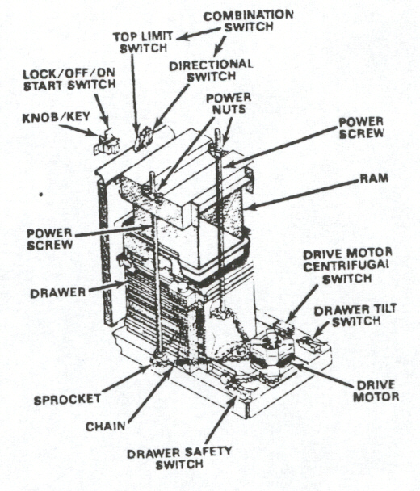

CENTRAL VACUUM

AGREEMENT: HW– ADD ON TO GOLD
PRIMARY TECHNICIAN: DENNY BENDER
EMERGENCY SERVICE: NO
DEMAND: YES

REVISED 3/5/03
WASHER

AGREEMENT: HW– GOLD– SILVER– PLAT II
PRIMARY TECHNICIAN: APPLIANCE
EMERGENCY SERVICE: NONE
DEMAND: YES

LEAKING - If it’s leaking from the faucet/hose connection or standpipe, dispatch to plumber
- Customer should be informed that leaving the faucets on may cause flooding.
- If the hose or washer leaks, send an appliance tech.

OFF - Redistribute clothes evenly around agitator.
BALANCE - If not level, lift back of washer 4” then gently drop an floor (gently).

NOT DOING - Check circuit breaker or fuse.
ANYTHING - Make sure washer is plugged in.
- Lift lid and close again (may reset off balance switch).
- Check that selector buttons are pressed firmly.

NO WATER - Check screens on hoses for restrictions (especially if customer has water softener,
TO WASHER the salt can clog the hoses.
- Is water on?

RUST ON - Comes from lid or tub (NOT COVERED). May offer NFM letter.
CLOTHES - Can also be caused by water source.

GREASE ON - Customer can check for possible pens, crayons, etc.
CLOTHES - Usually it is caused by a chemical reaction by detergents and softeners.

FILL HOSE - Inform customer to turn faucets off.
HAS BUBBLE - Send a Tech.

FURTHER SCHEDULING GUIDELINES

No EQUATOR except for CONTRACT CUSTOMERS
(per Tom L.)

WASHER
REVISED 3/29/03

AGREEMENT: HW– GOLD– SILVER– PLAT II
PRIMARY TECHNICIAN: APPLIANCE
EMERGENCY SERVICE: NONE
DEMAND: YES

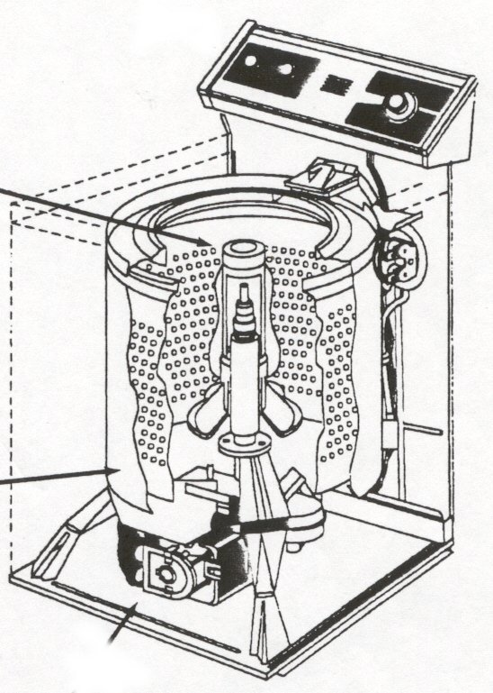
COVERED COMPONENTS
Appliance cords
Controls (electric & switches)
Fuse
Knobs & handles
Temperature sensing board
Timer
Touch pads
Agitator automatic laundry product dispenser
Door glass
Solenoids
Splash ring
Snubber
Balancing devices
Bearings
Water seals
Gasket
Drive block
Drain & fill hoses
Water valves
Brake system
Clutch
Belts
Motor
Pulleys
Relays
Shift levers
Transmission
(up to 12 years)
Water pump
Leveling legs

EXCLUDED COMPONENTS
Coin operated equipment
Scratch cosmetic repairs
Trim
Any condition caused by rust, corrosion or the customer.

WATER HEATER
REVISED 3/7/03

AGREEMENT: HW– GOLD – SILVER – BRONZE – PLAT I/II
PRIMARY TECHNICIAN: GAS – PLUMBING; ELECTRIC – ELECTRICIAN
POWER VENT – HVAC
SECONDARY TECH: HVAC
EMERGENCY SERVICE: SOFT (See “Noises” Below)
DEMAND: YES

UP TO 1 HR TO REHEAT WATER
NO HOT H20 - If electric, check the breaker (if fuses, there are 2).
- If gas, check the pilot light, check t-stat (“vacation” setting?)
  - NEVER SUGGEST CUSTOMER TRY TO LIGHT THE PILOT.

NOT ENOUGH
HOT WATER - WINTER – 15-20 minutes of hot water is normal because water coming into house is much colder.
- Advise to allow more time between showers & to use washer/dishwasher during non-peak times.
- Old heater can be limed up or single lever faucet causing cross-connection.
  - CHECK for PLUMBING COVERAGE
- Thermostat could be set too low or on “vacation” setting.

LEAKING - If leaking from top or bottom, shut off water to heater or house & (gas), turn t-stat to standby
    - If electric wh, turn breaker off.
    - WILL PROBABLY NEED A NEW HEATER – SEE QUOTES/MAKE NOTES
- Leaking from valve is REPAIRABLE.

SMELL GAS - Call local gas supplier to identify leak, send tech afterwards.
- Make sure flue pipe is secure on top of water heater.
- If holes are in flue pipe, can schedule a CHARGEABLE call.
PRESSURE
RELIEF - Turn off valve above water heater or at house service valve.
VALVE - Turn gas valve to “vacation”.
GOING OFF

NOISES - MOST SEVERE – BOOM, HISSING OR SIZZLING can be a gas pressure problem
    - TREAT AS EMERGENCY.
- LESS SEVERE – BANGING, GURGLING, OR BUBBLING
    - Older units may have sediment build-up that can cause noises.
BID NEW HEATER: Bid new water heater using your BRADFORD WHITE WH PRICE SHEET
IMPORTANT – Unless customer has walk-in access (no stairs), 2 techs will need to be dispatched.
**QUOTE the price as “normal installation” replacing like equipment & removal of old.
**Additional piping and/or wiring is extra. ***DON’T FORGET EXPANSION TANK!
**Sched for 2 hours & email ALL the info. to LISA SOUSEK to make the packet & pull permits.

AFTER HOURS/WEEKEND INSTALLATION

SAME DAY - GENERATE a service ticket & page it to tech. EMAIL info to LISA SOUSEK.
- The technician will contact PRIMARY PIPE & SUPPLY to pick up heater.
NEXT DAY - If next day is Mon thru Fri – GENERATE TICKET ON PL911, EMAIL LISA to prep pkt
- If next day is Sat – GENERATE TICKET ON PL911, EMAIL all dispatchers & LISA.
MORE THAN
ONE DAY - GENERATE a ticket on PL AM/PM & EMAIL LISA.
OUT
WATER HEATER
REVISED 3/29/03

AGREEMENT: HW– GOLD – SILVER – BRONZE – PLAT I/II
PRIMARY TECHNICIAN: GAS – PLUMBING; ELECTRIC – ELECTRICIAN
POWER VENT – HVAC
SECONDARY TECH: HVAC
EMERGENCY SERVICE: SOFT (See “Noises” Below)
DEMAND: YES

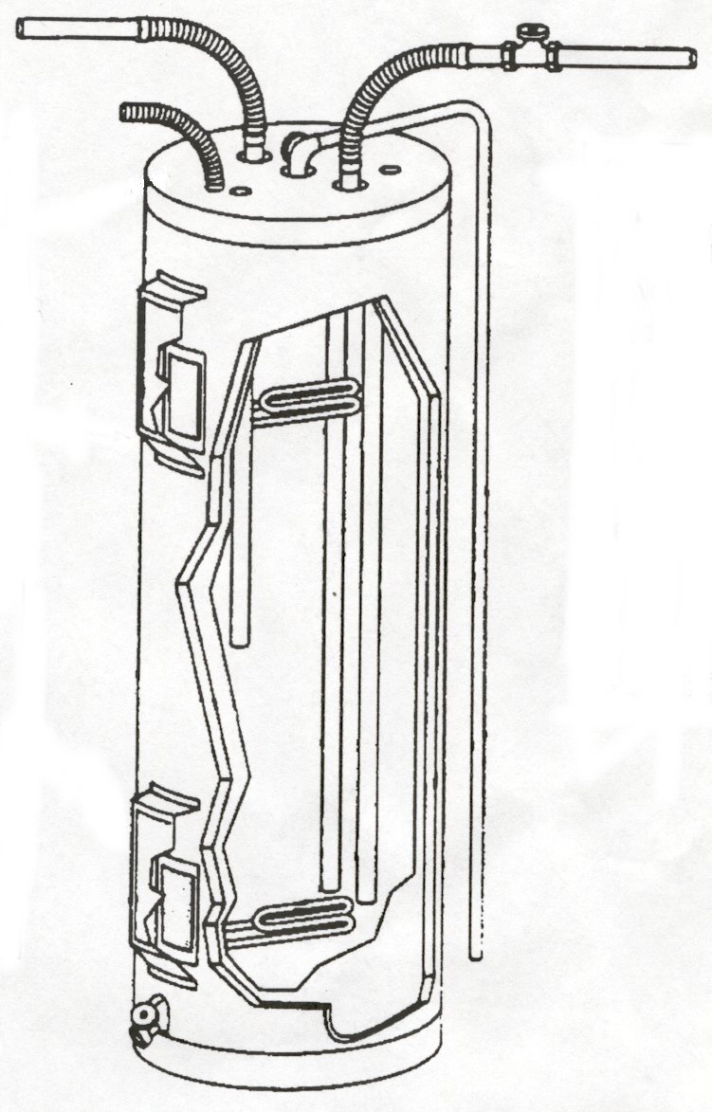
COVERED COMPONENTS
Combustion blower & motor
Relief valve
Fuse
Heating elements
Limit control
Pressure switch
Thermostat
Regulator
Gas valve
Main burner
Manifold
Flame spreader
Ignitor
Ignition module
Pilot burner & assembly
Thermocouple
Drain valve

EXCLUDED COMPONENTS
Power venting systems
(Not OEM)
Anode rods & dip tubes
Energy conserving devices
Instantaneous water heaters
Sediment related problems
Tanks
Vent damper
Any condition caused by rust, corrosion or the customer.

