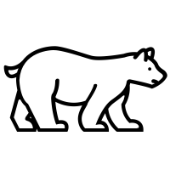

Vrsa ambulat  a -------------------t  ↑-------------------↑ | Vrsae ambulant  ae ---------------------nt  ↑----------------------↑
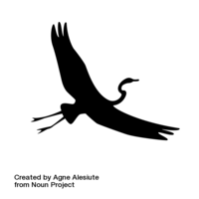
Ciconia uolat  a ------------t  ↑------------↑ | Ciconiae uolant  ae --------------nt  ↑---------------↑
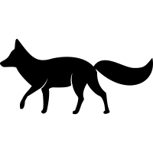
Lupus ambulat  us -----------------------t  ↑----------------------↑ | Lupi ambulant  i ---------------------nt  ↑--------------------↑
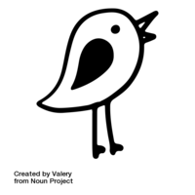
Passer cantat  -----------------------t  ↑------------------↑ | Passeri cantant  i ----------------nt  ↑---------------↑

