 | Electrical Workshop I  2010/2011  WS-1 | Grade 10

Name:…………………………………………………………………..Section:……………….…………..……..
______________________________________________________________________________________________
- Match hazards and safety signs in column A with its corresponding description in column B. Write your answer in the table provided.

 | Column A |  | Column B
1 | 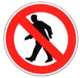 | a | Hard Hat Protection
2 | 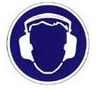 | b | No Walking
3 | 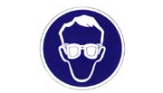 | c | No Smoking
4 | 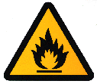 | d | Poisonous Hazard
5 | 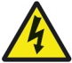 | e | Hearing Protection
6 | 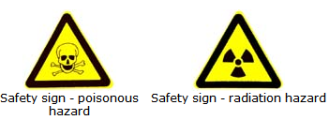 | f | Eye Protection
7 | 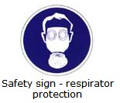 | g | Hand Protection
8 | 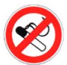 | h | High Voltage Hazard
9 | 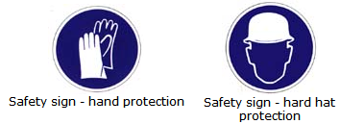 | i | Highly Flammable
10 |  | j | Radiation Hazard
 |  | k | Respiratory Protection
 |  | l | Biological Hazard

Column A | 1 | 2 | 3 | 4 | 5 | 6 | 7 | 8 | 9 | 10
Column B

- Write the correct electrical term that matches the following descriptions in the space provided. Use the word list given below.
Conductors Circuit Grounding Current Resistance
Voltage Insulators

- A complete path of the current. It consists of electricity source, a conductor, and an output device. ( )
- The pressure that causes the flow of electric current in a circuit. ( )
- Electrical movement of electrons. ( )
- Restriction to electrical flow. ( )
- Materials that allow electric current to flow easily. ( )

- Fill in the following table.
Term | Symbol | Measuring Unit | Symbol of the Measuring Unit | Measuring Device
Resistance
Voltage
Current

- List three safety rules for your laboratory and workshop.
______________________________________________________________

______________________________________________________________

______________________________________________________________

- List any two sources of electricity.

__________________________________

__________________________________

