

Measurements
Module 2: DC Measurements

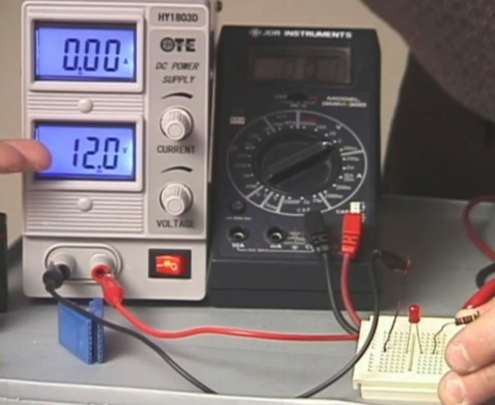

PREPARED BY

Academic Services Unit

August 2011

© Applied Technology High Schools, 2011

Module 2: DC Measurements

Module Objectives

Upon successful completion of this module, students should be able to:

- Define voltage and give its unit of measurement.
- Identify the two different types of voltmeters.
- Connect a voltmeter in a circuit to measure voltage.
- Use a digital multimeter to measure voltage.
- Define current and give its unit of measurement.
- Connect an ammeter in a circuit to measure current.
- Use a digital multimeter to measure current.
- Define resistance and give its unit of measurement.
- Determine the resistance value using the resistor color code chart.
- Use a digital multimeter to measure resistance.

Module Contents:

 | Topic | Page No.
2.1 | Introduction | 3
2.2 | Voltage Measurement | 4
2.3 | Current Measurement | 7
2.4 | Resistance Measurement | 10
2.5 | Lab Activity 1 | 12
2.6 | Lab Activity 2 | 15
2.7 | Review Exercise | 16

2.1 Introduction
All electrical/electronic appliances operate on a source of electrical energy. Have you noticed that your television uses electricity from the electric wall outlet, whereas its remote control operates on batteries? Have you wondered how your laptop operates even when it is not plugged to the power socket?
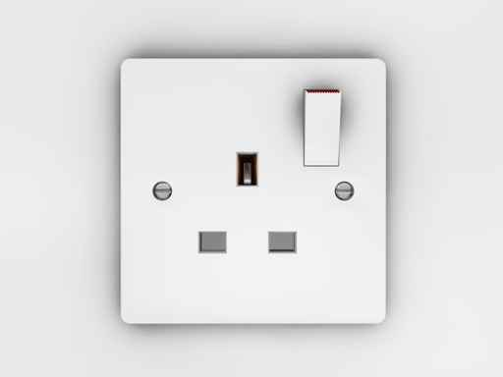  Fig 2.1(a): wall outlet/power socket | 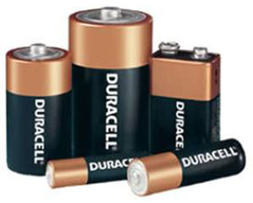  Fig 2.1(b): Batteries
There are two types of voltages which are as follows:
- DC: Direct Current
In DC, the flow of electric charge is only in one direction. DC is produced by a battery and is used to power portable devices such as the cell phones, ipods, etc.
- AC: Alternating Current
In AC, the flow of electric charge periodically reverses direction. AC is generated in a powerplant and is delivered to the electric outlets in your home and buildings. Washing machines, television, water heater etc. operate on ac.

When you do have devices that can work on batteries as well as when plugged into a regular electrical outlet (a laptop computer, for example), the circuits inside the device are usually designed to work on DC, and will convert the AC electricity into DC when it is plugged into an electric outlet.

2.2 Voltage Measurement
Most modern instruments or devices use electronics. In order to identify a faulty device or a component, information on the voltage and current values is required, and therefore it is important to understand and be able to measure current and voltage.
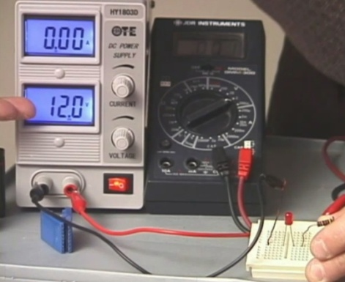

Fig 2.2
Voltage is the electric force that drives current around an electric circuit. The unit of voltage is the volt, and is denoted by the symbol ‘V’. Most cells produce a voltage of about 1.5V (dc), and the voltage delivered through the power socket to houses and businesses in the UAE is 230V (ac). On high-power transmission lines the voltage may be as high as 132kV (ac).
Voltmeters
A voltmeter is used to measure voltage. There are two types of voltmeters as shown in fig 2.3(a) and fig 2.3 (b).
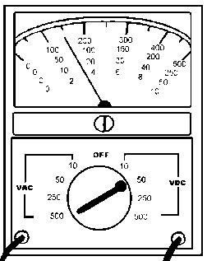  Fig 2.3(a): Analog Voltmeter | 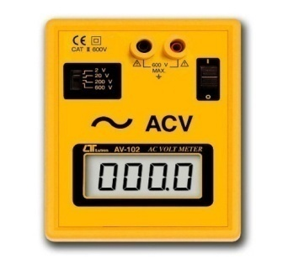  Fig 2.3(b): Digital Voltmeter
The analog voltmeter measures voltage by deflecting a needle against a scale.The most accurate reading is taken from the range which gives the biggest deflection. A digital voltmeter displays the voltage value in digits.
Voltage may also be measured using a digital multimeter (DMM) which is shown in Fig 2.4(a). Fig 2.4(b) illustrates the method of connecting a multimeter to measure voltage. When voltage is measured, the difference of electrical force at two points is measured. Therefore, touch the two points with the probes to measure the difference.
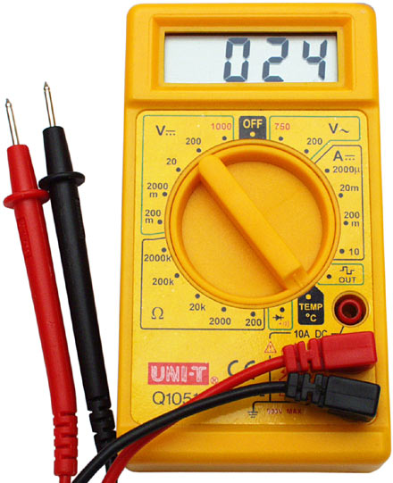  Fig 2.4(a): Multimeter | 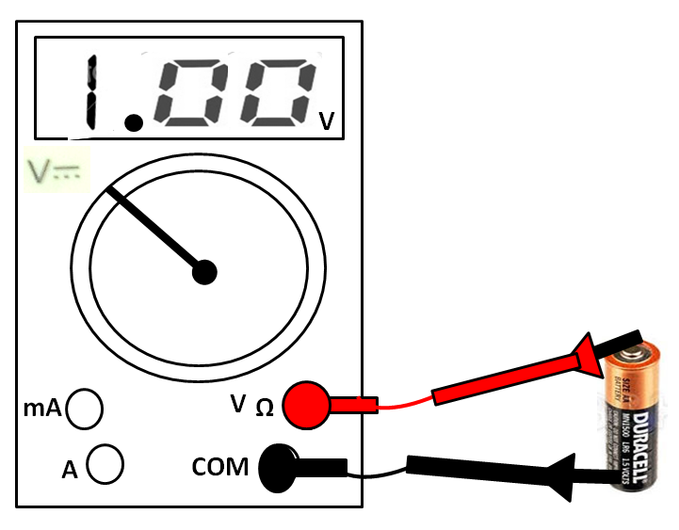Fig 2.4(b): Measuring voltage
Follow the steps below to measure voltage:
- Set the multimeter knob to read voltage (dc or ac) and select the range.
- Connect the two probes with proper polarity in parallel with the component/device, across which the voltage is to be measured.
- Switch ON the meter and read the voltage.
Note: For unknown voltages, it is better to begin with the biggest range, and then reduce the range as this will protect the meter.
The schematic symbol of a voltmeter is given in fig 2.5 | 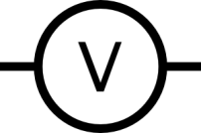  Fig 2.5: Voltmeter symbol

Skill 1 To connect a voltmeter in a circuit to measure voltage.
- Connect a voltmeter to measure the total voltage supplied by the battery. | - Connect voltmeters to measure the voltages across each of the three bulbs.
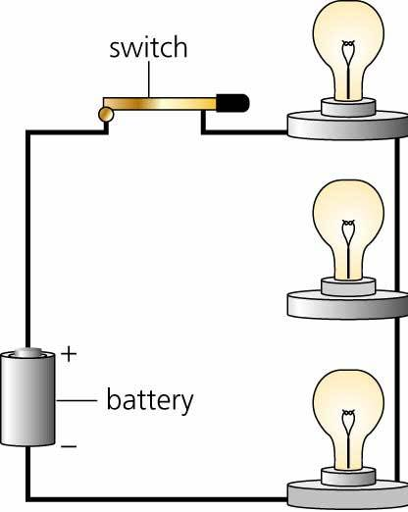  Fig 2.6(a) | Fig 2.6(b)
- Connect a voltmeter to measure the voltage across Bulb-A

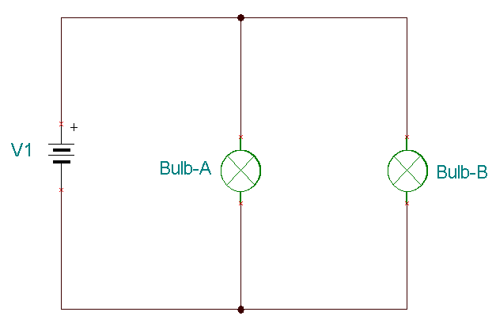
Fig 2.6(c)
Conduct Lab Activity 1 on measuring voltage.

2.3 Current Measurement
Current is a measure of the flow of electrons in an electric circuit. Current is measured in amperes (A) and is denoted by the symbol ‘I’. Small amount of current is measured in milliamperes (mA) and microamperes (µA). A torch bulb uses 60mA or less.
The instrument that could be used to measure current is an ammeter. The ammeter symbol is given in fig 2.7 | 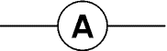  Fig 2.7
Current can also be measured with a multimeter. When current is measured, the meter has to be part of the circuit and therefore it must be placed in series with the component as shown in fig 2.8. The meter shows the reading while the current flows through the meter.
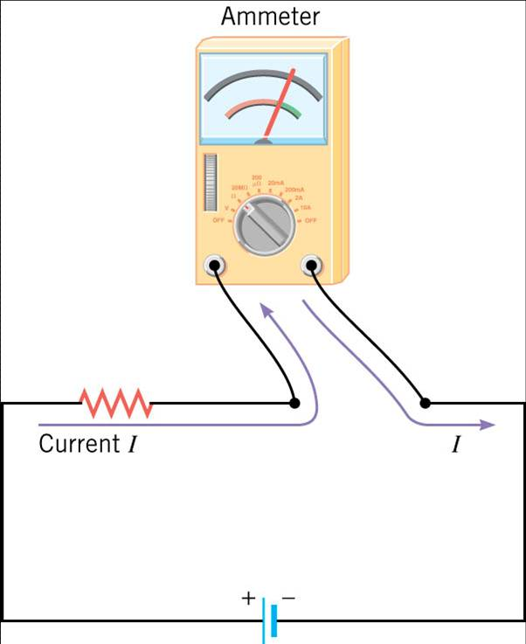
Fig 2.8
Follow the steps below to measure current:
- Set the multimeter knob to read current (dc or ac) and select the range.
- Break the circuit and insert the multimeter probes across the break to complete the circuit.
- Switch ON the meter and read the current.
Skill 2 To connect an ammeter in a circuit to measure current.
- Connect an ammeter in the circuit to measure the current through the Bulb-B. Redraw the circuit with the ammeter and use proper circuit symbols.
Fig 2.9

- Connect an ammeter in the circuit to measure the total current supplied by the voltage source V1 and the current through Light 1. Redraw the circuit, and use proper schematic symbols.
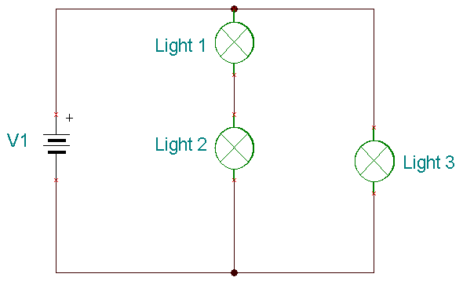
Fig 2.10

Conduct Lab Activity 1 on measuring current.

2.4 Resistance Measurement
Resistance is a measure of the opposition to the flow of current. It is measured in ohms (Ω) and is denoted by the symbol ‘R’.
According to Ohm’s law,
V = IR where
- R is the resistance in ohms,
- V is the voltage in volts and
- I is the current in amperes.
Therefore, R=V/I, and so, in order to measure resistance, a meter measures both the current and the voltage.
One of the basic components of electrical circuits is the resistor which is shown in fig 2.11. This component is designed to provide a specific resistance value measured in Ohms. | 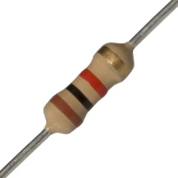  Fig 2.11
The instrument used to measure resistance is called the ohmmeter. Its schematic symbol is given in fig 2.12 | 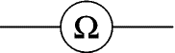  Fig 2.12
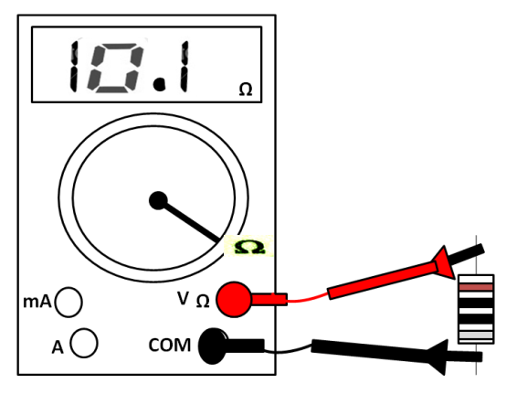  Fig 2.13 | A multimeter can also be used to measure resistance. Fig 2.13 illustrates the method of connecting a resistor to a multimeter to measure resistance. The component must be removed from the circuit for accurate measurements.
Follow the steps below to measure resistance:
- Set the multimeter knob to read resistance (Ω) and select the range.
- Remove the component to be measured from the circuit and connect it across the probes.
- Switch ON the meter and read the resistance.
Most resistors have color bands indicating the value. Specifically, the value is determined by the formula: Color1 Color2 x 10^{Color3}.  Table 2.1 on the right lists the value of each color. The gold and silver color bands indicate the value of tolerance which is a measure of variation from the true or actual value. | Table 2.1
  Color | Value
  Black | 0
  Brown | 1
  Red | 2
  Orange | 3
  Yellow | 4
  Green | 5
  Blue | 6
  Violet | 7
  Gray | 8
  White | 9
  Gold | 5%
  Silver | 10%
Example: Calculate the resistance of the resistor which has the following color code:
Red | Green | Red | Gold

R = Color1 Color2 x 10^{Color3} = 2 5 X 10²
= 2500Ω = 2.5kΩ. Tolerance= + 5%. Therefore, R =2.5kΩ+ 5%

Skill 3 To determine the resistance from its color code.
Find the resistance of the resistors with the following color code:
_____________________________  _____________________________ | _____________________________  _____________________________
  Yellow | Violet | Red | Gold
  Orange | Orange | Brown | Silver
Conduct Lab Activity 2 on measuring resistance.

2.5 Lab Activity 1
Objective: To measure dc voltage and current using a multimeter.
Procedure: Voltage Measurement
- Find the voltages across different items listed in the table 2.2.
- Set the multimeter to read dc voltage.
- Select the appropriate range.
- Connect the multimeter probes with proper polarity across each of the items listed in table 2.2.
- Record the voltage readings for each. (Use the Feedback teknikit console power supply, for power supply voltage measurements.)
- Complete table 2.2
Observation:

Items | Voltage
AA Size Battery
AAA Size Battery
Power Supply set at 5V dc
Power Supply set at 15V dc

Table 2.2
Procedure: Current Measurement
- Find the current through the resistors listed in table 2.3.
- Construct the simple circuit shown below in Fig. 2.14. Use 330 Ω resistor value.
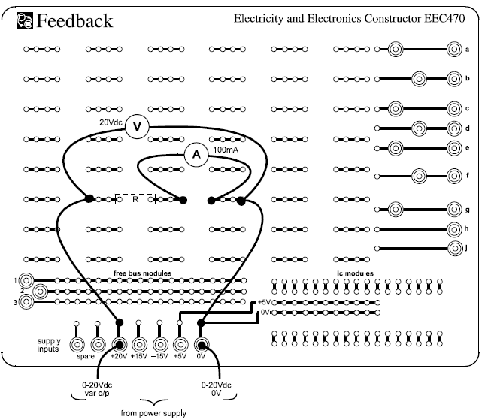
Fig. 2.14
- Set multimeter-A to read voltage and multimeter-B to read current.
- Connect the multimeter-A to read voltage to the power supply.
- Make sure that the variable dc control knob is fully counter clockwise, and then switch on the power supply.
- Increase the applied voltage to 4 V
- Read the current displayed in multimeter-B and ecord the current reading in table 2.3
- Increase the voltage to 10V and record the current.
- Replace the 330Ω resistor with 1000 Ω and repeat the above steps.

Observation:
Resistance (Ω) | Voltage (V) | Current (mA)
330 Ω | 6 V
330 Ω | 10 V
1000 Ω | 6 V
1000 Ω | 10 V

Table 2.3

What have you observed about the relationship between the voltage and current?
____________________________________________________________

____________________________________________________________

____________________________________________________________

____________________________________________________________

2.6 Lab Activity 2
Objective: To find the resistance using a multimeter and through color code, and to compare between the measured value and the calculated value.
Procedure:
- In the table below, record the color-codes of three given resistors.
Resistor # | First Color | Second Color | Third Color | Fourth Color
Resistor 1
Resistor 2
Resistor 3

- Using the color codes of the same three resistors, compute the standard, tolerance, maximum, and minimum values.
Resistor # | Color Code Value | Tolerance | Max. Value | Min. Value
Resistor 1
Resistor 2
Resistor 3

- Using the same three resistors and the DMM, measure the actual resistance, compute the error from the standard color code value, and report whether the resistor is within tolerance (yes or no).
Resistor # | Measured Value | % Error | Within Tolerance?
Resistor 1
Resistor 2
Resistor 3
Percentage Error= $\frac{\begin{aligned}\left|Measuredvalue−Standardvalue\right|\end{aligned}}{Standardvalue}X100\text{\%}$

2.7 Review Exercise
- A digital ohmmeter is being used to measure the resistance of a component. The meter reads 3.275kΩ. This indicates:
- 0.3275Ω
- 3.275MΩ
- 3275Ω
- 0.03275MΩ

- When using an ammeter to measure current:
- break the circuit and connect the ammeter in series between the two open ends.
- connect it across the battery or power supply.
- connect it across the load.
- connect the ammeter instead of the battery or power supply.

- Oscilloscopes can be used to:
- view the shape of AC waveforms.
- measure resistance.
- measure the time period of an ac waveform.
- both a and c.

- The color code for a 1W, 100Ω resistor with a tolerance of 5% which has four color bands is:
- brown, red, black, silver
- brown, black, brown, gold
- brown, green, black, gold
- brown, black, brown, silver

- The voltmeter in the circuit below should read:
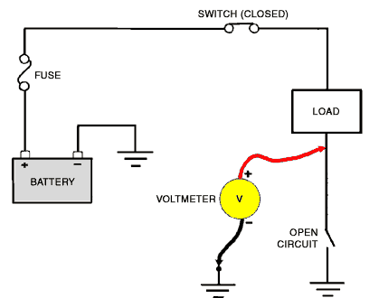
- 0V
- battery voltage
- 12V
- 6V

- Redraw the circuit below by inserting a voltmeter to measure the voltage supplied by the battery, and an ammeter to measure the current flowing through Bulb-B:

- A certain resistor has the following values:
- Color code value=220 Ω
- Measured value = 223 Ω
- Tolerance = 5%
Complete the table below by filling in the missing details:
Tolerance | Max. Value | Min. Value | % Error | Within Tolerance?
5% | ?? | ??

____________________________________________________________

____________________________________________________________

- Match the following:
Column A |  |  | Column B
 | 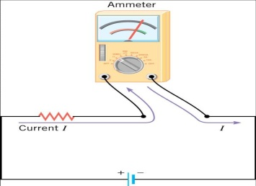 |  |  | Analog voltmeter
 | 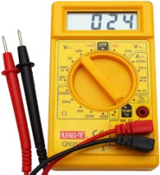 |  |  | Voltage measurement
 | 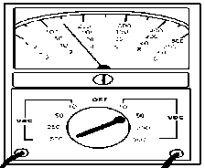 |  |  | Current Measurement
 | 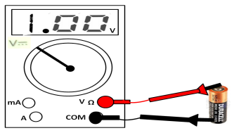 |  |  | Digital Multimeter

