

Measurements
Module 3: AC Measurements

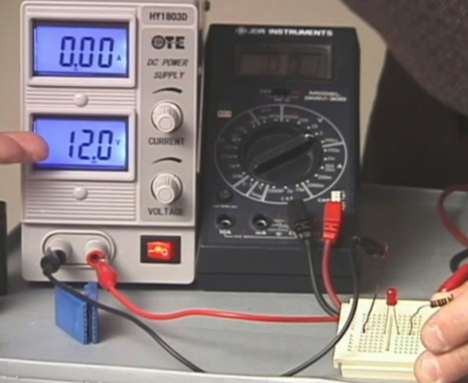

PREPARED BY

Academic Services Unit

August 2011

© Applied Technology High Schools, 2011

Module 3: AC Measurements

Module Objectives

Upon successful completion of this module, students should be able to:

- Familiarise with the definition of Alternating Current (AC).
- Identify appliances/devices that operate on AC.
- Familiarise with the laboratory instruments/equipment used to generate and measure AC signals.
- Use a function generator to generate an AC signal.
- Use an oscilloscope/multimeter to measure AC signal parameters.
- Differentiate between rms value and peak value.

Module Contents:

 | Topic | Page No.
3.1 | Introduction | 3
3.2 | AC Signal Parameters | 4
3.3 | Laboratory Equipment | 7
3.4 | Lab Activity | 10
3.5 | Review Exercise | 14
3.6 | Assignment | 17

3.1 Introduction
Alternating Current (AC) is the most common form of electrical power delivered to homes and businesses through electrical outlets and is used every day in all aspects of life. This is due to the fact that AC power is easy to transmit and convert.
This module will provide an understanding of how AC signals are generated, measured and analyzed.
The AC voltage alternates between positive and negative values. By tracing the variation over time we can plot it as a “waveform” as shown in fig 3.1. The AC voltage alternates (varies) in polarity and AC current alternates in direction.

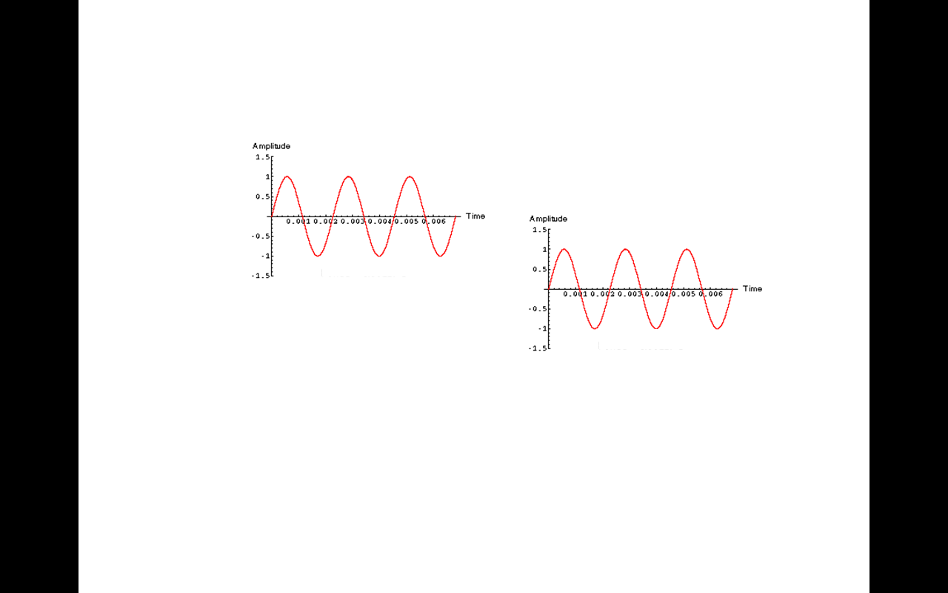
Figure 3.1: AC waveform (sine wave)
The usual waveform of an AC waveform is a sine wave, however, in certain applications, different waveforms are used, such as triangular, square, or sawtooth waves. Fig 2.2 shows other types of ac waveforms:
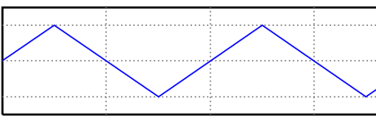  - Triangle wave | 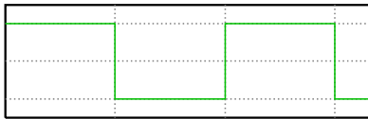  - Square wave | 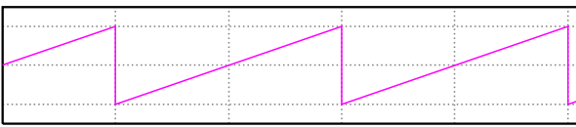  - Sawtooth wave

Figure 3.2

3.2 AC Signal Parameters
Since the DC voltage and current quantities are generally stable, it is easy to express how much voltage or current is present in any part of a circuit. Knowing that ac is a varying signal, how can we express how large or small an ac quantity is? How can a single measurement value be assigned to something that is constantly changing?

To measure an ac signal, it is important to know the following ac signal parameters:
- Peak Value (V_{p}): Peak value is the maximum value reached by an ac wave.

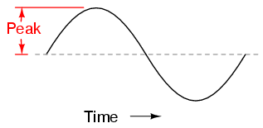

Fig 3.2

- Peak to peak Value (V_{p-p}): Peak to peak value is a measure of the total height between opposite peaks. It is twice the peak value.
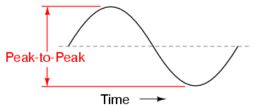

Fig 3.3

V_{p-p} = 2 V_{p}

- Root Mean Square (RMS) Value: The RMS value is the effective value of an ac signal.
A measure of the peak value does not give the actual ac value. The true ac value can be calculated using the formula:
V_{rms} = 0.707 × V_{peak} ; I_{rms} = 0.707 × I_{peak}
(They are only true for sine waves because the constant or the multiplier is not 0.707 for other shapes.)
- Cycle: One complete waveform is called a cycle.
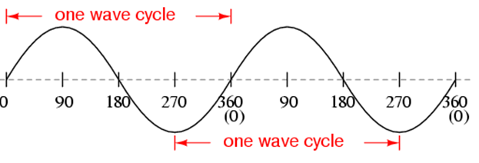
Fig 3.4

- Period: Time taken for the signal to complete one cycle. It is measured in seconds (s).
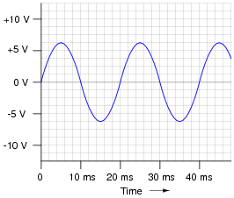
Fig 3.5

For example, the Period for the waveform shown in fig 3.5 is 20 ms
- Frequency: Number of cycles per second is called the frequency.
f = 1/T or T = 1/f where T is the Period.
Frequency is measured in hertz (Hz).

Skill 1
To draw a sine wave and mark its cycle, peak value, peak-to-peak value and period.

Skill 2
To calculate the period and frequency.
- What is the Period of the waveform shown? _____________________
- Calculate the frequency of the signal? _________________________

3.3 Laboratory Equipment
In the laboratory, ac signals are produced using the Function Generator and displayed and measured using the Oscilloscope.
Function Generator:
The function generator is a device that generates voltage signals (see Fig 2.6). Specifically, a sine, a triangle or a square wave may be created. Also, the signal parameters may be specified.
For example, the function V(t) = 3 sin(2π(100)t), is created by adjusting the function generator to output a sine wave with a frequency of 100 Hz, and peak value of 3 Volts .
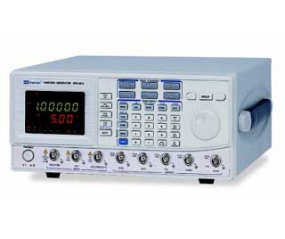
Fig 3.6 Function Generator
Oscilloscope:
Oscilloscopes are used to display and measure signal parameters. Specifically, the oscilloscope displays a signal similar to figure 3.7, with an axis for voltage and an axis for time. The scales of the two axes are given in Volts/Division and Seconds/Division, respectively.
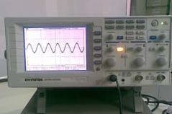
Fig 3.7: Oscilloscope
Skill 3
To calculate the peak voltage and peak-to-peak voltage from the oscilloscope reading if the Volt/div = 2 V and Time/div= 500 ms
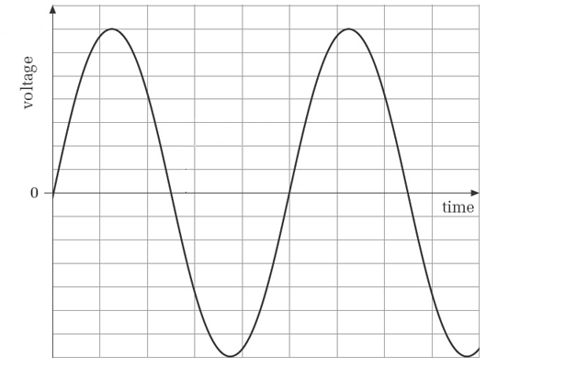

- What is the peak voltage (V_{p})?
_______________________________________________________
- What is the peak-to-peak voltage (V_{p-p})?
_______________________________________________________

Skill 4: To read/calculate the rms voltage
- Calculate the peak voltage with the given rms voltage.
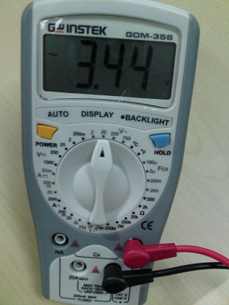 | - What is the rms voltage?  ________________________  - What is the peak voltage? ________________________

- Calculate the rms voltage with the given peak voltage. Volt/div=5V

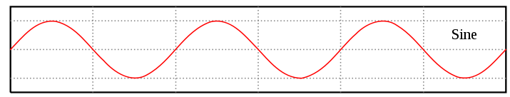 | - What is the peak voltage?  ________________________  - What is the rms voltage? ________________________

3.4 Lab Activity
Objective: To generate ac voltage using a function generator, and to measure the voltage using the oscilloscope.
Procedure: Voltage generation and measurement
- Connect the function generator to the oscilloscope as shown in fig 2.8.
- Set the function generator to output a sine wave with a frequency of 1 kHz, and peak value of 5 V.
- Adjust the oscilloscope to view two or three cycles of the signal.
- Follow the steps for measuring period, frequency, peak and rms voltages, and sketching the waveform.

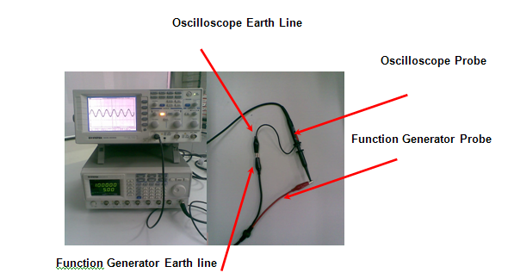

- Period & Frequency
- Calculate the period and frequency and complete table 3.1.
- Use 1 kHz (set on the Function Generator) as the standard value and calculate percent error in frequency.
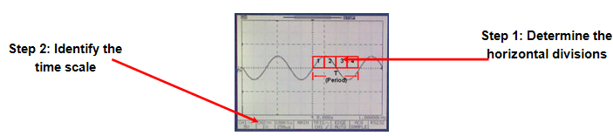
Signal | Signal Parameter
No of horizontal divisions
Oscilloscope Horizontal Setting  (time scale) | Time/div=
Period (T) | No of divisions X time/div=
Frequency | f = 1/T =
Table 3.1

Percent Error in frequency
Function Generator reading (f1) | Oscilloscope reading (f2) | % Error
1 kHz

% Error = $\frac{\begin{aligned}\left|OscilloscopeReading\left(f2\right)−FGReading\left(f1\right)\right|\end{aligned}}{FGReading\left(f1\right)}X100\text{\%}$

- Peak Voltage
- Measure the peak-to-peak voltage reading on the oscilloscope, calculate peak voltage and complete table 3.2.

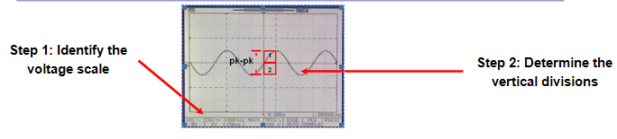

Signal | Signal Parameter
No of vertical divisions
Oscilloscope Vertical Setting  (voltage scale) | Volt/div=
Peak to Peak (V_{p-p}) | No of divisions X volt/div=
Peak Voltage (V_{p}) | V_{p-p}/2 =

Table 3.2

- RMS Voltage
- Set the multimeter to read ac voltage and set the range to 20 V.
- Connect the function generator probes to the multimeter and record the rms voltage.
- Calculate the rms voltage using the peak value.
- Complete table 3.3.

Signal | Signal Parameter
V_{rms} (multimeter)
V_{rms} (Function Generator) | 0.707 X V_{p} =
% Error

Table 3.3
- Waveform
- Sketch the waveform and mark the period, peak and peak to peak voltages using the values obtained.

Sketch of Waveform

Table 3.4

3.5 Review Exercise
- A sinusoidal waveform, when observed on an oscilloscope, has a peak-to-peak amplitude of 6cm. If the vertical sensitivity setting is 5V/cm, the rms value of the voltage will be:
- 10.6V
- 11.1V
- 12.6V
- 15V
- Draw a sine wave and mark the following:
- time on the X-axis
- voltage on the Y-axis
- cycle
- V_{p}
- V_{p-p}
- Period

- Calculate the Period of a sine wave with the following frequencies:
- 1 kHz

__________________________________________________

__________________________________________________
- 500 Hz

__________________________________________________

__________________________________________________

- A sine wave with the function V(t) = 2 sin(2π(500)t) is generated and displayed on the oscilloscope. Complete the table below by filling in the required details:

V_{p-p} | V_{p} | V_{rms} | frequency

- Calculate the frequency of the signal given below:
_______________________________________________________
_______________________________________________________
_______________________________________________________
_______________________________________________________
_______________________________________________________
_______________________________________________________

- Refer to the multimeter reading shown in the figure and answer the questions below:
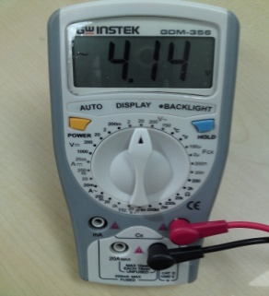
- Is the multimeter displaying the rms voltage or the peak voltage?
______________________________________________________
- What is the peak voltage?
_____________________________________________________

- If the frequency set on the function generator = 500 Hz and if the oscilloscope reading gives 550 Hz, calculate the percent error in frequency.

__________________________________________________________

__________________________________________________________

__________________________________________________________

__________________________________________________________

3.6 Assignment
Complete any one of the tasks given below. Prepare a poster or a chart using any one of the Microsoft Office tools.
Task-1:
Draw a T Chart to demonstrate the difference between dc and ac.
The T chart must include the following contents:
- What are DC and AC?
- DC and AC waveforms.
- Appliances that operate on dc and appliances that operate on ac. Include pictures.
Task-2:
Draw an ac voltage waveform, V(t) = 2 sin(2π(500)t) and mark the following parameters by obtaining the values through calculation:
- Cycle
- Period
- Peak value (Vp)
- Peak to peak value (Vp-p)
Task-3:
A multimeter displays rms ac voltage. Take a picture of a multimeter displaying the rms voltage and include the picture and a table with the following calculations:
- rms voltage
- peak voltage (Vp)
- peak to peak voltage (Vp-p)
A sample is shown below:
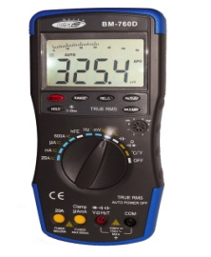 | V_{rms} = 325.4 V  V_{p} = _________  V_{p-p} = ________

