

Measurements

Module 4: AC to DC Conversion

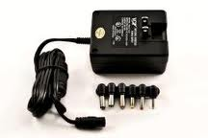

PREPARED BY

Academic Services Unit

August 2011

© Applied Technology High Schools, 2011

Module 4: AC to DC Conversion

Module Objectives

Upon successful completion of this module, students should be able to:

- Define a power supply.
- List the four main components of a DC power supply.
- Explain the purpose and function of each main component of a power supply.
- Perform experiments related to AC to DC conversion.
- Compare two different methods used for the rectification stage in a power supply.

Module Contents:

 | Topic | Page No.
4.1 | Introduction | 3
4.2 | AC to DC conversion process | 4
4.3 | Lab Activity 1 | 9
4.4 | Lab Activity 2 | 12
4.5 | Review Exercise | 15

4.1 Introduction
All electronic circuits need a power source to work. For electronic circuits, this power source must be a DC voltage of a specific value. As you studied previously, a battery is a common DC voltage source for some types of electronic equipment especially portables such as cell phones and iPods. Furthermore, most non-portable equipment use power supplies that operate from the AC power line but produce one or more DC outputs. In this module, you will study how to convert AC voltage to DC voltage in a power supply.
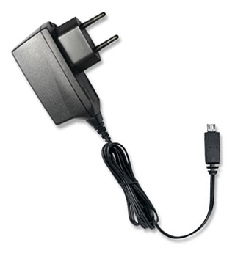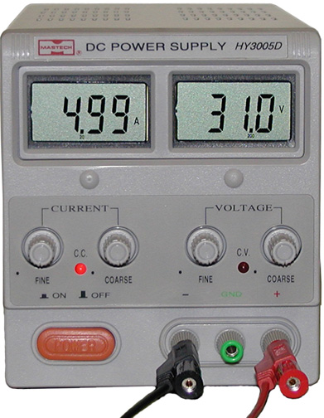
Figure 4.1: Examples of a power supply
Examples of power supplies include:
- Laptop/Mobile charger
- Power supplies inside your computers

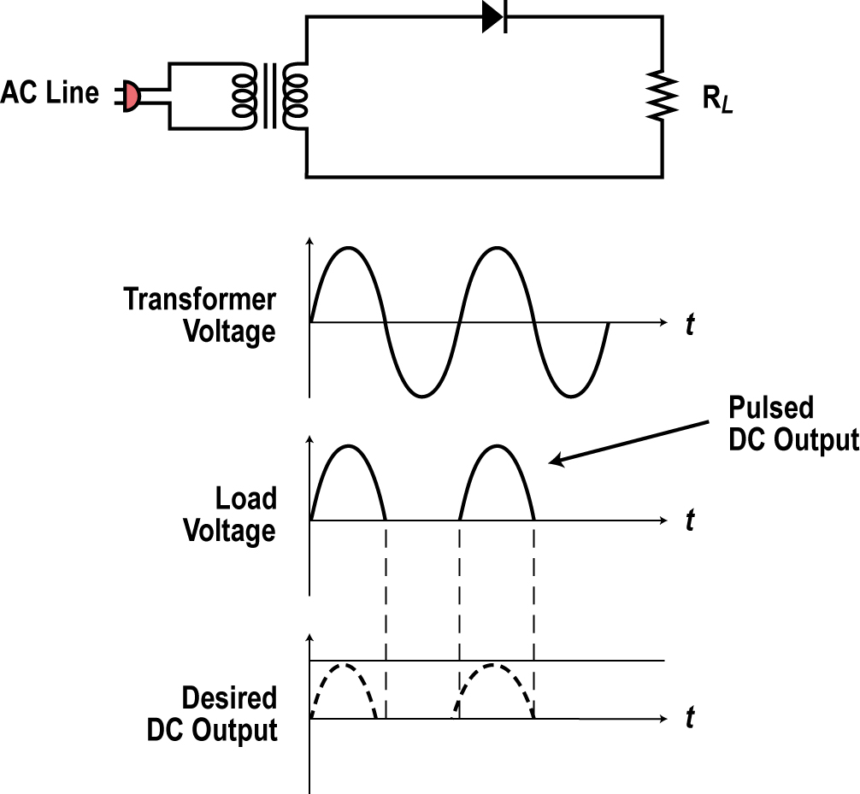
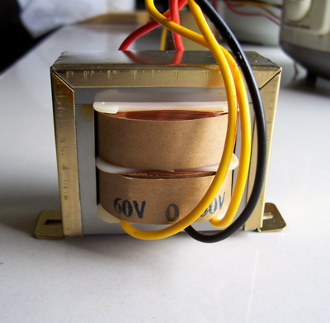
4.2 Main Components of a DC power supply
Figure 4.2 shows the block diagram of a DC power supply. Let’s learn about each of the major stages in converting from AC voltage to DC voltage.
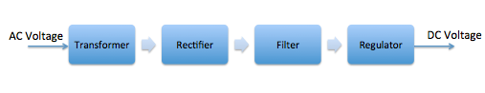
Figure 4.2: Block diagram of a DC power supply

A power supply consists of the following four main building blocks:
- Transformer
- Rectifier
- Filter
- Regulator
Transformer:
Power supply transformer is commonly used to step the input AC voltage level down or up. Figure 4.3 shows the symbol of a transformer and an image of a real transformer.

Figure 4.3: Transformer Symbol and Picture.
The transformer has two coils known as primary and secondary coils. A coil is simply a piece of wire (usually made from copper) wound on a core (usually made from iron). The input voltage is applied to the primary coil and the output is taken from the secondary coil. The number of turns in each coil determines the ratio by which the voltage (or current) will be increased or reduced.

Most electronic circuits operate from voltages lower than the AC line voltage so the transformer normally steps the voltage down by its turns’ ratio to a desired lower level.

For example, a transformer with a turns ratio of 10 to 1 (i.e. the primary coil has a number of turns 10 times the number of turns of the secondary coil) would convert the 120 volt 60 Hz input sine wave into a 12 volt sine wave.
Power supply transformers are available in two types:
- Step down transformers: decreases the AC voltage
- Step up transformers: increases the AC voltage
The AC output frequency from a transformer is always the same as the AC input frequency.

Rectifier:
A rectifier circuit converts AC voltage to a pulsating DC voltage.
The simplest form of a rectifier is the half-wave rectifier shown in Figure 4.4.
The half-wave rectifier produces one sine pulse for each full cycle of the input sine wave.
When the sine wave goes positive, the anode of the diode goes positive causing the diode to be forward biased. The diode conducts and acts like a closed switch letting the positive pulse of the sine wave to appear across the load resistor. When the sine wave goes negative, the diode becomes reversed biased (open switch), therefore blocking the voltage from appearing at the load resistor forcing the output to be zero during this negative half cycle.
Figure 4.4: Half wave rectifier

Filter:
The output of the rectifier circuit described above is a series of pulses. A power supply needs to produce a constant and stable DC output. A filter is used to remove the pulsations and create a constant output (with some noise still present). The most common filter is a large capacitor. Figure 4.5 shows the capacitor and its symbol.
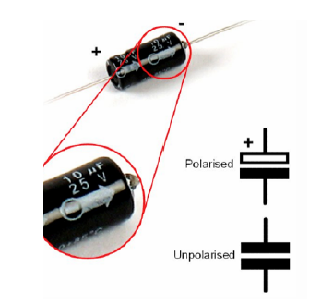
Figure 4.5: Capacitor and its symbol
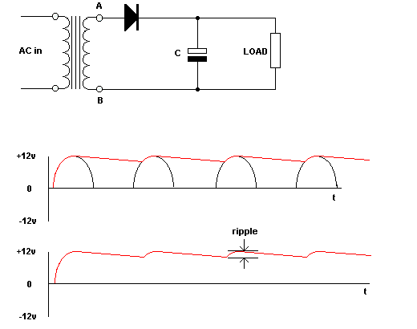
Figure 4.6: Filter circuit in a DC power supply
The figure above shows that the output of the filter is now close to being constant with some noise still present. This noise is known as ripple voltage and can be reduced by using proper values of capacitance and load resistance.
Regulator:
The regulator is a circuit that helps maintain a fixed or constant output voltage. When the power supply is not connected to any circuit (no load), the output voltage is an accurate and stable voltage, however if the power supply is connected to a load (like a laptop for example), then the output can vary if no proper regulation is used. Changes in the load or the AC line voltage will cause the output voltage to vary as well. Most electronic circuits cannot tolerate these variations since they are designed to work properly with a fixed voltage. Therefore, the regulator is used to fix the output voltage to the desired level then maintain that value despite any output or input variations.
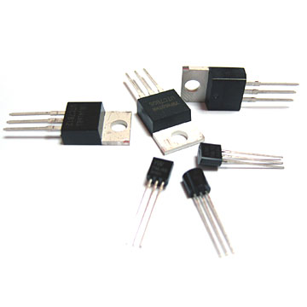
Figure 4.7: Examples of voltage regulators

In summary, in most AC to DC supplies, the AC line voltage is stepped up or down to the desired voltage level then rectified into pulsating DC, then filtered to a constant DC. A regulator holds the output to a desired level.

4.3 Lab Activity 1
Objectives:
- Observe and identify the role of half-wave rectifier in a DC power supply
- Observe and identify the role of the filter in a DC power supply.

Procedure:
- Connect the following circuit diagram where:
R= 10k Ω
Vin = 5 sin ( 2 π (1000) t)
C= 100 uF
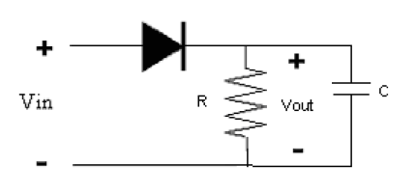
- Use the oscilloscope to observe the input AC waveform.
- Draw the input AC waveform in the space provided. Measure and record the frequency of this input AC waveform.

- Disconnect the capacitor and use the oscilloscope to observe the output wave from the rectifier.
- Draw the rectifier output waveform in the space provided. Measure and record the frequency of this output waveform.

- Connect the capacitor back into the circuit and use the oscilloscope to observe the filter output waveform:
- Draw the filter output wave form in the space provided:

4.3 Lab Activity 2
Objectives:

- Observe and understand the role of full-wave bridge rectifier in a DC power supply
- Compare full-wave bridge rectifier with half-wave bridge rectifier.
Procedure:
- Connect the following circuit diagram where:
R= 10k Ω
Vin = 5 sin ( 2 π (2000) t)
- Use the oscilloscope to observe the input AC waveform.
- Draw the input AC waveform in the space provided. Measure and record the frequency of this input AC waveform.

- Use the oscilloscope to observe the output wave from the rectifier:
- Draw the rectifier output waveform in the space provided. Measure and record the frequency of this output waveform.

- From your results in this practical activity and by referring to the previous practical activity (Practical Activity I), answer the following questions:
  - Compare the frequency of the rectified AC waveform for half-wave and full-wave rectifiers with respect to the input AC waveform.

  - State whether the half-wave rectifier will provide more or less power to an electronic circuit compared to a full-wave rectifier. Justify your answer.

4.4 Review Exercise
- Identify the DC power supply stages that are shown in the following pictures:
Stage
???

Stage Name:________________________________

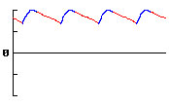
Stage
???

Stage Name:

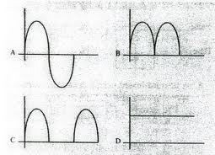
Stage
???

Stage Name:

- The following circuit diagram represents the stages of AC to DC conversion. Label each stage and identify the name of the components used in each stage. Fill your answers in the table provided.

Stage 1

Stage 2
Stage 3

No. | Stage Name | Required Components
Stage 1
Stage 2
Stage 3

