For each of the following resistor find the color code value. Evaluate the minimum and maximum acceptable value. Then calculate the error percentage based on the given measured value, tick the measured value if it is within the tolerance.

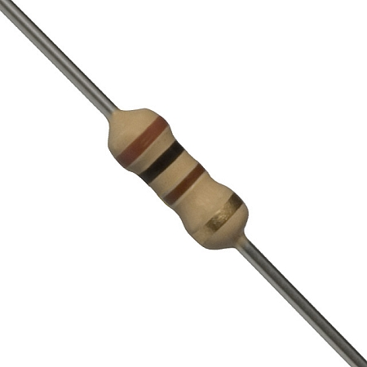
Color code value | Max | Min | Measured | Error Percentage
 |  |  | 93 Ω
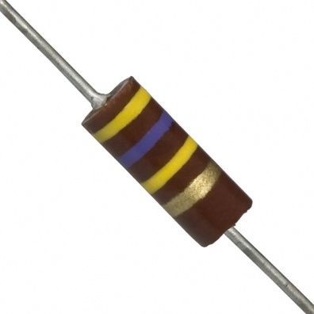
Color code value | Max | Min | Measured | Error Percentage
 |  |  | 472 K Ω

A student connected a resistor to DC voltage source; he measured the current as shown in the figure below:

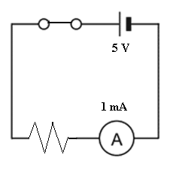

What is the color code for the used resistor.

