Science Exam Review

Forces, Motion and Simple Machines

Speed - is the rate at which an object covers a given distance. The formula is distance divided by time

Velocity - is the speed of an object and its direction of motion.

To calculate an average speed, you would use - distance and time

Negative acceleration - is used to describe an object slowing down because of decreasing speed.

Force is a push or pull – If something is pushing or pulling on something, it is a force

Mass is NOT a force. – mass is how much matter an object has

According to Newton’s third law, forces always occur – in equal but opposite pairs

Friction - the force that always acts opposite to the direction of motion of an object – Friction is caused by the roughness on the surface of the objects that are touching.

A bottle opener is a first class lever - remember, the placement of the fulcrum determines what class of lever it is.

Simple machine – device that makes work easier with only one movement

According to Newton’s first law, if a ball is thrown in the air, it will eventually stop due to gravity acting on the ball, causing it to fall. Air friction will also act on the ball, slowing it down.

Inertia - is the tendency to resist a change in motion. It is also the measure of an objects ability to stay at rest or to keep in motion

Energy

The ability to cause change is - energy Energy due to motion is kinetic energy

Materials that do not transfer heat easily are insulators

When objects collide, kinetic energy can be transferred.

Potential energy - stored energy due to an object’s position

Temperature - measure of the average kinetic energy of an objects atoms

Fahrenheit scale - freezing point water is 32° and boiling point is 212°

Celsius scale - freezing point of water is 0° and boiling point is 100°

The conversion of carbon dioxide and water to oxygen and sugar in photosynthesis is an example of an endothermic reaction

Radiation involves the transfer of energy by waves

Water is unusual because it takes a large amount of heat to raise its temperature; water’s temperature does not change as much as surrounding air or land.

Conduction - transfer of energy collisions between atoms; usually occurs in solids

Convection transfers heat when particles move between objects or areas that differ in temperature; most common in gases and liquids.

Energy transferred by waves is radiation.

Endothermic reactions – chemical reactions that absorb energy

Exothermic reactions – chemical reactions that release energy

Chemical reactions occur at different rates; a catalyst changes the rate of chemical reaction without its own structure being changed.

Waves

Waves can bend when they move from one medium to another. This is refraction.

An electromagnetic wave DOES NOT need matter for energy transfer.

Wave frequency is the number of waves passing a given point per second.

In a compressional wave, matter moves back and forth in the same direction as the wave.

The action of a wave bouncing off a surface is called reflection.

Amplitude reflects the amount of energy in a wave.

A wavelength is the distance between a point on one wave and the identical point on the next wave.

The speed of waves can change when the waves move from one medium to another.

A mechanical wave can travel only through matter

High pitched sounds have high frequencies and low pitched sounds have low frequencies.

All waves transmit energy, not matter

Noise is an example of destructive interference and harmonious sound is an example of constructive interference
An example of refraction is, a goldfish seeming to be in a different position that what it actually is.

Characteristic of matter that can be observed and measured physical property
A substance with this physical property can be rolled into a sheet malleability
Temperature at which a solid becomes a liquid melting point
State of matter with particles vibrating in a fixed position solid
The state of water at 50° C liquid
Solid, liquid, gas, or plasma states of matter
State of water at 150°C gas
Mass per unit volume of a substance - density
Amount of space an object takes up volume
Anything that has mass and takes up space matter
Temperature at which a substance changes from a liquid to a gas boiling point
Amount of material an object has in it mass

Label the particles below:

nucleus electron proton neutron

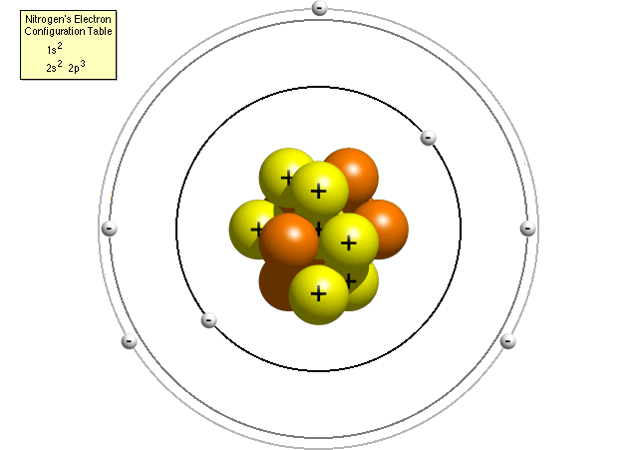

Neutron - uncharged particles in the nucleus of an atom

Nucleus - central part of an atom

Electron - negatively charged particle

Proton - positively charged particle in the nucleus of an atom

Theory - explanation of things or events based on scientific knowledge resulting from many observations and experiments

Metals - elements that generally have a shiny or metallic luster

Element - Matter made up of only one kind of atom

Metalloids - elements that have characteristics of both metals and nonmetals

Atom - A small particle that makes up most types of matter on Earth
Rocks and minerals

A natural, nonliving solid with a definite chemical structure is a mineral

Characteristics used to identify minerals are properties. These include: streak, luster, hardness, magnetism, cleavage and fracture.

Cleavage pattern refers to how minerals split along flat planes.

The Mohs scale uses hardness to classify minerals from softest to hardest.

A mineral that contains something that can be useful and sold for a profit is called an ore

A mineral that is rare and can be cut and polished, giving it a beautiful appearance is a gem

A rock is a solid, natural material made up of one or more minerals.

Rocks that are produced when melted rock cools and hardens are called Igneous rocks. Igneous rocks are either intrusive or extrusive. Rocks that form when lava cools on Earth’s surface are extrusive.

Igneous rocks that form below the surface of Earth are intrusive. This rock formed from magma has large crystals.

Sedimentary rock is made from pieces of rocks and minerals and is cemented together by other minerals. It forms in layers, with the oldest rock at the bottom. This rock has many fossils of sea organisms

Metamorphic rock forms when heat, pressure, or chemical reactions change one type of rock into another type of rock.

A diagram that shows the process of how rocks are changed from one type to another is the rock cycle.

New soil begins when exposed rock begins to break down. This process is called weathering.

Soil formation occurs at different rates and is based on environmental conditions

Soil forms in layers called horizons

