My Antonia

Pre-reading E-sheet

Name:

Date:

DIRECTIONS
Using the hyperlinks,
answer the questions
below.

1. Define prairie.
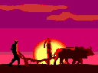

2. What and where is the Great Plains?

3. What is sod, and how was it used on the prairie?

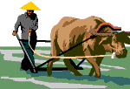

4. What were sod busters?

5. A character in My Antonia has a very unusual way of making bread. Describe a kind of bread eaten by early settlers.

6. Develop a menu that might have been eaten by these early settlers.

7. What brought the early settlers to the prairie?

8. What crops did the settlers grow?

9. Describe some early hardships faced by the settlers.

10. What country did many of the immigrants to the prairie come from?

