Mole Mass Calculations
Guided Practice
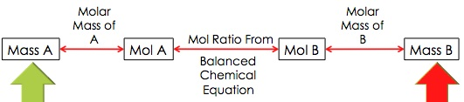

- How many grams of hydrogen are needed to react with 17.2 moles of nitrogen?
N₂ + 3 H₂ 2 NH₃

- How many moles of Aluminum can be produced from 8.25 grams of CuCl₂?
2 Al + 3 CuCl₂ 3 Cu + 2 AlCl₃

- How many moles of copper can be produced from 8.25 grams of CuCl₂?
2 Al + 3 CuCl₂ 3 Cu + 2 AlCl₃

- How many grams of C₂H₄ are needed to produce 0.65 moles of CO₂?
C₂H₄ + 3 O₂ 2CO₂ + 2H₂O

- How many grams of O₂ are needed to produce 0.65 moles of CO₂?
C₂H₄ + 3 O₂ 2CO₂ + 2H₂O

