Learning to Use PowerPoint: First things first!
Presented by Detna Levin Kacher

- Identifying parts of computer (You probably know this already, but humor me.)

Monitor Screen

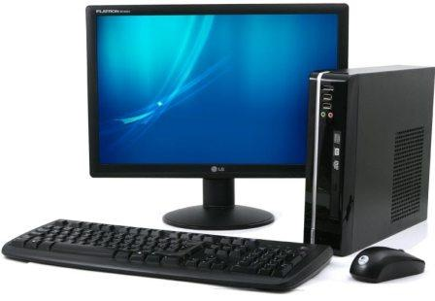
System Unit
Keyboard Mouse

Monitor
A monitor displays information whether it’s text or pictures. The portion of the monitor that displays the information is called the screen. Like a television screen, a computer screen can show still or moving pictures.

The Keyboard
A keyboard is used mainly for typing text into your computer. It’s like a keyboard on a typewriter in that it has keys for letters and numbers.

Computer keyboards also have special keys:
- The function keys, found on the top row, perform different functions depending on where they are used.
- The numeric keypad, located on the right side of most keyboards, allows you to enter numbers quickly.
- The navigation keys, such as the arrow keys, allow you to move your position within a document or webpage.

The System Unit
This is the core of computer systems. Usually it's a rectangular box placed on or underneath your desk. Inside this box are many electronic components that process information. This is where the "brain" of a computer resides.

The Mouse
A mouse is a small device used to point to and select words or pictures on your computer screen. Computer mice can come in many shapes, but the typical mouse is small, oblong, and usually connected to the system unit by a long wire that resembles a tail. You can get “wireless” mice nowadays, which don’t need a cable.

Turning on your computer!
The Power-on Button usually looks like this and is usually located in the upper right-hand corner on your keyboard.
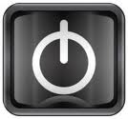

How to “wakeup” your computer’s monitor
If your computer screen is black, it could be “asleep”. To wakeup, simple move your mouse. If this doesn’t work, you need to turn on your monitor. Look on a power button on the lower right-hand side of the monitor frame.

Using the mouse
A mouse usually has two buttons: a primary button (usually the left button) and a secondary button. Many mice also have a wheel between the two buttons, which allows you to scroll smoothly through screens of information.

(Scrolling is when you move the mouse pointer (cursor) up and down or sideways, so that you can move through text or pictures on your computer screen.)

scrolling wheel
secondary button (“right-click” button)
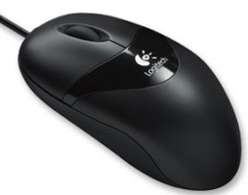
primary button
(“left-click” button)
When you move the mouse, you will see a pointer on your screen moving in the same direction. (The pointer's appearance might look like an arrow tip or hand with pointed finger.) When you want to select an item, you point to the item and then click (press and release) the primary button. Pointing and clicking with your mouse is the main way to interact with your computer.

I usually refer to these as a pointer.


When you are pointing at text and click you will see a symbol that looks like a capitol “I”, which I usually refer to this as a cursor. (see below)

Single-click, Double click, Triple-click

Often, single-clicking selects (or highlights) an object, while a double-click executes that object, but this is not universal.

Single-click the primary button to open the Start Button in the horizontal task bar at the bottom of your computer screen. You also single-click to:
- highlight a folder
- place a cursor between letters of text or make corrections

Double-click is two quick (without moving the mouse) clicks of the primary button. Double click to:
- open a program icon
- highlight a single word

Triple-click to:
- highlight entire paragraph

Right-click
Sometimes I might ask you to “right-click” in order to create a folder for your desktop. Simply click on right mouse button and you will see the following type of drop-down box. Scroll down to “New” (keep holding right button).
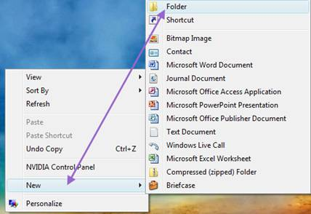
Another box will appear beside this box. Move mouse over to “Folder” and take finger off mouse button.

