Becoming Familiar with PowerPoint

- GETTING ACQUAINTED WITH YOUR DESKTOP (monitor screen image).

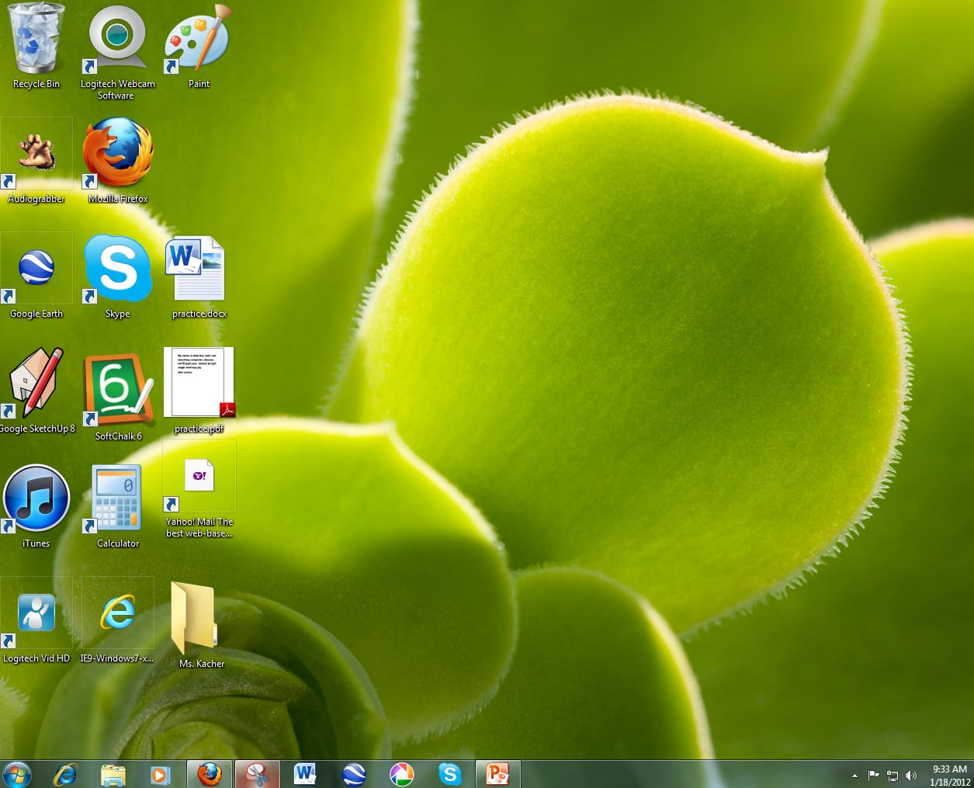

FIG. 1

Think of the screen as the surface of your desk. On it you might have a typewriter and paper (Word), various office supplies to create projects, and folders. Today we will be using your computer slideshow “projector”, which is known as PowerPoint.

2) LOCATING STUFF ON YOUR COMPUTER
Sometimes your office tools (known as Applications in the computer world) might be on your Desktop. Other times you need to retrieve them from inside your “desk”.

3) FINDING YOUR POWERPOINT APPLICATION
First, check your desktop and see if you have a PowerPoint icon, which looks like this:

FIG. 2

If you don’t see it on the desktop, then it’s “in your desk” and here’s what you need to do:

- Go to the Taskbar, the horizontal bar at bottom of your screen. (see next page)

FIG. 3

- Click on the Start Button, which is located in the lower left-hand corner on the long horizontal bar at the bottom of your screen. Looks like this:

FIG. 4

Once you click on the start button a vertical box will pop up on left atop the taskbar.
Find “All Programs” and place your pointer there (highlights it blue). A second vertical box will open next to this one (see below)

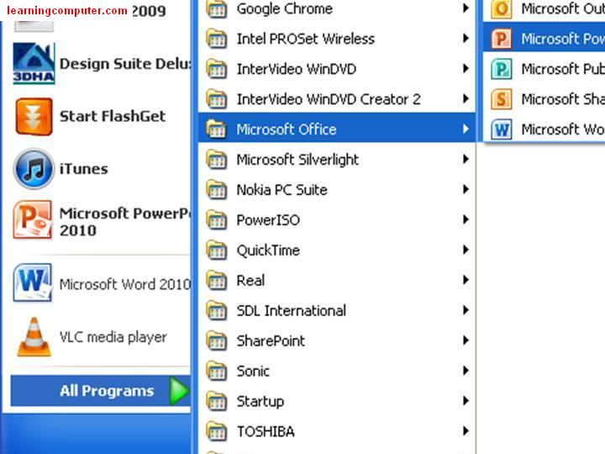
FIG. 5

Scroll across to adjacent box and highlight “Microsoft Office” with pointer.

FIG.6

A third vertical box will appear (see FIG. 7 on next page).

FIG. 7

Scroll up (or down) until you see “Microsoft Office PowerPoint 2010”. Click here and your PowerPoint application will begin to open.

This is called the “Normal” view where you will create and work on your slides.

4) HERE’S WHAT POWERPOINT LOOKS LIKE WHEN IT OPENS (Normal view)
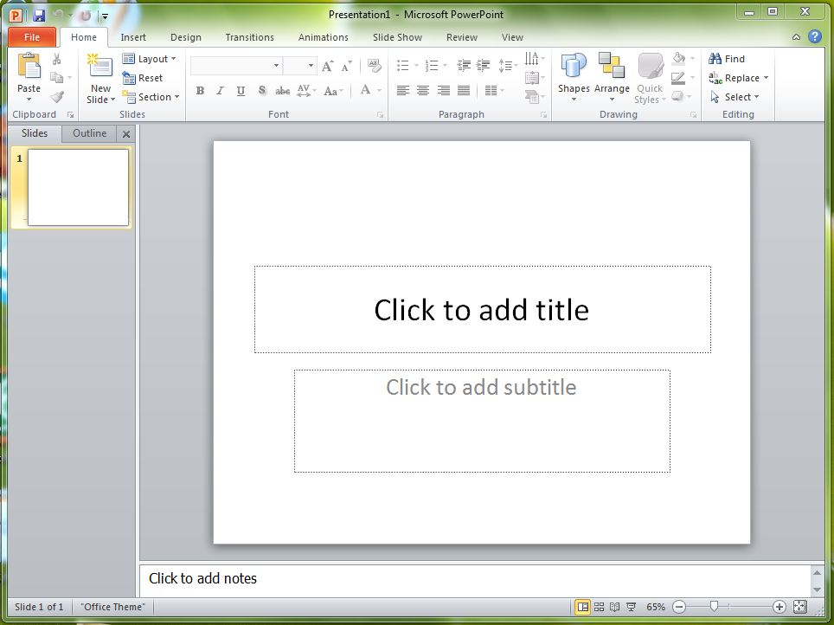
FIG. 8

5) THE RIBBON TOOLBAR
The ribbon toolbar is the strip of symbols across the top of the Normal view:
FIG. 9

This is where you will find *commands that allow you perform certain tasks such as: inserting a picture, changing font of text, adding music, etc.
*command - a specific instruction given to a computer application to perform specific tasks or functions

6) IDENTIFYING BASIC ELEMENTS OF POWERPOINT SLIDES

1

2
4

3

FIG. 10 - Picture of labeled elements in PowerPoint 2010’s Title Slide

- This is called the Slide Pane. It’s where you can work directly on each slide. This first slide pane is always referred to as the Title Slide.
- The dotted borders are called Placeholders or Textboxes, where you can type text or insert pictures or graphs.
- The Thumbnail Pane on the left shows a thumbnail (miniature) version of each full size slide shown in the slide pane. Every time you add a slide, you will see it appear in the slide pane in the order that you created it.
(FYI: If you want to rearrange the order of you slides, you can drag the thumbnails to a different spot. You can also add or delete slides on the slide tab.)
- In the Notes Pane, you can type extra notes about the current slide.

By default, PowerPoint 2010 applies the Blank Presentation as seen on previous page. Although there are many backgrounds and themes you can use with your slides, Blank Presentation is the simplest and most generic of the templates and good to begin with.

7) CLOSING & OPENING THUMBNAIL & NOTE PANES ON THE SLIDE

Sometimes you might want to close or open either the thumbnail or notes pane. Closing the panes make the working area on the slide pane larger.
- Point to the top border of the Notes pane.
- When the pointer looks like this, , drag the border down to make smaller or close or drag up to make more room for your speaker notes.
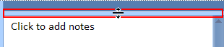
FIG. 11

You will notice that the Slide pane resizes automatically to fit the available space.

8) RECOGNIZING IMPORTANT ICON BUTTONS ABOVE SLIDE
Near the top of the screen there are three buttons that you might find useful as you start to work:
- Undo button: This undoes your last change. (Rest the pointer on the button and click. You can also undo a change by pressing CTRL+Z.

- Redo button: This redoes your last change, depending on what action that you previously performed. (Again, you will rest the pointer on the button and click.) You can also redo a change by pressing CTRL+Y.

Now that you can open PPT & identify parts of the application, it’s time to get started!

9) Name & Save PPT (Instructor will demonstrate.)
- Click the File tab in upper left hand corner of window. A box will drop down
- Scroll down & click Save As.
- On the left-hand pane in the Save As dialog box, click the folder or other location where you want to save your presentation. (You will be saving your PPTs to a folder on your desktop.)
- In the File name box, type a name for your presentation and click Save.
From now on, you can press click the Save icon near the top of the screen to quickly save your presentation at any time.
STEP 1: Slide 1
- This is your Title Slide. Every PowerPoint presentation begins with a title slide.
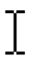
- Move your cursor inside of Click to Add Title Box and click. Once you click in the box your cursor will no longer look like an arrow pointer, but like a this:
- Type in a title (e.g. “If I could travel anywhere…”) Once you finish typing in this box move your cursor outside the textbox and click on the slide pane. The square border will disappear.


FIG. 12

Next, type in your subtitle box. (e.g. your name)
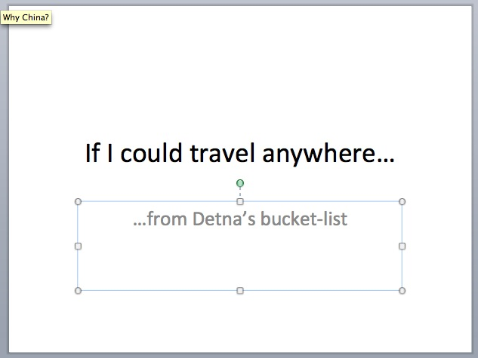

FIG. 13

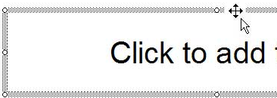
- If you don’t want to use a subtitle you can delete this box by clicking on the border. You MUST be right on the border. You will see a little cross when your cursor is positioned just right. Now you can click!

FIG. 14

The border will turn blue and there will be little circles embedded in the border. Now tap delete button (upper right hand corner of keyboard) and voila, the subtitle box is gone!
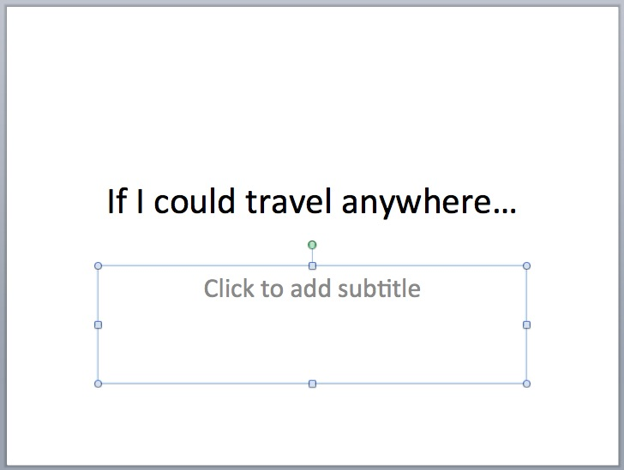

Once the text box looks like this you can tap the delete button & it will disappear.

FIG. 15

STEP 2: Slide 2
- Click on Home Tab at top of slide then click New Slide icon.

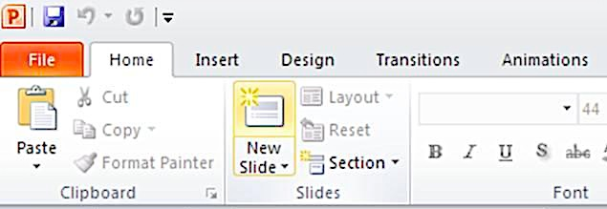

FIG. 16

- Your second slide should look like this:
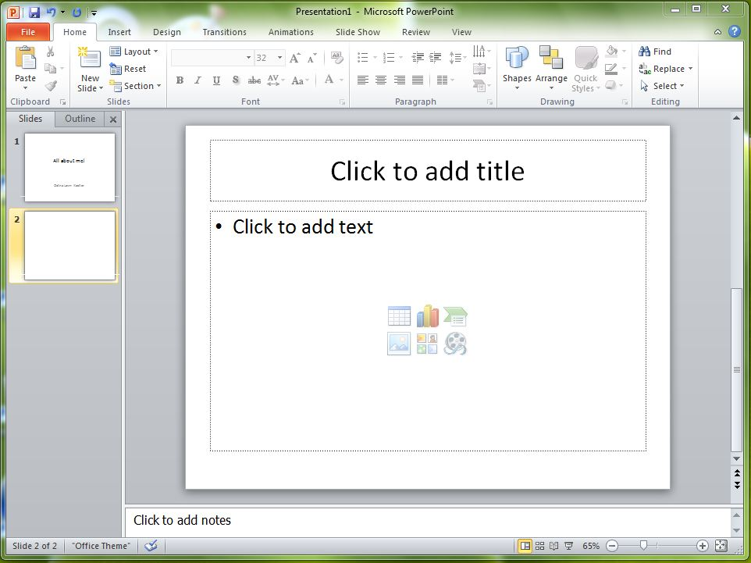

FIG. 17

- Now you’re ready to add a title to your second slide. Click in title box and type the name of a place you’d love to visit.
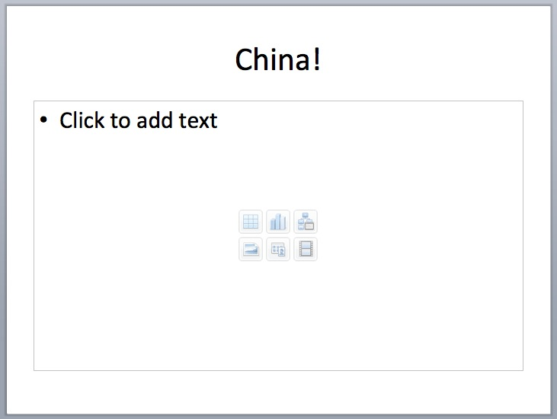

FIG. 18

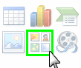
- Next we’ll add an image in the next box.
-In the middle of the large text box you will
see six icons.

-Place cursor on clip art icon (bottom row,
middle) & click.
FIG. 19

- A clip art box will appear on right side of slide.

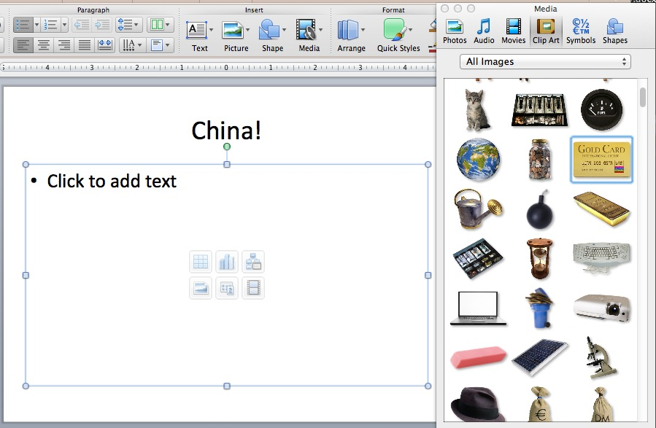

Click on image you want (once you click on an image, it will be framed in blue)

FIG. 20

- Now “click & drag” this image to your text box. (click on icon & hold down mouse button while you move your cursor to the text box—then you can release button)



FIG. 21

STEP 3: Slide 3
- Type in Title box: Why China?
- Type list of reasons why you want to visit that particular part of world.
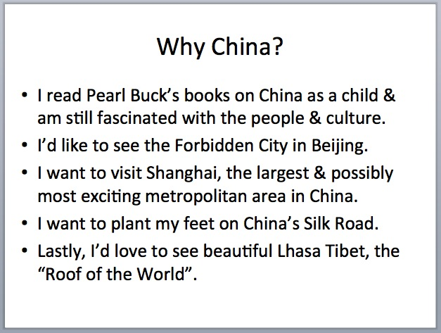

FIG. 22

STEP 4: Changing the font on title slide
- Go to the first slide and click on the title box.
- Highlight text by clicking on first letter in text and dragging to right until entire text is highlighted blue (instructor will demonstrate).
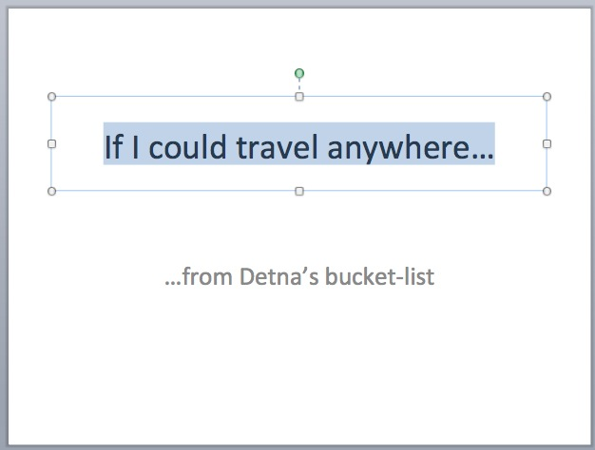

FIG. 23

- Next, click on Home tab at top of slide. Click arrow on font button and a list of fonts will drop down.
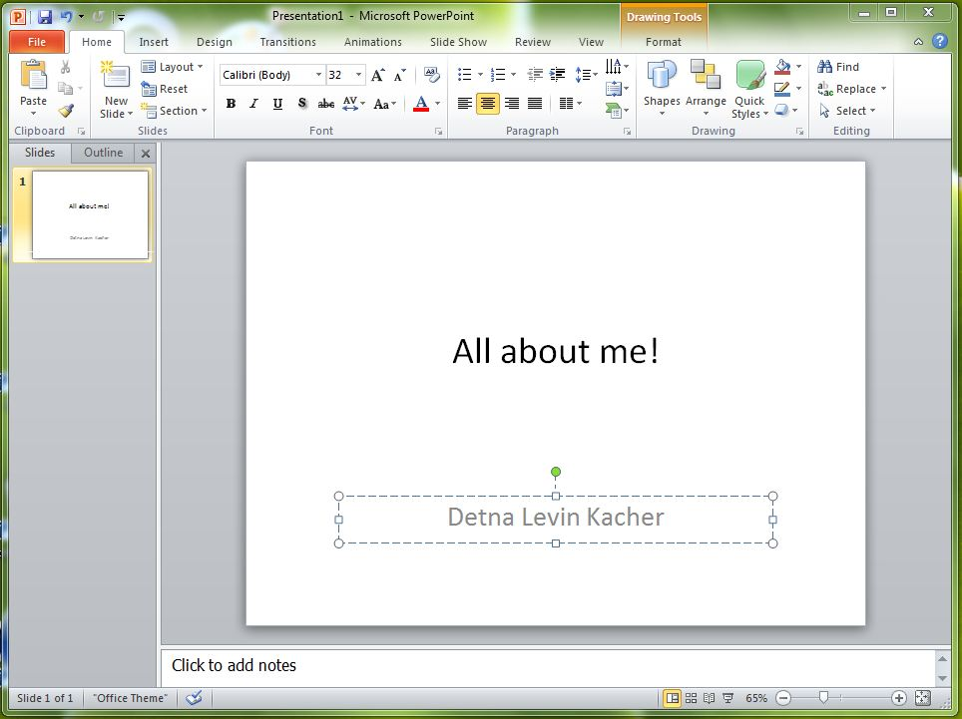

FIG. 24

Close-up of drop-down font list:
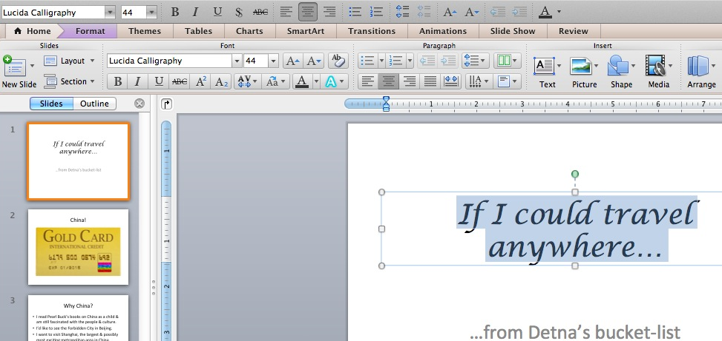
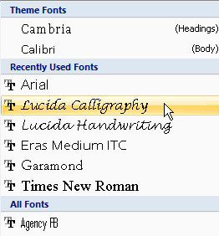

FIG. 25

- How to change the font size. Click on font button & a list of sizes will drop down.

FIG. 26
To make your font Bold; to Italicize font; to Underline font

To change the font color

