Kacher Revised 7/07
DHSHP

The Conducting System
Introduction
The heart's conducting system consists of the sinoatrial node (SA node), atrioventicular node (AV node), the bundle of His, the bundle branches and the Purkinje fibers.
The electrical impulse that causes rhythmic contraction of heart muscles arises in the SA node which is the intrinsic pacemaker of the heart. From the SA node, the impulse spreads over the atrial muscles causing atrial contraction. The impulse is also conducted to the atrioventicular (AV) node.
From the AV node the electrical impulse is conducted to ventricular muscles via the bundle of His, the bundle branches and the Purkinje fibers. The bundle branches and the Purkinje fibers are collectively called the ventricular conduction system.
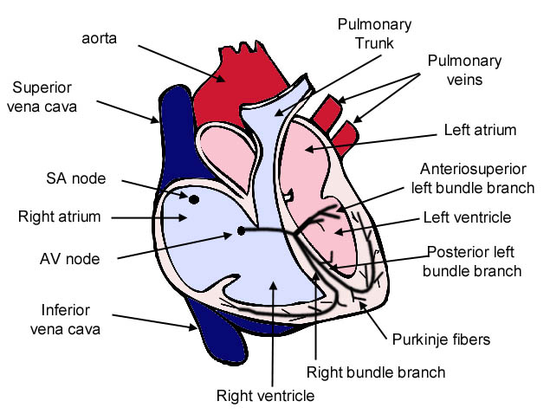
Sinoatrial Node (SA node)

Location
The sinoatrial node (SA node) consists of a cluster of specialized cells that have pacemaker activity (automaticity). These cells are responsible for initiating the electrical impulse that stimulates the heart muscles to contract rhythmically. The SA node is located high on the right atrium close to whether the superior vena cava enters the right atrium.

Sinus rhythm
The SA ryhthm is the normal pacemaker of the heart, firing at about 60-100 beats per minute. A heart controlled by the SA node is said to be in normal sinus rhythm. The electrical impulse from the SA node spreads over the right and left atria and causes atrial contraction. The impulses are also conducted to the atrioventicular (AV) node. It takes about 0.03 seconds for the impulse to travel from the SA to AV node. A few people believe that there are three internodal tracts (anterior, middle and posterior) that conduct the impulse to the AV node. The existence of these three tracts is controversial since their presence has not been firmly proven.

Fast and slow sinus rhythm
In sinus rhythm, every P-wave is followed by a QRS complex, the R-R interval is regular and the P-R interval is less than 0.2 seconds (one big box on the EKG paper). A fast sinus rhythm, faster than 100 beats a minute, is known as sinus tachycardia while a slow rhythm, slower than 60 beats a minute, is known as sinus bradycardia.

Innervation by the Autonomic Nervous System
The SA node under the influence of the autonomic nervous system. The sympathetic system innervates the heart and causes increases the heart rate via B₁ adrenergic receptors, for instance in fight or fright.
The parasympathetic system, via the vagus nerve, slows the heart rate and establishes the resting heart rate of about 60-70 beats per minute. If parasympathetic activity is blocked by anti-cholinergic drugs or the vagal nerve is cut, the heart rate increases. If parasympathetic stimulation is increased, for instance by massaging the carotid sinus (baroreceptors), the heart rate decreases.

Why does the rhythm originate in the SA node?
The rhythm originates from the SA node because the SA node depolarizes more frequently (60-100 beats per minute) than the AV node (40-60 beats per minute) and ventricular conducting system (30-40 beats per minute) so the AV node and ventricular conducting system are 'captured' by the sinus impulse and driven at 60-100 beast per minute.

The Atrioventicular Node

Location and activity
Atrioventicular node (AV node) is located on the interatrial septum close to the tricuspid valve. It receives impulses from the SA node and conducts them to the bundle of His. Conduction through the AV node is slow providing a deliberate delay that allows the ventricles you fill up (after atrial contraction) before the ventricles contract.

The electric impulse from the SA must be conducted though the AV node because the atria and ventricles are separated by a fibrous connective tissue septum that has poor conductivity. The AV node provides the path of least resistance for the impulse to proceed to the ventricles.

AV rhythm
The AV node together with the Bundle of His make up the AV junctional tissue. The AV junctional tissue has its own intrinsic pacemaker activity at of 40-60 beast per minute. If the SA nodes are injured AV junctional tissue can take over control of heart rate and rhythm.
Why must the electric impulse be conducted though the AV node
The electric impulse from the SA node is conducted though the AV node because the atria and ventricles are separated by a fibrous connective tissue ring that has poor conductivity. The AV node provides a path for the impulses to proceed from the atria to the ventricles.
Potential role of the AV node in protecting the ventricles
In pathological circumstances involving atrial fibrillation, the impulses arrive at the AV node at a very high rate (up to 300 impulses a minute). Since the AV node has a long refractory period, some of these impulses find the AV node refractory and are not conducted to the ventricles. Therefore, the AV node functions in a protective role, preventing ventricular fibrillation which can be quickly fatal.

Bundle of His
The bundle of His is located in the proximal intraventicular septum. It emerges from the AV node to begin the conduction of the impulse from the AV node to the ventricles. The Bundle of His branches into the right, left anteriosuperior and left posterioinferior bundle branches.

The AV node together with the bundle of His make up the AV junctional tissue. The AV junctional tissue is considered supraventicular (above the ventricles). The AV junctional tissue has an intrinsic rate of 40-60 beast per minute. If the SA nodes are injured AV junctional tissue can take over control of heart rate and rhythm.

Bundle Branches & Purkinje Fibers
The bundle of His branches into the three bundle branches: the right, left anteriosuperior and left postrioinferior bundle branches that run along the interventicular septum.

The bundles give rise to thin filaments known as Purkinje fibers. These fibers distribute the impulse to the ventricular muscle. Collectively, the bundle branches and Purkinje network comprises the ventricular conduction system. It takes about 0.03-0.04s for the impulse to travel from the bundle of His to the ventricular muscle.

The ventricular conducting system is capable of intrinsic pacemaker activity at a rate of 30-40 impulses per minute. If the SA and AV nodes are injured the ventricular conducting system can take over control of heart rate and rhythm.

