Dr. Watson’s Medical Terminology Week 16
Chapter 8 The Reproductive System

Click on The Reproductive System

Anatomy
- List and describe the four external organs of the female reproductive system:
a.

b.

c.

d.

- List and describe the four internal organs of the female reproductive system:
a.

b.

c.

d.

- What are the four external organs collectively known as?

- What is the medical term for the wavelike movement that occurs as an ovum moves through the fallopian tubes to the uterus?

- Label the diagram of the internal female reproductive organs.
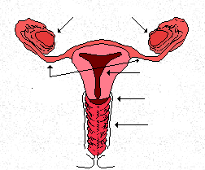

- What is the difference between a fetus and an embryo?

- What is another medical term for the fallopian tubes?

- Define:

  - fertilization

  - gestation

- What are these?
a. part of the organ that resembles a neck and protrudes into the vagina _____________
b. the principal part of the organ, or the body _________________
c. the part of the uterus that is above the opening of the fallopian tubes, or the top of the uterus
10. What is the correct medical term for a woman’s monthly period?

- What is the singular and plural for “egg” (the correct medical term)?

- Define menarche?

- When does menarche occur?

- Define menopause.

- When does menopause occur?

- When an ovum develops and prepares for ovulation, it becomes what?

- Give the word for the following:

rupture of the follicle and entrance of the egg into the fallopian tube

- How often does #17 above occur?

- When, during the menstrual cycle , does #17 occur?

- For each of the following stages of labor, what occurs?

  - Stage 1

  - Stage 2

  - Stage 3

- Label the drawing below:

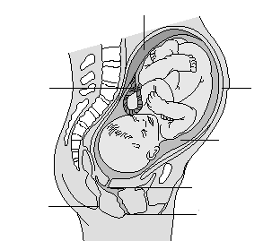

- What are the male reproductive organs called?

- What is a single male reproductive organ called?

- What is the hormone needed for male sexual characteristics?

- What is needed to fertilize the woman’s egg?

- What is the material in #25 above mixed with to help it travel through and out the male reproductive tract?

- What is the structure that is located on top and alongside the testes? What does it do?

- Trace the path of sperm through the male reproductive tract beginning with the testicles and ending with the urinary meatus.

- What is the medical term for the foreskin?

- What is the medical term for the end of the penis that is covered by the foreskin?

- Label the diagram of the male reproductive system.

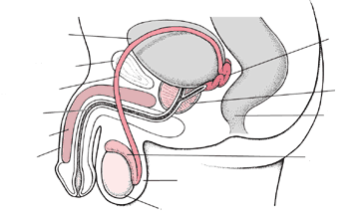
Pathology
- Define the following terms (break the word parts into their individual meanings:
  - dysmenorrheal

  - metrorrhagia

  - menorrhagia

  - amenorrhea

- What is PMS?

- What are the symptoms of PMS?

- What is TSS?

- What causes TSS?

- How can a woman get TSS?

- What are the two names for a common benign tumor of the uterus?

- What is the disorder that causes monthly bleeding in the abdominal cavity because of uterine cells that are misplaced outside of the uterus?

- What is the surgical treatment of # 7 & 8 above?

- What are four signs of any inflammation?

- What are the medical terms for the words below that occur as a result of yeast and fungal infections:

  - white discharge
  - severe itching

- What are the medical terms for inflammation of the following parts:
  - fallopian tubes
  - urethra
  - testes
  - cervix
  - bladder
  - ovary
  - structure on top and on side of the testicle
  - uterine lining
  - vagina
  - prostate gland

- Why does PID cause sterility in a male?
- Why is it relatively easy to become infected with a STD?
- What is HIV?

- What is AIDS?

- How can a health care worked become infected with HIV?

- Define wasting syndrome.

- What kinds of cancers can result in a person with AIDS?

- List the symptoms of gonorrhea in both males and females:

Males Females

- What causes gonorrhea?

- Why is treatment for gonorrhea more difficult today than in years before?

- What causes the great discomfort from genital herpes?

- How can someone contract genital herpes?

- What STD results in swollen lymph nodes, fever and headache?

- What STD results in permanent damage to the heart, liver and brain if it is not treated?

- List the symptoms of #26 above.

- How does the 2nd symptom differentiate it from other types of diseases?

- How can an infant contract genital herpes?

- What kind of male cancer can be very serious?

- What condition occurs in infants, and can be treated surgically between the ages of 1 and 5?

- What is the surgical treatment of #31 above and how is it done?

- What conditions can cause cystitis and nephritis in older men due to urethral obstruction?

- Describe the following surgical procedures:

  - perineal prostatectomy

  - transurethral resection

  - suprapubic prostatectomy

Pharmacy
- What 3 types of medications are used with men and women with reproductive disorders?

- What is the correct term for “the pill”?

- What are four other types of contraceptives?

- What are the following complications of oral contraceptives?

  - Embolism

  - thrombophlebitis

- What hormone is prescribed for menstrual disorders?

- What other symptoms is the hormone in #5 above also used for?

- What does Oxytocin do (during labor)?

The Lab
- How long after conception can an at home pregnancy test be reliable?

- What is evaluated with in a semen analysis?

- What do you call male sterilization?

- What is a PAP test?

- What type of biopsy or smear is done to diagnose uterine cancer?

- What kind of test can give a health care worker information about the health and status of a fetus, especially regarding inherited disorders? How is it done?

- List the medical term for mongolism.

- What kinds of symptoms might you see in an infant with mongolism?

The Clinic
- What is uterosalpingography?

- What kind of procedure can determine the health and sex of a fetus?

- Where is an ectopic pregnancy located?

- What kind of instrument is used to perform a female sterilization?

- What is a female sterilization called?

- Define:

  - conization
  - episiorrhaphy
  - D & C
  - Episiotomy
  - Panhysterectomy
  - Salpingo-oophorectomy
  - Panhysterosalpingo-oophorectomy
  - Orchiopexy/orchidopexy
  - Vasectomy
  - Circumcision
  - Prostatectomy
  - Tubal ligation

Records
- Give the meanings of the following abbreviations:
  - FEKG
  - FHR
  - FHT
  - AB
  - CPD
  - CS or C/S
  - FTND
  - EDD
  - DOB
  - LNMP
  - PMP
  - GYN
  - IUD
  - DUB
  - OB
  - GC

Miscellaneous Terms
- What are three terms that refer to how many pregnancies a woman has had?

- What are four conditions that only men have? Describe them.

- What are two terms that refer to abnormal conditions of a newborn? Describe them.

- What are three terms that refer to how many children a woman has delivered?

- What is the medical term for the 6 week period after the delivery of a newborn?

- What are two painful conditions for women?

- What is a medical term for anatomical structure measurement?

- What are three terms that refer to disorders that can occur during pregnancy? Describe them.

Be sure to click on Checking a patient’s Chart in the Class section..
Complete the Building exercise as well.

Don’t forget to try the Class Exercises!

