|  |
| --- |
| Department of Nursing |
| Orientation Handbook |
| Beyond Orientation. This handbook is intended to provide nurses who are new to Berkeley Medical Center with a guide to our vision of professional practice, key best practice standards, and clinical knowledge to facilitate that journey. Welcome Aboard! |
|  |



Table of Contents

|  |  |
| --- | --- |
| Philosophy, Mission, and Vision | 2 |
| Professional Practice Model | 3 |
| Service Excellence | 5 |
| Professional Practice through Shared Governance | 6 |
| Professional Excellence Program (PEP) | 18 |
| Nursing Quality – NDNQI | 10 |
| National Patient Safety Goals | 11 |
| Time keeping with Kronos | 13 |
| Employee Health | 14 |
| Infection Control | 15 |
| Behavioral Health Consultations | 18 |
| Restraints | 19 |
| Wound and Pressure Ulcer Management | 20 |
| Special Bed Selection Algorithm | 31 |
| Venous Thromboembolism (VTE) prophylaxis and  Sequential Compression Device (SCD) | 32 |
| Intake and Output | 33 |
| Hyper/hypothermia Systems | 34 |
| Telemetry and cardiology | 34 |
| Heart Failure | 39 |
| Body Safety and Patient Transfers | 42 |
| Hoyer and Camel Lifts | 45 |
| Code Blue, Rapid Response, Condition H, MERT | 48 |
| Lifenet | 49 |
| IV Therapy | 49 |
| Pain Management | 51 |
| Informed Consent | 54 |
| Blood Administration | 56 |
| Swallow Screening | 58 |
| Tube Feeding - Kangaroo Pumps | 60 |

Philosophy, Mission, and Vision

**PHILOSOPHY:**

Central to the individual’s hospital experience at City Hospital is the art and science of nursing practice. Nursing at City Hospital is defined as the holistic assessment of human responses to alterations in health status and the planning, implementation, and evaluation of each person’s plan of care. Nurses are part of the individual’s care plan and are an extension of the individual as he or she moves from a sense of brokenness to a sense of wholeness. An individual may experience that sense of brokenness in one or more of the four aspects of the human being: social/emotional, mental, physical, and spiritual. For an individual to resume his sense of wholeness, nurses provide the means or the personal extension to support a caring, healing, and protective environment where human dignity is preserved. This personal extension of the nurse to the patient is manifested by:

* A human-to-human caring presence
* Being in the moment and connecting with the individual
* Developing a caring and trusting environment
* Open communication (listening and providing information)
* Demonstrating open concern
* Setting realistic health goals with the individual
* Education that addresses individual needs and learning styles
* Collaborative relationships with members of the healthcare team
* Promoting the highest level of wellness
* The patient and family participating in the care received by the nurse

Our commitment to caring at City Hospital is evident when we display behaviors

associated with the value known as REGARD; Respect, Empathy, Giving, Attitude, Response, and Dignity. In the interest of optimal health care, the nurses at City Hospital function with autonomy to identify and solve the problems that arise within their profession. In this light, Nursing Service is committed to the continuous improvement of both the quality of care provided and the effectiveness of resource management. A Registered Professional Nurse coordinates each patient’s nursing care in collaboration with a team of caregivers. Each team member brings a variety of skills in their area of expertise, each of whom makes an independent and valuable contribution to patient care.

**Mission:**

The mission of Nursing Service is to provide high quality, cost effective patient care and foster the wellness of our community through interdisciplinary teamwork and education.

**Vision:**

To ensure professional nursing practice that exceeds the expectations of our community in a compassionate and caring environment of nursing excellence.

Reference:

NSER 001

Professional Practice Model

***Nursing***isthe protection, promotion and optimization of health and abilities, prevention of illness and injury, alleviation of suffering through the diagnoses and treatment of human response, and advocacy in the care of individuals, families, communities, and population (ANA 2010).

A ***Professional Practice Model*** reflects how nurses practice, collaborate, communicate, and develop professionally; and how mission, values, philosophy and theories of nursing are integrated with practice.

***Relationship Based Care*** is based on the theory of Human Caring of Jean Watson and is built around three key relationships.

* **Relationships with Yourself:** Ability to care for yourself so you have the ability to care for others.

Nurses knowledge of self and self-care is essential to providing quality patient care and maintaining positive relationships.

Self-knowing – Understanding how to balance personal values and beliefs.

Professional Growth enriches your mind.

Nurses who are distracted by inner conflicts can’t effectively meet their patient’s needs. Gather your thoughts before you enter the patient’s room. Then you can focus the needs of the patient and family.

* **Relationships with Co-workers:** Nine Commitments to Co-workers that help caregivers build and

maintain those key relationships.

Nine (9)Relationship Based Care Commitments with your co-worker

1. Establish and Maintain healthy interpersonal relationships with EVERY member of the team.
2. Talk directly to team members if problems exist – Time Sensitive. Don’t let issues “pile up”.
3. Treat every team member as an equal regardless of job title or levels of education.
4. Do Not Engage 3 B’s (Bickering, Backbiting, and Blaming). Instead practice 3 C’s (Caring, Committing and Collaborating).
5. Don’t complain about other team members.
6. Accept co-workers as they are today – forgiving past problems.
7. Be committed to finding solutions to problems.
8. Affirm contribution of other care team members.
9. Remember no one is perfect – human errors are opportunities.

Collaborative Role with Physicians

Physicians oversee medical diagnoses and delegates medical treatments. Nurses implement these delegated medical treatments based on their knowledge and critical thinking skills. Nurses see the patients 24 hours a day; using the nursing assessment and plan of care, update the physician on what has happened with the patient since they saw them. Communicate directly and openly. Respect their orders.

* **Relationships with Patients / Families / Significant others**: Focuses on how you as a nurse make them feel.

Caring Behavior Cues for Patient Interactions

**C**onnect with the patient, smile, introduce yourself and explain your role in the patient’s care

**A**sk the patient: “What is the most important thing you would like to accomplish today”?

**R**espect the patient’s privacy, diversity and individual needs

**I**nteract with the patient/ family. Include them in the plan of care. Sit with them for 5 minutes.

**N**urture in a positive, caring, and healing environment focusing on the spirit, mind and body

**G**o the extra mile with a positive attitude.

**NURSING PROFESSIONAL PRACTICE MODEL**

**RELATIONSHIP BASED CARE**

**Safety**

**< Best Practice**

**UNITY**

**--Harmony**

**--Respect**

**--Recognition**

**PURPOSE**

**MISSION**

**Improve Health Status of WV Panhandle Residents By**

* **Expand Access To Care**
* Education Of Healthcare Professionals
* Excellence In Health
* **Wellness Service**

**OUTCOMES**

**~Patient Satisfaction**

**~Nurse Satisfaction**

**~Nurse Quality Measures**

**~Quality Blue**

THEORY

JEAN WATSON’S CARING PRINCIPLES

Patient Focused Care

**COMMUNICATION / COLLABORATION**

**:Nursing Councils**

**:Strive toward Magnet Status**

OBLIGATION TO ACCEPT ACCOUNTABILITY FOR NURSING CARE

* Commitment To Education
* Professional Development
* Research

**VALUES**

* **Respect**
* **Integrity**
* **Quality**
* **Excellence**
* **Teamwork**
* **Stewardship**

**VISION**

* **Hospital Of Choice**



Service Excellence

**PATIENT FAMILY CENTERED CARE**

Patient- and family-centered care is an approach to the planning, delivery, and evaluation of health care that is grounded in mutually beneficial partnerships among health care providers, patients, and families. It redefines the relationships in health care.

Patient- and family-centered practitioners recognize the vital role that families play in ensuring the health and well-being of infants, children, adolescents, and family members of all ages. They acknowledge that emotional, social, and developmental support are integral components of health care. They promote the health and well-being of individuals and families and restore dignity and control to them.

Patient- and family-centered care is an approach to health care that shapes policies, programs, facility design, and staff day-to-day interactions. It leads to better health outcomes and wiser allocation of resources, and greater patient and family satisfaction.

* **Respect and dignity.** Health care practitioners listen to and honor patient and family perspectives and choices. Patient and family knowledge, values, beliefs and cultural backgrounds are incorporated into the planning and delivery of care.
* **Information Sharing.** Health care practitioners communicate and share complete and unbiased information with patients and families in ways that are affirming and useful. Patients and families receive timely, complete, and accurate information in order to effectively participate in care and decision-making.
* **Participation.** Patients and families are encouraged and supported in participating in care and decision-making at the level they choose.
* **Collaboration.** Patients and families are also included on an institution-wide basis. Health care leaders collaborate with patients and families in policy and program development, implementation, and evaluation; in health care facility design; and in professional education, as well as in the delivery of care.

**BEDSIDE SHIFT REPORT**

Desired Outcomes and Benefits of Bedside Report

**For the Patient**

* Patient’s perspective is valued as being most important -- it isn’t “about us,” our schedule or comfort zone. Our priority must be the patients as that is the reason why we are here.
* Patients will see – and hear – from the team of professionals who are providing their care.
* Patients will be reassured that everyone is getting all the necessary report about what is going on with them.
* Patients will feel more informed about their care thereby making them less anxious and more compliant with their care and treatments. Allow them to be involved in their care.
* Patients will be more satisfied because they know that things are being done and monitored throughout the shift.
* Patients will know who their nurse is on every shift.
* The process will reduce the “2 – 3 hour ‘alone’ time” during shift change. Many patients perceive the 2 – 3 hours around the change of shift to be a time when no one is around. Sentinel events also occur more often during this time. Bedside Report could help eliminate this.
* The process will aid in increasing communication. Communication issues are the root cause of about 30% of patient safety events and improved communication between caregivers greatly improves patient care and outcomes.

**For the Staff**

* Improves the sharing of information between health care providers by utilizing a standardized method of communicating.
* If asked questions, you won’t have to say “I haven’t seen my patients yet” and therefore you will be more prepared.
* The off-going nurse can use “hands-on” to show the on-coming nurse how to operate special equipment or how special orders are being handled.
* Accountability will increase since each nurse will know his or her patients’ condition at the end of the shift.
* Keeps report to items related to patient condition and social status.
* Improves the nurses understanding of patient condition as you are able to visualize the patient.
* Gives you an orderly room and patient at the beginning of the shift.
* Overcomes differing communication styles.

**AIDET**

The Five Fundamentals of Service

* **Acknowledge -** Acknowledge the patient by name. Make eye contact.   
      Ask: "Is there anything I can do for you?"
* **Introduce -** Introduce yourself, your skill set, your professional certification,   
      and experience.
* **Duration -** Give an accurate time expectation for tests, physician arrival,   
      and tray delivery.
* **Explanation -** Explain step by step what will happen, answer questions,  
      and leave a phone number where you can be reached.
* **Thank -** Thank the patient for choosing your hospital, and for their   
      communication and cooperation. Thank the family for assistance and being  
      there to support the patient.

**HOURLY ROUNDING**

Research has shown a reduction in falls by 50% and pressure ulcers by 14% through hourly rounding.

The “Four Ps,” vital for successful rounding

* **Positioning**: Making sure the patient is comfortable and assessing the risk of pressure ulcers.
* **Personal needs**: Scheduling patient trips to the bathroom to avoid unsafe conditions.
* **Pain**: Asking patients to describe their pain level on a scale of zero to 10.
* **Placement**: Making sure the items a patient needs are within easy reach, such as water, tissues, the TV remote control, and the telephone.

References:

The Studor Group. https://www.studergroup.com

The Institute for Patient and Family centered care. http://www.ipfcc.org

Professional Practice through Shared Governance

**Shared Governance Councils**

Shared governance is about empowering nurses. Our shared governance council gives nurses a voice in decisions that affect our nursing practice.

* **Participation** – *Shared Governance* starts with participation. Sitting on the sidelines has never solved any problem. For councils to be effective they need people who want to make a difference. People tend to have two very different perspectives on problems; complain or seek solutions. Council participation males you part of the solution.
* **Collaboration** – Working with the Vice President of Patient Care Services and members of the nursing management team, staff nurses from all nursing units are able to collaborate; to share their voice, their experience, and their knowledge to help guide how this organization reaches its overall goals.
* **Decision making** – The council system requires that staff nurses, not management, chair the individual councils. Two managers participate on each council with one acting as a voting member and the other as a mentor to the council chairperson. Council decisions are made by votes from all voting members, and then brought to the coordinating council to be shared with representatives from each council, members of the nursing management team and the Vice President of Patient care Services.
* **Empowerment** – Having a voice in the decision making process empowers nursing to help guide processes that affect our practice. There are many external pressures, regulations, and health and safety standards that can have significant impact of the way nursing is practiced. Our shared governance councils allow nurses at the bedside to find the best approach to best practice.

**Opportunity**

* Participate in the decision making process.
* Promote and create collegial relationships.
* Generate a consensus in professional practice matters .
* Opportunity for nurses to plan, implement, evaluate, and revise nursing practice .

All subsidiary council meetings are open. An open forum during which nursing staff members may address the council on any topic related to the role of that council. Requests to address the council must be scheduled in advance with the council chair. Suggestions and solutions will be heard at this time. Nursing staff members may audit the entire meeting, if not scheduled to work at that time. If the meeting is audited, nursing staff will not be financially compensated.

**Coordinating Council** - The Coordinating Council assists the Vice President of Patient Care Services in developing and implementing the strategic plan for the Division of Nursing that supports the strategic direction of City Hospital and West Virginia University Hospitals-East.

* Agenda is set by the Vice President of Patient Care Services.
* This council coordinates the efforts of the subsidiary councils.
* Chairpersons of each subsidiary council provide a progress report.
* There is free flow of communication between the subsidiary councils and the Vice President of Patient Care Services who will concur with or redirect the council’s actions.

**Quality Improvement Council**

* Establish the quality improvement plan for the division of nursing.
* Performs on-going evaluation of QI plans and QI projects.
* Ensure consistency between the hospital and the nursing department.
* Monitor changes in nursing practice.
* Report outcomes of nursing practice and nursing care.

**Research and Practice Council**

* Has two arms: one for nursing research and one for nursing practice.
* Identify and encourage nurse involvement in evidence-based nursing practice and the application of nursing research.
* Identify nursing problems.
* Conduct nursing research.
* Evaluate current evidence-based nursing literature.
* Implement changes to practice based on research findings.
* Develop nursing policy through the evaluation of standards of care and practice that are based on best practice.

**Education Council**

* Assesses the learning needs of the nursing department and coordinates continuing education programs for nurses in collaboration with the Department of Education.
* Advises the Department of Education regarding the nursing orientation and preceptor ship programs.
* Approves nursing educational materials to improve outcomes through learning.
* Provides on-going evaluation of all nursing graduate development programs and any future nurse externship, nurse internship or nurse fellowship programs.
* Encourages continual professional development.

**Work Life Council**

* Ensures staff nurse input regarding issues such as staffing and scheduling, floating, and other HR policy issues.
* Coordinates all nursing celebration and recognition programs.
* Works with other departments to ensure a positive, collegial supportive work environment.

Professional Excellence Program (PEP)

|  |  |  |  |  |  |
| --- | --- | --- | --- | --- | --- |
| **Rating** | **Clinician I** | **Clinician II** | **Clinician III** | **Clinician IV** | **Clinician V** |
| **Clinical**  **Experience**  **(Submit**  **resume)** | New graduate | > 1 Year RN experience  or 2080 hours  New RN or Current RN not seeking advancement | 3 or > years RN experience or 6,240 hours | 5 or > years RN experience or 10,400 hours | 7 or > years RN experience or 14,560 hours |
| **Education**  **(Submit copy**  **of diploma and/or most recent**  **transcript)** | Graduate of an  accredited  nursing program | Graduate of an accredited  nursing program | Graduate of an accredited  nursing program | Bachelor of Nursing degree  from an accredited nursing  program OR RN actively pursuing BSN degree demonstrating completion of 6 or > credit hours per year with Grade C or above | Master of Nursing degree  from an accredited nursing  program OR BSN actively pursuing MSN degree demonstrating completion of 6 or > credit hours per year with Grade C or above |
| **National**  **Certification –**  **(Submit copy**  **of current**  **card(s))** |  |  | Holds certification by a nationally recognized  certifying body resulting in additional credentials relevant to current position | Holds certification by a nationally recognized  certifying body resulting in  additional credentials relevant to current position | Holds certification by a  nationally recognized  certifying body resulting in additional credentials relevant to current position |
| **Professional**  **Activity –**  **(Submit copy**  **of card(s))** |  |  | Current member of a state or national nursing professional organization | Current member of a state or national nursing professional organization | Current member of a state or national nursing professional organization |
| **Staff Meetings** |  |  | Attends 75% | Attends 75% | Attends 75% |
| **Continuing**  **Education**  **(Submit**  **form with certificates)** |  |  | 20 contact hours of which 8 are specialty contact  hours** | 25 contact hours of which 12 are specialty contact hours** | 30 contact hours of which 16 are specialty contact hours** |

**Growing Up With Us and Peak Development newsletters will not be accepted as specialty contact hours

|  |  |  |
| --- | --- | --- |
| **PEP Level Requirements** | **Minor** | **Major** |
| **Level 3 --**  **Meet 2 Minor**  **& 1 Major**  **Criterion**  **Level 4 --**  **Meet 2 Minor**  **and 2 Major**  **Criterion**  **Level 5 –**  **Meet 2 Minor and 3 Major**  **Criterion**  **\*Selections**  **must be pre-**  **approved by**  **nursing**  **director.** | * Prepares an educational board for patient or staff education * Authors original pamphlet / brochure * Primary instructor of one unit based   educational program (e.g.-in service on falls risk using evidence based practice & standards)   * Attends one charge nurse, preceptor or submits CH certificate from acceptable on-line program within the past 12 months (3.5 CH min./program cannot repeat courses) * Recipient of Hospital Wide or Nursing   Service Award within past 2 years   * Serves as primary preceptor for Capstone student(s) * Attends leadership workshop within the past 12 months * Serves as data collector for performance improvement project or product evaluation * Participates in or coordinates research projects * Coordinates departmental in service and CE for hospital wide new product, software, or equipment initiative * Serves as leader / facilitator for evidenced based research journal discussion * Participates in a public service healthcare event * Hospital approved fund raiser department representative * Actively serves on shared government council and is in good standing * Leads one nurse recruitment event off site. | * Primary instructor of unit based patient education program (e.g.-Pre-Op Total Joint Class instructor) * Serves as charge nurse (min 280 hours/year * Serves as preceptor for staff (min 280 hr/year) * In service to multiple nursing units (e.g.- Nursing Grand Rounds) * Identifies & implements nursing research ideas and or performance improvement projects * Committee member or board member of   community nursing organization or school of nursing   * Participates in the organization and development of the charge nurse or preceptor program (unit based or hospital wide) * Officer or board member of local, state or national professional or community   service organization   * Successful implementation of one evidence based initiative within past 12 months * Authors journal article with a CH test within past 12 months * Leads and coordinating department staffing   Schedule   * Serves as a Chairperson of a   hospital or unit based committee, task force or Do It Team within past 12 months   * Paid reviewer of healthcare textbook or journal * Adjunct faculty member in good standing * Presents an evidenced based educational program for nursing (e.g.- advanced provider course instructor) * Primary instructor of unit based patient education program (> 1 session) * Authors evidenced based self-study educational program for nursing * Poster presenter at a state or national conference * Publishes in a peer review journal with bibliography * Authors original research article or chapter in nursing book within past 24 months * Organizes a public service healthcare event * Leads two or more nurse recruitment events off site. |

Forms and instructions for completing a portfolio are available on the INTRANET.

Nursing Quality Indicators (NDNQI)

The National Database of Nursing Quality Indicators (NDNQI) was founded in 1994 by the American Nurses Association (ANA) to gather data on nurse-sensitive indicators that affect patient quality and safety. Through NDNQI we are able to compare our hospital (and individual units) with other hospitals across the country through the use of benchmarks that identify exceptional nursing care. This provides us with an opportunity to evaluate how well we provide care compared to the rest of the nation and identify areas of opportunity to improve our practice.

The Nursing Quality Improvement Council assists each nursing unit in tracking the nurse sensitive indicators.

These are the nurse sensitive indicators we measure and submit to NDNQI:

* Falls
* Pressure Ulcers
* Nursing Care Hours
* Catheter Associated Urinary Tract Infections (CAUTI)
* Central Line Associated Blood Stream Infection (CLABSI)
* Ventilator Acquired Pneumonia (VAP)

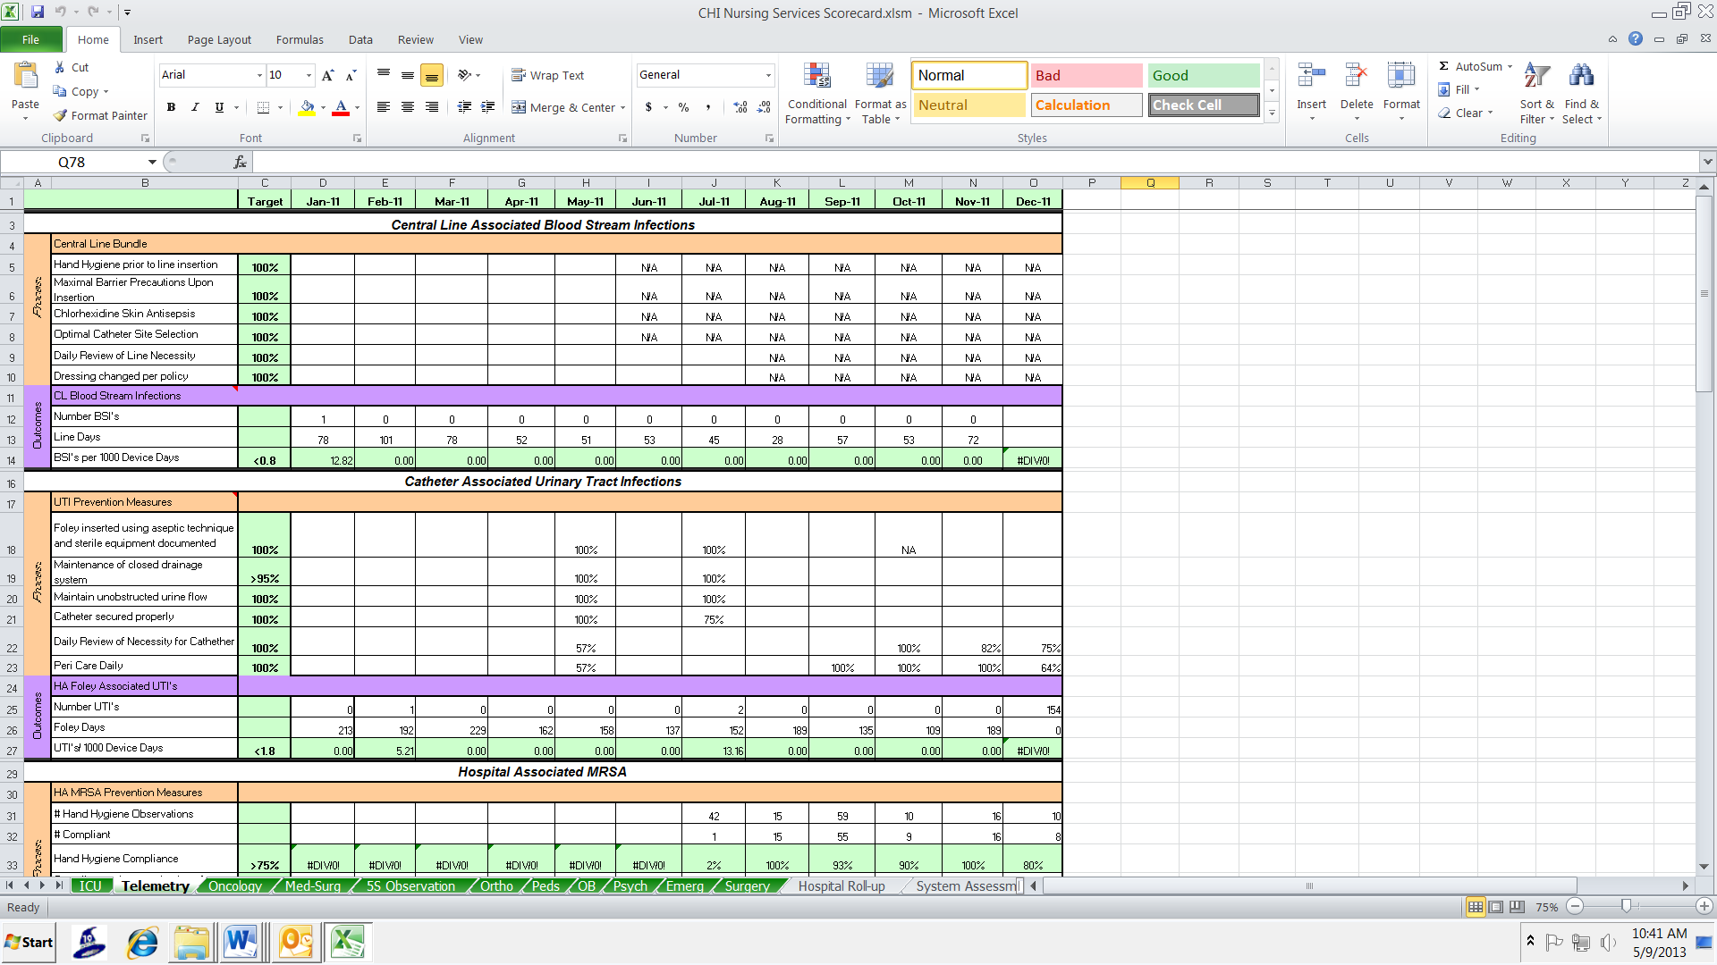

Collected data is maintained on the Nursing Services Scorecard. This is a tool used to identify our progress unit by unit. By identifying strengths and areas for growth, we are able to continue improving the quality and safety of patient care.

National Patient Safety Goals

City Hospital is a Joint Commission Accreditation Hospital. The Joint Commission develops National Patient Safety Goals to improve patient Safety. The goals focus on problems in healthcare safety and how they can be solved.

1. **Identify patients correctly**

* Use at least 2 patient identifiers.
* City Hospital uses the patient’s name and birthday.
* Prior to administering medications, blood, collecting blood samples, or specimens and when providing treatment, the patient must be identified with name and birthday.
* Compare the patient’s answer to their armband and medication record.
* Each patient room is equipped with a barcode scanner. Patient armbands are scanned prior to medication administration.

1. **Use medicines safely**

* Monitor daily APTT and PT/INR on patients who are taking blood thinners. This includes patients receiving VTE prophylaxis.
* Medication reconciliation is done on admission, with changes in level of care, and at discharge.
* All medications a patient will be taking are listed on the discharge instructions.
* Tell the patient it is important to bring their up-to-date list of medicines every time they visit a doctor or go to the hospital.
* All medications have bar codes and are scanned along with the patients arm band.

1. **Prevent infection**

Hand washing is the single most important method if preventing the spread of infection.

* Wash hands when entering and leaving patient rooms. “Foam in Foam out”
* Before and After Touching patients
* After touching patient surroundings
* Before and After eating
* After using the bathroom

If your patient has C-Diff, you MUST WASH your hands with SOAP and Water. You CANNOT use hand sanitizer with C-Diff.

Other goals are to prevent infections from central lines, after surgery, and from urinary catheters.

1. **Improve staff communication**

Use of SBAR handoff communication, Ticket to Ride and reporting of Critical Results are ways we have improved staff communication.

**Critical Results Reporting** provides effective communication of abnormal values to the physician.

* Critical Values are results that require prompt notification to the physician.
* The department that is performing the test will place a call to the appropriate nursing unit or outpatient department.
* The nurse who receives the results must communicate them to the responsible physician within 60 minutes.
* This process is documented in the medical record. In some situations—treatment in progress, improving value, chronic condition—it is at the discretion of the RN whether or not to call the physician. The lab evaluates the timeliness of reporting critical results with a performance improvement study.

The ***Ticket to Ride*** form is used to provide safe transportation of patients within the hospital. It provides ancillary departments with sufficient information to safely transport patients away from their nursing units when not accompanied by a nurse.

* Complete on any patient transported off of their unit without a nurse.
* All sections of this form must be reviewed and accurately completed prior to releasing the patient to the transport team.

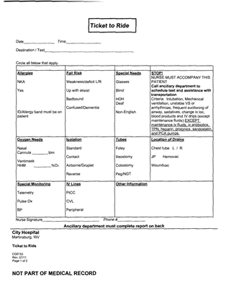

* Any patients who meet the exclusion criteria listed on this form must have a nurse accompany the patient on all transports.

The exclusion criteria includes the following: intubation, mechanical ventilation, unstable VS or arrhythmias, frequent suctioning of airway, sedatives, changes in level of consciousness, infusion of blood products and continuous fluids except maintenance fluids, iv antibiotics, TPN, heparin, protonics, sandostatin and PCA pumps. * “Ticket To Ride” Form available on form fast.

***SBAR Hand-Off Tool***

***Situation-Background-Assessment-Recommendation***

**Situation**

Patient name, age, room #, physician

**Background**

Date of admission and diagnosis

Brief synopsis of treatment to date

Code status

Isolation type and reason

Pertinent medical history

Family/significant other involvement

Precautions (fall, suicide, seizure, restraints)

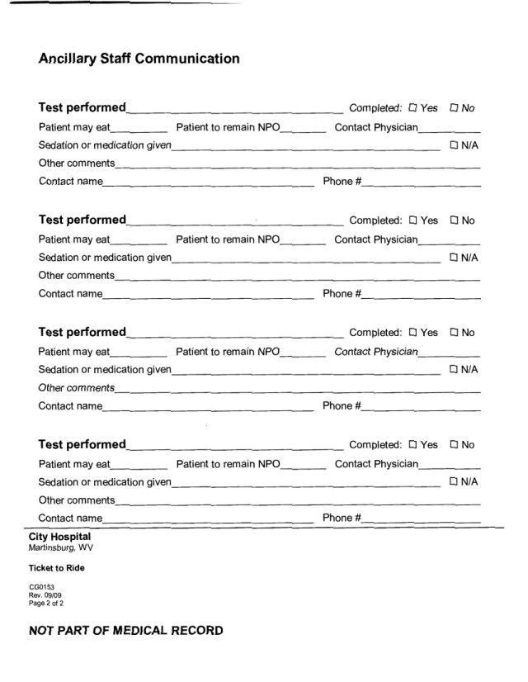

Medication reconciliation

**Assessment**

ROS information

Pain assessment-location scale, last dose of pain medication and effectiveness

Lab tests/results

Imaging tests/results

Key medications- drips, fsbs, insulin coverage

Physicians orders (received, carried out, pending)

**Recommendations**

Items that require follow up-

Patient teaching

Consults needed (PT, OT, RT, Education, Case Management)

Discharge needs

1. **Identify patient safety risks**

All patients are assessed for suicide on admission. If they say they have suicidal ideation the following steps are taken:

* Assess Suicide Plan/Availability
* Assess current Suicidal Precipitating Factor
* Ask if there were any previous suicide attempt (Describe)
* Willingness to Contact Staff Member If Feeling Like Hurting Self
* Notify the Physician of positive suicidal ideation

**Hourly Rounding Assessments**.

The purpose of hourly rounding is to regularly address patient’s needs.

* This practice increases patient safety and patient’s perception of care.
* Frequent rounds provide opportunities for proactive nursing interventions.
* RNs, LPNs and Techs can perform and document hourly rounds.
* There have been studies that support the benefits of hourly rounding—less call bells, fewer steps by the nursing staff, increased patient perception of care.



1. **Prevent mistakes in surgery**

UNIVERSAL PROTOCOL **-** Identify the patient and procedure in order to prevent errors of wrong patient, wrong site, and wrong surgery.

* Conducted immediately before starting any invasive procedure
* Involves all immediate members of the procedure team
* Team members agree, at a minimum, on the following:
  + Correct patient identity (full legal name and date of birth)
  + Correct site as marked or described if marking is not indicated
  + The procedure to be done
* A designated member of the team will conduct the “time out” process.
* The invasive procedure will not proceed until complete verification of all issues listed have been confirmed during the Time Out process

References

The Joint Commission. (2012). *National patient Safety Goals* http://www.jointcommission.org/standards_information/npsgs.aspx

Time Keeping

**KRONOS How to change COST CENTER on Time Clock**

|  |  |  |  |
| --- | --- | --- | --- |
| Department | **Cost Code** | **Department** | **Cost Code** |
| Nursing Admin | 6030 | Oncology | 6250 |
| Ortho | 6040 | Infusion Center | 2270 |
| Medsurg | 6050 | ICU | 6300 |
| Telemetry | 6070 | Behavioral Health | 6420 |
| Float Pool | 6080 | Nursery | 6500 |
| Float Pool | 6080 | OR | 6610 |
| Cath Lab | 6090 | Recovery | 6660 |
| Pediatrics | 6133 | L&D | 6700 |
| Cath Lab | 6090 | Central sterile | 6770 |
| Pediatrics | 6133 | ER | 6850 |
| OB | 6200 | IR | 7280 |

Step 1: Press # key

Step 2: Enter the department number where you will be working (ex: 0630)

Step 3: Swipe Badge

Note: when going from one department to the next, DO NOT clock out first! Follow directions above. At end of shift, clock OUT by swiping badge.

|  |  |
| --- | --- |
| Employee Health  The Employee Health office provides occupational health services to employees in order to create a safe and healthful working environment. The Employee Health office is located in the medical office building, Suite 107.  **What to do if you’re injured at work**   * Report your work- related injury or illness to your immediate supervisor ASAP * Supervisor and employee will fill out the PSN Event Report * OSHA Injury and Illness Incident Report (OSHA Form 301): if prescribed meds, lose time from work or transitional duty * Both forms are found on the intranet * Contact Employee Health at extension 31950 during regular business hours (Monday-Friday 8 am to 4:30 pm) * May need to go to the ED for evaluation and treatment, depending on the injury * During off shifts, the employee should report to the emergency department for evaluation, if care is needed   **Needlestick or Sharp Object Injury**   * Wash site with mild soap and lots of running water * Notify immediate supervisor * Fill out PSN Event Report, OSHA Form 301, and WV Needlestick & Sharp Object Injury Report Form (all are on the intranet) * Contact Employee Health at extension 31950 during regular business hours (Monday-Friday 8 am to 4:30 pm) * During off shifts, the employee should report to the emergency department for evaluation * Source testing, if known, will be done by the ED * Employee testing will be coordinated through Employee Health * Employee will have labs drawn at: baseline, 6 weeks, 3 months, and 6 months * While Employee Health will try to remind the employee of when testing is due, it is the employee’s responsibility to make sure that he/she follows up with Employee Health   **Immunizations**  The following immunizations are available through the Employee Health Department:   * Hepatitis B * Tetanus Diphtheria * Pertussis (Tdap) * Influenza * Measles, Mumps, Rubella (MMR) * Varicella * Pneumococcal   **PPD Testing**  Annual testing for TB is mandatory for nursing personnel. After your pre-employment testing, it is required annually during your birthday month. |  |

Infection Control

Hand washing is generally recognized as the single most important procedure in preventing hospital acquired infections.

All visitors are to report to the Nursing station prior to entering any isolation room.

Signs are posted on the door of all Isolation rooms. Nurses are responsible for posting the signs and ensuring visitors wear personal protective equipment (PPE). Educate patients and visitors regarding the need for Isolation as soon as isolation. Visitors refusing to cooperate will be asked to leave. Contact Hospital Security if assistance is needed.

**CDC ISOLATION RECOMMENDATIONS**

|  |  |
| --- | --- |
| * **CONDITIONS REQUIRING CONTACT PRECAUTIONS** | |
| **Condition** | **Precautionary period** |
| Abscess, major draining | Duration of illness or until drainage stops or can be contained by a dressing |
| Acute viral (acute hemorrhagic) conjunctivitis | Duration of illness |
| Adenovirus gastroenteritis, diapered or incontinent patient | Duration of illness or a duration that's appropriate to control a facility outbreak |
| Adenovirus pneumonia | Duration of illness |
| Avian influenza | For 14 days after onset of symptoms or until an alternate diagnosis is confirmed |
| Bronchiolitis | Duration of illness |
| *Burkholderia cepacia* pneumonia, patient with cystic fibrosis | Unknown |
| *Campylobacter* species gastroenteritis, diapered or incontinent patient | Duration of illness or a duration that's appropriate to control a facility outbreak |
| Cholera gastroenteritis, diapered or incontinent patient | Duration of illness or a duration that's appropriate to control a facility outbreak |
| *Clostridium difficile* gastroenteritis | Duration of illness (Some facilities continue isolation for several days after symptom resolution or until discharge because *C. difficile-*infected patients continue to shed the organism for a number of days after diarrhea ceases.)23 |
| *Cryptosporidium* species gastroenteritis, diapered or incontinent patient | Duration of illness or a duration that's appropriate to control a facility outbreak |
| Diphtheria, cutaneous | Until two cultures (obtained 24 hours apart) are negative |
| *Escherichia coli* gastroenteritis (0157:H7 and other shiga toxin-producing strains, other species), diapered or incontinent patient | Duration of illness or a duration that's appropriate to control a facility outbreak |
| Enteroviral infection, diapered or incontinent patient | Duration of illness |
| *Giardia lamblia* gastroenteritis, diapered or incontinent patient | Duration of illness or a duration that's appropriate to control a facility outbreak |
| Hepatitis type A | Duration of hospitalization in infants and children younger than age 3 years  For 2 weeks after the onset of symptoms in children ages 3 to 14 years  For 1 week after the onset of symptoms in children older than age 14 years |
| Hepatitis type E, diapered or incontinent patient | Duration of illness |
| Herpes simplex, neonatal | Until lesions are dry and crusted  For asymptomatic, exposed neonates, until cultures obtained at ages 24 and 36 hours are negative; incubation required for 48 hours |
| Herpes zoster, disseminated disease or localized disease in an immunocompromised patient | Duration of illness or until disseminated disease is ruled out in the immunocompromised patient |
| Human metapneumovirus | Duration of illness |
| Impetigo | For 24 hours after initiation of effective therapy |
| Monkeypox | Until lesions are crusted |
| Multidrug-resistant organism (MDRO) infection or colonization (such as with methicillin-resistant *Staphylococcus aureus,* vancomycin-resistant enterococcus, vancomycin intermediate-resistant *S. aureus,* vancomycin-resistant *S. aureus,* extended-beta lactamase producers, and resistant *Streptococcus pneumoniae*) | Duration specified by your facility's infection control program, which is based on local, state, regional, and national recommendations |
| *Mycobacterium tuberculosis,* draining extrapulmonary lesion | Until patient improves clinically and drainage has stopped or until three consecutive drainage cultures test negative |
| Norovirus gastroenteritis, diapered or incontinent patient | Duration of illness and a period following recovery while the patient is still shedding the virus at high levels (usually 24 to 72 hours) |
| Parainfluenza virus infection, infants and young children | Duration of illness |
| Pediculosis (head lice infestation) | For 4 hours after the initiation of effective therapy |
| Poliomyelitis | Duration of illness |
| Pressure ulcer; major, draining | Duration of illness  Until drainage stops or wound drainage can be contained |
| Respiratory syncytial virus infection; infants, young children, and immunocompromised adults | Duration of illness |
| Ritter's disease (staphylococcal scaled skin syndrome) | Duration of illness |
| Rotavirus gastroenteritis | Duration of illness |
| Rubella, congenital syndrome | Until the child is age 1 year or until nasopharyngeal and urine cultures are repeatedly negative after age 3 months |
| *Salmonella* species gastroenteritis, diapered or incontinent patient | Duration of illness or a duration that's appropriate to control a facility outbreak |
| Scabies | For 24 hours following initiation of effective therapy |
| Severe acute respiratory syndrome | Duration of illness plus 10 days after fever resolves (provided respiratory symptoms have improved or resolved) |
| *Shigella* species gastroenteritis, diapered or incontinent patient | Duration of illness or a duration that's appropriate to control a facility outbreak |
| *S. aureus* enterocolitis, diapered or incontinent children | Duration of illness |
| *S. aureus-*infected draining major skin wound or burn | Duration of illness |
| Streptococcus group A-infected draining major skin wound or burn | For 24 hours following initiation of effective therapy |
| Vaccinia, eczema; fetal, generalized, or progressive | Until lesions are dry and crusted and scabs are separated |
| Vaccinia blepharitis or conjunctivitis with copious drainage | Until drainage ceases |
| *Vibrio parahaemolyticus* gastroenteritis, diapered or incontinent patient | Duration of illness or a duration that's appropriate to control a facility outbreak |  |
| *Yersinia enterocolitica* gastroenteritis, diapered or incontinent patient | Duration of illness or a duration that's appropriate to control a facility outbreak |  |
| Zoster (chickenpox, disseminated zoster, or localized zoster in an immunodeficient patient) | Until all lesions are crusted; requires airborne precautions |  |
| * **CONDITIONS REQUIRING DROPLET PRECAUTIONS** | |
| **Condition** | **Precautionary period** |
| Adenovirus infection in infants and young children | Duration of illness |
| Diphtheria (pharyngeal) | Until off antibiotics and two cultures taken at least 24 hours apart are negative |
| Influenza (seasonal) | For 5 days after onset of symptoms  For the duration of illness in immunocompromised patients |
| *Haemophilus influenzae* type b disease, including epiglottitis, meningitis, pneumonia, and sepsis | Until 24 hours after initiation of effective therapy |
| Mumps | For 9 days after onset of swelling |
| *Mycoplasma pneumoniae* infection | Duration of illness |
| *Neisseria meningitidis* disease, including meningitis, pneumonia, and sepsis | Until 24 hours after initiation of effective therapy |
| Parvovirus B19 | When chronic disease occurs in an immunocompromised patient: Duration of hospitalization  In patients with transient aplastic crisis or red-cell crisis: 7 days |
| Pertussis (whooping cough) | Until 5 days after initiation of effective therapy |
| Pneumonic plague | Until 48 hours after initiation of effective therapy |
| Rhinovirus | Duration of illness |
| Rubella (German measles) | Until 7 days after onset of rash |
| Severe acute respiratory syndrome | Duration of illness plus 10 days after resolution of fever |
| Streptococcal group A disease, including pharyngitis (in infants and young children), pneumonia, serious invasive wounds, and scarlet fever (in infants and young children) | Until 24 hours after initiation of effective therapy |
| Viral hemorrhagic infection (Ebola, Lassa, Marburg, Crimean-Congo fever viruses) | Duration of illness |
| * **CONDITIONS REQUIRING AIRBORNE PRECAUTIONS** | |
| **Condition** | **Precautionary period** |
| Avian influenza | For 14 days after onset of symptoms or until alternate diagnosis is confirmed |
| Chickenpox (varicella) | Until lesions are crusted and no new lesions appear |
| Herpes zoster (disseminated disease in any patient or localized disease in an immunocompromised patient until disseminated disease is ruled out) | Duration of illness |
| Measles (rubeola) | For 4 days after onset of rash; for duration of illness in immunocompromised patients |
| Monkeypox | Until disease is confirmed and smallpox is excluded |
| Severe acute respiratory syndrome | Duration of illness plus 10 days after resolution of fever |
| Smallpox | Duration of illness until all scabs have crusted and separated (typically 3 to 4 weeks) |
| Tuberculosis, extrapulmonary, draining lesion | Until patient improves clinically and drainage has ceased or until three consecutive negative cultures of continued drainage are obtained |
| Tuberculosis, pulmonary or laryngeal disease, confirmed | Until patient improves clinically while on effective therapy (decreased cough and fever, improved chest X-ray) and has three consecutive sputum smears negative for acid-fast bacillus, collected on separate days |
| Tuberculosis, pulmonary or laryngeal disease, suspected | Until active tuberculosis is deemed highly unlikely and either there is another diagnosis that explains the clinical findings or the results of three consecutive sputum smears for acid-fast bacillus, collected 8 to 24 hours apart, are negative |

Behavioral Health Consultations

**Who we are:** 6 crisis workers providing 24 hour coverage: 2 full time: on site overnights, 2 part time: On site and on call, 2 OPT: Only on call

**What we do:**

* Assess patients and determine disposition.
* Complete admissions or transfers
* Give outpatient Mental Health referrals
* Complete Substance Abuse facility applications and give referrals
* Respond to any code gray situation in any area of the hospital
* In the event of in-house codes/ death we can be called to provide support and referrals for the family.
* Mental Hygiene petitions.

**Response time frame:**

Doctors have 24 hours to respond unless it is an urgent consult. If it needs to be urgent the ordering physician needs to contact out psychiatrist directly and tell him the reason for an urgent consult.

Crisis Workers have 4 hours to respond to a consult. This time may vary depending on:

* The time of the consult (if ordered after midnight)
* If our crisis worker is on call and not in the building
* If there are other patients in the ED.
* Emergency department patients are the top priority and will be seen first.
* Inpatients are considered to be in a safe location already.
* Patients needing to be seen immediately, such as for a patient being discharged, contact behavioral health and explain the circumstance.

**The difference in psychiatrist and social work consult:**

* Psychiatrist consult must be ordered by the attending medical physician.
* Psych social worker can be ordered by a nurse at their discretion.
* If the patient needs to be seen for medication or capacity issues it can only by done by the psychiatrist.
* Psych social worker can assess and determine appropriate disposition.

**Mental Hygiene Process:**

* A crisis worker will assist any person file a petition who witnesses behavior that indicates a patient is a danger to them self.
* A patient may not be held and may leave AMA during the time the petition is being filed.
* Once the petition is approved and there is a hold for a hearing order, the patient can be held. The hold order will be faxed to our facility.
* Security can be involved to assist until the Sheriff’s Department arrives to serve the patient. At that time, the Deputy will remain with the pt until the hearing is complete.
* If the patient is found committed the floor will only need to copy the chart and call report to the accepting facility. Transportation will not need to be arranged by the medical floor.
* Once a consult has been completed by the crisis worker, our assessment will be found on the ***EPS assessment*** and ***biopsychosocial admission*** ***assessment*** in the epic Doc Flowsheets. The crisis worker must also enter a note in EPIC.
* A patient cannot be admitted to gateway until they have signed all consents for Behavioral Health admission.
* Nursing may call behavioral health at any point in time they have any questions regarding patient needs such as a psych assessment, or general guidance.

RESTRAINTS

**Education**

Patient and family education documentation includes: Definition/explanation, when used, possible problems, concerns, issues, discuss appropriate alternatives, patient care, rights & responsibilities.

**Before you restrain**, try to find an alternative to restraints. Be sure to document all alternative measures in Epic.

* Redirect attention
* Verbal intervention
* Cover tubes
* Family or sitter
* Pain control measures
* Relaxation techniques
* Appropriate medications
* Bed alarm
* Personal needs
* Close observation

**Initiating restraints**

Once it has been determined that restraints are necessary, an order must be obtained.

* For non-violent, non-self-destructive restraints, the physician must be notified within 12 hours of initiation and a verbal or written order must be obtained. A written order must be recorded within 24 hours of initiation. **If the restraint was initiated due to significant changes in the patient’s condition, the physician must be notified immediately.** The order is effective for up to 24 hours.
* Behavior management restraints require the physician see the patient face-to-face and evaluate the need for restraint / seclusion within one hour after initiation of the intervention.
* Behavioral restraint orders are effective for: Up to 4 hours for adults 18 years and older
* Up to 2 hours for ages 9 – 17 years
* Up to one hour for children under 9 years
* Non-violent, non-self-destructive restraint orders must contain the following criteria:
* Date & time of order
* Justification of use
* Restraint device to be used
* Time the restraint order becomes effective (otherwise, it’s effective from the time it’s written)
* Time limit of the restraint order – cannot exceed 24 hours
* Criteria for removal should be stated if other than no evidence of the behavior for which the restraint was ordered.
* Order signed by physician
* If Security Officers are asked to participate in the restraint of patients in some manner, the request should be documented & the ordering physician should sign the order.
* Restraints cannot be ordered PRN
* Exception: In CCU, a specific order for the protocol for intubated/trached patients includes parameters for restraint.
* Renewal orders must be obtained every 24 hours while in use.
* Geri chairs with tray tables are included as a restraint device when used to restrict patient movement.

**Assessing & Documenting Restraint Use**

* The following must be monitored & documented q2h for non-violent, non self-destructive restraints **(including geri chair with tray table)** and q 15 minutes for behavioral restraints:
* Vital Signs
* Circulation
* Removal of restraint
* Skin integrity
* Range of motion
* Hydration/nutrition needs
* Elimination needs
* Mental status & emotional state
* Continued need for restraint/seclusion
* Face-to-face assessments by the physician must be done at least every 24 hours.
* If restraints are being used intermittently, the date & time they are removed and reapplied must be documented.

**Discontinuing Restraints**

* Restraints should be discontinued when the clinical reason for restraints (lines removed, extubated, etc.) is discontinued or the patient’s actions no longer warrant the need for restraints.
* Document in Epic the date and time restraints were discontinued and the patient’s mental status/behavior at that time.

Reference:

Restraint & Seclusion Policy ADM-302

Wound Care and Pressure Ulcer Management

**WOUND ASSESSMENT**

* Assess wounds **on admission**. Measure and stage all wounds. (Do within 24 hours of admission)
* Re-assess and re-measure at least weekly on Wednesdays.
* Braden score must be done on admission and every 24 hours.
* All patients with a Braden score ≤18 must have a PT and Nutrition consult.
* All patients with open wounds or Braden score ≤18 should begin receiving nutritional supplements appropriate to diet: Regular – Ensure, Consistent carb – Glucerna, Renal (non-dialysis) – Suplena, Renal (on dialysis) – Nepro, Clear Liquid – Ensure clear.
* Assess immobility –Immobilized patients need to be turned frequently (Q 2hrs).
* Nutrition status – All patients with a Braden score ≤18 will have a Nutrition Consult.
* Treat contributory factors such as infection, diabetes or renal failure.
* Assess pain related to pressure ulcers.

**Assess signs of healing**

* Decreasing amount of exudates.
* Decreasing wound size.
* Improvement in wound bed tissue. (increase in granulation tissue & epithelial tissue) .
* Expect some signs of healing in most individuals within 2 weeks.
* Signs of deterioration should be addressed immediately.

**Accurately document physical wound characteristics**

* Stage - Know difference between *Pressure Ulcer* and *Wagner scale.* Eschar cannot be accurately staged until the deepest viable tissue layer is visible.
* Stage other types of ulcers by partial or full thickness.
* Size - Length and width and depth in cm (use paper tape measure).
* Location – describe as accurately as possible.
* Wound bed and periwound condition.
* Wound edges.
* Undermining and tunneling.
* Exudates – drainage amount, color, odor.
* Necrotic tissue.
* Presence or absence of granulation tissue, formation of epithelial tissue.
* Evaluate with each dressing change the wound for improvement or deterioration, increase or decrease in exudate, or signs of infection that may indicate the need to change treatment.

**ASSESSMENT OF INFECTION**

Infection is not common in Stage I or II pressure ulcers.

Stage III and IV pressure ulcers - Infection may spread beyond the pressure ulcer resulting in serious systemic infections.

* Cellulites.
* Fasciitis.
* Osteomyelitis.
* Systemic inflammatory response syndrome (SIRS).
* Sepsis.
* Positive blood cultures.

**High Risk for local wound infection**

* Diabetes mellitus.
* Poor nutrition.
* Hypoxia or poor tissue perfusion.
* Autoimmune disease, or immunosuppression.

**Local infection in pressure ulcers**

* Suspect when there are no signs of healing after 2 weeks.
* Foul odor.
* Increased pain in the ulcer.
* Increased heat in the tissue around the ulcer.
* Increased drainage from the wound (new onset of bloody, or purulent drainage).
* Increased necrotic tissue in the wound bed (pocketing, or bridging is present) .
* Erythema, induration extending from the ulcer edge.
* Increase in wound size.
* Crepitus, fluctuance (boggy sensation over puss filled area), or discoloration to surrounding skin.

**Signs of systemic infection**

* Fever, malaise.
* Lymph node enlargement.
* Confusion/delirium.
* Anorexia.

Necrotic tissue and slough promote bacterial growth. Cleansing removes loose debris and bacteria. Use Dermal wound cleanser or sterile saline to cleanse wounds. Debridement and drainage of local abscess by a physician may be required. Use topical antimicrobial (Aquacel Ag, Iodosorb) in conjunction with systemic antibiotics for individuals with systemic infection.

|  |  |  |  |  |  |  |
| --- | --- | --- | --- | --- | --- | --- |
| BRADEN SCALE | |  | | |  | |
| PERCEPTION SENSORY  ability to respond meaningfully to pressure-related discomfort | **1. Completely Limited**  Unresponsive (does not moan, flinch, or grasp) to painful stimuli, due to diminished level of consciousness or sedation.  OR  limited ability to feel pain over most of body surface. | | **2. Very Limited**  Responds only to painful stimuli. Cannot communicate discomfort except by moaning or restlessness.  OR  has a sensory impairment which limits the ability to feel pain or discomfort over ½ of the body. | **3. Slightly Limited**  Responds to verbal commands, but cannot always communicate discomfort or need to be turned.  OR  has some sensory impairment which limits ability to feel pain or discomfort in 1 or 2 extremities. | | **4. No Impairment**  Responds to verbal commands. Has no sensory deficit which would limit ability to feel or voice pain or discomfort. |
| MOISTURE  degree to which skin is exposed to moisture | **1. Constantly Moist**  Skin is kept moist almost constantly by perspiration, urine, etc. Dampness detected every time patient is moved or turned. | | **2. Very Moist**  Skin is often, but not always moist. Linen must be changed at least once a shift. | **3. Occasionally Moist**  Skin is occasionally moist, requiring an extra linen change approximately once a day. | | **4. Rarely Moist**  Skin is usually dry. Linen only requires changing at routing intervals. |
| ACTIVITY  degree of physical activity | **1. Bedfast**  Confined to bed. | | **2. Chairfast**  Ability to walk severely limited or non-existent. Cannot bear own weight and/or must be assisted into chair or wheelch**air.** | **3. Walks Occasionally**  Walks occasionally during day, but for very short distances, with or without assistance. Spends majority of each shift in bed or chair. | | **4. Walks Frequently**  Walks outside the room at least twice a day and inside room at least once every 2 hours during waking hours. |
| MOBILITY  ability to change and control body position | **1. Completely Immobile**  Does not make even slight changes in body or extremity position without assistance. | | **2. Very Limited**  Makes occasional slight changes in body or extremity position but unable to make frequent or significant changes independently. | **3. Slightly Limited**  Makes frequent though slight changes in body or extremity position independently. | | **4. No Limitations**  Makes major and frequent changes in position without assistance. |
| NUTRITION  usual food intake pattern | **1. Very Poor**  Never eats a complete meal. Rarely eats more than 1/3 of any food offered. Eats 2 servings or less of protein (meat or dairy products) per day. Takes fluids poorly. Does not take a liquid or dietary supplement.  OR  Is NPO and/or maintained on clear liquids or IV's for more than 5 days. | | **2. Probably Inadequate**  Rarely eats a complete meal and generally eats only about ½ of any food offered. Protein intake includes only 3 servings of meat or dairy products per day. Occasionally will take a dietary supplement.  OR  receives less than optimum amount of liquid diet or tube feeding. | **3. Adequate**  Eats over half of most meals. Eats a total of 4 servings of protein (meat, dairy products) each day. Occasionally will refuse a meal, but will usually take a supplement if offered.  OR  is on a tube feeding or TPN regimen which probably meets most of nutritional needs. | | **4. Excellent**  Eats most of every meal. Never refuses a meal. Usually eats a total of 4 or more servings of meat and dairy products. Occasionally eats between meals. Does not require supplementation. |
| FRICTION AND SHEAR | **1. Problem**  Requires moderate to maximum assistance in moving. Complete lifting without sliding against sheets is impossible. Frequently slides down in bed or chair, requiring frequent repositioning with maximum assistance. Spasticity, contractures or agitation leads to almost constant friction. | | **2. Potential Problem**  Moves feebly or requires minimum assistance. During a move skin probably slides to some extent against sheets, chair, restraints, or other devices. Maintains relatively good position in chair or bed most of the time but occasionally slides down. | **3. No Apparent Problem**  Moves in bed and in chair independently and has sufficient muscle strength to lift up completely during move. Maintains good position in bed or chair at all times. | |  |

**TISSUE TYPES SEEN IN WOUNDS**

Epithelial Tissue and Granulation tissue

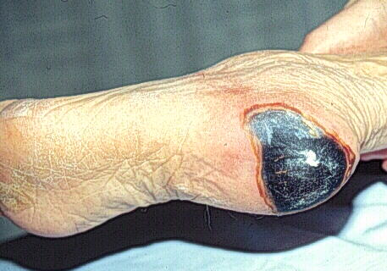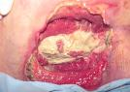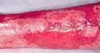

Granulation Tissue and Slough

Eschar

**Eschar** - Black, brown, dry, nonviable (necrotic) tissue, usually darker in color, thicker, hard, caused by tissue death. No blood flow. Flush with level of skin.

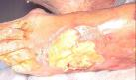

Slough

**Epithelial tissue -** The outermost layer of our skin is composed of epithelial cells, as wounds heal epithelial tissue regenerates across the wound surface from the edges to close the wound.

* Deep pink to pearly pink.

Maceration

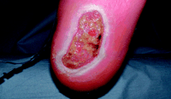

* Light purple from edges in full thickness wounds.
* May form islands in superficial wounds

**Granulation tissue -** New tissue that replaces the dead tissue in healing wounds.

* Beefy deep red irregular surface; puffy or mounded bubbly appearance
* Typically grows from the base of a wound and is able to fill wounds of almost any size it heals.

**Maceration -** occurs when the surrounding skin retains

too much moisture, causing it to soften and turn white.  
**Muscle -** pink to dark red, firm, highly vascularized (heavily endowed with blood vessels and thus richly supplied with blood), striated (not shown)

**Necrotic Tissue** - non-viable (Not capable of living or developing) dead (not shown)

**Slough (fibrin) -** yellow, green, grey, nonviable (necrotic) tissue, usually lighter in color, thinner, wet stringy; caused by tissue death- no blood flow

**Tendon -** gleaming yellow or white, shiny when healthy, strong fibrous tissue, attaches muscle to bone (not shown)

**Bone -** Shiny, smooth, milky white appearance when healthy (not shown)

References

Bowler, P., Jones, S., Parsons, D. & Walker, M. (2004). Microbial properties of a silver-containing hydrofiber dressing against a variety of burn

wound pathogens. Burn Care Rehabilitation, Mar-Apr; 25(2), pg. 192-196.

DeMoucell, P., White, J., & Oakes, D. (2008). Reduction of hospital acquired pressure ulcer prevalence after implementation of evidence

based best practices... Scientific and clinical abstracts from the 40th Annual Wound, Ostomy and Continence Nurses Annual Conference. Journal Of Wound, Ostomy & Continence Nursing, 35(3S), S34-5.

International consensus. Appropriate use of silver dressings in wounds. An expert working group consensus. London: Wounds International,

2012. retrieved from www.woundsinternational.com

Michael Kirby. (2007). Negative Pressure Wound Therapy. British Journal of Diabetes and Vascular Disease.7(5):230-234.

National Pressure Advisory Panel & European Pressure Advisory Panel. (2009). International Guideline Pressure Ulcer Treatment Report.

Retrieved from http://www.npuap.org/wp-content/uploads/2012/03/Final-2009-Treatment-Technical-Report1.pdf

National Pressure Advisory Panel & European Pressure Advisory Panel.(2009).Pressure Ulcer Prevention Quick Reference Guide. Retrieved

from http://www.npuap.org/wpcontent/uploads/2012/03/Final_Quick _Prevention_for_web_2010.pdf

National Pressure Advisory Panel & European Pressure Advisory Panel.(2009).Pressure Ulcer Treatment Quick Reference Guide. Retrieved

from http://www.npuap.org/wpcontent/uploads/2012/03/Final_Quick _Treatment_for_web_2010.pdf

Smith and Nephew. (2013) Wound care product descriptions. http://www.smith-nephew.com/us/professional/products/all-products

The National Pressure Ulcer Advisory Panel. (2007). NPUAP Pressure Ulcer Stages Categories. Retrieved from http://www.npuap.org

/resources/ The Wound Healing Society. (2007). Chronic Wound Care Guidelines. Retrieved from http://www.woundheal.org/

assets/documents/final% 20pocket%20guide%20treatment.pdf

Thomas, S, (1997) Compression bandaging in the treatment of venous leg ulcers. Retrieved from http://www.worldwidewounds.com/1997/

september/Thomas-Bandaging/bandage-paper.html

WoundSource, (2010). Arterial Ulcers and Wound Care: Symptoms, Causes, Treatments and Risks. http://www.woundsource.com

WoundSource, (2010). Venous Ulcers and Wound Care: Symptoms, Causes, and Treatments. http://www.woundsource.com

Wounds1.(19-May-04).Cadexomer Iodine Gel. Retrieved from http://www.wounds1.com/care/procedure20.cfm/14

NSER 357

Eschar to Heel

**STAGING PRESSURE ULCERS**

**Stage I: Non-blanchable redness of intact skin**

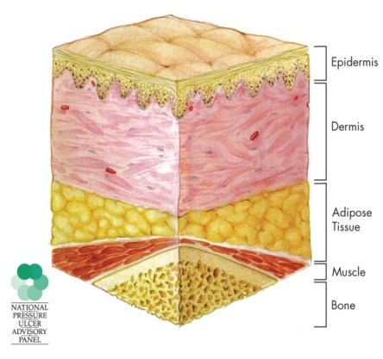

At right is normal skin. Below is stage 1 pressure ulcer. Intact skin with non-blanchable erythema usually over a bony prominence. Discoloration of the skin, warmth, edema, hardness or pain may also be present. Darkly pigmented skin may not have visible blanching.

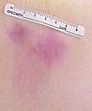

**Further description:** The area may be painful, firm, soft, and warmer or cooler compared to adjacent tissue. Stage I may be difficult to detect in individuals with dark skin tones. These patients are at high risk for further breakdown.

Stage 1

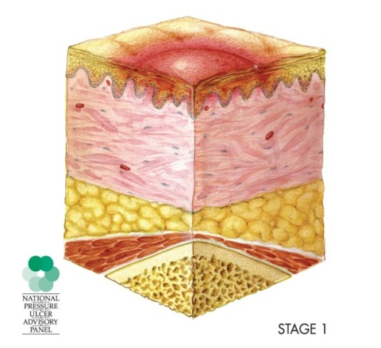

**Stage II: Partial thickness skin loss or blister.** Partial thickness loss of dermis presenting as a shallow open ulcer with a red pink wound bed, without slough. May also present as an intact or open/ ruptured serum-filled or sero-sanguineous filled blister.

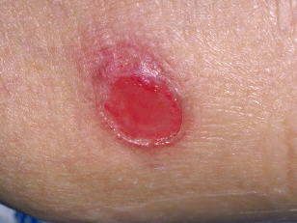

**Further description*:***

Presents as a shiny or dry shallow ulcer without slough or bruising.

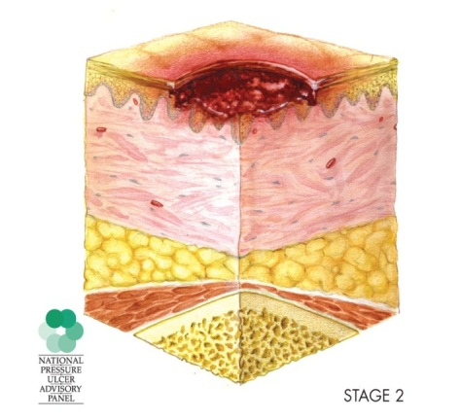

Stage II should not be used to describe skin tears, tape burns, incontinence associated dermatitis, maceration or excoriation.

Stage 2

**Stage III: Full thickness skin loss (fat visible)**

Full thickness tissue loss. Subcutaneous fat may be visible but bone, tendon or muscle is *not* exposed. Some slough may be present. May include undermining and tunneling.

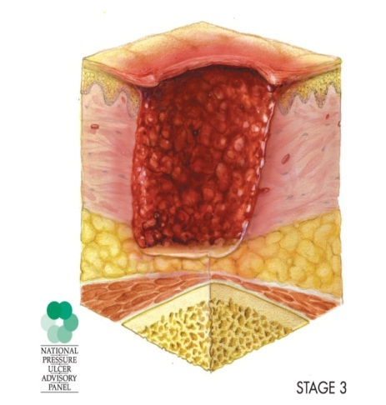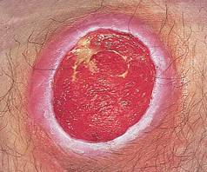

**Further description:** The depth of a Stage III pressure ulcer varies by anatomical location. The bridge of the nose, ear, occiput and malleolus do not have subcutaneous tissue and Stage III ulcers can be shallow. Areas with large amounts of subcutaneous tissue can develop extremely deep Stage III pressure ulcers.

Stage 3

Bone/tendon is not visible or directly palpable.

**Stage IV: Full thickness tissue loss (muscle/bone visible)**

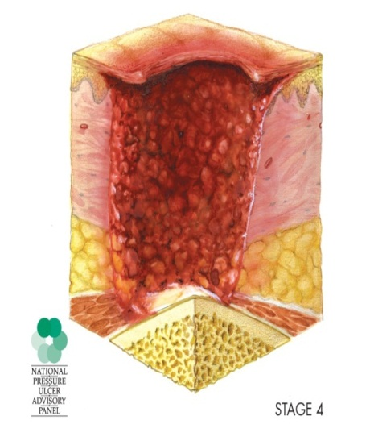

Full thickness tissue loss with exposed bone, tendon or muscle. Slough or eschar may be present. Often include undermining and tunneling.

Stage 4

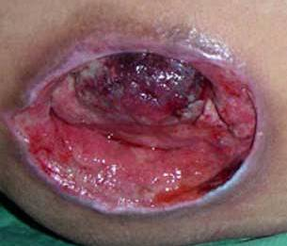

**Further description:**The depth of a Stage IV pressure ulcer varies by anatomical location. The bridge of the nose, ear, occiput and malleolus do not have subcutaneous tissue and these ulcers can be shallow.

Stage IV ulcers can extend into muscle and supporting structures (fascia, tendon or joint capsule) making **osteomyelitis** (infection of bone) or **osteitis** (inflammation of bone) likely to occur.

Exposed bone/muscle is visible or directly palpable.

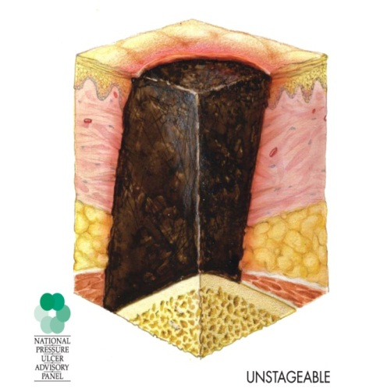

**Unstageable: Full thickness skin or tissue loss – depth unknown**

Full thickness tissue loss in which actual depth of the ulcer is completely obscured by slough (yellow, tan, gray, green or brown) and/or eschar (tan, black)

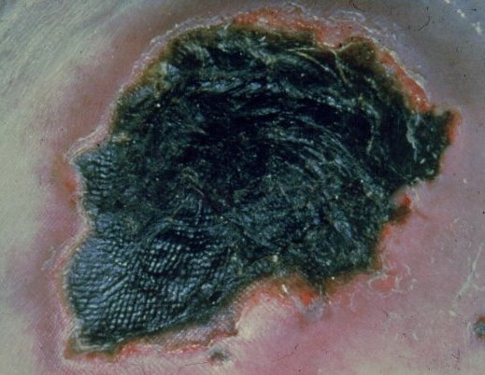

**Further description:**Until enough slough and/or eschar are removed to expose the base of the wound, the true depth cannot be determined but it will be either a Stage III or IV.

Unstageable

Stable eschar is dry and intact without erythema (redness) or fluctuance (boggy sensation over puss filled area).

Do not remove stable eschar from the heels.

**Suspected Deep Tissue Injury - depth unknown** Purple or maroon localized area of discolored intact skin or blood-filled blister due to damage of underlying soft tissue from pressure and/or shear.

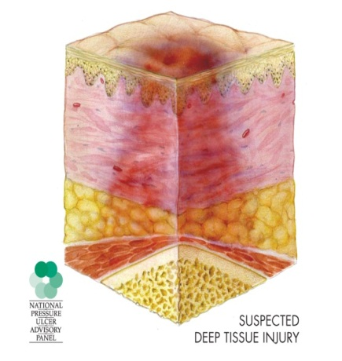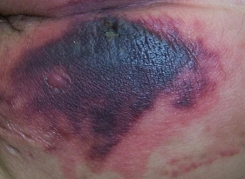

**Further description:**The area may be preceded by tissue that is painful, firm, mushy, boggy, warmer or cooler as compared to adjacent tissue.

Suspected Deep Tissue Injury

Deep tissue injury may be difficult to detect in individuals with dark skin tones.

Evolution may include a thin blister over a dark wound bed.

The wound may further evolve and become covered by thin eschar. Evolution may be rapid exposing additional layers of tissue even with treatment. Deep tissue injury above can often resemble a stage 1 pressure ulcer at first glance.

**STAGING DIABETIC FOOT ULCERS (Wagner Grading Scale)**

* **Grade 0** Pre-ulcerative lesions; healed ulcers; presence of bony deformity (not shown)
* **Grade 1** Superficial ulcer. Disruption of skin without penetration of the subcutaneous fat layer. Superficial infection with or without cellulitis may be present.
* **Grade 2** Penetration through the subcutaneous tissue: may expose bone, tendon, ligament, or joint capsule. No abscess or Osteomyelitis
* **Grade 3** Deep ulcer with abscess, Osteitis, or Osteomyelitis.
* **Grade 4** Gangrene of the toes, forefoot or heel. The remainder of the foot is salvageable though it may be infected.
* **Grade 5** Gangrene or necrosis to the entire foot to the extent that the foot will require amputation.

Wagner 2

Wagner 3

Wagner 5

Wagner 4

Wagner 1

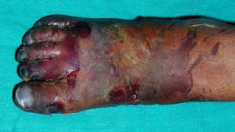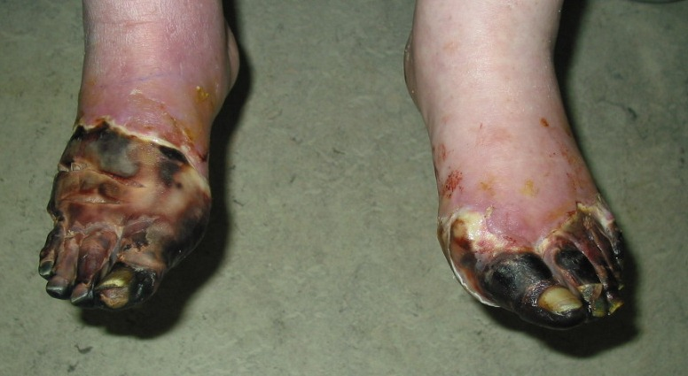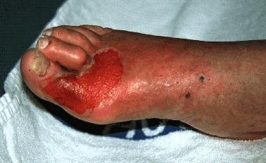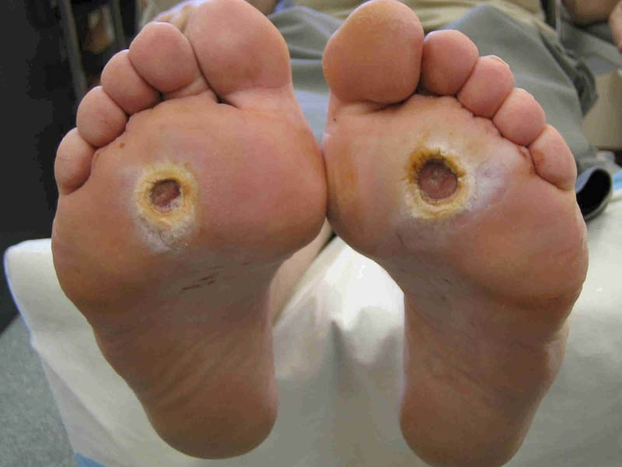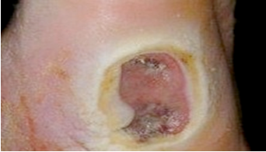

**VENOUS ULCERS (Stasis Ulcers)**

* Malfunctioning venous valves cause pressure in the veins to increase and blood pooling.
* occurs along the medial distal (inner and lower) leg resulting in [edema](http://www.woundsource.com/article/overview-edema) and skin breakdown

**Location**

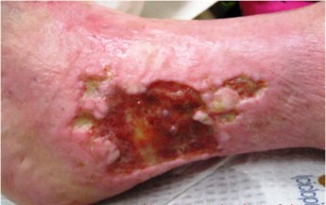

* Medial lower leg
* Ankle
* Superior to medial malleolar area

**Clinical Presentation**

* Large, shallow, irregular wound
* Superficial wound
* Ruddy granular tissue
* Painless to moderate pain

Venous (stasis) Ulcers

* Increased pain with infection or edema
* Exudate moderate to heavy
* Surrounding skin scaling weepy
* Elevation of the limb will help to relieve discomfort and swelling.

**Treatment**

* Debridement to remove dead tissue and surface contamination
* Maintain moist wound bed
* [Compression bandage](http://www.woundsource.com/product-category/compression) - only be used in patients without significant arterial disease.
* Obtain ankle brachial index (ABI) prior to initiating compression therapy

**ARTERIAL ULCERS (Ischemic Ulcers)**

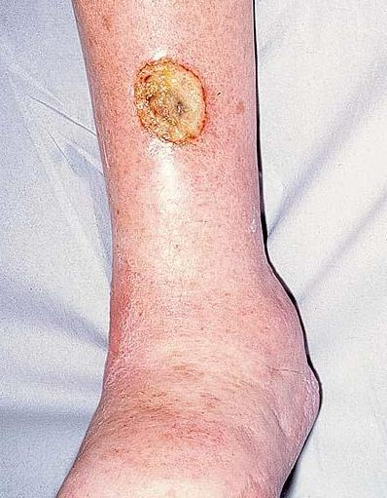

* Arterial ulcers are very painful
* Caused by poor perfusion to the lower extremities

**Location**

* Between or on the tips of the toes
* On the outer ankle
* Where there is pressure from walking or footwear

**Clinical Presentation**

Arterial Ulcers

* Well-defined, even wound margins (punched-out look)
* The wounds are deep, often extending down to the underlying tendons,

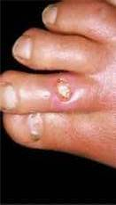

* Base of wound is yellow, brown, grey or black and usually does not bleed.
* The leg may be cool or cold to the touch
* Weak or no palpable pulse.
* hair loss, shiny, thin, dry, and taut appearance
* Very painful, especially while exercising, at rest, or during the night.
* A common source of temporary relief from this pain is dangling the affected legs over the edge of bed while sitting, allowing gravity to aid blood flow to the ulcerous region.

**Treatment:**

* Keep the wound as dry as possible
* Ischemic wounds differ from other wounds in that the wound bed should be as dry as possible to decrease the risk of infection.
* [***Cadexomer iodine***](http://www.woundsource.com/product/iodoflex-pad-absorbent-antimicrobial) absorbs drainage and releases iodine to kill bacteria in the wound.

**In general, wounds heal best when the wound bed is moist. Arterial Ulcers are the exception as they should be kept dry.**

**WOUND CARE TREATMENT BASICS**

**Prevention is the best treatment for pressure ulcers**

* Utilize Stryker beds – medsurg beds have a gelfoam mattress and are suitable for most pressure ulcers
* Use only flat pull sheet and paper chuck on patients
* Avoid use of diapers when patients are in bed
* Turn patients with limited mobility Q2 hours
* Elevate heels off bed on pillows (foam heel protector socks do not prevent breakdown of heels)
* Nutrition and physical therapy consult for all patients with Braden score ≤ 18, and for any existing wounds (diabetic, venous, arterial).
* Begin diet specific nutritional supplements bid: Regular – Ensure, Consistent carb – Glucerna, Renal with CKD only- Suplena, Renal on dialysis– Nepro, Clear Liquid – Ensure clear

**Dressing a wound**

* Always cleanse the wound bed and the area around the wound with dermal wound cleanser (preferred because it kills bacteria on surface of the wound and surrounding skin), or saline.
* Wounds heal best when moist. Wounds too wet or too dry can slow the healing process and actually cause a wound to worsen.
* Allevyn foam may be used as the primary dressing on superficial wounds.
* DO NOT COVER WOUNDS THAT HAVE ANY DEPTH WITH ONLY AN ALLEYN DRESSING.
* Wounds with any depth at all must be packed with the appropriate dressing. All surfaces of a wound must be in contact with the dressing media to promote healing.
* Cut dressings to fit within the borders of the wound to prevent maceration of the surrounding skin.
* Wounds should remain moist to promote optimal healing. Aquacel and Aquacel Ag (for infected wounds) are preferred because they can be placed moistened into a dry wound or placed dry into a wet wound.
* Allevyn foam dressings absorb excess drainage and help maintain moisture in a wound. Foam dressings make a good cover over other dressings packed in wounds. Change the dressing when saturated.
* If wounds are bleeding, Algesite is preferred over Aquacel because it promotes haemostasis.
* Iodosorb (Cadexemer Iodine) is best for wounds with high drainage with or without infection.
* Arterial ulcers are the exception to moist wound healing. They should be kept dry to prevent infection. Dry Aquacel or Iodosorb may be used.

**Gauze Dressings**

* Avoid use of gauze dressings for clean, open pressure ulcers.
* Painful debridement when removed dry. Moisten prior to removal.
* When other forms of moisture-retentive dressing are not available, ulcers with large tissue defects and dead space should be loosely filled with saline-moistened gauze (wet to dry), rather than tightly packed, to avoid creating pressure on the wound bed.
* Change gauze packing frequently to promote absorption of drainage.
* Use a single gauze strip/roll to fill deep ulcers; do not use multiple single gauze dressings, because retained gauze in the ulcer bed can serve as a source of infection .
* Consider using impregnated forms of gauze (such as Iodosorb) to prevent evaporation of moisture from continuously moist gauze dressings.
* Increased infection rates, Retains dressing particles
* Primarily used as surgical dressings.
* **Typically changed daily, unless wet to dry, then changed q 8 hours or more frequently per physician order to avoid dressing from drying out.**

**Transparent Film Dressings (opsite)**

* Consider using film dressings to protect body areas at risk for friction or tape injury.
* Do not use film dressings on wounds with moderate to heavy drainage
* Do not use film dressings as the cover dressing over enzymatic debriding agents, gels, or ointments

|  |
| --- |
| **HYDROFIBER (Aquacel)** Hydrofiber dressings gel upon contact with moisture and maintain moisture in the wound bed to promote healing.  **Treatment for:** Any wound with depth.Pressure ulcers, partial and full thickness wounds, diabetic, arterial, venous ulcers, and surgical wounds left to heal by secondary intention.  **How to use:** Cleanse wound with Dermal wound cleanser (preferred), or sterile saline. Cut to fit inside wound bed to prevent the wound edges from becoming macerated. Apply dry to wet wounds and moisten with sterile saline, or sterile water if wound bed is dry to **maintain a moist wound** environment.  **Cover with a foam dressing. Change every 2-3 days and PRN if saturated** |
| **HYDROFIBER with** **SILVER (Aquacel Ag).** Hydrofiber dressings containing silver are for short term use in wounds that are infected. It is a surface antimicrobial agent intended for use in conjunction with antibiotic therapy.  **Treatment for *infected wounds*:** Any wound with depth.Pressure ulcers, partial and full thickness wounds, diabetic, arterial, venous ulcers, and surgical wounds left to heal by secondary intention.  **How to use:** Cleanse wound with Dermal wound cleanser (preferred), or sterile saline. Cut to fit inside wound bed to prevent the wound edges from becoming macerated. Apply dry to wet wounds and moisten with sterile saline, or sterile water if wound bed is dry to **maintain a moist wound** environment.  **Cover with a foam dressing. Change every2-3 days and PRN if saturated**  **Re-evaluate use of silver dressing** **after 2 -3 weeks**. Notify physician if wound not healing. Discontinue no sign of infection present. |
| **CALCIUM ALGINATE (Algesite).** Maintains moisture in the wound bed to promote healing. Preferred treatment for bleeding wounds as it promotes haemostasis  **Treatment for *infected wounds*:** similar to hydrofiber intreatment of moderate to heavily draining wounds. **Preferred treatment for bleeding wounds.** Pressure ulcers, partial and full thickness wounds, diabetic, arterial, venous ulcers, and surgical wounds left to heal by secondary intention.  **How to use:** Cleanse wound with Dermal wound cleanser (preferred), or sterile saline. Cut to fit inside wound bed to prevent the wound edges from becoming macerated. Apply dry to moderate to high exudate wounds. Forms a soft gel as it absorbs wound drainage. Change dressing more frequently if dressing is dry at the scheduled dressing change. Cover with a foam dressing.  **Cover with a foam dressing. Change every 2-3 days and PRN if saturated** |
| **FOAM DRESSING (Allevyn) Adhesive and non-adhesive.** Made of polyurethane foam that absorbs excess drainage to keep wound moist. Foam dressings are available in adhesive and non-adhesive forms, use non adhesive when possible, such as leg ulcers and secure with gauze roll.  **Treatment for:** Shallow wounds such as stage 2 pressure ulcers, partial-thickness wounds and skin tears, diabetic foot ulcers, venous stasis ulcers. **Change every 2-3 days and PRN if saturated.** |
| **HYDROGEL (Solosite Wound Gel).** Creates a moist wound environment, which re-hydrates necrotic tissue, loosens slough, assists autolytic debridement, absorbs wound drainage.  **Treatment for:** Minor burns, superficial lacerations, partial-thickness wounds and skin tears, venous stasis ulcers, surgical incisions, diabetic foot ulcers, pressure ulcers.  **How to use:** Cleanse wound with Dermal wound cleanser (preferred), or sterile saline. Apply a thick coating to wound bed. Apply on dry to low exudate wounds. Cover with foam dressing and change Q 3 days or cover with gauze and change daily. |
| **CADEXOMER IODINE GEL (IODOSORB)** For use in cleaning wet ulcers and wounds. Best for infected and non-infected wounds that have heavy drainage. Reduces foul odor in infected wounds. Promotes moist healing. Conforms to the shape of the wound.  **Treatment for:** Infected and non-infected heavily draining wounds, second-degree burns, venous stasis ulcers, diabetic foot ulcers, pressure ulcers, infected traumatic and surgical wound.  **How to use:** Use dermal wound cleanser or sterile saline to clean wound. Apply small amount on sterile gauze and place in wound bed. Gel will expand as it absorbs moisture. Avoid use in large-cavity ulcers that require frequent (daily) dressing changes. Cover with foam or gauze dressing. Change daily and PRN if saturated, or when the color of the product changes from brown to yellow or gray.  **Precautions:** Iodine allergy, history of any thyroid disorder (such as Graves Disease, Hashimoto's Thyroiditis, goiter), potential for interaction with the following drugs: Lithium, Sulphafurazoles – anti infectives, Sulphonylureas - Diabinese (chlorpropamide), Amaryl (glimepiride), Glucotrol (glipizide), DiaBeta, Micronase (glyburide). Pregnant or lactating women. |
| **Collagenase (SANTYL).** Ointment is for debriding wounds. Ointment cleans dead tissue from wounds.  **Treatment for:** Pressure ulcers, diabetic ulcers, venous ulcers, severe burns.  **How to use:** Cleanse wound with Dermal wound cleanser (preferred), or sterile saline. Apply thin layer to wound bed "nickel-deep" (the thickness of a nickel lying flat). Cover with foam or gauze dressing and change dressing daily  Ointment should be discontinued when debridement is complete and granulation tissue is well established. Santyl is a prescription medication and is available from the pharmacy with a physician order. |
| **COMPRESSION BANDAGE** (**Profore)** Used for high compression or lite ccompression. These are available in central supply on 1st floor. Always obtain a physician order.  **Change weekly** . A newly applied dressing may need to be changed every 3-4 days due to heavy drainage. Check ABI before initiating on patient who has not worn them before.  **High Compression Bandage ABI >0.8**  Use all four(4) rolls in Profore kit. Instructions are included in package.  **Lite Compression Bandage ABI >0.6 – 0.8**  Use rolls #1, #2, and#4 in Profore kit. Omit roll #3.  Rolls #3 and #4 are what provide compression. Note: Roll #3 uses a figure 8 pattern up the leg. Roll #4 uses a standard 50% overlap up the leg.  They are applied with a 50% stretch as you wrap them (extend wrap distance to fully stretch fabric then return half that distance, that is 50% stretch).  **How to measure ankle-brachial index (ABI):** Obtain SBP from both arms with patient in a relined or supine position and use higher of 2 systolic pressures. Next obtain ankle systolic by inflating a manual cuff and using a Doppler to listen for the return of pulse as balloon is deflated.  ABI = Systolic of ankle ÷ systolic of arm |

**NEGATIVE PRESSURE WOUND THERAPY (NPWT) – wound vac**

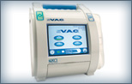

Treatment for:

* Most suitable for large, chronic, heavily draining wounds
* Treatment of deep, Category/Stage III and IV pressure ulcers.
* Treatment of non-healing diabetic foot ulcers.

How to use:

* Debride the wound of necrotic tissue prior to the use of NPWT
* Dressings are changed every Monday, Wednesday and Friday
* Use granufoam in the wound bed and white foam in any areas where there is tunneling or undermining
* Evaluate the wound with each dressing change and measure the wound
* Wound VAC is preset to 125 mm/hg continuous suction
* Ensure seal check is green (low)
* Remove dressing if Wound VAC seal lost for more than two hours and apply a moist gauze dressing.
* For pain, lower the pressure level, or change from continuous or intermittent suction
* Note drainage amount on canister and record Q shift in wound vac section of LDAW
* Patients requiring NPWT at home will have one provided through care management
* If the patient is going to another facility, or if a wound vac will be delivered to home at a later date, remove vac dressing and apply a moist sterile gauze dressing to site
* DO NOT SEND THE HOSPITAL UNIT HOME WITH THE PATIENT
* A home wound vac is available for patients going home. Contact care management.

Canister Granufoam White Foam Trac pad

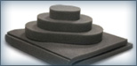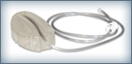

Adhesive Drape



NPWT must be ordered by a physician. One wound vac is located in central supply, if it is not available, contact the patient educator, or nursing supervisor.

References

NSER 357

**Bed Selection Decision Algorithm**

**Reason: Bariatric Patient:**

**Medsurg > 500# Critical Care > 550 #**

**Reason: Pressure Ulcer Treatment**

**Is pressure ulcer a non-healing Stage 3 or a stage 4?**

**Does the patient weigh <500# ? Use Stryker Medsurg or Critical Care Beds**

**NO**

**YES**

**Contact Nursing Supervisor to see if the Oncology Bariatric bed is available**

**1000 # + air mattress for wound therapy. This bed is oversized. Check to see if it fits in room**

**Use Our Bariatric Bed for patients with and without pressure ulcers**

**Use Stryker beds weight limit:500#**

**YES**

**The patient requires a bariatric bed?**

**Does the patient weigh >350# ?**

**NO**

**NO**

**Stryker beds are preferred for patients with pressure ulcers. The beds in ICU have low air loss mattresses. The Beds on the floors have a gelfoam matrix. Use these beds for patients with skin breakdown.**

**Total Care Bariatric**

**500# wt limit**

**Clinitron Rite Hite Wt limit 350 #**

**Triflex Bariatric 1000#**

**Wt limit**

* **Special beds are tracked in nursing admin by the patient educator.**
* **Special beds need to be approved by the Patient Educator, the Nursing Supervisor, or the Nursing Admin Director.**
* **Even if a special bed or mattress is ordered by a physician, it must still be approved for use as the physician may not be aware of the specifications of beds available within the hospital.**
* **Notify the Patient Educator, or Nursing Supervisor, when a bed is discontinued.**

Venous Thromboembolism (VTE) prophylaxis and Sequential Compression Device (SCD)

**Venous Thromboembolism (VTE)** prevention includes the administration of thrombolytic medications and the use of sequential compression devices (SCD).

**Causes**

* Prolonged sitting, such as during a long plane or car ride, or prolonged bed rest
* Recent surgery, especially orthopedic, GYN, or heart surgery
* Recent trauma to the lower body, such as fractured hip, thigh or lower leg
* Obesity
* Heart attack or heart failure
* Recent childbirth
* High altitude > 14,000 feet
* Use of estrogen or birth control pills
* Cancer
* Rare inherited genetic blood clotting factors
* DIC
* Certain heart or respiratory conditions
* Advanced age

**Low Risk**

* Under the age of 40
* Having minor surgery
* Treatment is to begin ambulation early

**Moderate Risk**

* Over the age of 40
* Having major surgery
* Treatment would include low molecular weight heparin BID, SCD’s, & ambulation as soon as possible

**High Risk**

* Patients having major surgery, especially of abdominal, orthopedic or genitourinary
* Treatment would include heparin, Coumadin, SCD’s and ambulation as soon as possible

**Sequential Compression Device**

SDC’s are used as an adjunct in the prevention of Deep Vein Thrombosis (DVT) and Pulmonary Embolism (PE). There are two different prophylactic methods with one controller; leg compression and foot compression

**Leg Compression**

The use of the Leg Sleeves is indicated for:

* Deep vein thrombosis
* Pulmonary embolism prophylaxis.

**Foot Compression**

The use of the Foot Cuffs is indicated for:

* Circulation enhancement.
* Extremity pain incident to trauma or surgery.
* Deep vein thrombosis prophylaxis.
* Leg Ulcers.
* Edema - Acute.
* Venous stasis / venous insufficiency.
* Edema - Chronic.

**SCD Contraindications:**

**Leg Compression**

* Leg condition in which the sleeves may interfere, such as: dermatitis, vein ligation, gangrene, or recent skin graft.
* Severe arteriosclerosis or other ischemic vascular disease.
* Massive edema of the legs or pulmonary edema from congestive heart failure.
* Extreme deformity of the leg.
* Suspected pre-existing deep venous thrombosis.

**Foot Compression**

* Conditions where an increase of fluid to the heart may be detrimental.
* Congestive heart failure.
* Pre-existing deep vein thrombosis, thrombophlebitis or pulmonary embolism.
* Use with caution on the infected extremity.

**Venous Thromboembolism (VTE) prophylaxis**

* Patients should be evaluated for venous thromboembolism risk on admission, change in level of care, and prior to discharge
* Patients should have proper education regarding VTE risk, signs and symptoms, and treatment.
* Patients at high risk of VTE should receive anticoagulation prophylaxis, such as heparin or lovenox, unless contraindicated.
* All patients at moderate to high risk of VTE should have anticoagulation prophylaxis. SDC’s are recommended if anticoagulation prophylaxis is contraindicated
* All patients should be encouraged to ambulate as early and as frequently as possible.
* Precautions should be taken for patients receiving spinal or epidural anesthesia to reduce the risk of epidural perispinal hematoma from anticoagulant prophylaxis.
* The need for post-discharge anticoagulation should be assessed as some patients are risk of VTE development after discharge.
* SCD's should be used primarily in patients at high risk of bleeding.
* Antiembolism stockings (TED hose) provide very little compression (ankle 15 mm Hg, calf 8 mm Hg) are designed for non-ambulatory patients.
* To prevent bleeding, low risk procedures may require only early ambulation or intermittent pneumatic compression devices for deep vein thrombosis (DVT) prophylaxis.
* Anticoagulant prophylaxis may be contraindicated, require decreased dosing, or make one agents preferred over another.
* Heparin is recommended over low-molecular-weight heparin due to its lower reliability in patients with renal insufficiency.

References

Institute for Clinical Systems Improvement (ICSI). Venous thromboembolism prophylaxis. Bloomington (MN):

Intake and Output

Important things to monitor:



* Any PO intake
* Any IV intake ( Clear pumps every 4 hours)
* Any Output (voiding, foley, emesis, etc)
* JP drain Output
* Chest tube drainage

**Complete I&O every 4 hours.** If there is nothing to document, do not leave blank, please put “0”. It is very important for the doctor to see what is being retained and how much is being eliminated.

Important diagnoses for I & O’s:



* Congestive Heart Failure
* Renal Failure
* SIADH
* DI
* Dehydration
* Over hydration
* Pulmonary Edema

**\*Daily weights** are also an important part of intake and output assessment. If weight has increased there may be a correlation to intake and output.

Hyper/hypothermia System

**Warming/Cooling Blanket**



Warming and cooling a patient in Automatic Mode, Manual Mode, or Monitoring Mode.

Used to treat hypothermia, febrile patients unresponsive to antipyretics and for therapeutic hypothermia after cardiac arrest.

This unit comes with a rectal probe to monitor core temperatures during therapy. The cooling blanket is for single patient use and is disposable. Available in central supply.

Monitor vital signs typically every 15 minutes and turn patients every 2 hours. Observe for skin and tissue injury especially when in cooling mode.



**Aqua K Pads**

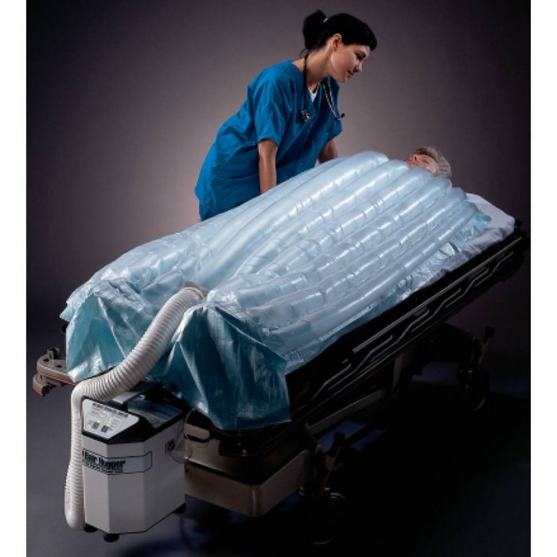

This is a small portable unit that is similar to the larger unit. Warm water filled pads provide patients with heat therapy. They provide dry heat or moist heat by placing a moist towel between patient and Aqua K pad. Apply for no more than 20 minutes each hour and monitor skin and tissue for injury during therapy. Available in central supply

**Bair Hugger Warming Blanket**

Bair Hugger is an air filled warming blanket that Is used to treat hypothermia and to rewarm patients after surgery. Monitor vital signs every 15 minutes during therapy. Kept in the ER, OR and ICU.

Telemetry and Cardiology

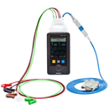

**Telemetry Boxes**

* Everyone placed on telemetry will get a monitor. These monitors also have continuous pulse oximetry capability.
* The nurse will get a box from the telemetry monitor tech for the assigned patient and place the patient on this box. The leads are color coded, below is how the leads should be attached.
* You will be able to see the patient’s rhythm right on the screen. It will go to sleep mode, but if you press on the blue button at the bottom right it will come back on to view.

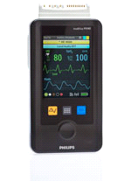

* If patient is off the monitor for any reason, the nurse will need to notify the monitor tech @ 36009.
* Patients with acute cardiac issues will be placed on the sixth floor (PCU)

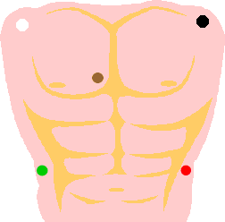

* A patient with a history of a cardiac issue, but is **NOT** admitted for the cardiac issue, may be placed on another floor with a remote monitor.
* The Telemetry floor currently has someone watching all of these monitors. If the patient is being monitored on another floor, we will call down to the floor with any cardiac changes and if needed a telemetry nurse will come down and assist
* Every four hours our monitor techs will interpret and document the rhythm. The telemetry strips are placed in the chart. If another floor is being monitored the monitor tech will call the floor and let them know telemetry strips are ready to be picked up.

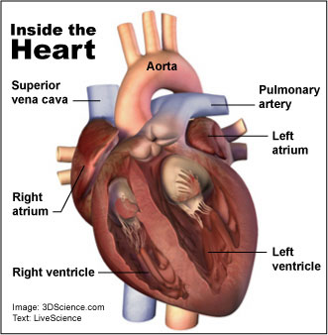

**Cardiac Review**

The heart is made up of 4 chambers:

**Atrium (Left and Right) -** “Holding Chambers” for blood from the atria allowing blood to flow down into the ventricles

**Ventricles (Left and Right) -** Contract and pump

blood out of heart

**4 Valves in the heart**- help the flow of blood through the heart and prevents backflow

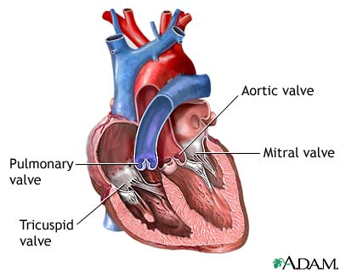

* ***Tricuspid Valve***- In between the right and left ventricle
* ***Pulmonic Valve***- In between the right ventricle and the pulmonary artery
* ***Mitral Valve***- In between the left Atrium and left ventricle
* ***Aortic Valve***- In between the left ventricle and aorta

Flow of blood through the heart:

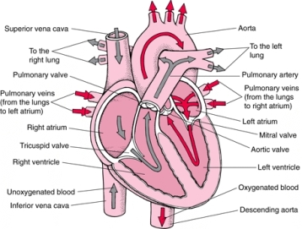

Blood from body (Deoxygenated)-> Superior/inferior vena cava-> Right Atrium -> Tricuspid Valve -> Right Ventricle -> Pulmonic Valve -> Pulmonary artery -> Lungs (Oxygenates Blood) -> Pulmonary Veins -> Left Atrium -> Mitral Valve -> Left Ventricle -> Aortic Valve -> Aorta -> Systemic Circulation

**Myocardial Infarction**

Coronary Arteries: Arteries that branch off of the aorta. Heart muscle receives oxygenated blood from coronary arteries.

When the coronary arteries become blocked:

* Heart does not receive needed oxygen (*Ischemia*)
* Can lead to death of cardiac tissue (*Infarction*)
* Lessens the ability of heart to pump adequately
* Can cause heart rhythm dysrhythmias

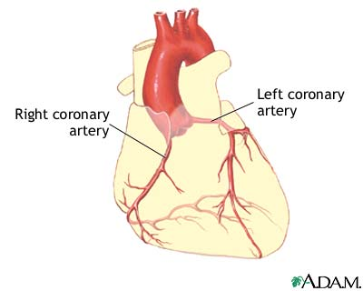

Symptoms

* Chest Pain/Pressure(“Heavy”, “Squeezing”)
* Pale, cold, sweating
* Left arm pain radiating to neck, jaw, back or shoulders
* Nausea, vomiting
* Confusion

Plan of care

* Assess patient- Vital signs, Level of consciousness, etc
* Provide oxygen (usually 2 liters/min)
* Maintain IV access
* Notify MD
* 12 lead EKG

Common medications used

* Morphine-Pain
* Nitroglycerin- Relieves chest pain-relaxes smooth muscle tissue and Increases circulation of oxygen in blood
* Aspirin- Thins the blood

**Common Dysrhythmias**

**Sinus Bradycardia** - Heart rate <60bpm (usually patient does not become symptomatic until <50bmp)

* Can be symptomatic or asymptomatic

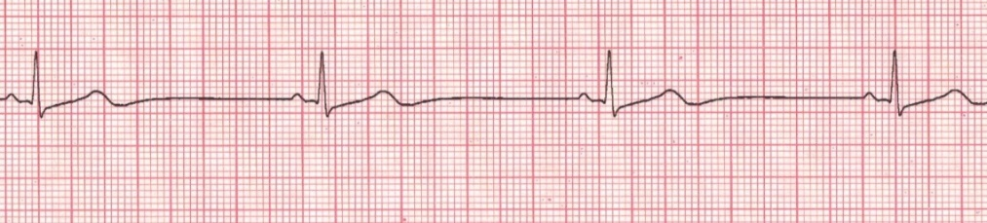

* Signs/Symptoms:
  + Shortness of breath
  + Dizziness “Light-headed”
  + Hypotension
  + Altered mental status
  + Diaphoresis
* Plan of Care:
  + Assess the patient-
  + Provide oxygen(Usually 2 liters/min)
  + Obtain vital signs
  + Maintain IV access
  + Obtain EKG (if there was a rhythm change)
  + Notify MD if this is a change in rhythm
  + Obtain 12 lead EKG
* Common medications for symptomatic bradycardia:
  + Atropine- Increases heart rate

**Sinus Tachycardia** **-** Heart rate >100bpm (symptoms usually present when >125bmp)

* Can be symptomatic or asymptomatic

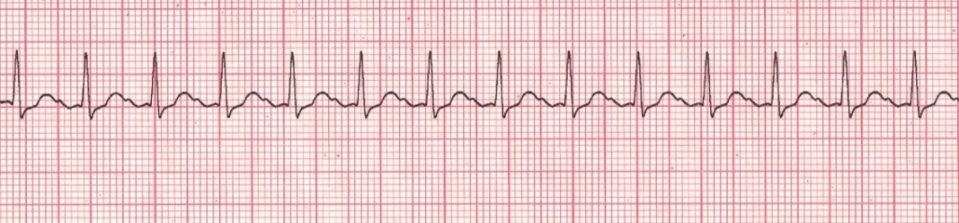

* Signs/Symptoms:
  + Ongoing chest pain
  + Altered mental status
  + Anxious
  + Shaking
* Plan of Care:
  + Assess patient- Symptomatic or asymptomatic
  + Provide oxygen (normally 2liters/min)
  + Retrieve vital signs
  + Maintain IV access
  + Evaluate reversible causes: Anxiety, Fever
  + Notify MD in this is rhythm change
  + Obtain 12 lead EKG

**Supraventricular Tachycardia** **-** Can be heart rate >200bpm

* Regular rhythm, rhythm is too fast to determine the underlining rhythm

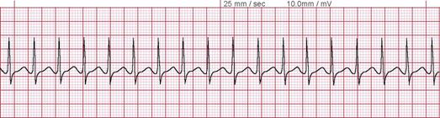

* Signs/Symptoms:
  + Rapid breathing
  + Sweating
  + Feels like “heart is beating out of chest”
* Plan of Care:
  + Assess patient- if unstable call rapid response
  + Retrieve vital signs
  + Provide oxygen (usually 2 liters/min)
  + Maintain IV access
  + Have patient “Bear down” like taking bowel movement (initiates vagal response)
  + Notify MD
  + Obtain 12 lead EKG
* Common medication used:
  + Adenosine- Slows down heart rate so we can evaluate underlying rhythm and treat

**Atrial Fibrillation** (Afib) - irregular heart rhythm due to atria quivering. Controlled rate <100

* Afib with rapid ventricular response (aka a fib with RVR, or rapid Afib) ventricular heart rate >100

**Notify physician if this is a rhythm change**

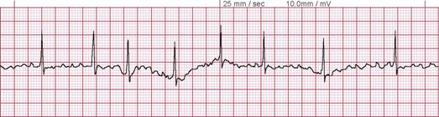

**Atrial Flutter**-Regular heart rhythm-“Saw tooth” pattern **Notify physician if this is rhythm change**

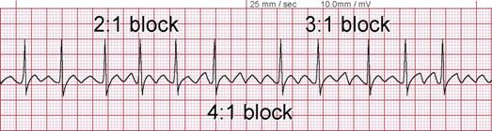

**Ventricular Tachycardia** - Heart rate >100bpm

* Dangerous because blood is not being pumped out of ventricles sufficiently to supply oxygen to the vital organs. The body cannot sustain this for long periods of time.
* Can be seen with a pulse and without a pulse. Important to assess patient first, then treat

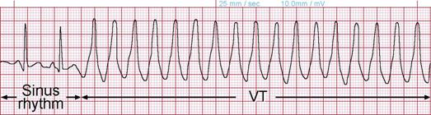

* With Pulse:
  + Retrieve vital signs
  + Maintain IV access
  + Treat symptoms and call MD
  + Symptoms: Altered mental status, Ongoing chest pain, Hypotension
* Pulseless V-Tach:
  + A **CODE BLUE** situation and CPR is to be initiated- Support Circulation, Airway, Breathing
  + Maintain IV access
  + Common medication used:
    - Epinephrine- Increases rate and force of contractions. Improves perfusion
* Possible contributing factors ( H’s & T’s)
  + - Hypovolemia
    - Hypoxia
    - Hypo/hyperkalemia
    - Hypoglycemia
    - Hypothermia
    - Toxins
    - Thrombosis (Pulmonary or coronary blood clot)
    - Trauma

**Ventricular Fibrilation**- Lethal Rhythm

*Quivering of the heart, irregular rhythm or waves

*No blood is circulating at this time, no oxygen to any vital organs

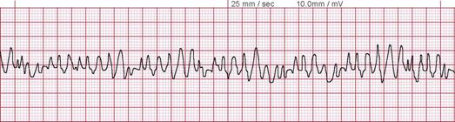

A pulse is never seen with this rhythm. Assess patient first before treating rhythm

* Call a Code Blue and initiate CPR- maintain Circulation, Airway & breathing
* Maintain IV access
* Common medication:
  + Epinephrine- Increases rate and force of contractions. Improves perfusion

**Asystole**- Lethal Rhythm.

*NO electrical activity “Flat line”. Assess patient first before treating rhythm

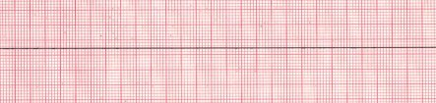

*Fine Ventricular Fibrilation can look like Asystole.

* Call a Code Blue and initiate CPR- maintain Circulation, Airway & Breathing
* Maintain IV access
* Common medications:
  + Epinephrine- Increases rate and force of contractions. Improves perfusion
  + Atropine-Increases heart rate

References:

Atwood, S., Stanton, C., & Storey, J. (1996). *Mosby, Inc*. St. Louis, MO: Mosby Lifeline ECG-A Pictorial Primer [med-online] (2008). Retrieved from:

http://www.medicine-on-line.com/html/ecg/e0001en_files/08.htm

Fields, J.M. (Eds.). (2010). *Advanced Cardiac Life Support*. Dallas, TX: American Heart Association.

Heart Failure

CHF is a weakening of the heart brought on by an underlying heart or blood vessel problem

* Pumping of the heart becomes less effective and blood does not circulate well causing congestion in the vessels, typically in the legs or the lungs.
* Pressure increases in the blood vessels and forcing water to be shifted from the blood vessels to the extracellular space in an effort to decrease the congestion.
* Heart failure can be either right sided or left sided, and classified as systolic or diastolic.

|  |  |
| --- | --- |
| Left-sided heart failure | Most common form of heart failure. Fluid may back up in your lungs, causing shortness of breath. |
| Right-sided heart failure | Often occurs with left-sided heart failure. Fluid may back up into your abdomen, legs and feet, causing swelling. |
| Systolic heart failure | The left ventricle can't contract vigorously, indicating a pumping problem. |
| Diastolic heart failure | The left ventricle can't relax or fill fully, indicating a filling problem.  (heart failure with normal ejection fraction) |

**Left Side Heart Failure:**

* The left side pumps less efficiently than the right side
* Fluid collects in the lungs causing pulmonary edema (right side pumps through lungs to left side) and left side cannot keep up with right side demand
* Breathing becomes more difficult

**Right Side heart failure:**

* The right side pumps less efficiently than the left side
* Fluid collects in the lower extremities (left side pumps through peripheral circulation to right side) and right side cannot keep up with left side demand
* Lower extremity edema present

**Systolic heart failure:**

* Pumping action of the heart is reduced, weakened
* Measured by ejection fraction

**Diastolic heart failure:**

* The heart contracts normally, but ventricle remains stiff and do not fully relax during diastole (a period when it should relax and fill with blood) This condition is referred to as diastolic dysfunction.
* Blood does not fill the ventricle fully and produces backflow usually into the lungs.
* This is more common in patients older than 75 years. Affects women more than men
* *Diastolic heart failure* is said to be present when diastolic dysfunction produces pulmonary congestion.

**Pumping action of the heart can be impaired by:**

* Cardiomyopathy: Heart becomes weak and does not contract or squeeze as well as it should
* Myocardial Infarction: Damage can lead to heart failure
* Hypertension: causes extra work on the left ventricle. The greater workload can damage the heart.
* Heart Valve Problems: Abnormal heart valves impede the forward flow in two ways
* Incompetent valve- does not close properly and allows blood to flow backwards; Heart must work harder to keep its output. Backed up blood accumulates in the lungs and body.
* Stenotic valve-does not open properly. Blood flow through narrowed opening increases workload of the heart.
* Irregular heartbeat: Abnormal heartbeat/rate lowers effectiveness of heart as a pump. If sustained heart can weaken

**Symptoms**

* Shortness of Breath (Dyspnea) - early symptom. Fluid backs up into the lungs and interferes with oxygen getting to the blood. Mostly at night (Orthopnea).
* Exercise intolerance-heart cannot pump enough blood to provide vital oxygen and nutrients to body
* Fluid retention and swelling- Puffy swelling (edema) in legs, feet, and ankles may occur. Pitting edema is common in heart failure. Non-pitting is NOT related. Daily Weight checks are mandatory!!! Fluid retention results in an increase in weight.

**Diagnosis**

* Chest X-Ray- Identifies heart enlargement and fluid buildup the lungs.
* B-type natriuretic peptide (BNP) - Produced at higher levels by the falling heart muscle. Increases as the severity of the heart failure worsens.
* Echocardiogram- provides an accurate measure of ejection fraction which is decreased in CHF.

**Medication**

Diuretics

* Most common medication for CHF. Kidneys remove excess salt and accompanying water from the bloodstream. This reduces blood volume from circulation
* Can lower potassium in body
* Common diuretics: furosemide (Lasix), bumetanide (Bumex), hydrochlorothiazide (hydroDIURIL), spironolactone( Aldactone)

Inotropes

* Stimulants (such as dobutamine & milrinone) increase the pumping ability of the heart. Temporary support of very weak left ventricle.

Digoxin (Lanoxin)-

* Improves pumping ability of the heart, causing it to pump more effectively. Digoxin helps relieve symptoms after vasodilators and diuretics have been tried.
* Used to control rhythm of the heart
* Excessive Digoxin can cause potentially dangerous abnormal heart rhythms

Ace Inhibitors-

* Lowers BP by enlarging the small arteries, which relieve the systolic workload of the left ventricle. ACE inhibitors are the most widely used vasodilators
* Block the production of the angiotensin II, which is high in CHF. This causes vasoconstriction with increased workload on the left ventricle, and it is directly toxic to the left ventricle.
* ACE inhibitors are important and have been shown to slow the progression of the heart damage, in some cases improving heart muscle function.
* ACE inhibitors include: captopril (Capoten), enalapril (Vasotec), lisinopril (Zestril/Prinivil), benazepril (Lotensin), quinapril (Accupril), fosinopril (Monopril), and ramipril (Altace)

Nitrates-

* Venous vasodilator that include isosorbide mononitrates (Imdur)
* Weaker that ACE inhibitors. used in combination with arterial vasodilator, such as hydralazine

Hydralazine (Apresoline) -

* Pure smooth muscle arterial vasodilator
* Especially valuable in patients who have poor kidney function and/or intolerant to ACE inhibitors

Beta-Blockers-

* Slow down the heart rate, lowers blood pressure and lessens workload of the heart.
* Beta-receptors are in the heart muscle and in the wall of the arteries.
* Blocks the action of norepinephine(vasoconstrictor) on the heart muscle

Natriuretic peptide-

* When the left and/or right ventricle are under excessive workload, excess BNP is excreted into the bloodstream
* BNP is already increased in CHF patients. Giving additional synthetic BNP lowers the pressure in the lungs and is a mild diuretic. This is excreted through the kidneys
* Example if medication used: nesiritide (Natrecor)

**Cardiac Discharge Contract**

**Follow-up Appointment**

All Heart Failure patients must have a follow up appointment within six (6) days of discharge made for them prior to discharge.

**Education**

Patients should receive education on the following:

* Heart failure disease process and treatment including notifying physician for increased shortness of breath or weight gain (2# in one day, or 5 # in one week)
* Checking daily weight at home
* Ejection Fraction (LVEF) results. One should be completed during current admission if not done within the past 90 days (normal LVEF >55%)
* Smoking cessation
* Cholesterol lab results
* Diet (low cholesterol & low salt)
* Regular exercise
* Follow up appointments
* Medications

**Medications**

Patients should have the following medications or noted contraindication.

* Aspirin
* Ace Inhibitor (alternatively an ARB)
* Beta Blocker
* Lipid Lowering agent
* Anticoagulant/ Antiplatelet
* Diuretic

Back Safety and Patient Transfers

It takes 10 pounds of pressure to lift a 10 pound object. Will it take more or less force to lift the same 10 pound object with the fulcrum shifted to one side?

When you add in the 105 pounds of the average human upper torso, lifting a 10 pound object puts 1,150 pounds of pressure on the human back.

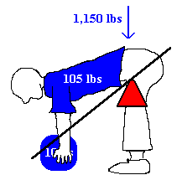

**How We Lift**

* *Plan ahead before lifting:* Clear a path and make sure both you a helper and the patient understand the plan.
* *Lift close to your bod*y**:** more stable lift if the object is held close to your body rather than at the end of your reach.
* *Feet shoulder width apart:* Keep the feet about shoulder width apart and take short steps.
* *Bend your knees and keep your back straight*: Focus on keeping you spine straight--raise and lower to the ground by bending your knees.
* *Tighten your stomach muscles:* Tightening your abdominal muscles will hold your back in a good lifting position.
* *Lift with your legs:* Your legs are much stronger than your back.
* *Get help:* Never lift anyone, or thing that is too heavy by yourself.
* *Hold the object close to your body:* Much more stable when a patient’s center of gravity is close to yours.
* *Don't twist or bend:* Always use proper positioning, never bend your back to pick something up.
* *Keep your eyes up:* Looking slightly upwards will help you maintain a better position of the spine.

**Patient Transfers**

**Transfer from one surface to another**

* Bed to chair
* Commode to wheelchair
* Commode to standing
* Car transfer
* Bed to stretcher
* Bed to wheelchair

**Mobility Matchup** – know your patients’ needs

* Independently
* Verbal cues/instructions
* Stand by assistance
* Minimum Assistance
* Moderate assistance
* Maximum assistance of 1
* Maximum assistance of 2 or 3
* Special equipment needs: sliding board, Hoyer lift, Camel lift

**Assessing Mobility**

* Independent- Patient can perform transfer w/o any type of asst. Assisted: Patient requires assist from another person (verbal or manual)
* Dependent: Patient requires total physical assist from 1 or more people to transfer
* Minimal Assistance: Patient performs 75% or more
* Moderate Assistance: Patient performs 50-75%
* Maximal Assistance: Patient performs 25-50%
* Stand by Assist: Patient requires verbal or tactile cues

**Organization of patient transfers**

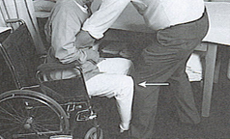

* Plan & organize transfer BEFORE moving patient
* Instruct patient in technique/procedure
* Demonstrate technique/procedure
* Be alert to safety factors
* Review chart to determine amount of assist, cognitive status, strength, type transfers already performed
* Utilize safety belt
* NEVER leave pt. unattended

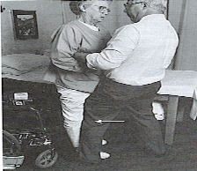

* Proper shoes on patient
* Appropriate equipment
* Alert to IV lines, catheters, weight bearing status
* Use proper body mechanics
* Position yourself to guard, protect and assist
* Break transfer into component parts
* Only assist as needed at each component

**Transferring Patients**

**Types of Transfers**

* Pivot

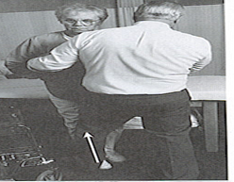

* Sliding Board
* Hoyer Lift
* 2-3 person lift
* Floor to chair
* Car transfer

**For All Pivot Transfers**

* Scoot to edge of chair/bed/wheelchair
* Position feet
* Lean forward
* Patient should have on shoes that will provide traction

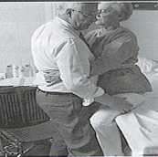

* Use gait belt
* Remove armrest on wheelchair if possible
* Lock brakes of wheelchair

**Bed to Stretcher Transfers**

* Insert draw sheet
* Utilize sliding board
* 2-3 people for average sized patient
* 3 or more for larger patients

**Standing Pivot Transfer**

* Partial stand if possible (keeps center of gravity lower)
* Position w/c or chair parallel or at 45-60 degree angle
* Easier to transfer to strongest side
* Transfer training involves teaching the patient to transfer to both sides
* Patient may push from wheelchair or hold around therapist shoulder / upper arms – like slow dancing.
* Never let a patient hold around your neck

**Sitting Pivot Transfer**

* For wheelchairs with removable sides
* Position wheelchair close to bed
* Patient scoots forward in chair
* Position feet
* Sliding board or pillow between the bed or wheelchair
* Patient lifts & scoots their bottom by pushing with upper and lower extremities as appropriate

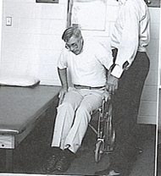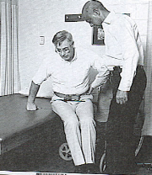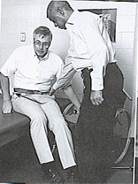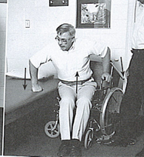

**Conditions Requiring Special PRECAUTIONS during Transfers**

* Total Hip Replacement
* Stage III and IV pressure ulcers and burns
* Low back trauma / Spinal cord injury
* Hemiplegia

**Total Hip Replacement transfer precautions**

* Avoid hip flexion > 90
* Avoid hip abduction
* Avoid hip rotation
* Utilize reclining Geri chair for sitting
* Do NOT have patient sit in upright position
* Do NOT have patient roll onto side to go from bed to sitting
* DO educate patient regarding precautions & utilize precautions during transfers

**Stage III and IV Pressure Ulcers and Burns**

* Avoid shear forces across stage II and IV pressure ulcers and burn or graft sites
* Avoid sliding

References:

Cluett,J. (2012). *How To Lift,* About.com Guide. Retrieved from http://orthopedics.about.com/cs/backpain/ht/lift.htm

Hedge, A (2009) Back Care for Nurses. Retrieved from http://www.spineuniverse.com/wellness/ergonomics/backcare-nurses

Oklahoma State University environmental health and safety, Back Safety. Retrieved from safetyinfo.com

Hoyer and Camel Lifts

**Typical Hoyer Patient Lift diagram**

Manual and Powered Hoyer Lifts operate similarly. The manual versions have hydraulic cylinders and a hand-pump, the powered patient lifters use rechargeable battery packs and a pushbutton hand control. All lifts share the same nomenclature names as pictured (left).

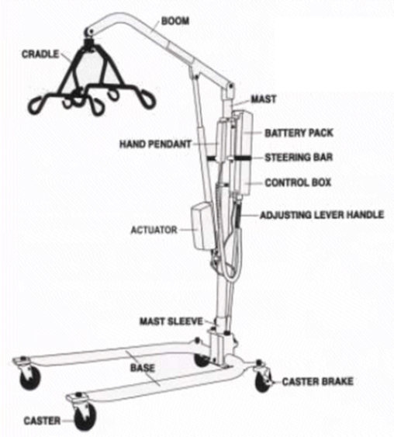

To raise the patient the base of the Hoyer Lifter must be spread to its widest possible position to maximize stability. To lower patient open the hydraulic pressure release knob by turning it counter-clockwise, not more than one full turn. The release knob is located on pump near pump handle. Battery powered Lifters have a button on the hand control for lowering patient.

**Transfer from Bed**

If patient needs support and is in a [hospital bed](http://www.phc-online.com/Full_Electric_Bed_p/hospital_bed-ic-5410.htm), raise [side rails](http://www.phc-online.com/Bed_Rail_s/74.htm) and have patient hold onto rails. Raise the level of the bed to the highest position before moving the patient onto the sling. This will reduce strain on the caregiver's back. Also, when the patient is ready to be lifted, lower the side rail and the level of the bed, decreasing the distance the patient has to be elevated.

**Positioning the Lift for Use:**

* With the legs of the base open and locked, use the steering handle to push the patient lift into position.
* Lower the patient lift for easy attachment of the sling.
* When the patient is clear of the bed surface, swing their feet off the bed.
* Using the steering handle, move the lift away from the bed.
* When moving the patient lift away from the bed, turn the patient so that he/she faces assistant operating the patient lift.

Press the DOWN button (electric) or open the control valve (manual/ hydraulic) lowering patient so that his feet rest on the base of the lift, straddling the mast. Close the control valve.

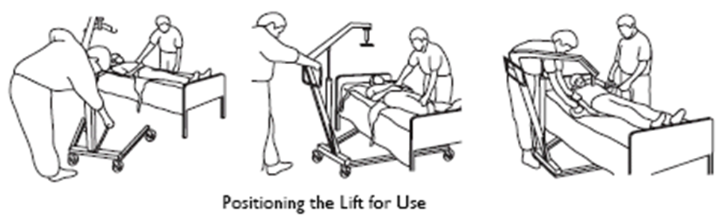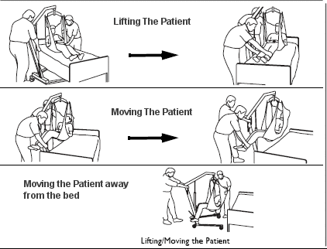

**The Sling**  
The U-Sling is the most commonly used sling for transferring patient from bed. Consult the sling manual on how to fold the sling before placing under patient. Folding the sling makes for less work. The U-Sling wraps around the thigh and crosses between the legs. This gives the patient a secure feel and prevents patient sliding out of the sling.

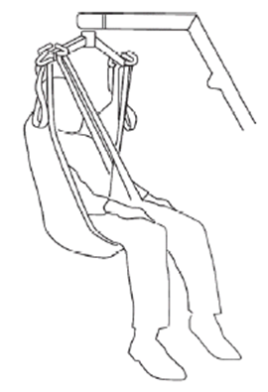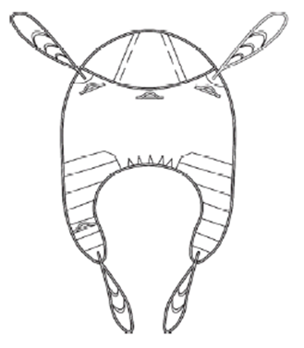

**Applying the Sling**

* Roll patient so they are resting on their side. Put the folded sling behind patient's back and roll patient onto their back.
* Pull the leg loops forward and under the thigh.
* Cross the loops
* Roll the base as far under the bed as possible locating the cradle over the patient. Be careful not lower the frame onto the patient.
* The parking brakes (caster locks) should not be on when lifting the patient, let the lift move a little with the weight adjustment.
* When both sides of the sling are attached to their respective sides of the cradle, raise the patient slowly. If patient is in a hospital bed it will help to raise the head section slightly.
* Raise the patient until buttocks are just above the mattress. The self-leveling cradle will bring patient into a sitting position. Grasp patient's legs and turn patient so their legs dangle off side off the bed. Do not push or pull patient off of bed. Lower bed if you need more clearance.
* Grasp steering handles and move lifter away from the bed. Move patient into position over the seat of wheelchair. Make sure wheelchair brakes are on.
* Lower patient into wheelchair or other transport device.

**How to Fit Sling from Lying Position**

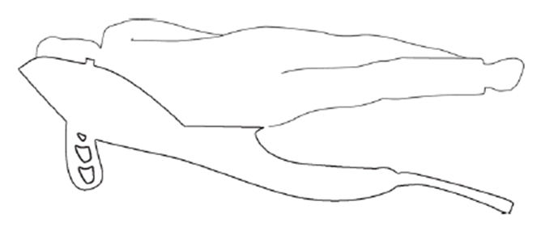

Draw sheet roll the patient onto the sling, ensuring that the top of the commode aperture is at the base of the spine.

Bring the leg support straps up and between the client's legs and proceed as from the seated position, attaching to the shortest possible loops. If you are going to place the patient on a high bed it may be necessary to lower the patient onto an intermediate surface and adjust the strap length.

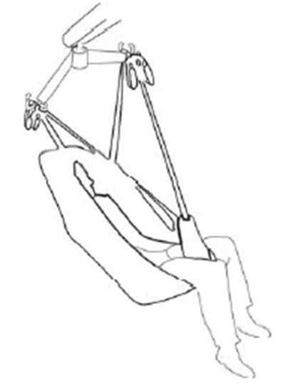

Reference

Preferred Health Choice, Mobility and Patient Aide Center. (n.d.) *How to Use a Hoyer Lift.*Retrieved from http://www.phc-online.com/How_to_use_Hoyer-Lift_a/146.htm

**How to Use the Camel Lift**

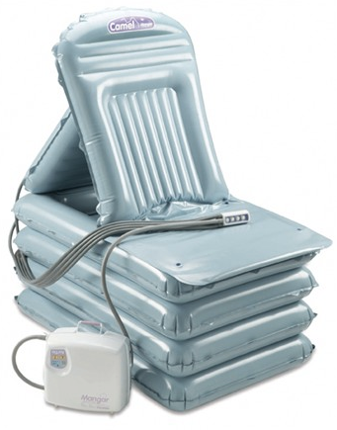

**Camel Lift**

* **C**omplete **A**ir **M**oving **E**levating **L**ift
* Holds up to 700 lbs in sitting position
* Holds up to 1000 lbs without the back inflation
* Made out of Nylon
* Two compressors for each lift
* Compressors can be plugged in at all times
* Cannot use DC power to work lift. The compressor runs on battery power only.
* The air compressor cords and slide sheet are all inside the lift bag
* Air compressor weighs 20lbs/ lift weights 15 lbs
* The back of the lift is color coded and numbered
* The air compressor cord is also color coded and numbered
* There is also a belt in the lift bag, used to help steady the patient if need be. This is NOT a “gait belt” .Not recommended for use to aid in transferring a pt. It is just used to help “steady” a pt.
* Recommend at least 2 users
* May be used as a downward transfer from lift to walker or lift to bed

**Using the CAMEL**

* Turn compressor on. Push the on button until it “burps”
* There is also a button to push to see how “charged” the unit is
* Roll the pt on their side
* Place numbered cords into appropriate slots in back of lift
* Place the other end of the cord into the compressor
* Push the lift up as close to the pt as possible
* Place slide sheet under pt as well
* Place pt on back
* Sitting beside pt, place your hands on the shoulder and the hip
* Slide pt to the middle of the lift
* The back of the head should be placed directly over the CAMEL logo
* **Remove Slide Sheet**
* #1 button raises the back rest for respiratory relief do this “a little bit” first
* #2 raises the base (This can cause the patient to be unstable. If they start to lean to one side or the other, use a hand to push down on the other side of the lift to correct.) (There is fiberglass in the back rest as well as in the seat to keep patient in place.)
* Keep button compressed until you hear the difference in sound, or compressor stops. (You cannot “overinflate” the lift.)
* Continue raising the back rest as needed
* Once the base is fully inflated, move on to button #3
* Inflate all levels completely
* Once the patient is in a full sitting position there are multiple ways of getting them up
* If patient is stable, Use the CAMEL tip technique
  + Two person technique to get them up to a standing position to use walker or ambulatory aid.
  + One person stand pivot to wheelchair
  + Two person stand pivot to wheelchair.

**Deflating the CAMEL**

* Detach cords from insertion sites the same way we remove our BP cuffs.
* Pull back on the insertion site while pulling outward on compressor cord.
* Detach the cords from the compressor and push the compressor buttons to release the air or detach the cords directly from the lift.

Code Blue, Rapid Response, Condition H, MERT Team

Codes  
Dial 31911

Code Blue: Cardiac/Respiratory Arrest -Adults

Code Gray: Crisis Situation or Crisis Intervention Needed

Code Walker: Missing Patient or Patient Elopement

Code Orange: Hazardous material Spill/ Release

Code Amber: Infant/ Child Abduction

Code Red: Fire

Code Silver: Person with weapon or hostage situation

Code Triage-Internal: Internal Disaster

Code Triage-External: External Disaster

Code Black: ER Saturation

Code White: Cardiac/Respiratory Arrest – Pediatric/Newborn

Code Yellow: Bomb Threat

Dr Evac: Total Building Evacuation

MERT Team: External Medical Emergency Response Team

Code…Drill: Practice Drill to the designated code

Code… All Clear: Inactivation of the code previously announced

**Emergency Equipment**

**Crash Carts** - located in each department and on each patient unit.

**AED -** located on crash carts.

**Monitor/Defibrillator - l**ocated in ICU, Cath Lab, Surgery, PACU, 7th Floor, 6th Floor, X-ray and ED.

* Code nurse from ICU is responsible for bringing defibrillator to code blue on upper floors
* Code nurse from ED will bring defibrillator to Codes on 1st floor.

**Code Blue**

**How to call a Code Blue**

* Dial 31911 – inform emergency control center that it is a code blue and provide the location/room #
* Press code blue button located at each patient bedside

**When to call a Code Blue**

* Unresponsiveness
* Absence of effective breathing
* Absence of carotid pulse
* Ineffective circulation (clinical judgment that arrest is imminent)

**Members of the Code Blue Team**

* ED Physician / Primary Physician
* Nursing Supervisor
* RN from both ICU & ED
* Unit nursing staff (RN, LPN and Tech)
* Respiratory Therapist
* EKG Technician (when available)
* Pharmacist
* Phlebotomist

**Rapid Response**

**How to call a Rapid Response**

* Dial 31911 – inform emergency control center that it is a rapid response and provide the location/room #

**When to call a Rapid Response**

* Rapid Response is called when a patient begins to deteriorate and before the patient experiences a cardiac or respiratory arrest.

**Members of the Rapid Response Team**

* ICU RN
* Respiratory Therapist
* Nursing Supervisor

**Medical Emergency Response Team (MERT)**

**How to call the Medical Emergency Response Team**

* Dial 31911 – inform emergency control center that it is a rapid response and provide the location/room #
* MERT team is activated when an employee, outpatient, or visitor is in need of emergency medical assistance in any public or non-patient care area (typically the 1st floor).

**Members of the Medical Emergency Response Team**

* Emergency Department RN
* Emergency Department Tech

**Condition H (Condition Help)**

Initiated by a patient, family, or visitor if they feel that the patient’s condition is declining but not being adequately addressed. This is essentially a customer generated rapid response.

**How to call Condition H**

* You see a change in the patient’s condition and the healthcare team is not recognizing the concern.
* You have spoken to the hospital staff and you continue to have serious concerns about the patient’s care.
* There is a breakdown in how care is given, or uncertainty over what needs to be done

**When to call Condition H**

* Dial 34444 from any hospital phone

Lifenet

**Lifenet** is the organization used for organ donation.

* They must be notified for all patient deaths.
* They must also be notifies for any patient that has a Glasgow Comma score ≤ 5.
* A lifenet representative will contact the family and handle all questions concerning organ donation. Nurses do not discuss organ procurement with patients except to refer them to a Lifenet representative

Reference

NSER 317

IV Therapy

**IV Medication Administration**

**SAS (saline + administer med + saline)** – for peripheral IV’s, PICC lines, and groshong

**SASH (saline + administer med + saline + heparin)** – for central lines that require a heparin lock.

Use SAS or SASH method for all IV push medications. A saline line is not required to administer IV push medication.

* Saline lines for IV push medications are only recommended when the patient is receiving multiple IV medications and fluid overload is not an issue.
* For patients with a primary IV fluid infusing, a separate saline line is not required for IV push or IVPB medications unless these meds are incompatible with the primary fluid.
* Drug compatibility charts are available on all units (example: Dilantin and Valium should be given through a saline line) Potassium in IV solutions is a common source of incompatibility.
* Some infusions, such as TPN and Insulin should not have IV push or IVPB infused with them.
* Tubing must be changed daily on some infusions, such as TPN and Insulin.

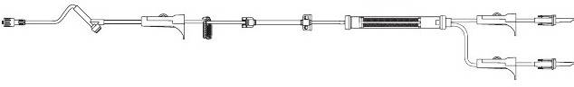

Blood Tubing



Primary

Tubing

|  |  |  |
| --- | --- | --- |
| **Type of line** | **Dressing Change** | **Flushing Requirements** |
| **Peripheral IV**  **Catheters &**  **Saline Lock** | Dressing Change every  72-96 hours. | Flush with 2- 3 ml in a 10ccn syringe every 8 hours. |
| **Central Venous**  **Catheters (CVL)Triple Lumen & Hickman** | Dressing change every 7 days and PRN. Change caps on with dressing change. | For any unused port, flush with 10 ml saline followed by 3-5ml of Heparin 10 units/ml in a 10 ml syringe every 8 hours.  Flush with 10 ml saline before and after lab draws or medication administration followed by 3-5ml of Heparin 10 units/ml in a 10 ml syringe. |
| **PICC**  (Peripherally  Inserted central  Catheter) & **Groshong** | Dressing change every 7 days and PRN. Change blue neutral pressure caps on PICC lines with dressing change. | For any unused PICC port flush with 10 ml every 8 hours. No heparin required. Flush with 10 ml saline before and after lab draws or medication administration. Flush Groshong with 10 ml saline weekly. No heparin required. A two-way valve will maintain patency of device. |
| **Implanted**  **Portacath (Open-**  **Ended)** | Dressing change every 7 days and PRN.  Also change Huber needle. | To de-assess, or lock accessed port: flush with 10 ml saline followed by 3-5 mL Heparin 100 units/ml in a 10 mL syringe. |
| **Vas Cath** | Dressing change every 7 days and PRN. | Access catheter by aspirating and discarding 10 ml blood first.  Flush with 10 ml saline prior to connecting IV fluids. Flush unused lumen with 5000 units heparin every 48 hours. |
| Change IV tubing every 72 hours, except for certain infusions such as TPN, or insulin and intermittent infusions which are changed every 24 hours. A final filter is required on all IV access except peripheral access. | | |

**IV Pumps**

IV Pump Footnotes:

* Primary and secondary volumes must be cleared separately.
* **Always clamp** IV tubing before opening pump
* **Bubble Up** – Air accumulates in the flow sensor area inside the pump causing the pump to beep.

Rotate the pump clockwise 90 degrees (left side is now up) to prevent micro-bubbles from getting

trapped in the sensor chamber.

* **Pressure Up** - The high pressure sensor alarm has to be reset with each bend of the arm. There is no reset feature. For PICC lines and some antecubital IV’s, increase the pressure setting from the default of 5 to 9.

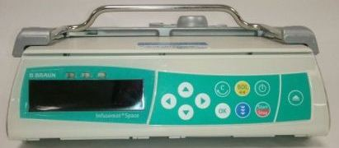

* **Primary** and **secondary** volumes must be cleared separately.
* Uses **dictionaries** to program all meds that are infused.

B Braun Infusomat

Best practice for peripheral IV’s is to keep them in for 72-96 hours and possibly longer if they are without symptoms of phlebitis such as redness or swelling. Check catheter sites at least every 4 hours.

Pain Management

**Pain Assessment** – Good pain management begins with a good pain assessment.

**Pain is assessed:**

* On admission
* On hourly rounds
* Within 1 hour after giving medication for pain
* As part of the physical assessment

The following 4 pain scales are used to assess a patient’s level of pain.

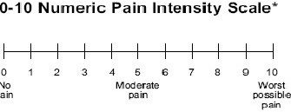

**Numeric pain scale** - used with patients who are able to associate their pain level with a numerical value between 0 (no pain) and 10 (worst pain they have ever experienced)

**FACES pain scale** - used with patients who are unable to associate their pain level with a numerical value but can use a picture to indicate their level of pain. The numerical value associated with the chosen picture is the pain level to be documented (you can chose either one of the numbers associated with a face to document).

Ask patient: “These faces show how much something can hurt. Point to the face that shows how much you hurt right now.”



0 1-2 3-4 5-6 7-8 9-10

No hurt Hurts Hurts Hurts Hurts Hurts

a Little Bit Little More Even More Whole Lot Worst

**FLACC pain scale** - used with non-verbal patients unable to provide reports of pain.

|  |  |  |  |
| --- | --- | --- | --- |
| **FACE** | 0  no particular expression or smile | 1  occasional grimace or frown, withdrawn, disinterest | 3  frequent to constant frown, clenched jaw, quivering chin |
| **LEGS** | 0  normal position or relaxed | 1  uneasy, restless, tense | 2  kicking or legs drawn up |
| **ACTIVITY** | 0  lying quietly, normal position, moves easily | 1  squirming, shifting back/forth, tense | 2  arched, rigid, or jerking |
| **CRY** | 0  no cry  (awake or asleep) | 1  moans or whimpers, occasional complaint | 2  crying steadily, screams or sobs, frequent complaints |
| **CONSOLABILITY** | 0  content, relaxed | 1  reassured by touching, hugging, or talking to, distractible | 2  difficult to console or comfort |

**Neonatal/Infant Pain Scale (NIPS)** - used for neonates/infants.

|  |  |
| --- | --- |
| **Facial expression** |  |
| 0 – Relaxed muscles | Restful face, neutral expression |
| 1 – Grimace | Tight facial muscles, furrowed brow, chin, jaw |
| **Cry** |  |
| 0 – No cry | Quiet |
| 1 – Whimper | Intermittent mild moaning |
| 2 – Vigorous cry | Loud scream; continuous shrill crying (Note: A silent cry may be scored if the baby is intubated, but crying is evidenced by facial movement.) |
| **Breathing pattern** |  |
| 0 – Relaxed | Usual pattern for the individual baby |
| 1 – Change in breathing | Retractions, irregular respirations, tachypnea, gagging, breath holding |
| **Arms** |  |
| 0 – Relaxed | No muscular rigidity, occasional random movements |
| 1 – Flexed/Extended | Tense straight arms, rigid and/or rapid extension/flexion |
| **Legs** |  |
| 0 – Relaxed | No muscular rigidity, occasional random movements |
| 1 – Flexed/Extended | Tense straight legs, rigid and/or rapid extension/flexion |
| **State of arousal** |  |
| 0 – Sleeping/ Awake | Quiet, peaceful, sleeping or alert and settled |
| 1 – Fussy | Alert, restless, thrashing |

**For patients who present with a pain score > 3:**

* Enter a plan of care for Pain and education plan for pain
* Make sure patients understand how to use pain scale
* Instruct patients that pain medications are often PRN and usually not scheduled
* If a patient is ordered pain medication (outside of ICU) more frequently than every 2 hours, contact the physician and ask to consider using a PCA pump

**Things to consider**…….

* Pain medications can put our patients at higher risk for falling.
* Narcotic analgesia may decrease peristalsis and contribute to constipation and ileus. Monitor bowel movements and consider a bowel program.
* Be proactive rather than reactive.

**PCA Pump**

**PCA pump is for IV and epidural use.**

* Review use of PCA prior to initiating dose (if patient is coherent) and PRN to ensure the patient is able to properly manage their pain.
* Two RN’s must independently verify the PCA settings when the PCA is initiated, for epidural PCA anesthesia will load the pump and connect it to the patient.
* Two nurses (one may be an LPN) must verify medication in E-MAR system when a new bag is hung.
* Two RN’s must verify all dose changes.
* A nurse and LPN may verify bag changes.
* IV PCA solutions must be run with a dedicated normal saline solution connected at the medication port closest to the patient. Label tubing “IV PCA infusion”. Do not run other medications through this line.
* Assess: Blood Pressure, Temperature, Pulse, Respirations, Pain Score, and Sedation Level. For epidural PCA also assess sensory motor function and the epidural site. Do this every 4 hours, or more frequently if not stable.
* Do VS at the time PCA is initiated and following any clinician bolus of medication. Perform VS every 15 minutes X2, every 30 minutes X2, every hour X2, and then every 4 hours if stable.

|  |
| --- |
| **Curlin PainSmart Reference Guide** |
| **To initiate treatment:**   1. Press Orange **ON** key 2. Press **YES** on Program 3. Use down arrow key to move to **NEW PROGRAM** and press **YES** 4. Enter code 94629 5. Press **YES** to **ALERT RX IN PROGRESS** screen 6. Press **YES** to erase Rx in **ALERT RX PROGRAMMED** screen 7. **PRE-RX** screen  * **Units** - press **YES** to ml * **Admin route** - press **YES** to IV. If doing epidural push **NO** for **EPI** * Then push **YES** * **Load dose** - type in amount & press **YES**. If load dose is 0, press **YES** * **Med Limits** - press **YES** to remain off * **NEXT** - press **YES**  1. **RX** screen  * **Bag volume** – type in amount & press **YES** * **Basal Rate** – type in amount & press **YES** * **Bolus** – type in bolus amount & press **YES** * **# Bolus/Hr** – type in # and press **YES** * **DONE** press **YES**  1. Press **RUN** to start |
| **To change bag with same Rx**   1. Press **PAUSE** in upper right 2. Move cursor with down arrow to key to **REPEAT RX** 3. Press **YES** to repeat Rx 4. Press **YES** to keep same med limits 5. Allow to scroll automatically through fields to validate info 6. Press **RUN/PAUSE** to start |

* An increase in PCA or basal rate requires VS every 30 minutes X2, then every 4 hours if stable.
* Document IV PCA and Epidural PCA on paper flow sheets located in form fast. There is currently only an LDAW to link medications but not to document patient data related to PCA infusions.
* STOP INFUSION and call the physician for hypotension, excessive sedation, or weakness or numbness of lower extremities (for epidurals).
* PCA drugs: Dilaudid, Demerol, Fentanyl, Morphine
* Epidural Drugs: Fentanyl and Bupivacaine
* Nurses may discontinue epidural catheters

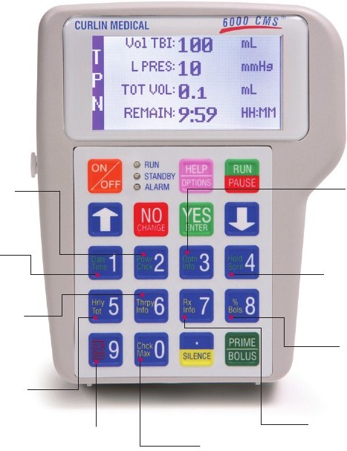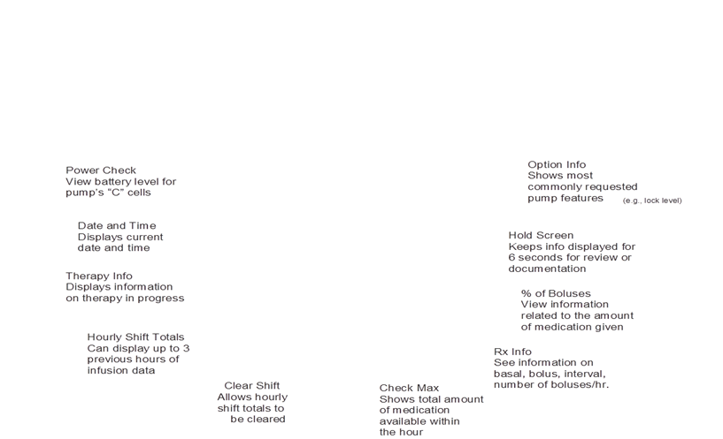

**Ofirmev** (IV acetaminophen) is now available in conjunction with opiates for better pain

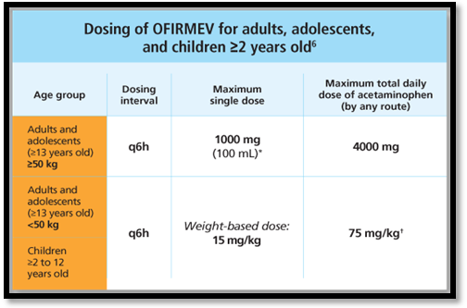

management.

* There is no difference in dosing between IV and oral acetaminophen.
* Be aware that other medications may contain acetaminophen.

**Toradol** (ketorolac) is a non-steroidal anti-inflammatory medication given IM or IV for moderate to severe pain.

* It is intended for short term use (typically up to 5 days)
* Given alone or in conjunction with other pain medication therapies.
* It can inhibit platelet formation and cause bleeding. Never given prior to surgery.
* Works well for pain related to kidney stones.

**NSAIDS** such as ibuprofen can be effective separately or in conjunction with narcotic analgesia.

**Complimentary therapies** such as physical therapy, relaxation techniques, and application of heat or ice can also be effective.

References:

Goodman, G. (2003). Outcomes measurement in pain management: issues of disease complexity and uncertain outcomes. *Journal Of Nursing Care Quality*, *18*(2), 105-113.

McLennon, S. (2007). Evidence-based guideline: persistent pain management. *Journal Of Gerontological Nursing*, *33*(7), 5-14.

Informed Consent

The physician who orders, or is to perform the treatment or procedure, is responsible for explaining to the patient:

* The elements of informed consent
* Answer questions as necessary
* Assure that the appropriate consent form is signed

**Witnessing an Informed Consent**

The witness who signs the consent form provides confirmation that:

* The physician discussed the proposed treatment with the patient or surrogate
* The patient or surrogate gave consent to treatment after this discussion
* The patient or surrogate was given the opportunity to ask questions about the proposed treatment
* All of these questions were answered fully.

The witness should be present during the informed consent discussion whenever possible.

If the witness is not present during the informed consent discussion, the witness should ask the following questions:

* Did your doctor/provider explain the procedure/treatment to you?
* Have all your questions about the operation or procedure been answered?
* Is this your signature on the consent form?
* Have you given your consent to the proposed treatment?

If the patient or surrogate answered **“yes” to all** of the above questions, then the witness should sign the consent form on the appropriate signature line.

If the patient or surrogate does not answer **“no” to any** of the above questions, then the witness should not sign the consent form and should notify the physician/provider of the patient’s or surrogate’s concerns.

* A single informed consent is sufficient for any admission which may include one or more blood transfusions.
* Documented informed consent is required for autologous and cell saver infusions.
* Only sign if there is a reasonable probability that a transfusion will be needed and only if at least a type and screen have been done.
* A consent form needs to be signed for the initial transfusion in Outpatient Oncology patients, and this is sufficient for all transfusions in that course of treatment.
* Consent to blood transfusion must be completed in addition to consent for surgical or medical treatment where transfusion is anticipated.
* Documented informed consent is required for autologous and cell saver infusions (Yes, you need to consent to receive your own blood).

**Patient Unable to Sign**

If the patient is physically unable to sign, but able to consent, the reason should be noted at the bottom of the form and the patient's expression of consent should be documented by two witnesses. If a family member or friend of the patient is present, he/she should serve as one of the witnesses.

**Phone Consents**

In cases where the legal guardian, MPOA, or healthcare surrogate is unavailable to give written consent for a patient, phone consent may be obtained.

It should be worded “MPOA, legal guardian or healthcare surrogate (name of representative) is not available to sign an informed consent form because (reason) , but has consented over the telephone (name of procedure/treatment) ". **Two (2) witnesses** should then sign, date and time the consent form. The same questions above should be asked by the witness.

**Consent by Minors**

An informed consent must be obtained from a parent or legal guardian unless the minor is “emancipated” or considered a “mature minor”.

* An emancipated minor is one who is over the age of sixteen (16) and is married or has been declared emancipated by a court of law.
* A mature minor is one who is between the ages of 16 and 18 and in the opinion of the attending physician; the minor is of sufficient maturity to understand the nature and effect of that which he/she is being asked to consent.
* An emancipated or mature minor may consent to admission, treatment and procedures without the consent of his/her parent(s).
* For the purpose of treatment of pregnancy (including prenatal care), venereal diseases or drug/alcohol abuse, parental consent is not required. Although parental consent is not required for performance of an abortion upon a minor, specific parental notification procedures must be followed prior to the abortion.
* In other instances parental consent is required.
* In circumstances where an emergency situation exists and the physician feels that waiting for parental consent would jeopardize life, limb, or bodily function, the minor may consent for him/herself.

**Emergency situations**

In the event that consent is unobtainable and in the physician's judgment treatment is necessary to avoid loss of life, limb, or bodily function, treatment may be rendered without a signed or verbal consent. A statement must be written in the progress notes thoroughly explaining the situation.

Reference: ADM 301

Blood Administration

**Charting Blood Administration in Epic**

1. Go to **Acknowledge Orders** in the Patient Summary and review and acknowledge orders for the transfusion**. Ensure consent has been obtained.**
2. Go to the MAR tab and to check for **pre-transfusion medications** to be given and document.
3. Go to the **Navigator** activity button and select **Blood Transfusion** button.
4. The **Transfusion Report** shows recent blood administration related labs including the Type & Cross and the blood product.
5. Go to the **Vital signs** and document pre-transfusion vital signs (all temperatures in degrees Celsius).
6. Under the **Assessment** tab complete the questions:

* Blood avoidance/Restrictions?
* Previous Transfusion?
* Informed Consent Obtained?

1. Under the **Transfusion Status** document:

* Component
* Transfusion Status
* R Band number
* Blood ID number

1. A **second clinician** is needed for verification of blood product administration. At this point you will need a fellow clinician **to review your documentation** and the blood product to ensure everything is correct.
2. Ask your second clinician to review your documentation prior to filing. If everything is correct, accept the documentation.
3. The second nurse now needs to sign into hyperspace, select the patient. Open the blood transfusion navigator, select transfusion documentation, scroll down to the **Med/Blood Verification (2nd**) section and click on second clinician verification of medication/blood.
4. You can now close the blood administration navigator.
5. It’s now time to **document the 15 minute vital signs**. Open the Blood Administration Navigator again. Enter the time and document the vital signs.
6. Once the transfusion is complete again select your patient, click on the blood transfusion navigator, click on transfusion documentation and complete the following:

* Transfusion status
* Blood product volume
* # of units given
* Transfusion reaction suspected
* Enter another set of vital signs

1. Close the Navigator.
2. The last step is to go to the one time nursing orders and **complete the Nursing- Transfuse order**. This is especially critical for blood transfusions.
3. **Remember to complete the paper blood administration form also**.

* Only 0.9% NaCl can be hung with blood components.
* Obtain informed consent before administering any blood or blood product. Consent is not required for albumin.
* Do not add drugs or other IV solutions.
* *Monitor all temperatures in degrees Celsius.*
* A registered nurse is responsible for the administration of blood and blood products in all patient care settings.

|  |  |  |  |
| --- | --- | --- | --- |
| **Blood Product** | **Indications** | **General requirements** | **Tubing/ filters** |
| CRYOPRECIPITATE (CYRO)Product | Hemophilia. Von Willebrand’s Disease. Hypofibrinogenemia. (Fibrinogen< 80-100mg /dL) particularly in DIC. Removal of calculi in renal pelvis Isolated factor XIII deficiency. | Obtain consent.  Good for 4 hours once pooled and requires 20-30 minute thaw time.  Infuse over 30-60 minutes. | Blood Component set with 170 micron filter. Primary IV solution set NaCl flush bag (250ml) Infusion pump |
| ANTIHEMOPHILIC FACTOR AHF (Commercially Prepared Factor VIII) | Hemophilia A (Factor VIII deficiency)  Correct or reduce incidence of bleeding episodes.  -Minor injury 1000 units  -Major injury 1500 units  *NOTE: Patients may have their own supply of AHF used as home therapy. If this is used, the expiration dates/lot numbers must be recorded same as CHI plus record info for home records | Obtain consent  Push solution no faster than 1ml/min through running NS line | Prepare according to manufacturer’s recommendations using supplies provided in Kit from Blood Bank. Withdraw solution using filter needle provided into 50cc syringe |
| PLASMA, FROZEN (FRESH FROZEN PLASMA) | Severe blood loss PT or PTT>1.5 times the normal mean or reference range. DIC. Reversal of Coumadin effects. Patients with multiple factor deficiencies, including severe liver disease to correct or prevent bleeding complications. Thrombotic Thrombocytopenia Purpura (TTP) Post-OP bleeding (PT/PTT> 1.5 normal). | Obtain consent. Infuse over 30-60 minutes.  During a Massive Transfusion, FFP is transfused at a 1:1 ratio with Red Blood Cells. | Blood Component set with 170 micron filter. Primary IV solution set NaCl flush bag (250ml) Infusion pump. Do not use transfusion set for more than 4 hours. NaCl flush bag (250 ml) -Infusion Pump. |
| PLATELETS: RANDOM DONOR AND APHERESIS | Treatment of bleeding due to critically reduced circulating platelets or functionally abnormal platelets. Prophylaxis: 10x1000u/dl platelet ct. Significant bleeding/Invasive Procedure 50X1000 u/dl platelet ct. Massive blood loss and abnormal bleeding pending platelet ct. | Obtain consent.  Apheresis platelets are routinely supplied by Red Cross and Bacterially tested prior to release. Equivalent to 6-8 random donor platelets..  Infuse over 30-60 minutes | Blood component set with 170 micron filter and Primary IV set -0.9% NaCl -Infusion Pump |
| RED BLOOD CELLS (PRBC) | Symptomatic anemia in normovolemic patient. Hct<24% , Hbg<8 g/dl  Prep for major surgery with blood loss/pre-op anemia. Acute blood loss. Newborn Hct<40 immediately after delivery | Obtain consent.  Infusion over 2-3 hours. Do not exceed 4 hours from time retrieved from BB. A unit must be returned within 20 minutes of BB release time. | Y-Type Blood infusion set. Do not use transfusion set for more than 4 hours. NaCl flush bag (250 ml) -Infusion Pump. |
| ALBUMIN | Hypovolemic shock. Albumin >2.0  Fluid replacement after paracentesis over 4L hyperbilirubinemia. Cirrhosis and spontaneous bacterial peritonitis hypotension during Hemodialysis hypovolemia, ARDS, severe anemia or cardiac failure | No consent required  Infusion rate should be as rapidly as possible | Administer by provided set undiluted or diluted with saline solution or 5% dextrose water. |
| BeneFix Coagulation Factor IX (Recombinant) | Treatment of hemophilia B.  Factor IX deficiency | Obtain consent  Administered by IV infusion over several minutes. | Reconstitute with Sterile water for injection included in the kit. |

References: NSER 327

Swallow Screening

**Instructions for Administering MGH-SST (Swallow Screening Tool)**

Equipment needed:

* Flashlight
* long cotton-tipped swab
* tongue depressor
* cup of water
* teaspoon
* rubber gloves.

The purpose of this screening tool is to ensure patient safety by accurately screening patients at risk for aspiration, or suspected of being an aspiration risk.

**Part 1**

**Wakefulness:** Is patient able to remain awake for at least 5 minutes?

* If yes, continue
* If no, fail Part 1 and defer Part 2. Maintain NPO until re-screened when alertness maintained for a minimum of 5 minutes

**Head of Bed:** Can the patient tolerate head of bed elevation to at least 30 degrees (as upright as possible is ideal)

* If yes, continue
* If no, fail Part 1 and defer Part 2. Maintain NPO until head of bed can be elevated and patient can be re-screened.

**Breathing:** Can the patient maintain reasonable oxygen saturation at rest with O2 via nasal cannula?

* If yes, continue
* If no, fail Part 1 and defer Part 2. Maintain NPO until stable breathing and acceptable O2 sats and patient can be re-screened.

**Clean Mouth:** Does patient meet standards of oral hygiene? Inspect entire oral cavity.

* If yes, continue
* If no, clean oral cavity before proceeding to Part 2. If unable to fully clean, fail Part 1 and defer Part 2. Maintain NPO with ongoing oral care. Re-screen.

If all four items in Part 1 are present, proceed to Part 2. Otherwise, maintain NPO, determine alternate route of nutrition, hydration and meds. Defer part 2 and re-screen when able.

**Part 2**

**Tongue Movement:** Does patient have adequate tongue range of motion and strength for moving and controlling food and liquid in the mouth?

* TASK: Ask or demonstrate "Stick out your tongue beyond your lips" and "Lick all the way around your lips."
* SCORE: 1 point if tongue protrudes past lips and to both sides fully. 0 points if incomplete or absent.

**Cough:** Does patient have a cough strong enough for clearing the airway?

* TASK: Ask or demonstrate "Cough as hard as you can."
* SCORE: 1 point if sharp, audible cough is present. 0 points if cough is weak, breathy or absent.

**Vocal Quality:** Does patient have a strong, clear voice indicating ability to close and protect airway?

* TASK: Ask or demonstrate "Say ha-ha-ha-ha."
* SCORE: 1 point if voice is loud, clear and dry. 0 points if voice is wet/gurgley, hoarse, breathy or absent.

**Pharyngeal Sensation:** Can patient sense when pharynx is touched? Reduced sensation means a greater likelihood of aspiration.

* TASK: Have patient close his eyes and open mouth. Gently stroke right pharyngeal wall with cotton-tipped swab. Ask patient to indicate which side was stroked. Repeat on left side of pharynx. If patient gags before you reach the pharyngeal wall, you may stop as patient has adequate pharyngeal sensation.
* SCORE: 1 point if patient can indicate that he felt stroking. 0 points if unable to detect stroking on one or both sides of pharynx.

**Swallowing Water:** Can the patient drink water without aspirating?

* TASK: Provide 3 single teaspoons of water. After each teaspoonful, assess for aspiration including presence of cough, throat clearing, wet or congested vocal quality, or shortness of breath. If any present, STOP and fail item. If none of the above are present, give patient half a cup of water to drink and assess for cough, throat clearing, wet/congested voice quality, or shortness of breath.
* SCORE: 2 points if able to drink ½ cup of water without signs of aspiration; 0 points if signs of aspiration present when drinking water either by teaspoon or cup.

**Scoring**: Add up points on Part Two (maximum total of 6 points). Based on your findings score as follows:

**PASS**: A score of 5 or 6 is needed to PASS the MGH-SST. Initiate a regular diet with a consistency that is appropriate to dentition and thin liquids. Patient should be observed at first meal to ensure safety. Ongoing monitoring is critical to ensure that patient’s status does not deteriorate.

**FAIL**: A score of 4 or less results in a FAIL.

**If at any time during the screening there is concern for aspiration, you may score the patient a FAIL based on clinical judgment**.

Maintain NPO, including medications. Consult speech therapy. Determine non-oral route of nutrition, hydration and medications. Nutrition consult as indicated.

In Epic under Doc Flow Sheets on the Adult Patient Profile under the heading “Functional Level Prior”., there are questions related to your patient’s ability to swallow food and fluids.

0-Swallows foods and liquids without difficulty

2- Difficulty swallowing liquids

2- Difficulty swallowing food

These patients with a history of swallowing difficulty should remain NPO until further evaluation.

From there go to the standard swallow assessment in Doc Flow for any patient suspected of having swallowing issues such as patients who have a new diagnosis of stroke, are actively short of breath, or appear to cough or choke when swallowing.

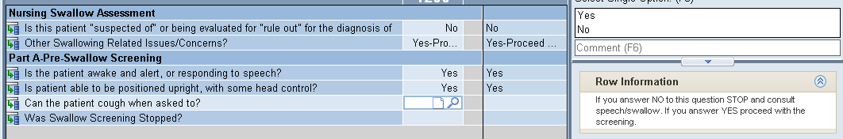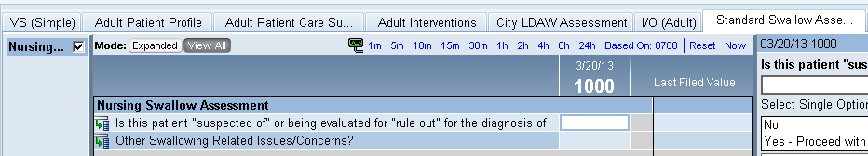

Each row has additional information in the docked detail report guiding the user to the next step.

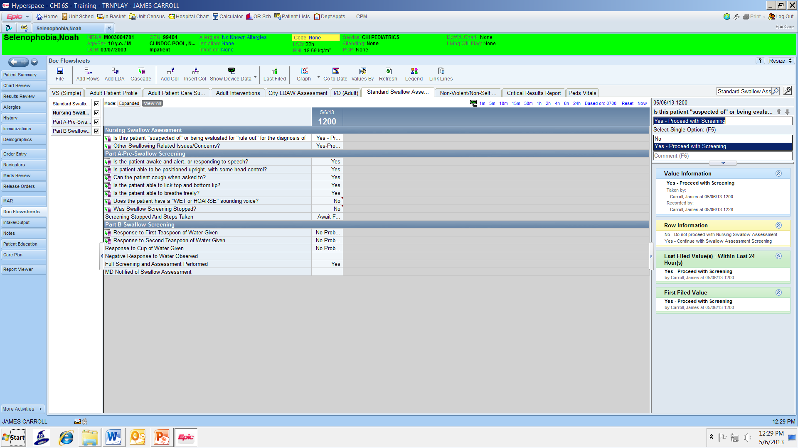

Reference: Massachusetts General Hospital Stroke service. Retrieved from http://www2.mass general.org/stopstroke/swallowScreen.aspx

Tube Feeding - Kangaroo Pump

**General Instructions**

1. Fill or spike feeding container prior to setting up pump.
2. Turn pump on – Press Power button in lower right-hand corner.
3. In order to achieve proper accuracy, the fluid line in the feeding set bag must be 6 inches above the top of the feeding pump, when initiating the feeding cycle.
4. Select “Keep Settings” or “Clear Settings” (for day to day use with the same feeding regimen the “Keep Settings” option should be selected).
5. Load the Feeding Set per diagram. Do not overstretch the tubing.

**Priming the Pump**

1. Press “Prime Pump” to access the pump priming options.
2. Press “Auto Prime” to automatically prime the pump set. The pump will quickly prime the feed line and stop the formula before reaching the end of the feeding line.
3. Press the “Hold To Prime Feed” menu selection to manually top off the line.
4. Press “Done”.

**Setting the Feed Rate**

1. Select “Adjust Feed” then “Feed Rate” use the buttons on the left to program the pump from 1 to 400 in increments of 1 mL. Select “Enter” when desired rate is set.
2. Note: the Volume To Be Delivered “VTBD” Rate is an Optional Feature
3. Only use the “VTBD” option if you want the pump to stop and alarm once a set amount of formula is delivered. • Select “Feed VTBD”. Use the buttons on the left to program the VTBD from 1 to 3000 in
4. Select “Run”. You will notice small drop increments of 1 mL. Select “Enter” when desired VTBD is set.

**Re-Priming the Pump After the Feed Bag Empties**

1. A pump set bag that has been emptied will trigger the Feed Error screen. In this condition the pump set bag can be refilled to continue the feeding, but only after the pump set has been re-primed.
2. Disconnect the feeding line from the patient.

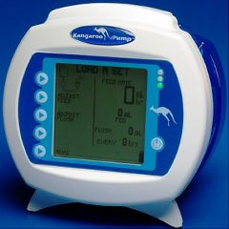

1. Refill the bag.
2. Press “Continue” to begin the pump running.
3. Press “Hold”, then press “Adjust Settings”, then press “Prime Pump”.
4. Press “Done”, then select “Run”

**To Change Rate or Clear Volume**

1. Select “Hold”.
2. Select “Clear Vol Fed” to clear the volume.
3. Select “Adjust Settings” to adjust all settings.
4. Select “Run” to return to normal operations.

Pump sets should not be reused after 24 hours of initial usage.

Tube feeding in closed systems, such as the bottles we use can hang between 24-48 hours.

Tube feeding in open systems change container/tubing at least every 24 hours

**The American Society for Parenteral and Enteral Nutrition (A.S.P.E.N.) recommends the following regarding gastric residuals in adults:**

* Holding tube feeding for a residual of 100 cc is no longer a best practice.
* If the gastric residual volume (GRV) is >250 mL after a second gastric residual check, consider a medication to increase motility such as Reglan or milk of magnesia.
* A gastric residual volume GRV >500 mL should result in holding enteral nutrition and reassessing the patient tolerance by doing the following: physical assessment, GI assessment, evaluation of glycemic control, minimization of sedation, and consider a medication to increase motility, if not already given.
* Turning off a tube feeding pump while repositioning a patient is no longer considered best practice. Most of what a patient will aspirate is already in the stomach. There is evidence that turning off pumps for this reason results in a reduction in the amount of nutrition a patient receives.