Appendix F

FUNDAMENTALS OF NURSING CLINICAL Renton Technical College
Basic Physical Assessment Handout LPN Program/ Spring 2006

Basic Physical Assessment (Head to Toe Assessment)

Subjective: Ask patient to describe current health status in own words

Objective: Obtain objective data by performing a basic physical assessment.
Assess the integumentary system while progressing through
the basic physical assessment.
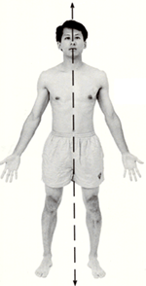
Assess in the following order:
1

1. Neurological Assessment

2. Vital Signs
3
4
2
3. Cardiac Assessment
5
4. Pulmonary Assessment

5. Gastrointestinal Assessment
6
6. Genitourinary Assessment

7. Musculoskeletel Assessment
7

8. Integumentary Assessment
8

1. Neurological Assessment

Alertness, Orientation to person, place, time
Mood, affect
Head: Symmetry of head and face
Eyes: PERRL, Glasses/ Contacts, Read pill bottle label
Ears: Hearing of soft voice from 10 feet away, Drainage, Hearing Aids
Nose: Drainage
Throat/ Mouth: Swallowing, Speech clear or slurred, Oral mucosa

2. Vital Signs
Blood Pressure
Temperature
Apical Pulse
Respirations
Pain
Oxygen Saturation if any
respiratory problems


3. Cardiovascular (CV) Assessment
Heart Sounds
Aortic
Pulmonic
Triscupid
Mitral
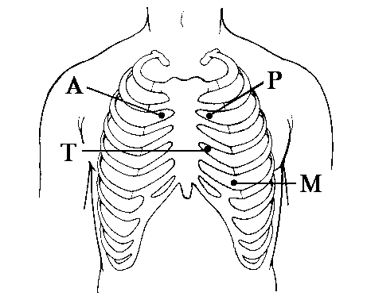

Vascular
Bilateral Radial Pulse
Bilateral Pedal Pulse
Capillary refill less than 3 seconds
Temperature and color of extremities

4. Respiratory Assessment
Lung Sounds
Anterior: 5 Locations
Posterior: 6 Locations
Quality of Respirations
Symmetrical Chest Expansion
Posture: Kyphosis, Scoliosis

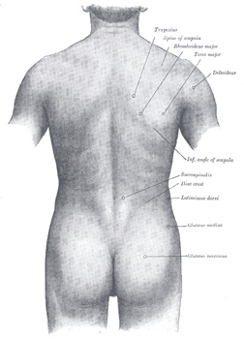
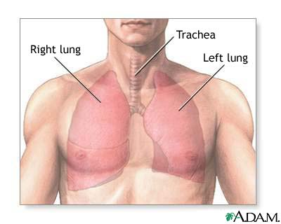
1
2

1
2

1
4
3
4
3
5
6
5

5. Gastrointestinal (GI) Assessment
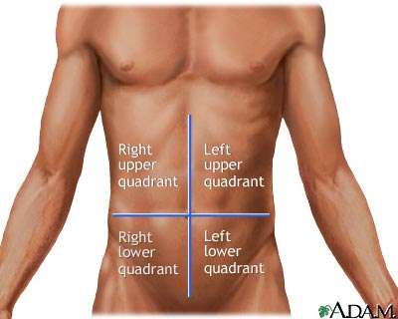
Last Bowel Movement
Constipation
Diarrhea
Nausea, vomiting
Appetite
Bowel Sounds:
4 Quadrants
Abdomen Soft, Firm, Distended, Tender to light palpation

1
2

3
4

6. Genitourinary (GU) Assessment
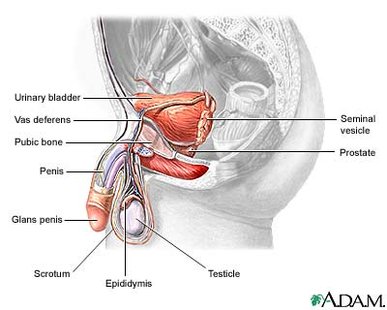
Genitalia: Physical assessment of genitalia is unnecessary unless patient has a current concern. If physical assessment of genitalia is done, note any odors, foreskin if male, STD S/S
Urination: Color, frequency, continence, pain
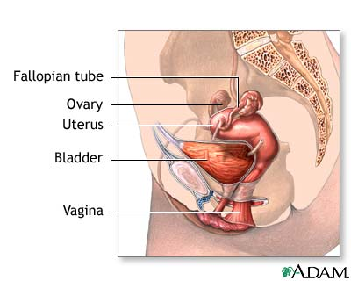

7. Musculoskeletal (MS) Assessment
Symmetry
Strength:
Equal upper extremities
Hand grasp
Equal lower extremities
Raise LE off bed/ chair
Plantar & Dorsal flexion
Muscle tone: spasms
Gait: Steady
Range of Motion of upper and lower extremities

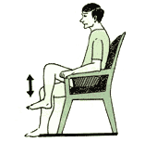

8. Integumentary Assessment
Assess skin turgor on forearm
Assess for edema – LE, UE

Assess for breakdown and other abnormalities:
Assess Feet/ Heels during pedal pulse check
Assess Back and Chest during lung assessment
Assess both Arms and Legs
Assess Perineal Area if history of breakdown or mobility is impaired

Documentation of findings:

Subjective data – Patient’s current health status in patient’s own words (Assessment data)
Objective data – Above basic physical assessment data (Assessment data)
Assessment – Your Analysis of the subjective and objective data (Nursing diagnosis)
Plan – Your plan (Goal, Interventions)

