DIRECTIONS TO SEATTLE DIVISION
VA PUGET SOUND HEALTH CARE SYSTEM
(Veteran’s Affairs Medical Center, Seattle)

1660 South Columbian Way
Seattle, WA 98108
1-800-329-8387
206-762-1010

Directions
GOING SOUTH ON I-5:
- Take I-5 South to Exit 163A "Columbian Way" on the right.
- The off ramp splits to West Seattle or Columbian Way. Veer left onto Columbian Way.
- Merge into the far right lane.
- Proceed through the next two traffic lights.
- At the third light, veer left with the road and get ready to merge into the left turn lane about 500 feet ahead.
- At the next light, get into the left turn lane and turn left. This is the entry onto the hospital grounds.
GOING NORTH ON I-5:
- Take I-5 North to Exit 163 "Columbian Way" on the right.
- Stay in the far right lane and you will merge onto Columbian Way and proceed up the hill.
- Proceed through the next two traffic lights.
- At the third light, veer left with the road and get ready to merge into the left turn lane about 500 feet ahead.
- At the next light, get into the left turn lane and turn left. This is the entry onto hospital grounds.
Parking At VA Seattle

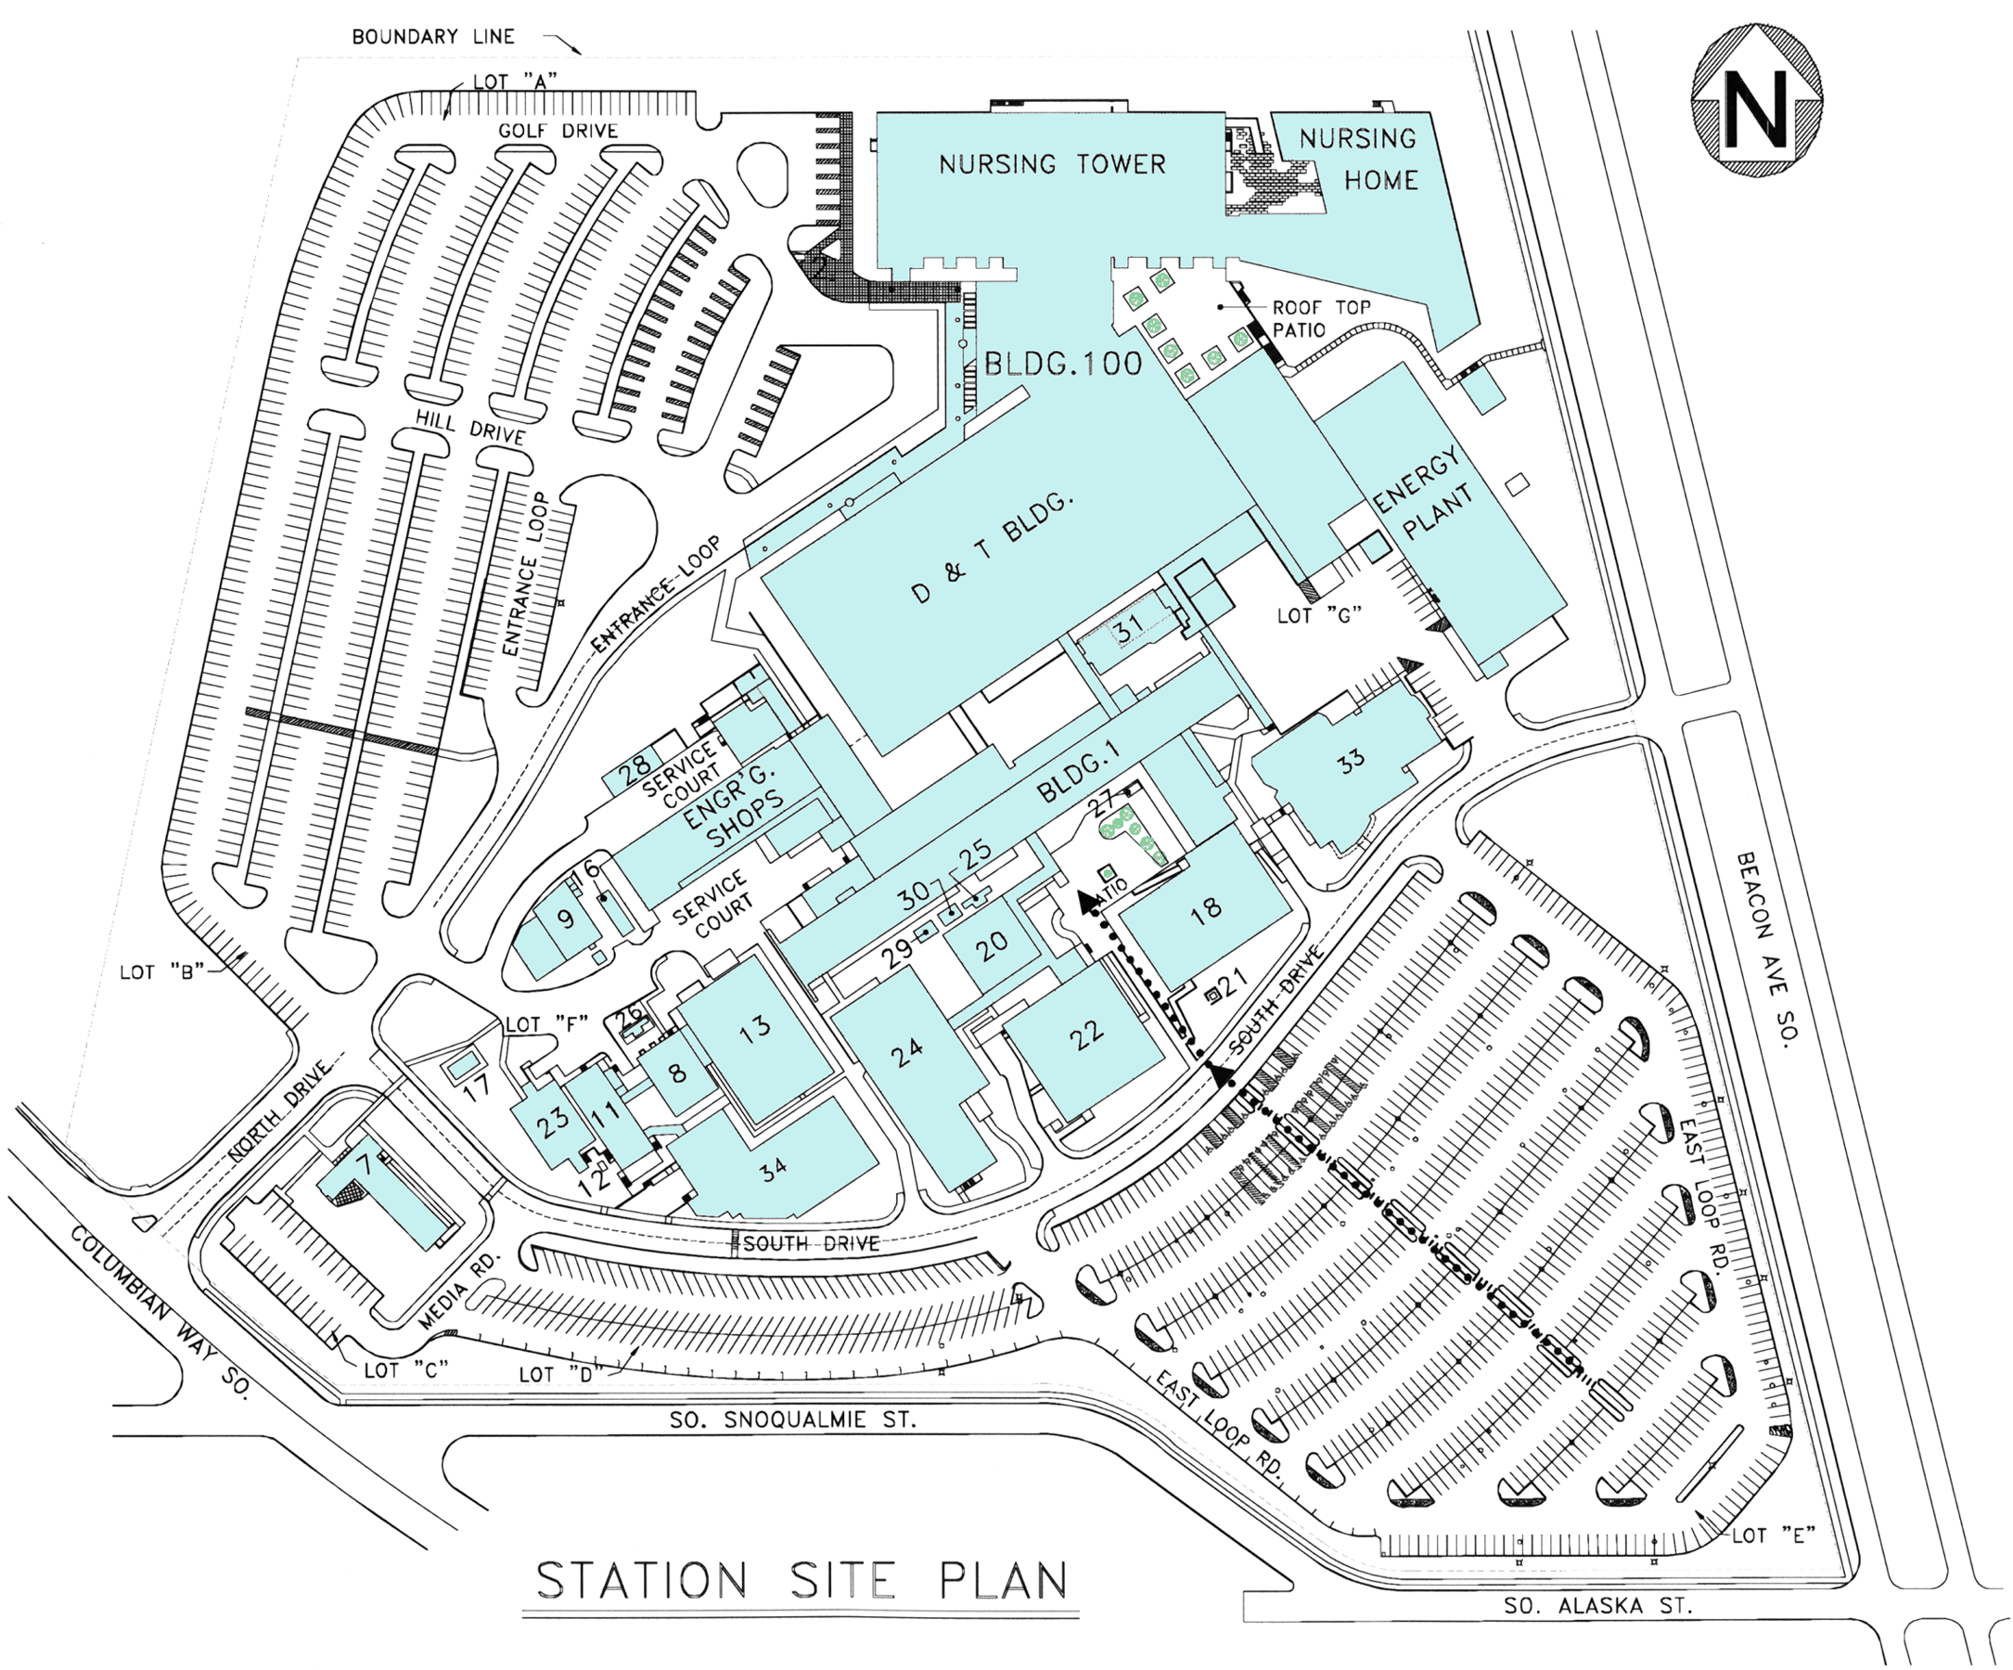
From Freeway
Park on Beacon Ave S on clinical days
Park in Lot E on orientation days
Orientation at Seattle, VA Puget Sound, usually occurs in Building 1. Students may park in Lot “E” for orientation days. During clinical days, parking on campus is discouraged. Students may park on the street on Beacon Ave and enter the Nursing Tower/ Nursing Home from the back path by the smoking area, the roof top patio.
Warning: Please don't leave your valuables in your car in plain view and always lock your vehicle.
The VA Police may provide after hour escorts to parking lots, battery jump starts, vehicle unlocks, and in some cases flat tire assistance (limited to disabled persons). Please contact the VA Police at ext 63113.

