Medication administration techniques
Prepared by zeyad H Alkahlout.(B.S.N, RN MPH)

Subcutaneous (SQ)
- Review medication orders, and check for drug allergies.
- Wash hands, and put on gloves.
- Identify client by checking armband.
- Use 1 - 3 cc syringe and 23 - 25 gauge, 1/2 - 5/8 inch needle. Maximum amount of fluid to administer SQ is 1 cc.
- Choose site: abdomen, lateral and anterior aspects of upper arm or thigh, scapular area of back, or upper ventrodorsal gluteal area.
Note: Avoid areas of bony prominence, major nerves, and blood vessels.
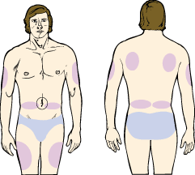
Figure1: Body sites commonly used for subcutaneous injections.
- Wipe with alcohol in a circular motion to cleanse. Allow to dry.
- Pinch skin between finger and thumb. Spread taut if client has substantial cutaneous tissue.
- Insert needle at 45° or 90° angle depending on body size of client: 90° if obese; 45° if average weight. If client is very thin, gather skin at area of needle insertion and administer at 90° angle.
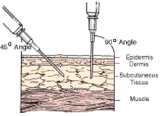
Figure 1A: Insert needle at 45° or 90° angle into tissue for subcutaneous injection.
- Release the subcutaneous tissue, and aspirate prior to injecting medication (except insulin or heparin).
- Inject medication slowly, remove needle quickly, and gently massage site with alcohol swab. Do not massage after the administration of heparin.
Intramuscular (IM)
- Review medication orders, and check for drug allergies.
- Wash hands, and put on gloves.
- Identify client by checking armband.
- Use 3 cc syringe and 20 - 23 gauge, 1 - 2 inch needle. Maximum amount of fluid should be determined by client's muscle mass and site to be injected. Use 2 inch needle with obese client to ensure that medication is injected into a large muscle.
- If amount to be injected for adults is > 5 cc or children > 3 cc: divide dose into two syringes to administer.
- Position client, and locate site using appropriate anatomical landmarks.
- Wipe site with alcohol in a circular motion to cleanse. Allow to dry.
- Spread skin taut, and insert needle at 90° angle with quick, dart like action.
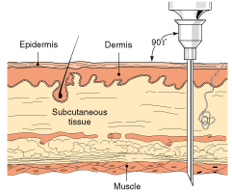
Figure 2: Insert needle at 90° angle for intramuscular injections.
Aspirate, and observe for blood. (If blood appears, remove and discard needle).
- Inject medication slowly, remove needle quickly, and gently apply pressure to site with dry, sterile 2 x 2 gauze. Do not massage injection site.
Deltoid (Upper Arm)
- Use if volume is 0.5 - 1 cc, but not more than 3 cc. Use a 23 gauge, 1 inch needle.
- Client may be positioned sitting, standing, supine, or prone.
- Locate site by measuring 2 - 3 fingerbreadths below the acromion process on the lateral midline of the arm.
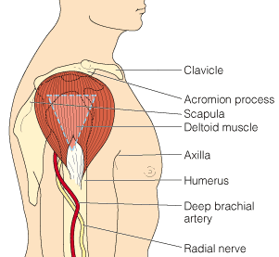
Figure 2A: The deltoid muscle of the upper arm, used for intramuscular injections.
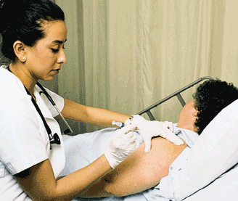
Figure 3B: The upper arm can be used for both intramuscular (IM) and subcutaneous (Sub Q) injections.
- Administer in nondominant arm when possible.
Dorsogluteal (Upper Outer Quadrant)
- Use if volume is 1 - 3 cc, but less than 5 cc. Use a 20 - 23 gauge, 1-1/2 inch needle.
- Do not use this site in children < 2 yr or emaciated clients.
- Position client in side-lying or supine position, with knee flexed on injection side, or prone with toes pointed inward to rotate femur.
- Locate site by palpating the posterior iliac spine where the spine and pelvis meet. Imagine a line from the posterior iliac spine to the greater trochanter. Administer medication above imaginary line at midpoint.
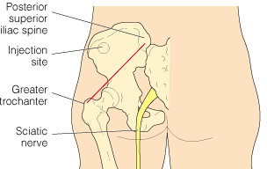
Figure 3C: The dorsogluteal site for intramuscular injections.
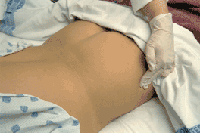
Figure 4D: Locate greater trochanter to identify dorsogluteal site.
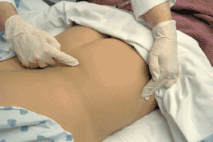
Figure 4E: Locate poster superior spine of iliac crest.
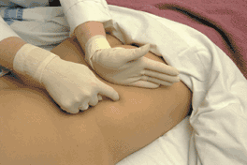
Figure 4F: Draw imaginary line between trochanter and iliac spine.
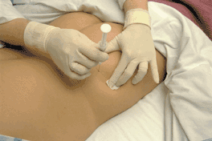
Figure 4G: Inject medication directly into dorsogluteal site at 90° angle.
Ventrogluteal
- Use if volume is 1 - 3 cc. Use a 20 - 23 gauge, 1-1/2 inch needle.
- This is the preferred site for adults and children < 7 mo.
- Position client in supine lateral position.
- Locate site by placing the hand with heel on the greater trochanter and thumb toward umbilicus. Point to the anterior iliac spine with the index finger (forming a "V"). Injection of medication is given within the "V" area.
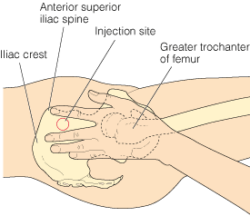
Figure 4H: The ventrogluteal site for intramuscular injections.
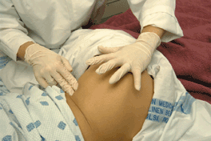
Figure 4I: Identify greater trochanter, and place palm at site.
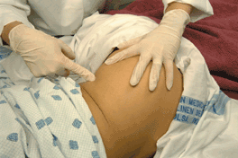
Figure 4J: Place palm on greater trochanter, and point to anterior iliac spine.
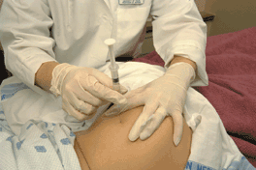
Figure 4K: Inject medication at 90° angle within "V" area.
Anterolateral Thigh (Vastus Lateralis)
- Use 22 - 25 gauge, 5/8 - 1 inch needle.
- This is the preferred site for infants and children < 7 mo.
- Position client in supine or sitting position.
- Locate by identifying the greater trochanter and lateral femoral condyle. Injection site is the middle third and anterior lateral aspect of the thigh.
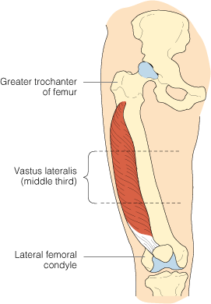
Figure 4L: The vastus lateralis site of the right thigh, used for intramuscular injections.
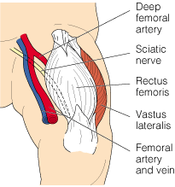
Figure 4M: The vastus lateralis muscle of the upper thigh.
.
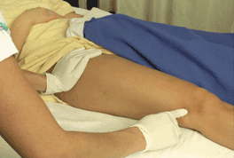
Figure 4N: Identify greater trochanter and lateral femoral condyle.
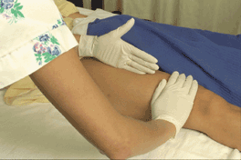
Figure 4O: Select site using middle third and anterior lateral aspect of thigh.
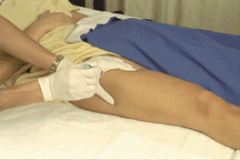
Figure 4P: Inject medication at 90° angle directly into muscle.
Z-Track Method
- Discard needle after medication is drawn up, and use new needle for injection to minimize tissue staining or irritation.
- Use this method when administering injection in ventrogluteal or dorsogluteal sites.
- Displace skin to one side (laterally) before inserting needle.
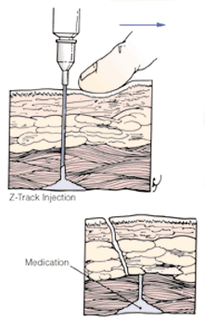
Figure 4Q: Z-track is used to prevent backflow of medication into subcutaneous tissue.
- Insert needle at 90° angle, aspirate, and administer if no blood is present.
- Withdraw needle before releasing skin.
Intradermal
- Review medication orders, and check for drug allergies.
- Wash hands, and put on gloves.
- Identify client by checking armband.
- Use a tuberculin or 1 cc syringe and 25-27 gauge, 3/8 - 5/8 inch needle. Amount to be injected is usually 0.01 - 0.1 cc.
- Choose site: dorsal forearm, upper back or upper chest.
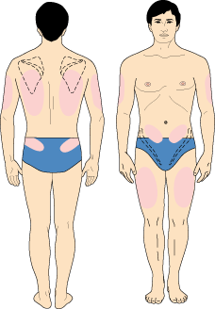
Figure 5: Body sites commonly used for intradermal injections.
- Wipe site with alcohol in a circular motion to cleanse. Allow to dry.
- Insert needle, with bevel facing upward, at angle of 10 - 15°.
- Advance needle until entire bevel is under skin.
- Slowly inject medication to form small bleb.
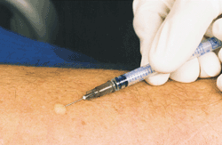
Figure 5A: Inject solution to form wheal on skin.
- Withdraw needle quickly, and pat site gently with sterile 2 x 2 gauze pad. Do not massage area.

Thanks for attention

