Peripheral IV’s for Beginners

This article: the work, the thought, and especially the humor that went into it, is dedicated to the memory of our good friend; hilarious, smart, and loving colleague, Robin Holloway…

Here’s the next in our series for new grads coming into the MICU – this seemed like a pretty useful topic. As we gain experience with putting these articles together, we’re using more embedded links, like this one (try it): http://www.aic.cuhk.edu.hk/web8/Very%20BASIC%20venous%20cannulation.htm - remember that if you’re looking at our articles online, you can click on any of the blue links to open your browser and go to the page that the link came from.

We’re also including some questions for the newbie nurse to ponder, maybe with the help of the preceptor…

Hardware

- What is an intravenous?
  - The bag
  - The tubing
      - the spike
      - the drip chamber: maxi and mini
      - roller clamps
      - pump tubing
      - buretrols and solusets
      - blood tubing
  - The ports
  - What are needle-less connectors all about?
  - The connection to the catheter – what are Luer connectors?
  - The dressing
  - Filters
- What is a heparin lock?
- What does the gauge number mean?
- How do I know if my patient needs an IV or a hep-lock?
- Who inserts IV’s?
- Where should they go?
- How do I choose a catheter size? What do they look like?
- How are IV’s inserted?
- How do I know if my patient’s IV is working properly?

Problems

- How long can peripheral IV’s stay in?
- What does “infiltration” mean? An ugly picture that you do need to see…
- What is phlebitis?
- What is thrombophlebitis?
- What is phlebothrombosis?

Pumps

- What are infusion pumps all about?
- What does “KVO” mean?
- What is a flush line?
- What is the “primary rate”?
- “Secondary rate”?
- How do I figure out where to plug things in to the connectors?
  - Above the pump?
  - Below the pump?

Treatments

- Volume infusions.
- Blood products.
- Types of IV fluids.
- What is a rapid bolus? Something incredibly important!
- How much of a bolus should my patient get?
- What kind of IV fluid should I use for a bolus?
- Intermittent meds
- Continuous med infusions.
- Multiple infusions.
  - Compatibility
  - Incompatibility
- What is a med bolus?
- How do I give a med bolus?
- What is an IV push med?
- How do I give IV push meds?

Peripheral IV’s for Beginners

Hardware

- What is an intravenous?

Most people have some kind of idea what IV’s are about before they get to the MICU, but for new grads, a review of the basics is probably in order, since it’s pretty hard to imagine something more important to patient care. Let’s have a look:

  - The bag
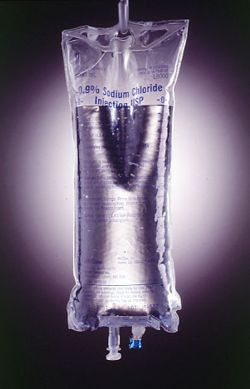

Yup, that’s the bag. Looks like normal saline. Ok new grads, what’s “normal” about normal saline? What does “isotonic” mean? What other commonly used IV fluid is isotonic?

This stuff that’s “clear as crystal” is commonly referred to as “crystalloid”.

Sterile! The entire IV setup has to be EXTREMELY sterile: the bag, the tubing, the connectors, the catheter, the dressing…

Why?

http://www.uthscsa.edu/mw/photogallery/Media/biomed/images/IV_BAG.jpg

b. The tubing

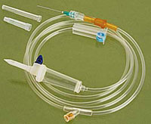

The whole fluid path from the spike to the needle is sterile.

http://www.mediplusindia.com/infusio-trans-dripline-y-set.jpg

      - The spike
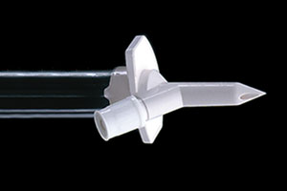

This one’s vented – you use this kind with bottle mixes; it lets air get into the bottle, so the fluid can come out, while with bag mixes, the bag just collapses closed.

http://www.cookurological.com/images/3_05_imgs/3_05_03.jpg

      - The drip chamber

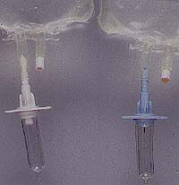
A little hard to see, but the one on the left is “maxi” drip, or ten drops per cc, and the one on the right is “mini” - 60 drops per cc. We never regulate constant infusions by eye anymore – most everything goes on an infusion pump nowadays.

But for a rapid IV volume bolus of something (not meds) – normal saline, Ringer’s lactate, whatever, we still use gravity. Which one of these are you going to reach for? In other words, which one is going to run more rapidly?

http://www.vetmed.wsu.edu/courses_vm551_crd/_archive/fluids/images/drip_chamber.JPG

      - Roller clamps
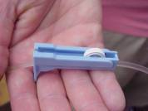
We only use gravity tubing in two situations nowadays: for rapid IV bolus infusions, and for blood. For boluses, the roller clamp has two positions: “all the way open”, and “closed”. For blood – mm… depends. For acute bleeds? – all the way open. Otherwise we titrate by eye to infuse the blood over an hour or two.

http://www.crvetcenter.com/ivflui9.jpg
      - Pump tubing
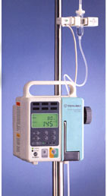

They’re all different. The only thing to do is to learn the system where you’re at. One important thing that’s developed recently: ALL the sets have to self-clamp if they come out of the pump.

Why?

http://www.terumo.co.th/Medical.htm

      - Buretrols and Solusets
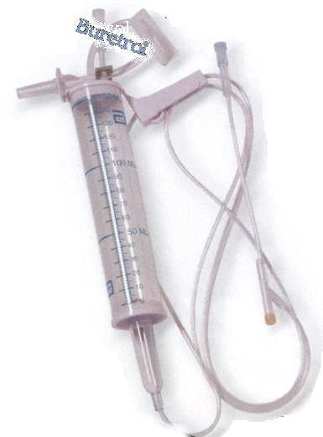

Interchangable names for the same thing, so far as I know. I still use these once in a while for premixed meds – Flagyl comes to mind. The problem is that single doses of intravenous meds really need to be given over predictable periods of time – an hour is usually good for most doses of antibiotics. Vancomycin I usually give over two. The problem is that anything with a roller clamp is never going to be as precise in timed delivery as a pump, so these are rapidly vanishing.

http://www.accd.edu/sac/nursing/math/peds10.html

      - Blood tubing
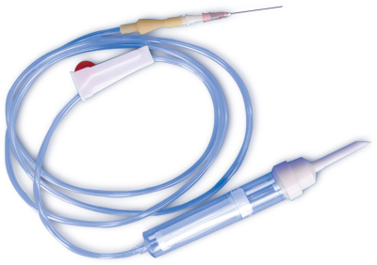

The drip chamber is a bit different for this one – there’s a filter built in to catch debris and the like, anything larger than a red cell…

Open sharp! (Might be a blunt, actually…)
http://www.anhuikangda.com/Upload/Photo/20041012163443.jpg

  - The ports
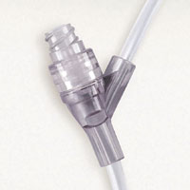

This is where things get plugged into the line. Are you running, say, normal saline at 53.7 cc’s per hour? And you want to plug in the patient’s dose of IV colace? This is where you go…

Wait a second… IV what?
http://www.baxter.com/images/products/medication_management/iv_tubing_and_access_devices/clearlink.jpg

  - What are needle-less connectors all about?

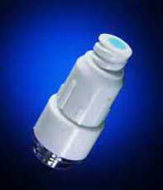
It’s been a LONG time since we used needled connectors, but it’s worth mentioning, I guess. Needles, or “sharps”, as we call them, are generally considered a Bad Thing. This doesn’t mean we don’t use them all the time for various things – we draw up meds with them, we give subcutaneous and intramuscular injections with them… but poking yourself with one – whether it’s been in contact with a patient or not – is pretty much a Bad Thing. People were getting hepatitis from patients, I think there were a few cases of HIV… so the word went out: the fewer needles, the better.
And lo - non-needle connection systems were created. And they were pretty good…

http://www.isips.org/Needle-free_IV_systems.html

  - The connection to the catheter – what are Luer connectors?

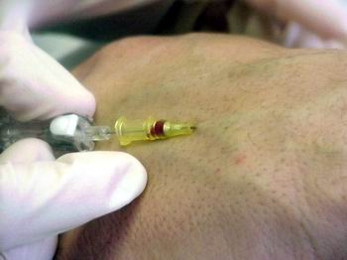
Not a bad picture of the end of the catheter. The tubing actually screws onto the yellow end there – except sometimes it’s blue, or green, or pink, or whatever, usually depending on the catheter size. But the screw technology is pretty uniform, all under the name of Luer connectors. That guy Luer – what a genius!

So – what the heck part of the patient is that, anyhow?

http://www.silverlon.com/images/iv_catheter/iv_catheter_patient1.jpg

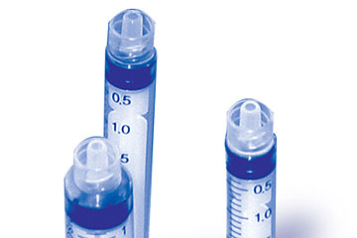
These syringes have female luer connections at the ends.

The catheter hub of the IV, the hubs of injection needles, the connector hubs at the ends of IV tubing – they all use the same size and type of connector, which was probably what developing the Luer standard was all about.

http://img.alibaba.com/photo/50347934/Luer_Lock_Syringe.jpg

  - The dressing

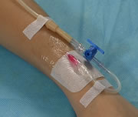
We like to be able to see the site (why?), so we put a clear tegaderm over it…

Change the dressing if it gets loose, or dirty.

http://www.puntex.es/busqueda/descripciones/3M/imagenes/tegaderm.jpg

  - Filters

Some infusions need filtering – this is an inline blood filter that a company makes, I guess for people who don’t use the filtered IV tube sets that we do. (You mean there are OTHER hospitals in the world? OMG!)

Patient’s with PFO’s need air filters attached to ALL their IV lines.

Why?

http://www.celanesechemicals.us/print/celanexbloodfilter_ticona.jpg

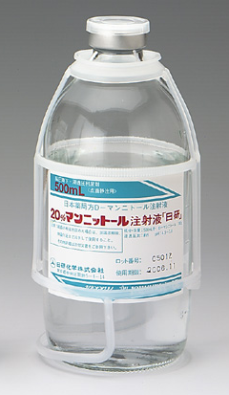

Mannitol needs to be filtered. Crystals! There’s a special little filter thingy that goes on the end of the infusion line.

Well – they SAID it was mannitol…

http://www.nikken-chemicals.co.jp/medical/pictures/images/mannitol_inj.jpg

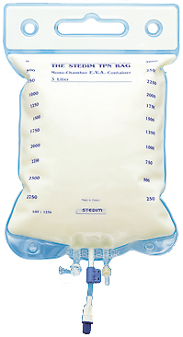
TPN is always filtered – check with the pharmacy to make sure which filters to use for which.

www.stedim.com/parentlbags.html

- What is a heparin lock?

Trick question! A peripheral IV that’s been capped and flushed with saline is still called a “hep-lock” nowadays, but we flush very few lines with heparin any more – dialysis catheters come to mind, and even they get flushed with ACD these days. More and more patients are being found sensitive to heparin – someone in the group tell us what HIT is, please?

- What does the gauge number mean?

I think I have this right – this is a pretty antiquated measurement system, based on the number of tubes that will lie, next to each other, in the space of an inch. Inch? Wow – that IS old… so an 18 gauge catheter? – 18 of them will lie in the space of 2.54 centimeters. 20 gauge? Um… I give up! But it explains why higher numbers means smaller catheters, right?

- How do I know if my patient needs an IV, or a hep-lock?

I don’t think any patient sick enough to be in the MICU should have less than two IV’s – whatever they’re getting, they probably really need! What are you going to do when the only line they have suddenly infiltrates, and they’ve got nothing?

- Who inserts IV’s?

We do. I happen to think that the more you can do for your patient, the better, as long as you’re staying in constant practice, and these skills are practiced all the time in the MICU. Different institutions have different rules: some places only let IV nurses place peripheral lines, some places let all nurses do it – go with what your local rules say. We do have an IV team, and they really are amazing - they can get lines in rocks, seems like.

- Where should they go?
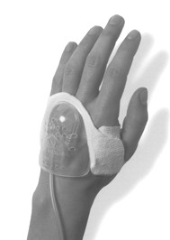

In practice, we stick to the arms for peripherals. Only very rarely will a patient get an IV in a foot – it’s risky for dislodging DVTs…

Hands are good…

http://www.asaging.org/awards/awards02/images/ivhouse.jpg

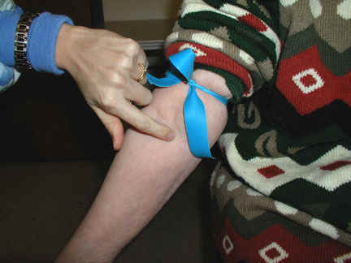

I like antecubital veins. I know that people will sometimes try to avoid them for one reason or another – the patient might need them if they get really sick!

What’s wrong with that statement… ?

http://www.eyetec.net/group5/images/inject2.jpg

- How do I choose a catheter size? What do they look like?

What are you going to be running through the line? It’s pretty hard to run blood through a tiny little 22-gauge IV. An 18 is good for giving blood – once in a while a patient with really excellent veins will come up from the ER or the OR with a couple of 14’s in place. (14’s are BIG IV’s…)
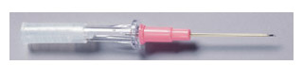
This is what I would call a 20 gauge straight angiocath… this is the one that we use for arterial lines, too. See the stylet in place, sticking out beyond the top of the catheter?
http://www.rimed.com.br/img_produto/3562.jpg

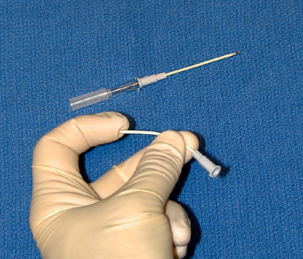

On top, the stylet in place – after insertion, the stylet comes out, leaving the soft, bendable catheter in the vessel.

Hm – gray hub – that a 14? Wooo…

http://www.med.umich.edu/anes/tcpub/glossary/graphics/anesthesia_glossary-75.jpg

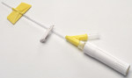
Then there’s the butterflies – we use these a lot. What the heck size is a yellow one? 24? Wow – too small!

http://grogans.com/gimages/product/BD383323.JPG

For continuous infusions of crystalloid, intermittent meds, most situations, we use 20’s and 18’s.

- How are IV’s inserted?

Here’s a link to look at: http://www.aic.cuhk.edu.hk/web8/Very%20BASIC%20venous%20cannulation.htm

There’s no lack of insertion guides, classes, certification programs, trainings… you just need to find the one near where you are, and learn what they have to teach you. That said, there’s a couple things we can mention here…

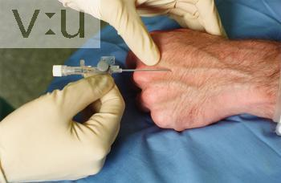
This is pretty good technique. Nice and flat relative to the hand (not coming in straight down). Nice veins! You know you’re starting to get into it when you admire strangers’ veins at the bank…

Learning to find un-obvious veins is tricky – it comes with practice, so get as much as you can.

http://img.photobucket.com/albums/v219/julsitos/1517.jpg

- How do I know if my patient’s IV is working properly?

Well… there are certain basics: for one, the catheter is supposed to be in the vein. How can you tell if the catheter is in the vein?

Couple of tricks:

- if you’re running the patient’s IV fluids through a gravity line, open the roller clamp, unhook the bag from the hook, or the pole, or whatever else it’s hanging from, and lower it down below the level of the bed. What should you see backing up in the line?

- Another way to do the same thing without unhooking things: crimp the IV tubing with your fingers. Now with the other hand, squeeze the tubing below the crimp, and release. Get a blood return?

- Third trick – sometimes you just can’t get a blood return. This doesn’t mean the IV’s no good, but it can be hard to tell. Try this: hang your gravity bag up so you can see the drops falling in the drip chamber. Now compress that patient’s arm a couple of inches up above where the IV catheter should end. Did the dripping stop? What does that mean? What if it didn’t?

Problems

- How long can peripheral IV’s stay in?

Where we work, they’re supposed to stay in no longer than three days. If a peripheral site looks ok, and you’re stuck for other access, you might not want to pull it even if it’s older than it should be. Talk to the team about your patient’s access needs.

- What does “infiltration” mean? An ugly picture that you do need to see…

Sometimes the tip of the catheter pokes its way out of the vein into the surrounding tissue, and what’s going through the catheter goes into the tissue spaces instead of the vein where it was supposed to be. If the fluid is something isotonic, like normal saline or D5W, then this is usually not a big deal, and once you recognize the problem and stop the infusion, the fluid is rapidly absorbed by the tissues and the swelling goes away.

What if the fluid has potassium in it? Vancomycin? Dopamine?

The trick of course is to recognize what’s happening – which is why checking your peripheral infusion sites is one of the first things you do in your assessment survey.


That’s a pretty good one. Might’ve been something with K+ in it…

http://162.129.70.33/images/infiltrate_2_011220.jpg



Sorry about this one, but you do need to know – this might’ve been peripheral dopamine. If a vasoconstrictive drug gets into the tissues… this is why we use central lines for pressor drips.

www.healthsci.utas.edu.au/.../issues/iv/iv_infil.htm.

- What is phlebitis?

“Inflamed vein.”, right? The vein is becoming sore, and unhappy. If you see a red streak tracking upstream from an intravenous site, this is probably your problem. Your patient’s problem!

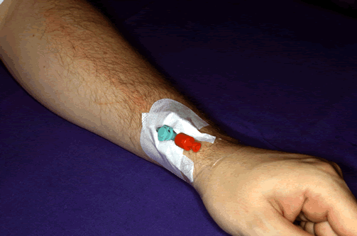

http://www.gefaesschirurgie-bremen.com/Lexicon/Suchwoerter/Grafiken/thrombophlebitis.gif

I left this image big, because the phlebitis is hard to see otherwise. Can you see the reddening, heading north from the stick site? This IV needs to come out. Soon!

But! What if this is your patient’s only IV?

It still needs to come out. Get a new one in as soon as you can, then get this one the heck out.

Can’t get another one? Call the IV team. Call the medical team – has the patient run out of veins?

What could you do?

- What is thrombophlebitis?

This is phlebitis, caused by a clot in the vessel. This is rather worse, and can obstruct flow back from the affected limb.

- What is phlebothrombosis?

This is the obstruction of a vessel with a clot, but without the inflammation. Ok, who’s the wise guy with the big words?

Pumps

- What are infusion pumps all about?

We use these all the time, and they’ve almost completely replaced gravity drips for everything.
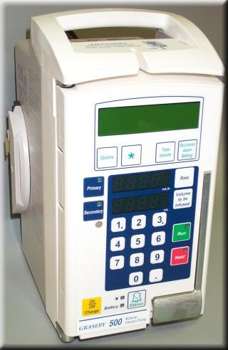

This happens to be the kind we use – we hate them every time we get new ones – then we get used to them… then after a few years we get to hate some newer ones. They’ll try to tell you that change is good, but…

Of course, the fluid is pumped towards the patient through whatever kind of tubing comes with the particular pump your institution bought. All of them need part of the tubing to sit inside the pump – this one has three little ball chambers in a row that sit in little openings, and is held in place with little prongs. You learn to use ‘em…

If the little pump chambers aren’t full, the pump will holler at you – this is technically known in our unit as “having air in the balls”.

http://www.qmc.nhs.uk/Divisions/Diagnostics/MESU/images/Graseby%20500%20Infusion%20Pump.jpg

These big pumps are for volume infusions: D5NS with 20 of KCL at 100/hour – stuff like that. We also use them to give antibiotics – most antibiotics like to be given over an hour, and the pumps pretty much guarantee properly timed delivery. I give Vancomycin over two hours – why?
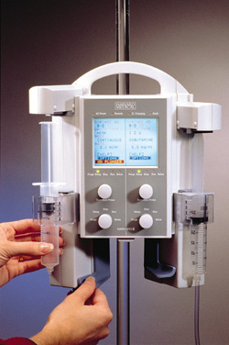
Then there’s these guys – syringe pumps? We’ve used these for a lot of our pressors in recent years, and while we’ve gotten used to them, there’s are a couple of reasons not to like them, which I’m going to try to explain:

A syringe mix of almost anything is – by definition – extremely concentrated. That’s fine – lots of patients can’t handle a lot of IV fluid – renal failure patients, CHF patients – like that.

But think about it – you may be delivering your drug at one cc per hour. Is that enough to keep the blood vessel open?

Also – if you’re using a pressor – how quickly will your patient “see” a change in rate from one to two cc’s per hour?

Now hold that thought for a minute while we go on.

http://www.devicelink.com/mpmn/97/05/9705_18b.jpg

- What does “KVO” mean?

The pump will also holler at you if the line is blocked – is the IV tubing kinked? It’s worth remembering that it does take a certain amount of flow to “keep the vein open”, so that the blood vessel doesn’t clot itself off – lots of opinions about this, as usual, but you really need to keep something running through the line at a rate of at least 10cc per hour to keep things infusing smoothly. This is why we always use flush lines for slow infusions, and for any drug being delivered by syringe pump.

- What is a flush line?

It’s a simple idea – suppose you’ve got a patient on an insulin drip, and the insulin is mixed one-to-one. One unit of insulin in one cc of diluent – right? If you run that drip by itself, is that enough volume to keep the vein open? Probably not. So - rig a normal saline line with a stopcock manifold at the end, and plug in the insulin at the manifold connector, like this one:


The end of the IV line goes here.

Connect the insulin, fentanyl, versed, whatever, to the female luer connectors, down here…

http://www.smtl.co.uk/Datacards/IV/images/manifold-2-tap.gif

But - why use this fancy stopcock business? Why not just plug the insulin into one of the line ports on the main IV tubing?

Well – you could do that. People do do that. But – suppose you were doing your q2 hour glucose check, and your patient’s blood sugar was 52… ok – you stop the insulin. What’s the problem?

The problem is that the whole length of IV line from the port downwards – from where the drip was connected – is still full of the insulin solution, been driven into the patient by the flush line. Are you going to want to take the whole line down? Nah… just disconnect it from the stopcock, all the way close to the patient. No problem!

- What is the “primary rate”?

You can set the infusion pumps to deliver fluid at a fixed rate – right? D5NS at 100 hour? And the pump will run until the bag goes dry, or until it reaches the end of the volume you’ve told it to give – say, 900 of the liter bag you hung. That’s your primary rate.

- “Secondary rate”?

Suppose you want to give a rapid dose of something being pumped – the one that comes to mind is propofol. Say your patient is doing fine on 10 cc of propofol per hour, but now you have to suction him, and you know from experience that he bites his ET tube closed when you do. Bad. What to do? Give him a little squirt of sedative? Probably a good idea. (Offically, this is called a “bolus”.) How we do this?

Our pumps have a secondary rate setup: this means, “Ok pump, what I want you to do is to give the stuff you’re pumping at a different rate, but only for a while, and then go back to what you were doing before”. So – in this case – I would set the secondary rate at something fast – say, 500cc per hour, and set the volume for 2cc. This would zip in 20mg of propofol as a bolus dose – the pump would then go back to the regular delivery rate. The patient would relax, the suctioning would go smoothly, no biting, all would be well. Nice trick.

Bear in mind that small – gauge IV’s don’t like really rapid infusions – 22’s and the like will not work well if you set a pump at a really rapid rate – so I usually set my secondary rates at 555 cc/hour or something, instead of 999.

- How do I figure out where to plug things in to the connectors?\

These guys.

  - Above the pump?

Someone wrote in to ask this one – and since there are no dumb questions – we’ll answer it here: are there any connectors above the pump?

  - Below the pump?

Has to be – they only put the connectors below the pump on the tubing. But would a newbie nurse know that? Well – she ought to. But who know what they’re learning in nursing schools now? Alteration in cosmological reality of the human spirit, potential versus actual? I don’t care! But they should be teaching them how to run infusion pumps!

Treatments

- Volume infusions.

We mentioned these before – this is your simple, plain-vanilla volume-over-time infusion of something really simple: normal saline at 80cc per hour. D5W with 20 of K at 100 hour. Stuff like that.

- Blood products.
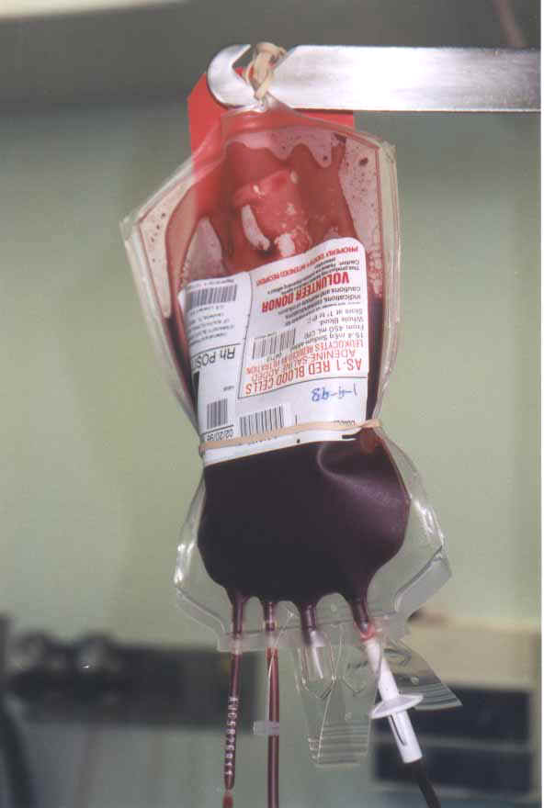

Mostly, we still give blood by gravity – hang it up with a filtered tubing set, open the roller clamp, and time it so it runs in over an hour or two.

http://www.castenholz.org/ptguide/Blood.JPG

- Types of IV fluids.

These take a bit of learning about, but one thing to understand is the idea of tonicity – some fluids are equal to blood in concentration, some are more, and some are less. Hypertonic: more concentrated. Hypotenic: less. Iso – the same.

The point is that solutes in the body – in the blood and in the cells, are going to respond to whatever IV fluid you give your patient.

Most of the time, your patient who needs hydration is going to want some kind of isotonic IV fluid – something like normal saline – D5W. Maybe with a little KCL…

Thinking about how different IV fluids act on your patient is something that comes with time. It’s more complex than it seems, so work with them for a while and see what situations call for what kinds of fluids – then study up some more.

- What is a rapid bolus?

Sometimes you want to give a whole lot of volume, really quickly. Gravity is still the best way – the pumps will go up to about a liter per hour, but if you really want to give volume at high speed, hang your liter of saline way up on the pole, open the clamp and watch it fly in. You’ll need the right kind of access – an 18 gauge in a large vein will do just fine. Central lines are even better – a cordis is the piece of hardware you want in this situation. Take a look at the FAQ on “Central Lines” for lots more on that topic.

Lately with the advent of “guided sepsis therapy”, the volume resusciation has gotten a LOT more aggressive: we see the docs running something like 6 to 8 liters of fluid into a septic patient in the first couple of hours… wow!

A word about giving these rapid boluses – sometimes you’ll see people do this by squeezing the IV solutions, with one of the white pressure bags that we use to keep A-lines pumped up. This is ok, but it needs to be done the right way:

Something incredibly important!

Look at this bag. Hasn’t been spiked yet – hmmm… what’s that, inside the bag, up at the top?

Ok – now, suppose you put this bag under pressure, to push the IV fluid into the patient?

What happens when the fluid runs out?

What is an air embolism?

How could you avoid one?

http://www.uthscsa.edu/mw/photogallery/Media/biomed/images/IV_BAG.jpg

Simple: before giving a bolus this way – spike the bag upside down. Squeeze the bag with the line clamp open to get all the air out of the bag. Then hang it up, and off you go!

Don’t forget!

- How much of a bolus should my patient get?

Well – what are you trying to do? Raise her blood pressure? Is she really dry? Or is she oversedated? My point is that your treatment decisions always depend on the context – lots of patients become hypotensive to one degree or another when they’re sedated – to you give them a lot of fluid? Or “touch” them with a bit of neo?

You’ll gain experience in figuring out whether your patient is “wet”, or “dry” – partly it’s about the CVP, or the wedge – partly it’s about how much pee they make, partly it’s about whether or not they’re septic and having leaky capillaries, partly it’s about how well nourished they are comng in, and what their serum albumin is (why?)… it’s about a whole lotsa stuff! Your job as a newbie in the unit is to absorb, osmose, and learn – gain experience – and let it all soak in. Just be aware, at the beginning, that there’s more to it than just adding up the Ins and the Outs…

A puzzler for the newbie nurse and her preceptor: your patient has, say, ARDS. He’s on the vent, on 100% oxygen, a rate of 26/minute, and 15 of PEEP. His CVP is 10. Why’s he only making 10cc of urine an hour?

- What kind of IV fluid should I use for a bolus?

We usually use normal saline for “volume resuscitation”. This works well for a while, but after many liters, patients can develop a hyperchloremic acidosis – it can be pretty severe, too. At this point we usually switch to Ringer’s Lactate.

- Intermittent meds

Yup – as we looked at earlier: most doses of intermittent meds do NOT want to be infused too rapidly – most antibiotics like to go in over an hour. I clearly remember reading an article about an antibiotic error on an otherwise healthy young person: some med, a dose of antibiotic, was pushed, rather than dripped into her – she coded, and died a couple of days later. Anaphylaxis? Hard to know – most people survive anaphylactic events in the hospital – and this was a preop dose, given in the OR! Anyhow – as always – check with your local authorities and references. Slower is better. To a point ☺

- Continuous med infusions.

Yup, we run em all the time. Heparin bag mixes, propofol drips, all sorts of continuous bag mix drips that have to be run at fixed doses, every hour. We ancient nurses were sitting around telling stories last weekend: we remember dropping whatever number of cc’s it was into a burette EVERY HOUR – usually of heparin – and infusing a controlled volume that way, before infusion pumps became common.

- Multiple infusions.

Lots of old sayings about “bad signs”: “it’s never good when a patient’s white count is higher than her hematocrit”. That’s true. Another one is that it’s never good when the patient is surrounded by a forest of pumps – more than six – not a very good sign.

It makes for a lot of things to think about, doesn’t it? Not least of which is the fact that a lot of these meds may not like each other, may actually form precipitates or crystals in the IV tubing if you try to make them run together.

  - Compatibility

An important concept, and one that you have to make sure you check. Will these meds run together in the line, or will they create smoke and flame, or whatever? Not that I’ve ever seen that, but I have seen lines go crystallized along their length. This is certainly not good for the patient. It almost always means the loss of the catheter as well, which can be pretty tough to deal with in a grossly edematous patient on a zillion drips.

  - Incompatibility

What we were saying ☺. We use an online compatibility reference. Make sure – every time.

- What is a med bolus?

Didn’t we talk about propofol up above, a while back? You can use the infusion pumps to give bolus doses over time: heparin comes to mind, propofol… make sure you understand how to set up the pump to do this.

- What is an IV push med?

Now you’re getting into serious territory. The old saying is quite true: once you push a med into a patient, you ain’t getting it back! Although how you’d get other meds back isn’t quite clear… you really need to remember to take the time, every time, to do all those right things: right drug, right dose, right patient, all that – every… single… time. You just do! And you need to refresh your memory on how fast these drugs can be given – also every single time. Heparin for example: I think it’s supposed to be pushed at no more than 1000 units per minute. Digoxin doses are supposed to be given over a couple of minutes. These rules don’t exist because some mean unpleasant person decided they wanted to tell other people what to do all day – these rules exist because giving these meds too fast can hurt your patient!

Take the time to think about how fast your patient is going to see this drug. It’s hilarious sometimes to see some intern grab an IV line, grab a med, push the drug into a port eight feet away from the patient without clamping the line above the port, stand back, and be amazed when magical things DON’T happen… why is it that doctors develop this idea that they can turn to a nurse and say: “Make such and such happen immediately, nurse!” . This same idea applies to things like IV meds – they’ll decide they need to give it – shove it into the line, probably most of it goes back up towards the bag – then stand back with the line not running, and wonder why their treatment hasn’t produced a miracle cure.

Then they’ll turn to you, and in this patronizing way tell you how much they have to learn from you…

Then they come back in a year and they REALLY want to know what you think…

- How do I give IV push meds?

Well – there’s a way, and you need to know. First, the IV has to be working, right? Not sort of, not maybe, not kind of, not iffy – it’s either working, or it ain’t. If it ain’t – don’t use it. If a rotten IV is the only one your patient has, do all the tricks to try to see if there’s a blood return. If there isn’t, try to impress on the doctor’s head the fact that you have no reliable IV access – they hate this kind of thing – reality intruding, as it interrupts their intellectual process. However, it’s not your fault if the patient has no veins.

I clearly remember an anesthesiologist who insisted on using the IV that some patient had, which was clearly infiltrated, until I practically tied him up in a corner while I put in a new line. Interrupted his discussion – very annoyed. Sorry, dude.

Let’s use the instance of intubation to talk about pushing IV meds – it’s something you’ll see often enough, and it’s a good example of how it needs to be done properly.

Now – what you’re going to be giving here are the push meds for the anesthesiologist. Etomidate, maybe – maybe some propofol. Maybe some succinylcholine – I hate that stuff.

What you want to do is to rig a gravity flush line, with maxi drip tubing. Got that? Liter bag of saline, with a drip chamber halfway full, that you can visibly see dripping. All set?

Now – got a good vein? Nice blood return? All hooked up? Get the gravity line running. Now pick a port close to the patient. Plug in the drug syringe. Use an alcohol swab.

Ok? Now – crimp the IV tubing above the injection port with your other hand. This prevents what you’re pushing from going backwards, up the IV, towards the bag, instead of towards the patient. If you do it wrong, you’ll know right away, because the drip chamber will fill up…

Now push – slowly. Give the etomidate over at least thirty seconds. Propofol the same – ask the anesthesia person how fast, if you’re not sure. (No comment…)

Now let go of the crimp in the tubing – let the gravity flow flush the med into the patient.

And there you are! So cool!

