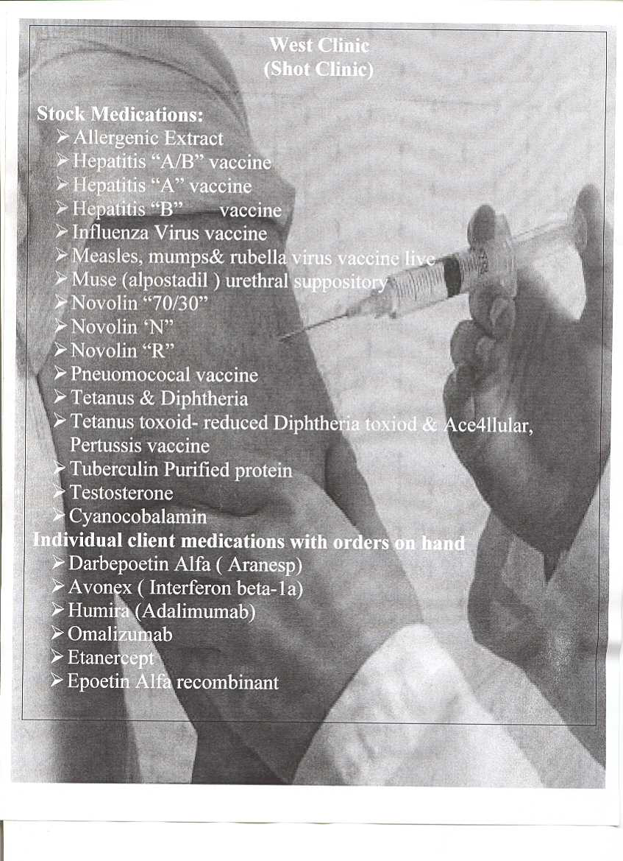

* Zoster Vaccine, Live,