First Semester Review:

Standards covered first quarter:

- Determine and use appropriate safe procedures, tools, measurements, graphs and mathematical analyses to describe and investigate natural and designed systems in a physical science context.

- Demonstrate the conversion of units within the International System of Units (SI, or metric) and estimate the magnitude of common objects and quantities using metric units.

- Distinguish between mass and weight.

Topics, Demonstrations or Labs:

What is Science?, Egg in a bottle, Yeast, Soap and Hydrogen Peroxide, Markers and Alcohol, Mobius Strip, Two Loop Airplane Lab, Candle Lab, Rocket Lab, Milk Lab, Mass, Volume, Length and Science Safety.

Safety Contract:

1. Conduct yourself in a responsible manner at all times in the science room. Horseplay, practical jokes, and pranks will not be tolerated.

2. Follow all written and verbal instructions carefully. Ask your teacher questions if you do not understand the
instructions.

3. Do not touch any equipment, supplies, animals, or other materials in the science room without permission from the teacher.

4. Perform only authorized and approved experiments. Do not conduct any experiments when the teacher is out of the room.

5. Never eat, drink, chew gum, or taste anything in the science room.

6. Keep hands away from face, eyes, and mouth while using science materials or when working with either chemicals or animals. Wash your hands with soap and water before leaving the science room.

7. Wear safety glasses or goggles when instructed. Never remove safety glasses or goggles during an experiment. There will be no exceptions to this rule!

8. Keep your work area and the science room neat and clean. Bring only your laboratory instructions, orksheets, and writing instruments to the work area.

9. Clean all work areas and equipment at the end of the experiment. Return all equipment clean and in working order to the proper storage area.

10. Follow your teacher’s instructions to dispose of any waste materials generated in an experiment.

11. Report any accident (fire, spill, breakage, etc.), injury (cut, burn, etc.), or hazardous condition (broken equipment, etc.) to the teacher immediately.

12. Consider all chemicals used in the science room to be dangerous. Do not touch or smell any chemicals unless
specifically instructed to do so.

13. Handle all animals with care and respect.

a. Open animal cages only with permission. b. Never handle any animals when theteacher is out of the room.
c. Do not take animals out of the science room. d. Do not tease or handle animals roughly.

e. Keep animals away from students’ faces. f. Wear gloves when handling animals.

g. Report any animal bite or scratch to
the teacher immediately.

14. Always carry a microscope with both hands. Hold the arm with one hand; place the other hand under the base.
15. Treat all preserved specimens and dissecting supplies with care and respect.

a. Do not remove preserved specimens from the science room. b. Use scalpels, scissors, and other sharp
instruments only as instructed.

c. Never cut any material towards you—always cut away from your body.

d. Report any cut or scratch from sharp instruments to the teacher immediately.

16. Never open storage cabinets or enter the prep/storage room without permission from the teacher.

17. Do not remove chemicals, equipment, supplies, or animals from the science room without permission from the teacher.

18. Handle all glassware with care. Never pick up hot or broken glassware with your bare hands.

19. Use extreme caution when using matches, a burner, or hot plate. Only light burners when instructed and do
not put anything into a flame unless specifically instructed to do so. Do not leave a lit burner unattended.

20. Dress properly—long hair must be tied back, no dangling jewelry, and no loose or baggy clothing. Wear aprons when instructed.

21. Learn where the safety equipment is located and how to use it. Know where the exits are located and what to do in case of an emergency or fire drill.

Metric System:

Length: Tool : Meter Stick

Vocabulary:

Meter (m) (perfect sword length) 100 cm, 1,000 mm and 1/1000 of a kilometer.

Kilometer (km) (.6 miles) 1,000 meters, 100,000 cm and 1,000,000 mm

Centimeter (cm) (about the thickness of a pinky) 10 mm and 1/100th of a meter

Millimeter (mm) (about the thickness of a penny) 1/1000th of a meter and 1/10th of a centimeter.

Zero Line The first line which you measure from.

Volume: Tools: Meter stick, Beaker, Graduated Cylinder

Vocabulary:

Liter (L) 10cm × 10cm × 10cm or 1,000 milliliters

Milliliter (mL) (a dice full of water) 1/1,000 of a Liter

How to Measure Volume:

- Measure and multiply: Length, Width, and Height
- Pour into a beaker or graduated cylinder and identify the bottom of the Meniscus.
- Fill a beaker or graduated to a specific volume. Drop the object you measuring into the water and identify the change in volume.

Mass: Tools: Triple Beam Balance

Vocabulary:

Kilogram: (kg) (mass of a 1 liter of water) 1,000 grams and 1,000,000 milligrams.

Grams: (g) (mass of a dice full of water) 1/1,000 of a kilogram and 1,000 milligrams.

Milligrams: (mg) (mass of a bee) 1/1,000 of a gram.

How to Measure Mass:

- Put object on balance and align weights starting with large weight and moving to smallest weight.

Scientific Method:

1. Question: (About a relationship between two variables)

2. Variables:

-Changed Variable (Those things that are changed by the investigator; Sometimes referred to as the independent or manipulated variable)

-Measured Variable (Those things that are measured by the investigator; Sometimes referred to as the dependent, responding or observed variable)

-Controlled Variables (Those things that are kept the same)

3. Hypothesis (A prediction of what the investigator thinks will happen)

4. Controlled Experiment:

-Materials Needed (Materials needed for the experiment)

-Procedures (Description of procedure)

5. Results/Evidence

-Qualitative Observations: Information collected with your sense. (no numbers)

-Quantitative Data (To include 1. tables, 2. graphs-line graphs, scatterplots, circle graphs and histograms, 3. statistics-mean median and range if applicable)

6. Conclusions/Explanations (To include: 1. Explanations based on results/evidence and 2. Predictions based on results/evidence. May include: 1. Sources of error, 2. Revisiting the hypothesis and 3. Future controlled experiment questions)

Mass and Weight

Mass:
-amount of matter something has.

- grams, kilograms, milligrams

-Constant
Weight:
-amount of force applied by gravity.

-Based on location
-Both
measurement

Standards covered second quarter:

Explain density, dissolving, compression, diffusion and thermal expansion using the particle model of matter.

Identify evidence of physical changes, including changing phase or shape, and dissolving in other materials.

Use the relationship between heat and the motion and arrangement of particles in solids, liquids and gases to explain melting, freezing, condensation and evaporation.

Describe how mass is conserved during a physical change in a closed system.
For example: The mass of an ice cube does not change when it melts.

Identify evidence of physical changes, including changing phase or shape, and dissolving in other materials.

Identify a common engineered system and evaluate its impact on the daily life of humans.
For example: Refrigeration, cell phone or automobile.

Recognize that there is no perfect design and that new technologies have consequences that may increase some risks and decrease others.
For example: Seat belts and airbags.

Describe the trade-offs in using manufactured products in terms of features, performance, durability and cost.

Explain the importance of learning from past failures, in order to inform future designs of similar products or systems.
For example: Space shuttle or bridge design.

Apply and document an engineering design process that includes identifying criteria and constraints, making representations, testing and evaluation, and refining the design as needed to construct a product or system that solves a problem.
For example: Investigate how energy changes from one form to another by designing and constructing a simple roller coaster for a marble.

Labs or Demonstrations:

PT flyer lab, meter stick lab, gum lab, food coloring, Thermal Expansion, Colored water density and Bar of soap/microwave.

Engineering Design Process:

- State the problem:
Find a situation or product that can be improved.
a. Evaluate Design
b. Ways to improve:
- Performance
- Features
- Durability
- Cost

- Generate Ideas
Create representations of possible prototypes:
a. Evaluate these representations with the following criteria:
- Cost
- Feasibility
- Durability
- Materials
- Ethics

- Select Solution
Choose a prototype based on your evaluation

- Build your Prototype:
Build affordable and functional prototype that can be tested farther.

- Evaluate:
Test the product considering the characteristics used in the generated ideas portion of the design process.

- Present Evaluation and Findings:
The presentation should answer basic questions using data and representations of the data.
- Will the prototype solve the identified problem?
- Is it affordable, durable, ethical, feasible and functional?

Chemistry:

The study of matter and the changes that it undergoes.

Vocabulary:
Matter: Anything that has mass and takes up space.
Phases of Matter: Solid, Liquid, Gas and Plasma.
Atom: The smallest particle of an element that retains the properties of that element.
Proton: The positively charged particle in the nucleus of the atom.
Electron: The negative charged particle that is surrounds the nucleus.
Neutron: The neutral particle in the nucleus of the atom.
Nucleus: The center of the atom which contains the protons and neutrons.
Periodic Table: A table of elements which are organized by their atomic number.
Atomic Number: The number of protons in the nucleus of an atom.
Atomic Weight:The average mass of an atom of an element in atomic mass units.
*The atomic mass is used to determine the number of neutrons in the atom by subtracting the atomic number.
Element: A pure substance that cannot be broken down.
Physical Properties: A property of a substance that can be observed without changing its characteristics. Example: Shape, color, phase, boiling point, etc.
Density: Mass per volume.
Diffusion: the spread of particles from areas high concentration to create an area of evenly concentrated spread.
Dissolving: When solid particles mix with a liquid to form a solution.
Compression: The stress created by reducing the volume of a substance.
Thermal Expansion: The tendency for matter to change its volume with changes in temperature.
Conservation of Mass: The mass of a closed will remain constant.

Drawing an atom:
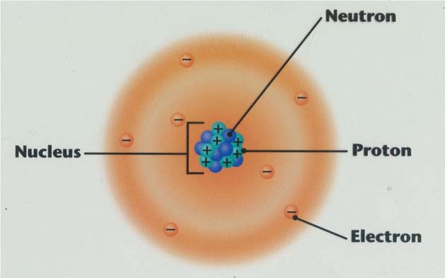
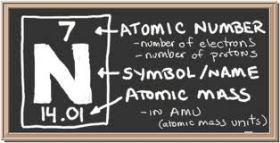

- Atomic Number will tell you how many plus circles to draw in the nucleus.
- Subtract the atomic number from the atomic mass to figure out how many neutrons to draw in the nucleus.
- Last the atomic number will tell you how many electrons to draw around the nucleus in the electron shells. The number of electrons per shell is determined by the shell. The first shell can take 2, second 8, third 18, fourth 32, and so on. Students will not need to remember these numbers (they will be provided).

The arrangement of particles in the phases of matter:

Solid Liquid Gas
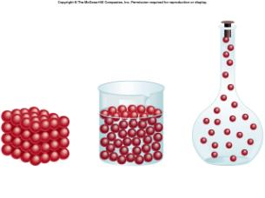
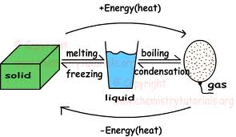
*Boiling could also be evaporation. Both are forms of vaporization.*

