6th Grade Homework Hotline
Week of May 31st, 2011

Monday- Happy Memorial Day!!

Tuesday- Check off sewing supplies
Finish Pg 13 (Learning Machine controls)
Begin Pg 10 (Seam Samples)
** Sewing Supplies and Fee Due**
Wednesday- Finish Seam Samples
“Toe Page” – Cutting and Sewing

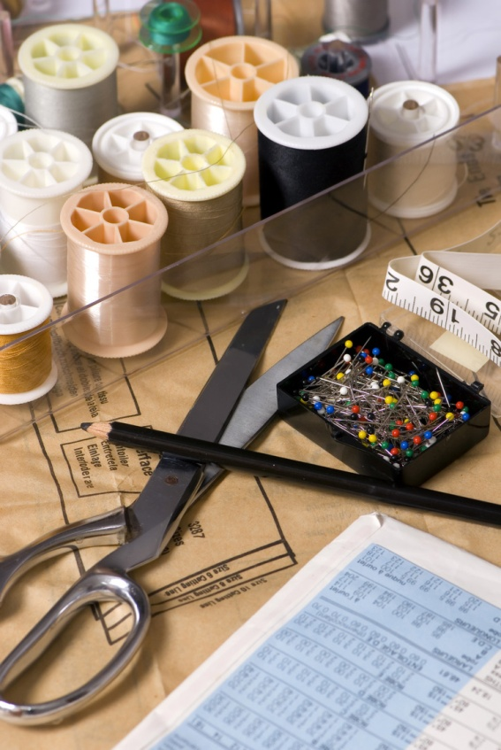
Thursday- Start Bigfoot Pillow!!

Friday- Bigfoot Pillow Work Day

