Earthquake Project Instructions

Your group will perform five activities in this lab:

- Read through the background information on the lab in the appendix at the end of the lab. Prepare a summary of the material via PowerPoint to be presented with your final lab report.
- Explore earthquake-resistant building techniques by designing, building, and simulating an earthquake that destroys a structure made of various materials.
- Compile felt reports of a hypothetical earthquake, assign intensities to these reports, and draw an isoseismic map for the earthquake.
- Locate an earthquake using the difference in arrival time of P, S and surface waves.
- Simulate the behavior of dry and wet sand during seismic shaking.

PART 1: Do Your Research

Thoroughly read and understand the background information provided in the appendix. You will need to prepare a summary of the main points in your own words with appropriate diagrams in PowerPoint. You will attach your notes and/or typewritten notes along with a print-out of your PowerPoint to your groups’ answer sheet for the remaining aspects of the project.

PART 2: Structural Seismic Design

DESIGNING YOUR STRUCTURE
The next step in this lab is to design and build your structure. After you have built the structure, you should let the glue dry while you complete the rest of this lab. Once each group has completed the other aspects of the lab, each group will be able to test your structures on the shaking table, and compare the effects of shaking on different types of designs.

As you are designing your building, keep in mind that the goal of this lab is to understand what factors cause buildings to collapse. Therefore, you do not want to over-design your building. Don't make your walls solid, or use so many craft sticks that other lab sections will run out of supplies. However, you might consider how different building heights, amounts of symmetry, or orientations of supporting sticks might affect your design.

Structural Styles to Choose From (Each group will be provided with an index card indicating which structural style they will be creating so that all are fairly represented):

- Light Wood Frame – toothpicks and glue
- Heavy Wood Frame – craft sticks and glue
- Unreinforced Masonry – sugar cubes and glue (index cards as floors, roof)
- Reinforced Masonry – sugar cubes, craft sticks and glue
- Steel Skyscraper – wire and glue (index cards as floors, roof)
- Mobile Home – index cards and glue

Building Requirements:
- Buildings must have 3 stories.
- Each story must have a floor.
- Buildings must have roofs.
- Framed buildings cannot have solid walls. Only masonry (sugar cube) structures can.
- Building bases (footprints) must be approximately one craft stick long on each side. (You may make your base any shape you choose, however.)

answer THE REQUIRED QUESTIONS on YOUR GROUP’S answer sheet:

- Sketch the design of your building.
- Explain what happened when your structure was hit by an “earthquake” on the shaking table. What kinds of “seismic waves” was it subjected to?
- What part of the building design withstood the earthquake best? What part or parts failed and in what order?
- How did its foundation design help or hinder the design and earthquake resistance of the building?
- Which building style withstood earthquakes the best in your lab? Which performed the worst? Why do you think these results occurred?
- Describe/sketch your ideal earthquake-resistant building in terms of real materials, design, height, foundation, etc. Would your design be practical?
- What other natural forces (besides earthquakes) does a building need to withstand? How are those factors different from seismic shaking? How might building design be different if those forces were the primary considerations for building safety?

Complete Parts 3, 4, and 5 of the lab while you are waiting for your building’s glue to dry.

PART 3 – Creating an Isoseismic Map from Felt Reports

Intensity is a measure of an earthquake’s effects upon people and property. Earthquake intensity is most commonly classified using the Modified Mercalli Intensity Scale that assigns a roman numeral to an event. Reports and observations obtained from newspapers, diaries, interviews, and inspections of structural damage and natural features are compiled for all areas where an earthquake was felt. Highest intensities are usually observed closest to the epicenter, but the entire pattern of observed intensities can reveal information about the nature of the earthquake. These patterns of intensity distribution are drawn as isoseismic maps to help scientists better figure out how seismic waves travel through different regions.

Modified Mercalli Intensity Scale
I Not felt except by very few under favorable conditions.

II Felt by only a few people at rest, especially on upper floors of buildings. Delicately suspended objects may swing.

III Felt noticeably by those indoors, especially on upper floors of buildings. May not be recognized as an earthquake. Vibration feels like a truck passing by. Standing cars may rock slightly.

IV Felt indoors by many, outdoors by some. At night, some people are awakened. Dishes, windows, and doors rattle. Feels like a heavy truck striking the building. Standing cars are noticeably rocked.

V Felt by nearly everyone, with many awakened at night. Some dishes and windows are broken. Unstable objects are overturned. Pendulum clocks may stop. Trees might shake, and liquids might spill out of open containers.

VI Felt by all, with many frightened. People have trouble walking. Some heavy furniture is moved and objects fall from shelves. Slight damage to structures, including cracked and fallen plaster.

VII People have difficulty standing. Drivers can feel their cars shaking. Loose bricks fall from buildings. Slight to moderate damage in well-built buildings; considerable damage in poorly built structures.

VIII Drivers have trouble steering. Houses might shift on their foundations. Tall structures such as towers and chimneys might twist and fall. Hillsides might slide if wet. Water levels in wells might change.

IX All buildings, including well-built structures, suffer considerable damage. Houses shift off of foundations. Some underground pipes are broken.

X Most buildings and foundations are destroyed. Some bridges are destroyed. Dams are seriously damaged. Large landslides occur. Water is thrown onto the banks of rivers and lakes. Large fissures can break ground. Railroad tracks are bent slightly.

XI Most buildings collapse. Many bridges are destroyed. Underground pipelines are destroyed. Railroad tracks are badly bent.

XII Almost everything is destroyed. Objects are thrown into the air. The ground moves in waves or ripples.

(Table derived from USGS and FEMA descriptions of intensity)

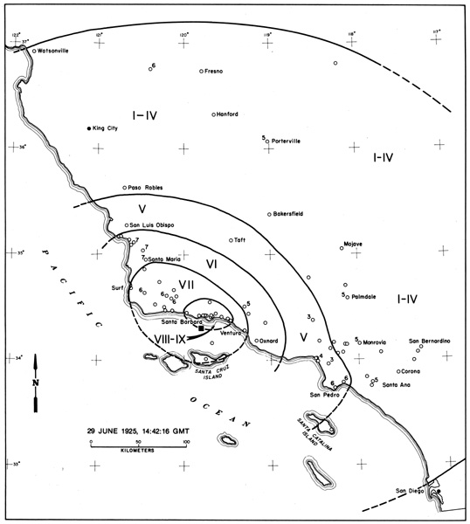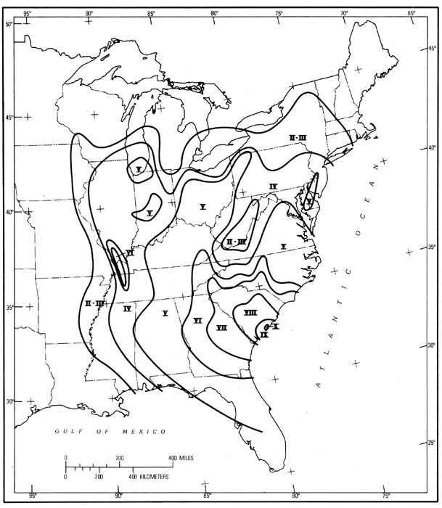

Sample Isoseismic Maps, showing intensity contours for the 1925 Santa Barbara Earthquake (left), and the 1886 South Carolina Earthquake (right). The contours can be colored for further clarity.

PART 3 – Creating an Isoseismic Map from Felt Reports (CONT)

- Assigning Intensities to Felt Reports
Use the Modified Mercalli Intensity Scale above to assign Roman numeral intensities to the following reports of a hypothetical 2009 earthquake in the Durango area. The epicenter is in the Electra Lake area.
______ Cortez, CO: Windows, doors, and rush-hour traffic received a rattling during this earthquake. Most of the city’s residents felt the quake, and some were awakened from afternoon naps. Will Payne, who works in Alpine Bank, remarked: “I thought another truck ran into our building like that time in ’87, but the shaking kept going for about 30 seconds. Lots of people left without their money!”
______ County road 240 (Florida Rd.) between Durango and Bayfield: Closed due to multiple landslides onto the road during the earthquake. The ground was saturated due to recent rain and snow melt. Some residents in this area are reporting dry wells.
______ Monticello, UT: No-one in town recognized the event as an earthquake until afterwards. Several residents said that they had noticed strange vibrations in their beverages and said that hanging plant baskets swayed without reason at the very moment of the earthquake near Durango.
______ North of Durango, Animas Valley: All residents are reporting significant structural damage to homes. Many houses have shifted off of their foundations and are therefore inhabitable. Many masonry structures are almost completely destroyed. Two fires were ignited from broken gas lines beneath and near homes.
______ Hwy 550, Molas Pass just south of Silverton: Closed due to multiple landslides in saturated soils and rock. Significant road damage has occurred from rock fall and landslides, including one 50-foot section of missing road. Drivers reported extreme difficulties while driving during the earthquake event, and one car was swiped off the road from a falling boulder.
______ Downtown Durango: Historical buildings along Main Street and in residential areas are badly damaged. Bricks fell during the earthquake and injured several people who were walking along Main Street.
______ Pagosa Springs, CO: Hot springs are reporting changes in water temperature after the earthquake and multiple cracks in plaster linings of improved pools. Damage to residential and commercial structures is slight – mostly reports of cracked plaster and chimneys. The earthquake was felt by everyone in town.
______ Farmington, NM: Most of Farmington’s residents reported feeling the earthquake and many complained of broken dishes and overturned bookshelves. One woman working in a law office was injured from a falling bookshelf full of heavy law books. Diners at Denny’s noticed that several drinks in the restaurant spilled when the ground began to vibrate.
______ Chama, NM: The staff at Vera’s New Mexican Kitchen noticed that dishes, pots, and pans rattled for approximately 30 seconds. No structural damage in Chama has been reported. Most residents felt the quake, except for those who were outside guiding Texans through the wilderness.
______ South Fork, CO: Felt by only three of the five year-round residents. Those who felt it did not recognize it as an earthquake.
______ Montrose, CO: Those who felt it described vibrations as similar to when the Wal-Mart truck speeds through town. Residents did not recognize it as an earthquake until reports arrived from Durango.
______ Ouray, CO: Slight damage to older masonry buildings has been reported. Residents say that grandfather clocks stopped and many antique dishes collections were broken beyond repair.
______ Moab, UT: Not Felt.
______ Grand Junction, CO: Not Felt.
______ Buena Vista, CO: Felt by several residents who have experienced earthquakes before.
______ Chinle, AZ: Not Felt.
______ Gunnison, CO: Not Felt.
______ Saguache, CO: Felt by many residents who described vibrations as “like being near a construction zone with heavy machinery passing by”.
______ Alamosa, CO: Relatively strong “shock” felt by most residents. Windows rattled for about 30 seconds after initial shock.

- Creating an Isoseismic Map

On the MAP OF THE FOUR CORNERS REGION on the answer sheet, plot the appropriate intensity roman numerals next to the towns mentioned above. Put zeroes next to towns where no ground shaking was felt. Then draw concentric circles around each intensity zone, starting from the highest intensities in the center and working towards the outer, lower intensities. Label each zone clearly with the Roman numeral indicating intensity.

MAP OF FOUR CORNERS REGION

Chinle
Moab
Monticello
Grand
Junction
Cortez
Farmington
Alamosa
Chama
Durango
Bayfield
Montrose
Gunnison
Buena
Vista
Saguache
Ouray
Silverton
South
Fork
Pagosa
Springs
Epicenter

PART 4: Determining an Epicenter Location

When an earthquake occurs, it releases seismic waves that can be detected at stations all around the globe. Remember that there are three types of waves released by an earthquake: primary, secondary, and surface waves. Primary waves (P-waves) travel via compression and are the first to arrive at seismic stations. They generally travel at a rate between 5.95 and 6.75 kilometers per second (km/sec), depending on various factors in the crust including density, compressibility, and rigidity. Secondary waves (S-waves) have a shearing motion and are the second type of wave to be detected, traveling between 2.9 and 4.0 km/sec. The last waves to arrive are the surface waves (L-waves), which have velocities around 2.7 and 3.7 km/sec.

Geologists can use these known travel times to approximate the distance from the reporting station to the epicenter. Three or more stations can compare their distances to the epicenter in order to determine its exact location – and so can you!

Let’s assume that you work at the seismic reporting station in Golden, Colorado. At 1:45pm you receive the first P-waves from a quake at an unknown location. Surface waves (L-waves) follow at 1:59pm. To determine your distance from the quake you must first establish the difference in arrival times: 1:59pm - 1:45pm = 14 minutes. Using a ruler or a scrap piece of paper, figure out the distance between 14 minutes on the Y axis and move your ruler along the graph until you find a spot where the two lines (P- and L-waves) are exactly 14 minutes apart. Project that location down to the X axis to determine the distance to the epicenter.

You determine that your epicenter is 2125 km away from your location; however, you do not know the direction to the epicenter! In order to determine the exact location, you must call two colleagues from different reporting stations around the globe.
Distance (kilometers)

- Let’s do it again with data from three reporting stations. Pay careful attention to the type of wave arriving at each time. Record your answers in Table 4.1 on your answer sheet.

Station A: The first S-wave arrives at 6:32:45 pm. L-waves begin to arrive at 6:39:45 pm.
Distance (kilometers)

Station B: P-waves first appear at 6:30:45 pm, L-waves at 6:51:45 pm.

Station C: P-waves arrive at 6:34:27 pm, S-waves follow at 6:45:27 pm.
- Plot the location of the epicenter by drawing a circle around each station. The radius of each circle should be equivalent to the distance from that station to the epicenter. Use the same scale as the graph above to determine your distances. Show your circles and a dot to indicate the location of the epicenter.
Distance (kilometers)

- Using the information that you have gathered, determine the approximate time that the earthquake occurred at the epicenter. Record your answer on your answer sheet.

PART 5: Testing the Effects of Liquefaction

One of the deadly side effects of an earthquake is a phenomenon that we call liquefaction. This occurs when water-saturated material is shaken by seismic waves, causing the material to lose its strength. Anything sitting on the saturated material will sink into it: buildings can sink, tip over, or collapse; sidewalks may settle (and form "sand volcanoes" on the cracks between the concrete slabs). Without witnessing a cataclysmic earthquake, we can still observe the effects of this phenomenon.

Take two trays: one filled with dry sand, the other with wet sand. Rest a rock on top of the sand in each tray. Apply pressure to the top of the rock, pushing directly down.

Answer the following questions on your answer sheet.

- What happens when you apply pressure to the core in the dry sand? Is it any different with the wet sand?

- Make a hypothesis: which rock do you expect to be more stable, the rock in the dry sand, or the rock in the wet sand?

- Now place the dry sand tray on the RoTap and allow it to shake for about 15 seconds. What happens to the rock on top?

- Try the same experiment with the wet sand tray. What happens?

- Why do you think that the dry sand responded differently from the wet?

APPENDIX: SEISMIC WAVES, EARTHQUAKE SIZE, AND EARTHQUAKE DAMAGE

Earthquakes occur when rocks suddenly slide past one another along faults. Most earthquakes occur along faults near plate boundaries, releasing the energy built up over tens, hundreds or thousands of years, during which the plates tried to move, but remained stuck. Seismologists (scientists who study earthquakes) are still unable to predict when an earthquake is likely to occur, but they are very good at predicting where earthquakes are likely. However, there have been some large earthquakes in the middle of plates, usually along weak zones that were plate boundaries in the distant past.

The size of an earthquake depends mostly on the size of the fault that slipped. The enormous (M 9+) earthquake that occurred in Indonesia on December 26, 2004, generating a catastrophic tsunami, ruptured 1200 to 1300 kilometers (750 miles) of the plate boundary between the Indian Plate and Indonesia. In comparison, the 1906 San Francisco earthquake (M 7.8) was caused by slip along 430 kilometers (267 miles) of the San Andreas Fault, which forms the boundary between the North American and Pacific Plates. Larger earthquakes also occur when the two sides of the fault slip longer distances past one another: Indonesia moved approximately 15 meters (50 feet) compared with the Indian Ocean floor during the 12/26/04 earthquake, whereas North America only moved 3 to 6 meters (10 to 20 feet) past the Pacific Plate in the 1906 earthquake.

In all earthquakes, energy is released as the two sides of the fault slide past one another. This energy, which generates the ground shaking that causes much of the damage during earthquakes, is carried through rock by seismic waves. Seismic waves come in two forms: body waves and surface waves. Body waves move through the Earth's interior, and travel much more quickly than surface waves. Surface waves move over the surface of the Earth, and cause much of the destruction during earthquakes.

Body Waves

P waves (also known as primary or compressional waves) are the first seismic waves to arrive at an earthquake recording (seismograph) station after an earthquake occurs. Primary waves behave much like sound waves, traveling through both solid and liquid layers of the Earth by compressing and stretching the rocks through which they travel. P waves travel as fast as 5.5 km/second, or more than 12,000 miles per hour, depending on the type of substance through which they travel. Because P waves travel in a linear motion, there is little displacement of Earth materials. Primary waves are the least damaging of all seismic waves.

Primary or P Wave

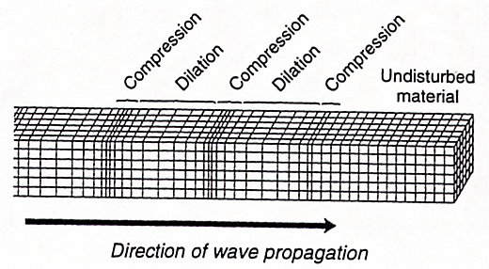

S waves (also known as secondary or shear waves) are a second type of body wave. S waves travel in a serpent-like motion, changing both the shape and volume of rock as they travel through it. Unlike P waves, S waves can only travel through solid rock; S waves can not travel through liquids. In fact, S waves are one of the main things that tell us that the Earth has a liquid outer core: no S waves are recorded on the directly opposite side of Earth from an earthquake. S waves travel more slowly than P waves, reaching a maximum velocity of about 3 km/second; when an earthquake occurs, a seismograph records a P wave first, then an S wave. S waves can be more damaging than P waves.

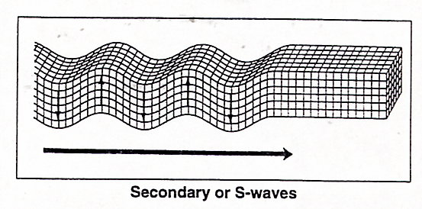

The farther a seismograph station is from an earthquake epicenter, the longer it will take for seismic waves to arrive. (If you are on the telephone with a friend during a nearby earthquake, you might actually warn them of shaking before they feel it!) The time lag between the first shaking due to P waves and due to S waves also increases with distance from the epicenter. This time lag allows seismologists to precisely calculate the distance between an epicenter and their seismograph stations, and to determine the location of the epicenter. Computers follow a similar procedure to the one in this lab to locate real earthquakes.

Both types of body waves shake with high frequencies (that is, they shake rapidly). The high frequencies of body waves are often similar to the natural frequencies of short buildings and other structures. As the frequencies of body waves approach the natural frequencies of buildings, the buildings begin to vibrate; if the frequency of the seismic waves matches the "resonant frequency" of the building, the building may collapse. The amount of shaking increases towards the top of tall buildings, in a fashion similar to the child's game "Crack the Whip," where the greatest amount of energy is felt at the end of the line.

The intensity of shaking caused by body waves decreases away from the epicenter, in the same way that loud sounds seem quieter the farther you are from the source. This causes the worst damage, in general, to occur nearest the epicenter of an earthquake. However, shaking is typically quite intense all along the fault, and many other factors (including the type of ground supporting a building and the materials from which a building is constructed) also contribute to the amount of damage that occurs.

Surface Waves

Surface waves are seismic waves that travel along the earth's surface, rather than through solid bodies of rock. There are two types of surface waves: Rayleigh waves and Love waves. Both types of waves travel more slowly than body waves, and both types of waves are more destructive than both P and S waves, in part because they have lower frequencies, which are similar to the natural frequencies of tall buildings.

Rayleigh waves, named after Lord Rayleigh, an English physicist, travel in a backwards elliptical motion, much like the upwards uncoiling of a spring or the rolling motion of an ocean wave. Rayleigh waves are the last to arrive at a location distant from the epicenter.
Love or L waves, named after English mathematician A.E.H. Love, are horizontal, transverse waves that travel across the surface of the Earth. Like a snake, these type of waves move forward as energy is distributed from side to side.
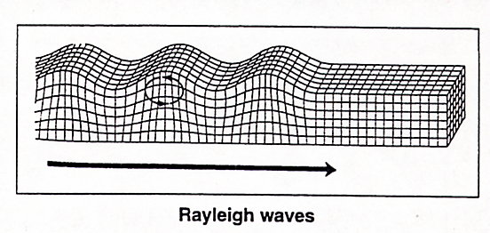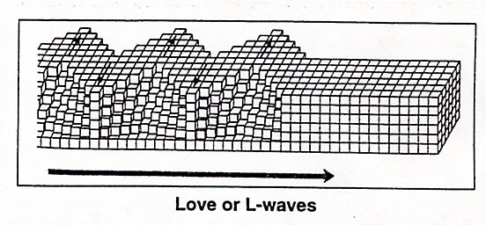

The intensity of vibrations and, therefore, the damage caused by both surface and body waves, often depends on the type of material on which a building sits. Buildings constructed on bedrock usually sustain little damage from an earthquake. Buildings, structures, and cities built on unconsolidated or loose material such as sand, silt, and clay are often subject to devastating loss of property and human lives. Loose or unconsolidated Earth materials often magnify the intensity of seismic waves.

Earthquake Size

The size of an earthquake can be measured in two ways: intensity and magnitude.

The intensity of an earthquake measures the effect of an earthquake on people, objects, and structures, and is determined by reports of people who experienced the earthquake. (If you feel an earthquake, you can help determine its intensity by filling out a questionnaire for the U.S. Geological Survey at http://pasadena.wr.usgs.gov/shake/.)

Magnitude (measured on a logarithmic scale referred to in the press as the "Richter scale") is measured based on a seismograph's record of the amount of shaking during an earthquake. A traditional seismograph consists of a free weight suspended from a wire attached to a support, which is anchored to the ground. A pen is attached to the weight. As the ground shakes, the pen traces a jagged line on the paper below it. The farther the pen moves (and the larger the wobbles recorded on the paper), the higher the amplitude of shaking. Amplitude of shaking is converted to Richter scale magnitude by correcting for distance from the epicenter and taking the logarithm of the amplitude. The resulting magnitudes reflect a 10-fold increase in strength for every one-fold increase in Richter magnitude. An earthquake registering a magnitude 6 is 10 times stronger than magnitude 5, 100 times stronger than magnitude 4, 1000 times stronger than magnitude 3, and 10,000 times stronger than magnitude 2. Magnitudes greater than 7 are classified as major earthquakes, capable of causing mass destruction and death.

Earthquake Damage

Actual earthquakes rarely last more than 60 seconds. In these 60 seconds, the ground moves violently, sometimes causing poorly designed buildings to collapse. Populations living in earthquake-prone areas are at greatest risk primarily from the collapse of structures during the earthquake, rather than from the ground shaking itself. (Other secondary effects of fault slip and ground shaking, such as tsunamis, landslides, and liquefaction, can also harm people.) Architects and engineers employ several strategies in an attempt to "earthquake-proof" buildings and structures such as bridges and overpasses in earthquake-prone areas.

One strategy employed by engineers to earthquake-proof a building is to drill through loose earth material and anchor the base of the building into underlying bedrock using pillars or pilings and a reinforced concrete slab. A properly designed and reinforced pile foundation resists shearing and bending forces even as loose earth material shifts horizontally around the foundation.

A second approach to building earthquake-resistant structures uses a series of base isolators, which help to cushion and disperse forces between a physical structure and its foundation. Base isolators can consist of sheets of rubber bonded to thin steel reinforcing plates. Another way to cushion and deflect energy is to use large springs between a building and its foundation.

In addition to foundation designs, the design of the building itself plays an important role in how it withstands destructive forces produced by seismic waves. In general, the most earthquake-resistant building designs are based on two principles: they are symmetrical, and they use materials that are strong yet ductile (bendable).

Symmetrical buildings can be visualized by imagining a mirror running through the middle of the building. Except for the fact that they face each other, the two halves of the building on either side of the imaginary mirror are exactly the same. Symmetry helps a building maintain its balance in the event of an earthquake. In buildings that are not symmetrical, mass is unevenly distributed, and horizontal forces produced by earthquake waves cause twisting and distortion of the structure. Once this occurs, the building may become unsafe and eventually collapse.

Ductility is a term that refers to how well a material can be fashioned into a new form, usually by hammering it thin or stretching it. Usually, when you stretch a material, it becomes more flexible, and is therefore able to absorb energy. The key, of course, is not to stretch a material too much, or it may break. (Think, for instance, of a piece of taffy; it becomes more flexible when you stretch it; if you stretch it too much, though, it breaks.) Although concrete is strong, it is not at all ductile. Steel is a very strong material; it is also a very ductile material that maintains its strength long after it has been bent or otherwise deformed. Because of this, steel rods are often used to strengthen and reinforce building materials such as concrete. Concrete walls that are reinforced with steel rods are known as shear walls.

