**Chapter 28 Outline**

**28.1 A Closer Look at Light**

-Refers to a form of radiation that stars and other celestial objects emit.

**What is Light?**

Light is a form of **electromagnetic radiation = energy that travels in waves**

Examples: music (radio waves), x-rays

ALL types of electromagnetic radiation travels in the form of **waves** – at a speed of about 300,000 km per second = **the speed of light**

The lengths of the waves determines the characteristics of each form of EM Radiation.

The distance from one wave crest to the next = **wavelength**

Examples: longest wavelengths are radio waves

Shortest wavelengths are gamma waves

The **electromagnetic spectrum** is an arrangement of EM radiation along a continuum (shortest to longest).

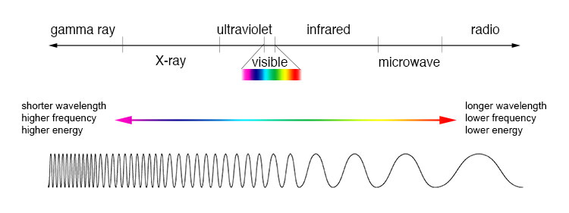**The Spectroscope**

Visible white light is actually made up of various colors, each with a different wavelength.

Examples: Red light has the longest wavelength

Violet light has the shortest wavelength

Astronomer use spectra of distant stars to learn more about the stars – using spectroscopes or spectrometers, they are able to split the light into a spectrum of colors.

**Types of Visible Spectra**

Spectroscopes break light into three different types of spectra. By analyzing and comparing these different spectra, astronomers can figure out what elements make up the atmospheres of stars and planets.

A **Continuous Spectrum** = an unbroken band of colors, which shows that its source is emitting light of ALL visible wavelengths.

Emitted by: Glowing solids, glowing liquids, and hot, compressed gases inside stars.

An **Emission spectrum** = series of unevenly spaced lines of different colors and brightnesses. The bright lines show that the source is emitting light of ONLY CERTAIN wavelengths.

Glowing thin gases produce emission spectra.

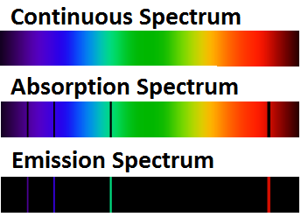 **Since EVERY element has a unique emission spectrum, scientists are able to identify the elements in objects by analyzing the spectra of light emitted.

An **Absorption spectrum** = a continuous spectrum crossed by dark lines. These lines form when light from a glowing object passes through a cooler gas, which absorbs some of the wavelengths. (They absorb EXACTLY the same wavelengths they would emit if they were glowing gases).

A star’s absorption spectrum indicates the composition of the star’s outer layer. This can be used to determine the composition of a planet’s atmosphere.

A planet shines by reflecting sunlight. If the spectrum of a planet contains dark lines that are NOT found in the sun’s spectrum, then these lines must be caused by substances unique to that planet’s atmosphere.

**The Doppler Effect**

As a sound approaches its sound waves are compressed (when the wavelength decreases - the distance between the wave crests become shorter) the sound’s pitch becomes HIGHER.

As the sound moves away, the wavelengths are longer and the pitch drops.

This also works with light. When moving towards us the light of a star shifts to the left or right. – evidence of the star’s motion relative to Earth. To the left is **Red Shift** (moving away) to the right is **Blue Shift** (moving towards). Moving away the wavelengths of light INCREASE (towards the red end of the spec trum). Moving towards results in the wavelengths become compressed and wave crests DECREASING (towards the blue end of the spectrum).

**28.2 Stars and their Characteristics**

**Early Observations**

**Constellations**

**Constellations** = name given to groups of stars.

* + - 88 constellations can be seen from Earth’s northern and southern hemispheres.
    - Constellations are not natural groupings – they are human inventions.
    - Big Dipper – **an asterism** (a small star grouping), is part of a large constellation known as Ursa Major or the Great Bear.
    - **The apparent regular movement of the constellations across our sky is caused by Earth’s motions – its rotation and revolution.**  (Because Earth turns from W to E, the whole sky appears to turn from E to W). The sections above the poles seems stationary as Earth turns on its axis = thus, Polaris (the North Star) seems fixed, while the stars nearby move counterclockwise around it.
    - A **circumpolar star** is a star that, as viewed from a given latitude on Earth, never sets (that is, never disappears below the horizon), due to its proximity to one of the celestial poles.
    - A constellation’s position changes with the seasons. These changes are caused by Earth’s changes in position as it orbits the sun.
    - Some constellations can only be seen during certain seasons.

**Apparent Magnitude**

The **apparent magnitude** = a measure of how bright a star appears to be to an observer on Earth. The **LOWER** the star’s magnitude number the **BRIGHTER** the star is.

Each magnitude differs from the next by a factor of about 2.5x.

**DOES NOT indicate how bright the star ACTUALLY IS, because it depends on the star’s distance from Earth as well as its luminosity.**

**Distances to the Stars**

The average distance between Earth and the sun is about **150 million km** = 1 AU (\***astronomical unit**).

Astronomers use two other units: light-years and parsecs

A **light-year** = a unit that measures the distance that a ray of light travels in one year. Light travels about 300,000 km/second. Thus, in 1 year, light travels 9.5 trillion km.

**Parallax** = change in an object’s direction due to a change in the observer’s position. To express parallax astronomer use the unit = **parsec** (“parallax second”).

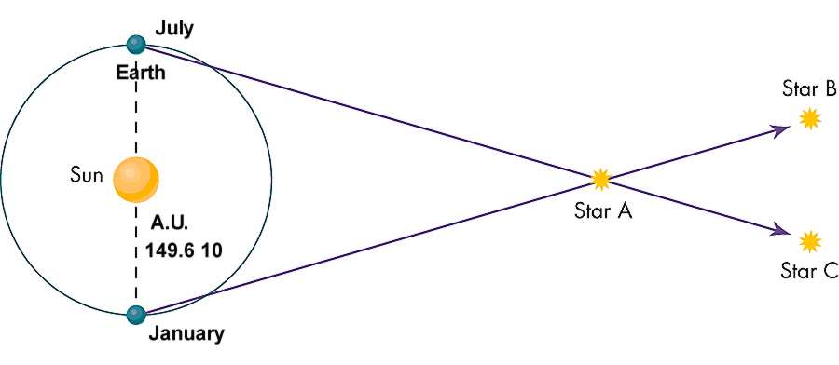 **Elements in Stars**

A star is a sphere of super-hot gases – mostly HYDROGEN and HELIUM.

Each star has a spectrum as unique as fingerprints.

**Mass, Size, and Temperature of Stars**

**Mass** is the measure of the total amount of materials in a body. It can be determined by inertial properties of the body or by its gravitational effect on the bodies around it. GREAT mass will have a STRONGER gravitational effect.

Stars vary more in size than in mass. Stars differ even more in density.

**Temperature and Color of Stars**

The range of colors depends on a star’s surface temperature.

Astronomers group stars by temperature and color into spectral classes.

**Luminosity and Absolute Magnitude**

The actual brightness of a star = **luminosity**.

* + - Depends on its size and temperature (distance from Earth is NOT a factor).
    - If 2 stars have = surface temperature, the LARGER star would be MORE luminous
    - If 2 stars have = size, but different temperatures, the HOTTER star would be MORE luminous

Astronomers use a scale of absolute magnitude to determine a star’s true brightness or luminosity. A star’s **absolute magnitude** = a measure of how bright the star would be if ALL stars were the same distance – 10 parsecs – from Earth.

**Variable Stars**

Variable stars demonstrate cycling in brightness from days to years. Stars that change in brightness as they expand and contract are called = **pulsating stars**. When they contract, they become hotter and brighter. When they expand, they become cooler and dimmer.

**Cepheid variables** – stars that are yellow supergiants whose cycles of brightness range from 1 day to 50 days (most have a cycle of about 5 days).

A non-pulsating star may change in brightness because it is not one star, but two or more stars. Unlike the Sun, most stars are parts of systems in which 2 or more stars revolve around each other = called **eclipsing binaries**.

**28.3 Life Cycles of Stars**

**The Hertsprung-Russell Diagram**

The H-R Diagram plots the luminosity of stars against their surface temperatures.

Most stars fall into distinct groups in the H-R Diagram because the groups represent stages in the life cycles of stars.

The majority of stars – about 90% - are in a band that runs from the UPPER LEFT of the diagram (HIGH LUMINOSITY, HIGH SURFACE TEMPERATURE) to the LOWER RIGHT (LOW LUMINOSITY, LOW SURFACE TEMPERATURE). This band is called the **main sequence** and the stars are called main-sequence stars.

Main sequence stars vary in surface temperature and absolute magnitudes. ALL main-sequence stars are **actively fusing hydrogen into helium**.

ABOVE the main-sequence stars are the **giant stars** with **greater luminosity** and diameters from 10 to 100x greater than the Sun.

Even MORE luminous are the **supergiants**, stars with diameters >100x that of the Sun. Because of their great size, red supergiants are very luminous despite being relatively cool stars.

The H-R Diagram also includes **white dwarfs**, stars that are near the end of their lives. They were once red giant stars, but have lost their outer atmosphere and now are only the glowing stellar core.

**Birth of a Star**

A star begins its life in a cloud of dust and gas called a **nebula**. (about 99% gas, most of which is hydrogen and about 1% is a kind of dust made of very tiny grains).

Nebula begins to condense due to outside force (shock wave) → compresses regions of nebula → particles of gas and dust move closer together due to gravity → become DENSER → temperature INCREASES → begins to glow (**protostars**).

As contraction continues, protostars become HOTTER and BRIGHTER → nuclear fusion begins and the STAR IS BORN.

**Death of a Star Like the Sun**

These stars remain about the same size for billions of years. During this time, hydrogen in the core continues to fuse into helium. The energy produced by the fusion reactions balances the force of gravity that is pulling the star’s matter inward. When the hydrogen is depleted, the core shrinks and its contractions produces additional heat, which triggers hydrogen fusion outside the core → the entire star begins to EXPAND.

The star begins to die when the core temperature RISES to the point that helium can fuse into HEAVIER elements carbon and oxygen → a carbon-oxygen core forms. Hydrogen and helium fusion reactions continue in the layers surrounding the core.

THEN, the gases at the star’s surface begin to blow away in abrupt bursts → eventually leaving only the fiercely hot carbon-oxygen core → a **white dwarf**.

The expelled layers of the star ABSORB the white dwarf’s UV emissions and give off visible light → resulting halo of gases is called a **planetary nebula**.

After approx. 25,000 years, the planetary nebula fades as its gases dissipate leaving only the white dwarf behind.

**Death of a Massive Star**

When massive stars 8x the mass of our Sun run out of hydrogen, fusion processes continue until iron nuclei are formed. After a lifespan of LESS than a billion years, the star swells to more than 100x the diameter of our Sun → becoming a **supergiant**.

The formation of iron nuclei does NOT release energy; instead it ABSORBS energy, so the iron core quickly and suddenly collapses producing a shock wave → **supernova**, a brilliant burst of light.

When a large star explodes as a supernova, it produces many elements, including copper, uranium, silver and lead. These elements are blown into space.

**Remnants of Massive Stars**

After a massive star “goes supernova” it leaves behind its core → **neutron star**. In a neutron star the gravitational force is so great that each atom’s electrons are crushed into the nucleus, overwhelming the natural forces that would keep them apart → becoming a dense mass of neutrons.

When first formed, the neutron star spins rapidly and gives off bursts of radio waves → called a **pulsar** because of the pulses of energy.

Another remnant of a star at least 15x as massive as the sun is a **black hole** – with a gravitational force so strong that even light cannot escape.

**28.4 Galaxies and the Universe**

**What are Galaxies?**

**Galaxies** are patches of systems containing millions / billions of stars.

Astronomers estimate that there are 50 – 100 billion galaxies in the universe.

The Sun belongs to the Milky Way Galaxy, which is a spiral shaped galaxy. **Spiral shaped galaxies** are shaped like a thin disk with a central bulge.

The Milky Way Galaxy belongs to a group of 30+ galaxies called the **Local Group**.

Two closest neighbors to the Milky Way Galaxy are the Magellanic Clouds and the Andromeda Galaxy.

**Types of Galaxies**

Most galaxies can be classified by shape:

* **Spiral Galaxies** – such as the Milky Way and Adnromeda Galaxy
* **Elliptical Galaxies** – range from nearly spherical to lens shaped. Their stars are concentrated at their centers and they have NO arms. They contain LESS gas and dust than spiral galaxies. They also contain FEW, if any, young stars. Example: M87
* 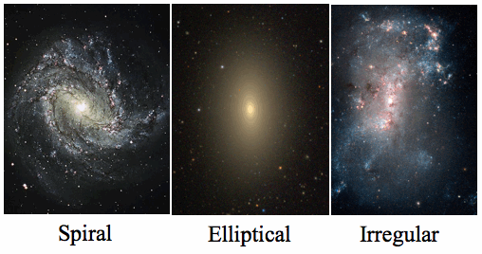**Irregular Galaxies** – much smaller and fainter. Stars are spread unevenly. Example: the two Magellanic Clouds

**Active Galaxies**

**Normal galaxies** = the total energy it emits is the totality of the energy emitted by its component stars.

**Active galaxies** = emit far MORE energy than could be given off by their stars. Some emit large amounts of radiation (radio, infrared, uv, x-ray and gamma wavelengths) and some are highly variable, changing in brightness considerably over short periods of time.

* The current model of active galaxies suggests they may be powered by a supermassive black hole at its center, from which pour forth jets of hot gas in opposite directions at nearly the speed of light.
* Phenomena associated with active galaxies:
  + **Quasars** = extremely distance objects; extremely luminous (bright)
  + **Blazar** = an active galaxy that has one of its jets pointed towards Earth
* Lower luminosity active galaxies exist – weaker versions of quasars or powered by star formation rather than supermassive black holes

**Origin of the Universe**

**Big Bang Model** = explains the history of the universe from beginning to present

**A Model Beginning**

* 10 – 20 billion years ago ALL matter in the universe existed in an incredibly HOT and DENSE state, from which it expanded and cooled, slowly CONDENSING into stars and galaxies.
* Inflationary Model – universe began as tiny region of space-time that expanded at incredible speed.
  + Then, almost at once, MOST of the energy of the high-speed expansion materialized – at the same time, through ALL of space – into high-energy particles of matter and light.
  + This superhot, superdense universe continued to expand, but at a slower rate.
  + The Universe DID NOT expand into existing space – SPACE itself was expanding.
  + Temperature and density gradually decreased, but was still too high for ordinary atoms to survive.
  + AFTER the universe became cool enough for atoms to form, they began to clump together into clouds of gas → galaxies.
  + First stars formed, went through their life cycle and died, creating supernova leaving behind heavier elements that eventually provided the material to form our sun and the planets.

**Evidence for the Big Bang Model**

* **FIRST piece of evidence** – universe expansion. The distance between galaxies and groups of galaxies seems to have been increasing with time.
  + **Redshifts** showed that distant galaxies in ALL directions are receding from Earth faster than nearby galaxies.
* **Second piece of evidence –** discovery of cosmic radiation = radiation left over from the beginning of the universe. Temperature of this radiation is similar to what cosmologists predicted it would be, taking into account the amount of time the universe had to cool.