
Cheyenna Glass
Marion Senior High School
Chapter 802
Marion, Virginia
2012-2013

ELECTRONIC CAREER PORTFOLIO

February 20, 2013

Dear Sir or Madam:

Pursuing a career in the Criminal Justice system as an administrative assistant has been my goal for several years. With the education, work experiences, and extra-curricular activities that I have received and participated in at Marion Senior High School, I believe that I am ready to enter a post-secondary institution and the workforce.

While in high school, I have been enrolled in business courses that prepared me to work as a volunteer for our school’s athletic director and administrative assistant and as a paid employee for a local fruit drink company and certified public accountant. My membership in Future Business Leaders of America provided an opportunity for me to use my business skills and to participate in community service activities with our local Smyth County Humane Society.

The following pages of my electronic portfolio shows a brief synopsis of my background, education, work experiences, activities, and recommendations from leaders in our school and community. Your consideration for me to be your next administrative assistant would be greatly appreciated. You may contact me at (276) 698-5720. I look forward to meeting and talking with you.

Sincerely,

Cheyenna Glass

Cheyenna Glass

Change is the one thing that we fear the most. Armed with my upbringing, education and experiences, I am ready to be the ARBITER of my future.
--Cheyenna Glass

A “Normal” Life 1
Resume 2
Business Opportunities 3
Interview 5
Team Experiences 6
Extra-Curricular Activities 9
Recommendation Letters 11


N
obody grows up with a perfect or normal childhood. I’ve come to the conclusion that “normal” is just the setting on a washer and dryer.


Several of my family members have experienced a unique heart condition called Left Bundle Branch Block. This includes my mother. Due to this condition, May 31, 1995 was pure chaos. My father rushed my mother to the hospital; she was pregnant with me. The doctors had to perform an emergency C Section, due to my non-beating heart. After I was born as Cheyenna Elizabeth Glass, my frail little body had to stay in the NICU for two weeks in an incubator. Nobody was allowed to hold me until the very last of the two weeks. When I went home, I had to use a very small oxygen tank so I could breathe.

Growing up in a big gray house in the country where I currently reside today, I had many
“normal” choices of what I could do each day. My favorite thing was playing outside. But then, there were rainy days where I would stay inside and build tents with blankets. I also had imaginary friends—Stacey and Macey. I even took them to Carowinds when my family and I went on a day trip. I also loved my Jessie baby doll.

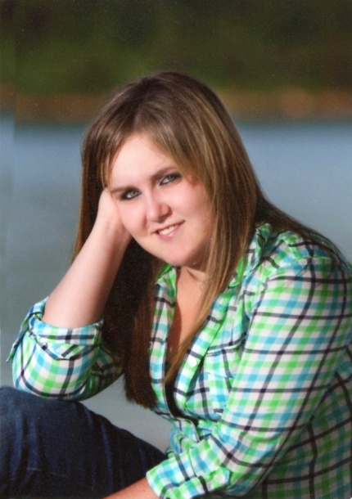
As I entered the halls of Marion Senior High School as a freshman, I didn’t know what to expect. Now, as a senior, I have accomplished many things. I currently hold enrollment in my third year in the business curricular and my first year membership in Future Business Leaders of America. When we took our trip to the Fall Regional Conference, I attended many workshops and enjoyed them. I got to know our FBLA Chapter better and what it’s like to be in it. During my junior year, I had the opportunity to participate in the Business Cooperative Education Program. My work experience included working for a fruit beverage company and a Certified Public Accountant. It was during my junior year that I also became involved in printing the awards certificates for the sports teams and theatrical participants. At the beginning of my senior year, I volunteered to film the junior varsity and varsity boy’s basketball games. The four years at Marion Senior High School has been extra ordinary for me and not anywhere near “normal.”

After graduating from high school, I plan to attend Wytheville Community College and pursue a degree in Business Administration and Criminal Justice.

Although I was a difficult birth, growing from a baby into the teenager that I am today with many dreams and opportunities has been pretty “normal” for me.
1

CHEYENNA GLASS
1550 Aspen Lane
Marion, VA 24354
(276) 698-5720

EDUCATION
2013 Graduate, Marion Senior High School, Marion VA 24354
Business Courses Completed: Keyboarding Applications, Desktop Publishing, and Business
Cooperative Education (one year)
Currently enrolled in Entrepreneurship Education
Electives: Completed Horticulture I-II, Theatre I and Individual Development

SKILLS
- Computer: General knowledge of Microsoft Word, PowerPoint, Publisher, Excel and Photoshop; above average use of keypad
- Can operate three-line switchboard
- Good communication skills—written and oral

WORK EXPERIENCE
Athletic Director Student Assistant, Marion, VA, August 2011-present
Duties: Printing the awards certificates for the sports teams and theatrical participants

Tax Preparer Assistant, Albano & Associates P.L.C., Marion, VA, February 2012-March 2012
Duties: Proofed tax documents and correct errors on the computer

Receptionist/Switchboard Operator, First Fruits Beverage Company, Marion, VA. (Business Closed)
August 2011-December 2011
Duties: Answered and transferred telephone calls; received and delivered messages;
performed other duties as requested

Assistant to IT Department, Bank of Marion, Marion, VA., January 2009-January 2011
Duties: Folded bank statements and inserted into envelopes to mail to customers

School Activities
Future Business Leaders of America, 2012-present
Friends of Rachel, 2012-present
Future Farmers of America, 2009-2011
Youth Alcohol & Drug Abuse Prevention Project, 2009-2010

REFERENCES
Mr. Gabe Long, Athletic Director, Marion Senior High School, 848 Stage Street Marion, VA 24354
276-783-4731 (school)

Mrs. Lynn White, Business Teacher, Marion Senior High School, 848 Stage Street Marion, VA 24354
276-783-4731 (school)

Mr. Mike Albano, President, Albano and Associates P.L.C, 129 S. Chestnut Street Marion, VA 24354
(276) 783-7257 (work)
2

Having an interest in a career in Business Administration and Criminal Justice, I researched information via Occupational Outlook Handbook and interviewed the Administrative Assistant at Marion Senior High School, Beverly Wymer.

Secretaries and administrative assistants
typically do the following
- Maintain paper and electronic filing systems for records and messages
- Route and distribute incoming mail and email
- Answer routine letters and email
- Reply and attach files to incoming messages
- Correct spelling and grammar to ensure accuracy
- Operate fax machines, videoconferencing and phone systems, and other office equipment
- Use computers for spreadsheet, word processing, database management, and other applications
- Complete forms in accordance with company procedures

Secretaries and administrative assistants perform a variety of clerical and organizational tasks that are necessary to run an organization efficiently. They use computer software to create spreadsheets, compose messages, manage databases, and produce presentations, reports, and documents. They also may negotiate with vendors, buy supplies, manage stockrooms or corporate libraries, and get data from various sources. Specific job duties vary by experience, job title, and specialty.

The following are types of secretaries and administrative assistants:

Executive secretaries and executive administrative assistants
3
Provide high-level administrative support for an office and for top executives of an organization. They often handle more complex responsibilities, such as reviewing incoming documents, conducting research, preparing reports, and arranging meetings. They may supervise clerical staff.

Legal secretaries
Do specialized work requiring knowledge of legal terminology and procedures. Legal secretaries prepare messages and legal papers, such as summonses, complaints, motions, responses, and subpoenas under the supervision of an attorney or a paralegal. They also may review legal journals and help with legal research for example, by verifying quotes and citations in legal briefs.

Medical secretaries
Transcribe dictation, prepare messages, and help physicians or medical scientists with reports, speeches, articles, and conference proceedings. They also take simple medical histories, arrange for patients to be hospitalized, and order supplies. Medical secretaries need to be familiar with medical terminology, insurance rules, billing practices, medical records, and hospital or laboratory procedures.

Secretaries and administrative assistants, except legal, medical, and executive
The largest subcategory of secretaries and administrative assistants. They handle an office’s administrative activities in almost every sector of the economy, including schools, government agencies, and private corporations. Secretaries in schools are often responsible for handling most of the communications among parents, the community, teachers, and school administrators. They schedule appointments, keep track of students' records, and handle matters that do not require the principal's attention.

Virtual assistants
Work from a home office. They use the Internet, email, and fax machines to communicate with clients. Although their assignments often vary from short term to long term, their typical duties are similar to those of other secretaries and administrative assistants. Working from a remote location allows virtual assistants to support multiple clients in different industries at the same time.

Wages
The median annual wage for secretaries and administrative assistants was $34,660 in May 2010. The median wage is the wage at which half the workers in an occupation earned more than that amount and half earned less. The lowest 10 percent earned less than $21,730, and the top 10 percent earned more than $55,960.

The median annual wages for different types of secretaries and administrative assistants in May 2010 were the following:
- $43,520 for executive secretaries
- $41,500 for legal secretaries
- $30,530 for medical secretaries
- $30,830 for secretaries, except legal, medical, and executive

Although secretaries and administrative assistants work in nearly every industry, many are concentrated in schools, hospitals, government agencies, and legal and medical offices. Most work full time in comfortable office settings.
Secretaries and administrative assistants held about 4 million jobs in 2010.

Job Growth
Overall employment of secretaries and administrative assistants is expected to grow 12 percent from 2010 to 2020, about as fast as the average for all occupations. Employment growth, however, will differ by occupational specialty.
4
Employment of executive secretaries and administrative assistants is projected to grow 13 percent from 2010 to 2020, about as fast as the average for all occupations, as these workers continue to provide high-level support for executives.

Employment of medical secretaries is projected to grow 41 percent from 2010 to 2020, much faster than the average for all occupations. Employment growth will be driven by rapid growth of the healthcare and social assistance industries. An anticipated increase in the use of medical services by an aging population will require many additional medical secretaries.

Employment of legal secretaries is expected to grow 4 percent from 2010 to 2020, slower than the average for all occupations. This slow employment growth is due primarily to the slower-than-average growth of the legal industry overall.

Employment of secretaries, except legal, medical, and executive, is expected to grow 6 percent from 2010 to 2020, slower than the average for all occupations. Although developments in office technology are certain to continue, many secretarial and administrative duties are of a personal, interactive nature and are not easily automated. Responsibilities such as planning meetings, working with clients, and instructing staff require tact and communication skills. Because technology cannot currently substitute for these interpersonal skills, secretaries and administrative assistants will continue to play a key role in most organizations.

Interview with beverly wymer, adminstrative assiStant

Q. What is your title at Marion Senior High School?
My title is an Administrative Assistant to Michael A. Davidson, Principal.

Q. How long have you been here?
I have been here for 13 years.

Q. What did you do before coming to Marion Senior High School?
I was an administrative assistant to the Mayor of the Town of Marion.
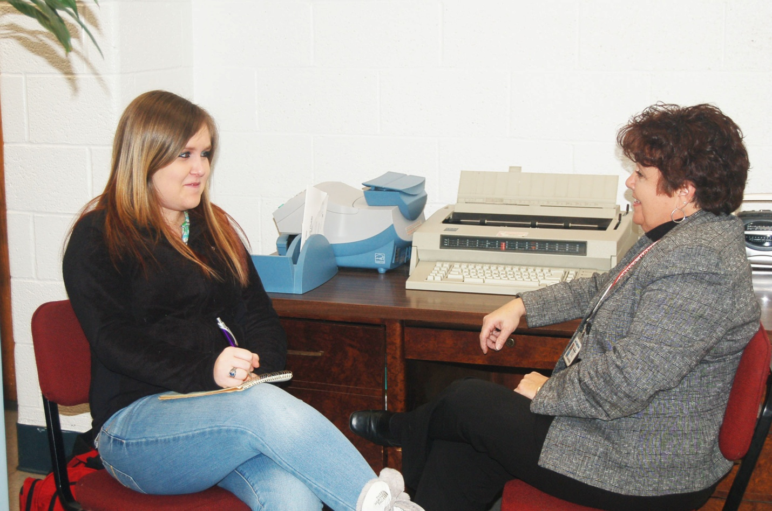
Q. What are your duties here at school?
I assist Mr. Davidson and Mr. Rick Blevins, Assistant Principal. I am in charge of all activities at the front desk; answer the telephone and direct calls; and direct parents, students, and guests to the appropriate place.

Q. What do you like best about working here?
I like working with the students, faculty, and staff best here at my job.

Q. What do you like the least about working here?
Sometimes it is difficult and frustrating when trying to get substitutes for our teachers who are absent.

Q. Do you have any advice for me about being an Administrative Assistant?
You need to make sure you like working with the public.
5

Athletic Director Student Assistant

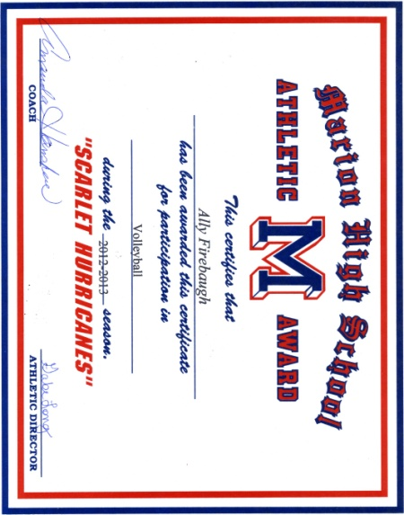
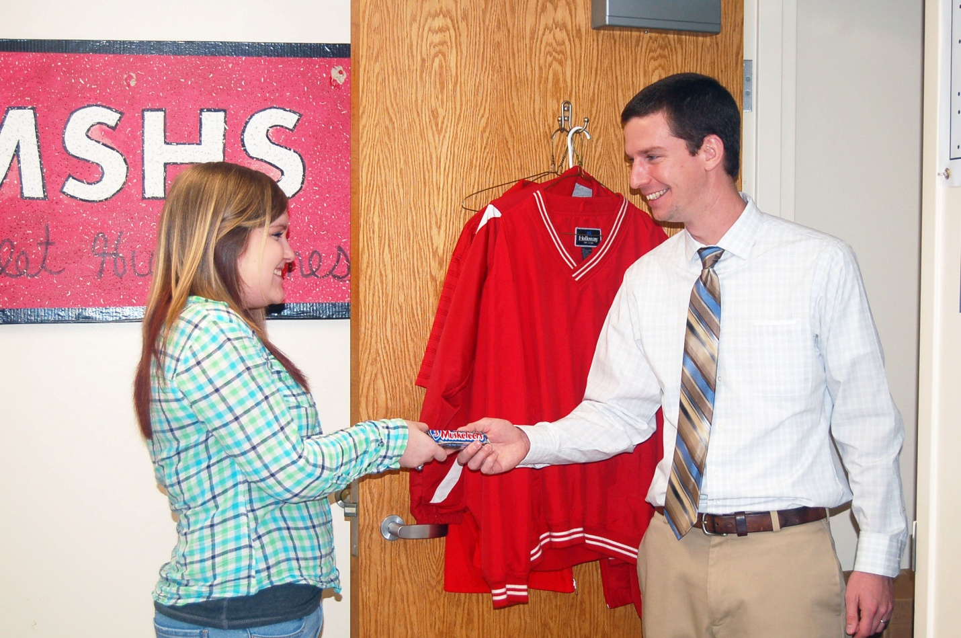
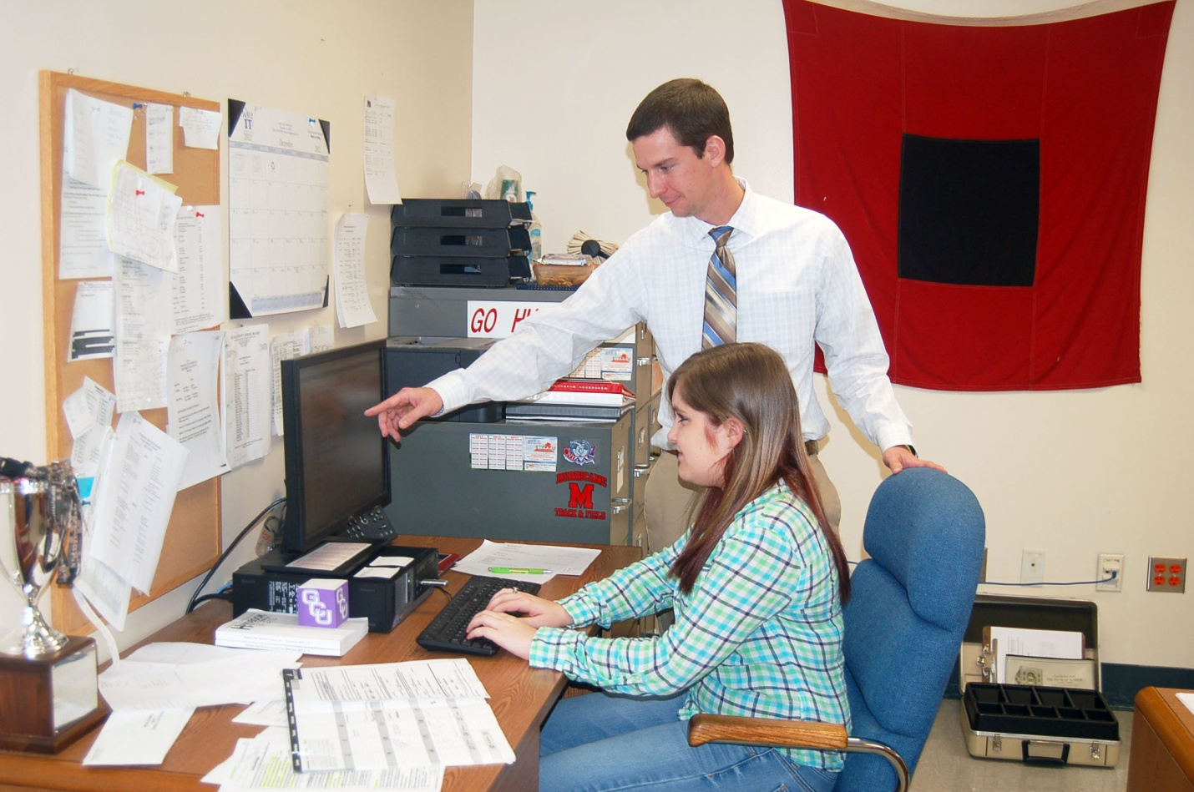
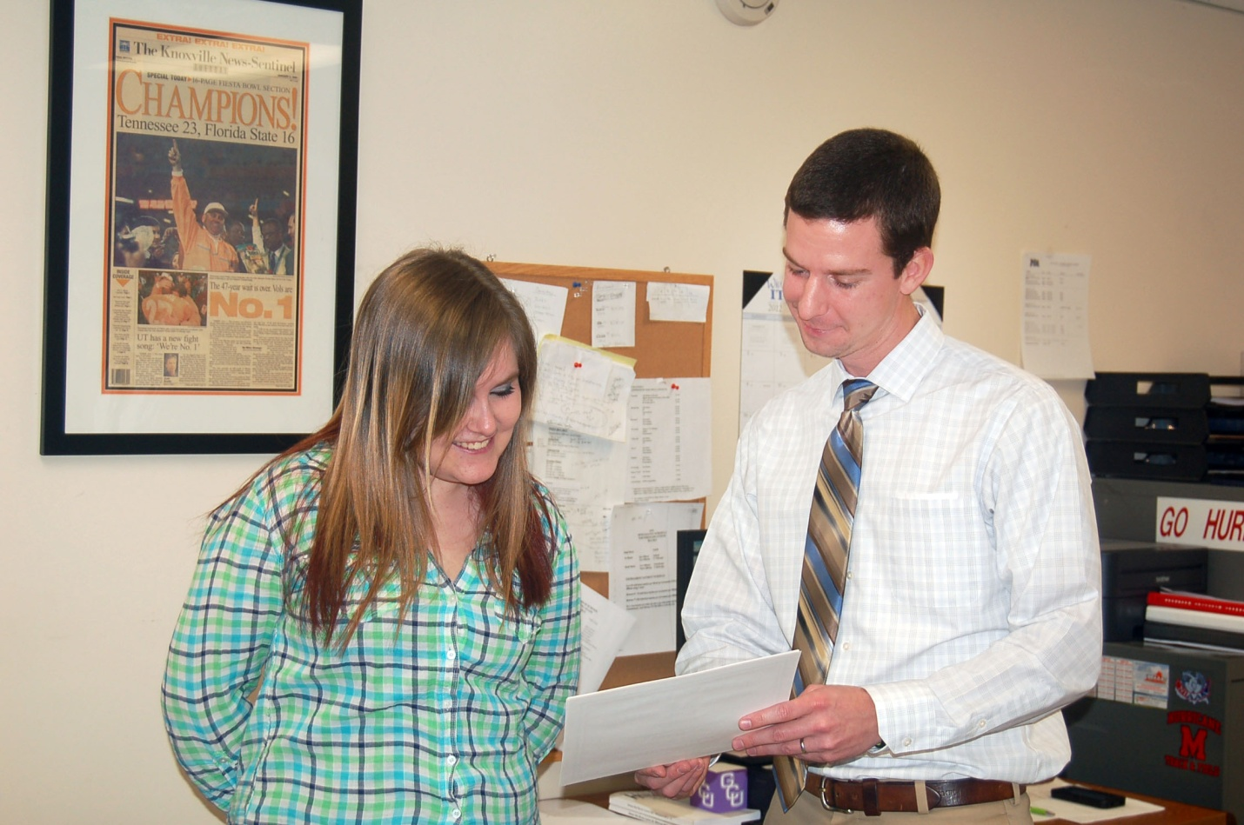
Certificate Sample
6
Athletic Director Student Assistant, Marion, VA, August 2011-present
Duties: Printing the awards certificates for the sports teams and theatrical participants.

My experiences with Cheyenna indicate to me that she is not only a good student, but also a person of high character. Cheyenna is a well rounded student that displays outstanding qualities that you would hope to see in all young adults.
--Gabriel Long
MSHS Athletic Director

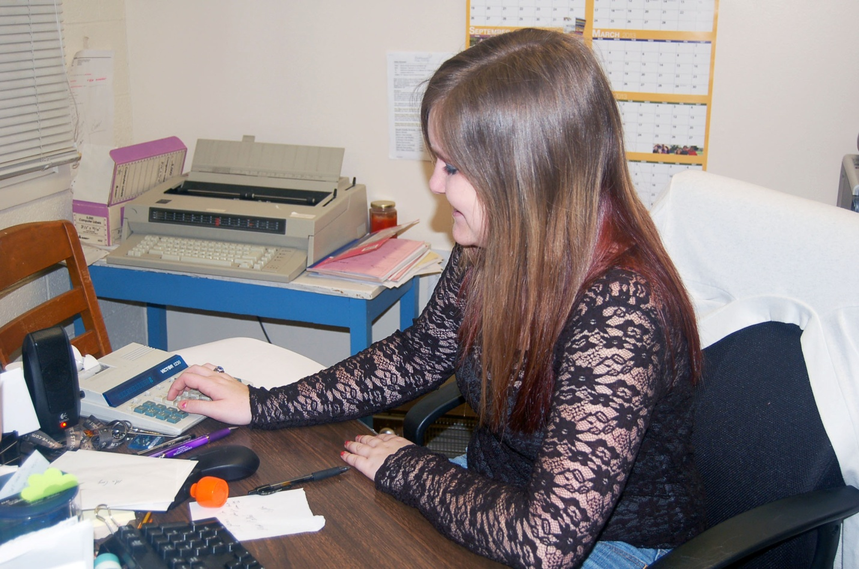
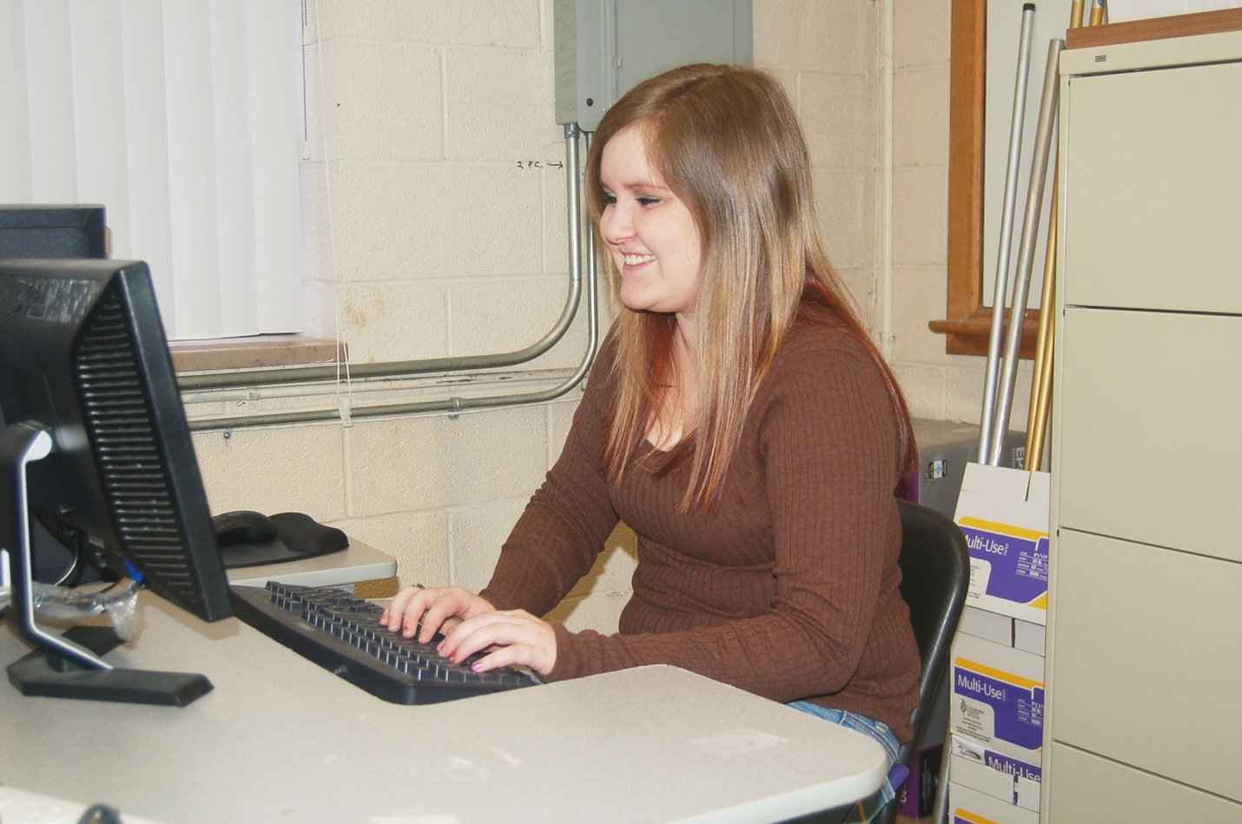
7
Tax Preparer Assistant, Albano & Associates P.L.C., Marion, VA, February 2012-March 2012
Duties: Proofed tax documents and correct errors on the computer

Cheyenna demonstrated sincerity in her desire to accomplish work goals and gain knowledge. She was considered a dedicated employee and performed to the best of her abilities without complaint. She consistently stayed focused on her work, demonstrated an ability to communicate effectively and perform efficiently, while meeting task completion deadlines.

--Latricia Irvin
Albano and Associates Staff Accountant

Tax Preparer Assistant

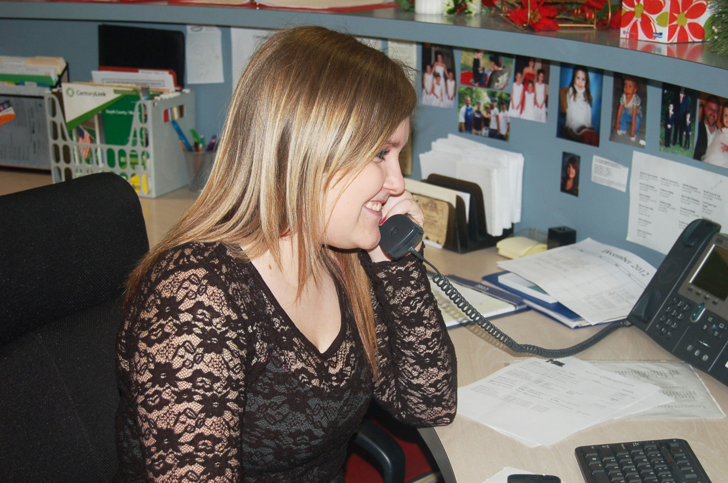
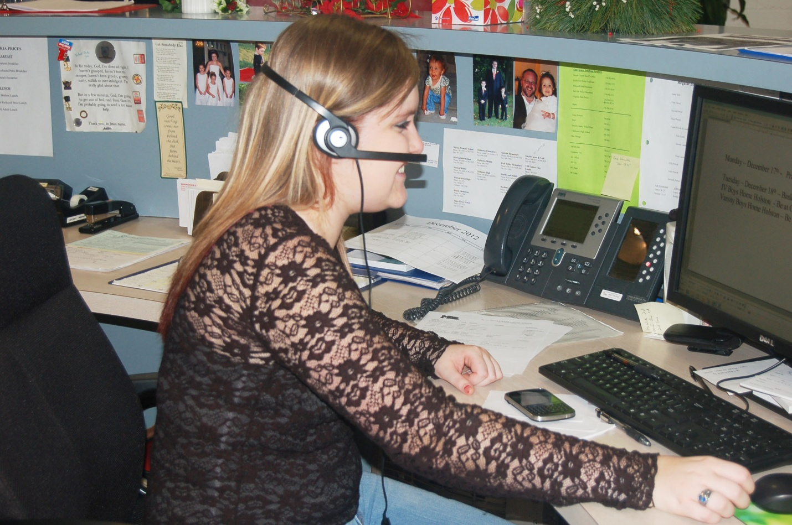
8
Receptionist/Switchboard Operator, First Fruits Beverage Company, Marion, VA. (Business Closed)
August 2011-December 2011
Duties: Answered and transferred telephone calls; received and delivered messages; performed
other duties as requested

Receptionist Switchboard Operator
Since Cheyenna had experience in telephone procedures, I often ask her to answer the telephone at Marion Senior High School. She has a friendly and warm voice which put our callers at ease. Cheyenna handles calls with great dignity and respect.

--Beverly Wymer
MSHS Administrative Assistant

--Latricia Irvin
Staff Accountant

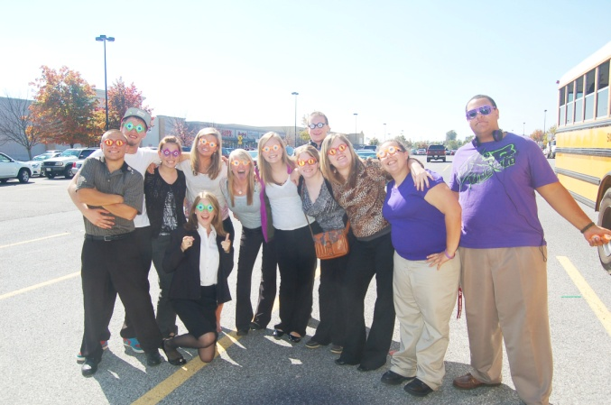
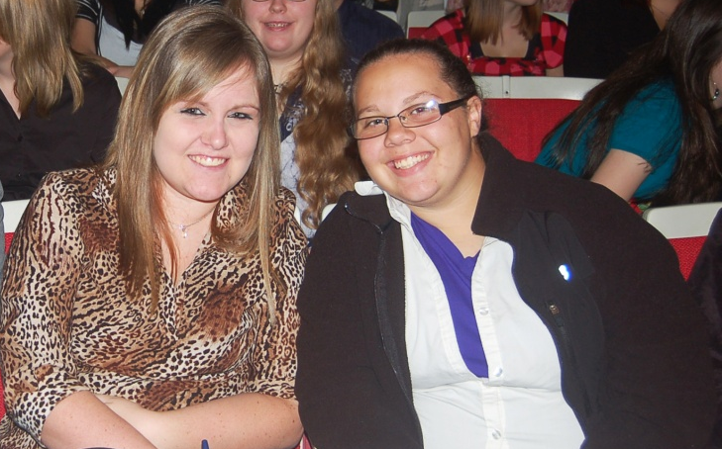
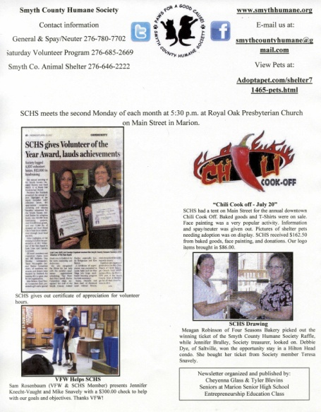
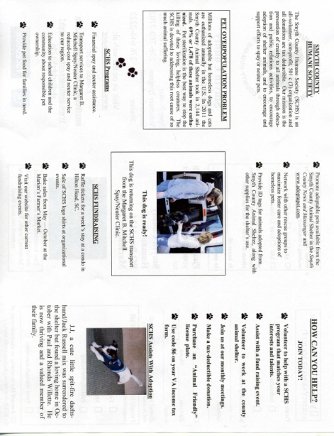
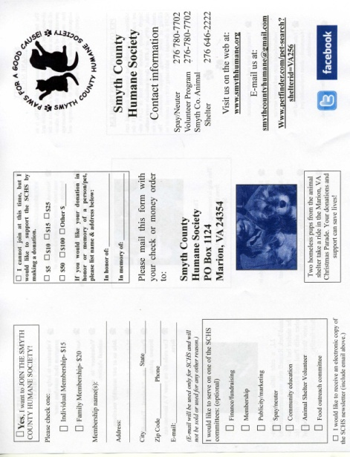
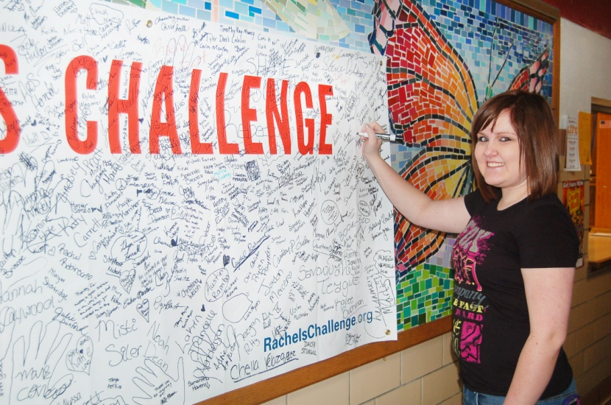
Smyth County Humane Society Newsletter
Page 1 of 4
Future Business Leaders of America is an organization for secondary and postsecondary students enrolled in business classes or those interested in the field of business. FBLA members focus on serving schools and communities; developing competent, aggressive leadership skills; and promoting academic excellence. Working with the Smyth County Humane Society has taught me patience, perfection, and pride. This team experience will help me in my future studies and career.
9
Smyth County Humane Society Tri-Fold Brochure
Rachel’s Challenge is based on the life of Rachel Scott, the first victim of the Columbine shooting. The club strives to live by her belief that if “one person can go out of their way to show compassion, then it will start a chain reaction. People will never know how far a little kindness can go.” The FOR Club, Friends of Rachel, consists of students who have accepted Rachel’s challenge by committing to being a part of a chain reaction with the goal of making their school, community, and world a better place. I took the challenge to help make a change in my life and the world around me.
10
*Other clubs: Youth Alcohol & Drug Abuse Prevention Project and Future Farmers of America
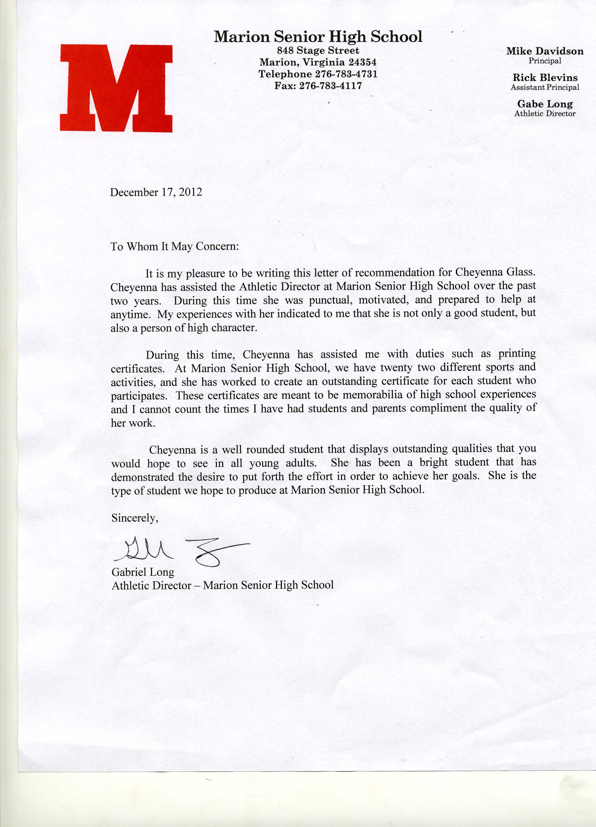

11
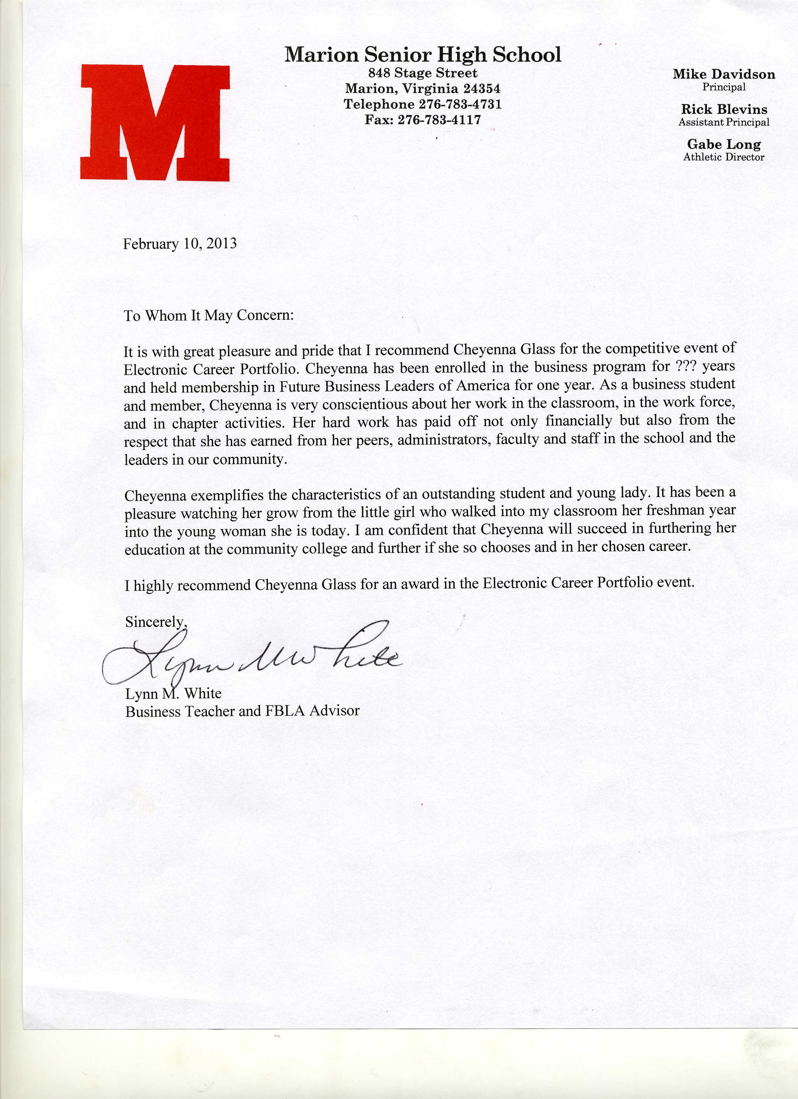
12

