 Labor Latinus May 2015 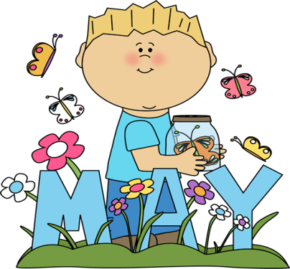
Sunday Monday Tuesday Wednesday Thursday Friday Saturday
 |  |  |  |  | 1 | 2
3 | 4  Genitive Case  Where in the Word: ‘lintigenous’  HW: gods and goddesses crossword  Chapter 11 Note cards due tomorrow | 5  Where in the Word: ‘frugivorous’  Genitive Case WS  Declension Songs  gods and goddesses review film  HW: Mythology Creation WS | 6  Gods and goddesses review  Go over Creation WS  Go over Genitive WS  Declension Songs  HW: Study for Mythology Test | 7  Take Mythology Test  HW: Nihil | 8  Read Chapter 11 story  Genitive practice  HW: Nihil | 9
10 | 11  Where in the Word: ‘crux’  Review Chapter 11 Vocabulary  Review Translation of Story  HW: Genitive and case practice WS | 12  Where in the Word: ‘equilibrium’  Go over case practice WS  Review Endings song  HW: | 13  Where in the Word: ‘exorbitant’  Review Vocabulary  HW: Chapter 11 Quiz tomorrow | 14  Where in the Word: ‘rejuvenate’  Take Chapter 11 Vocabulary Quiz | 15  Chapter 12 Vocabulary  Start Chapter 12 Story  HW: Where in the Word Fan  Test on Tuesday | 16
17 | 18  Review Where in the Word  Chapter 12 story WS  HW: Study for where in the Word Quest | 19  Take Where in the Word Test  HW: Exam Review #1 | 20  Begin Review for Final Exam  Verb Review WS  HW: Study for declension Quiz tomorrow | 21  Take All Declensions Quiz  Review Imperatives, positive, negative  Review Vocative case  HW: Practice Exam questions Review #2 | 22  Go over Practice Exam  Review Adjectives, Adjective/Noun agreement  Chapter 9 reading comprehension  HW: Exam Review Question #3 | 23
24 | 25  Memorial Day  No Classes   | 26  Review for Final Exam | 27  Final Exam | 28  Final Exam   Latin Club: Movie | 29  Perseus and Medusa Film  HW: Nihil | 30

