Name……………………………………………………… Date………………………………………..…
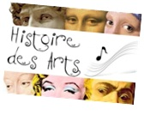
The Four Freedoms
Resources: http://www.quia.com/pages/mprou10/rockwell
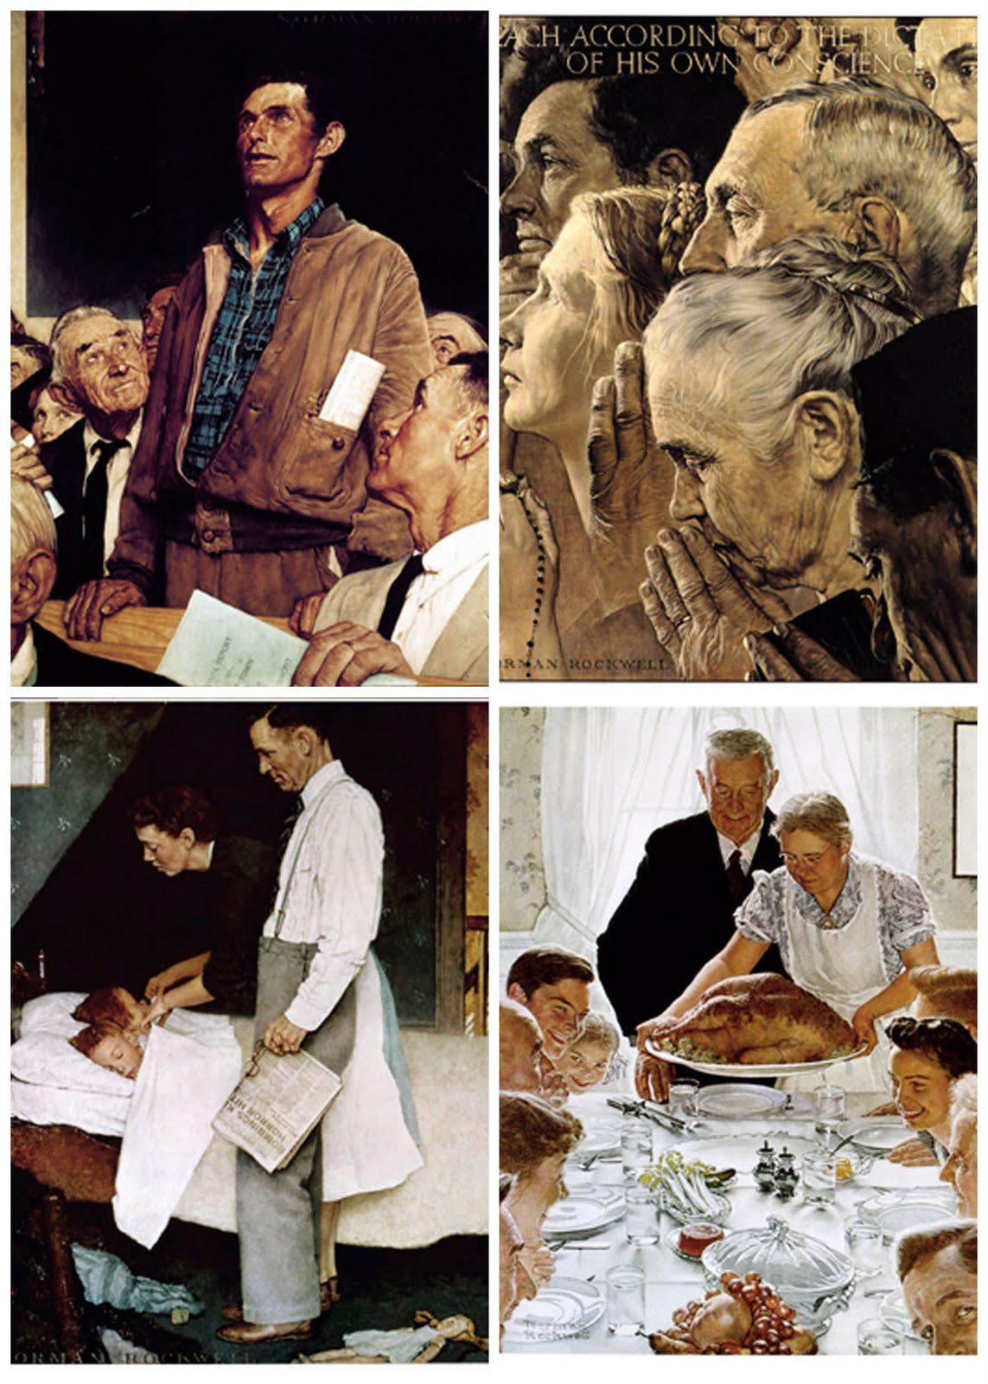
- Freedom of……….
2. Freedom of……………………………
3. Freedom from…………………….
4. Freedom from………………………….

- Basic information about this artwork (see the webpage)
Who painted it? (Give the name and the dates of birth / death of the artist)
When?
Why? (What was at the origin of this series of paintings)

How long did it take Rockwell to paint them?
In what order did he paint them?
Which painting was the most difficult to make?

- Description :
  - The most important element of the painting is…
What are the other people doing around him?

Look at the man sitting on the left: does he seem to agree?
Compare the people’s clothes:

  - How many people are represented?
Who are they?
What are they doing?
Their eyes:
What is the main colour of this painting?
Is it a warm or a cold colour?
  - Who are the people on this painting?
Where are they?
What are they doing?
What can you see on the newspaper?
  - Who are the people on this painting?
–The ones standing:
–The ones sitting:
What day is it?
How do you know this is a holiday meal (repas de fête)?
What are they doing?
Who is the man on the right looking at?

- Interpretation, analysis :
  - Where is the scene?
What is the message of this painting?
What style of painting is it?
  - What does the yellow light coming from the left represent?
What religions are represented here?
What is the message of this painting?
  - How are the children feeling?
Can you imagine the father‘s thoughts?
What is the message of the painting?

  - What is your impression when looking at this picture?
-The viewer’s position:
-The general atmosphere:
The message given by this picture: It is important to ….
- Rockwell and his time…The impact of this artwork (see the webpage)
What happened to this series of paintings in 1943?

How much money did these paintings raise?
How many people saw it?
Why can we say this artwork is part of American history?

Do you think this work of art is famous nowadays?
- Your opinion about this work of art. Say if you like it or not and justify your answer.

