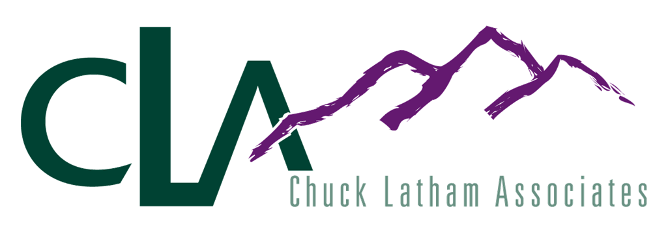

September 2006

JOB DESCRIPTION

Position: Project Assistant | Corporate/Field: Field
Reports to: Area Manager | Revised by: Rick Warnken & Shelly Sickbert
Reports indirectly to: RSA | Revision Date: 3/1/06

Position Summary:
The primary purpose of the Project Assistant position is to assist with the completion of special projects and services. In addition, Project Assistants will back up RSA’s and ESA’s as needed.

Essential Functions:
- Timely completion of store sets and resets
- Working knowledge of RSA and ESA responsibilities

Nonessential Functions:
- Attend district meetings
- Product demonstration

Willing to travel to remote locations

Required Qualifications:
Knowledge:
- Ability to read a plan-o-gram

Retail sales/merchandising experience – pet industry a plus

Skills:
- Must be able to work with deadline constraints

Excellent communication skills
- Organized
- Communicate effectively with CLA personnel

Behaviors:
- Follows and supports CLA policy/procedures

Excellent people skills

Flexible (must be able to work occasional week-ends)

Positive role model

Team player

Takes initiative
- Self motivated

Internal Measures of Success:
- 100% execution
- Consistently enter data into computer (web entry) within 24 hours of store visit

Physical Demands of the Position:
- Must be able to stand for extended period of time
- Fast paced work environment- some stress
- Able to lift 50 lbs
- Will be exposed to different types of live animals

This description is meant to be a representative summary of the major duties and responsibilities performed by incumbents of this job. Incumbents may be requested to perform position-related duties that management may deem necessary other than those stated in the position description.

Chuck Latham Associates was founded in 1984 by Chuck Latham as a manufacturer’s rep firm specializing in the farm and pet store markets of the western US. Today CLA has more than 700 employees providing nationwide sales calls at major retailers and distributors.
Our Retail Sales Associates (RSAs) provide monthly retail service calls, perform resets, assist with new store set ups, and conduct product knowledge training with store associates and consumers. Our Event Sales Associates (ESAs) demonstrate products and educate consumers at the retail level. Our Project Assistants (PAs) work alongside the RSA to ensure the timely and accurate completion of projects, such as resets, product cut-ins, or new product displays.
As a Project Assistant, you not only represent CLA but also our manufacturers. When completing a project you may be approached by consumers and/or store personnel with questions. In this training guide you will find an overview of the top manufacturers represented by CLA. Your CLA Manager will also provide you with specific training material related to your assigned project. It is important that you familiarize yourself with the manufacturer and the product with which you will be working prior to beginning your project.
CLA generates revenue through both commissions and store service. Commissions are paid when our manufacturers’ product is sold through the store. This is why product placement, accurate inventories, product rotation, and outstanding customer service are extremely important at CLA.
At CLA, we pride ourselves on offering our clients “Peace of Mind”.
We hope that you will find the role of Project Assistant to be a fun and fulfilling one. Welcome to CLA!!
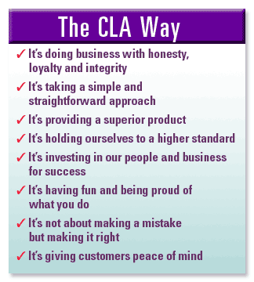
CLA Contacts
The CLA office is comprised of helpful personnel in different departments to support you in your job. You may contact them in the following ways:

Phone: 877-392-3783 (dial extension desired)
Fax: 888-824-1484
Mail: P. O. Box 4370, Parker, CO 80134
E-Mail: firstname_lastname@clareps.com

Human Resources Customer Service
Erin Dobkin – HR Generalist Carolyn Olson - Adm Asst Projects/Events
(800) 249-3768 x235 / (303) 949-2296 Cell (800) 249-3768 x234
Peggy Danner – HR Support Jodi Barber – Customer Service
(800) 249-3768 x230 (800) 249-3768 x210
Payroll
Jean Lev - Payroll Manager
(800) 249-3768 x217

Web Entry problems should be directed to our technical support provider, Unique Solutions, by calling 1-866-302-7677, Ext. 3 during the following hours:
Monday-Friday: 6 AM-10 PM (Eastern Standard Time)
Saturday & Sunday: CLOSED

1-866-REPSCLA is a service phone number that can be used by Store Managers or CLA employees for customer service. These calls will be routed to the appropriate CLA Manager.
Getting Started
Here are some basics that you need to keep in mind for any project that you are working on:
- Be organized. Make sure you have reviewed all project forms, POGs, objectives and instructions prior to the store visit and have those documents with you.
- If you are visiting several stores, make sure you have directions to each store location.
- Have a pen or pencil, box cutter, hammer, screw driver, measuring tape, packing tape, and any necessary tools described in your instructions.
- Sign into the CLA binder and store vendor log (where applicable). Greet the store personnel and introduce yourself to the Manager on Duty. Make sure your name tag is visible.
- Perform each visit according to CLA standards.
- Complete all required reports. If working independently, enter all reports via web entry within 24 hours of the store visit. If working in tandem with a RSA or as part of a team, make sure the RSA or team lead has all required reports before leaving the store.

Customer Service
There are two types of customers: external and internal.
The external customer may be the person who is shopping for a product in the aisle of the store where you are working. This customer is looking for something to buy. Your acknowledgement and friendly greeting may be just enough to convince them to buy a product that CLA represents. Always be aware of the people around you. Look up from your work and notice who is in your area. Ask if you can be of assistance. These people help to pay your salary when they purchase our products!

This customer may ask you questions about unfamiliar product lines. Be friendly, be open to listen, offer them alternatives from the CLA products on the shelves, or refer them to someone else in the store that can answer their questions. Never let the customer walk away without getting the help they need. You never get a second chance to make a first impression!

The external customer may be a member of store management or a sales associate in the store where you are working. This customer requires communication from you. Making the Manager on Duty aware that you are in the store goes a long way to providing the initial service required by CLA. Let the store team know what you are doing, communicate problems and issues you see and offer your assistance whenever possible.

Always be friendly, listen to what is being said, and make yourself a part of their team when you are in the store. Give people more than they expect and do it cheerfully!
The internal customer may be the person on the other end of the phone. This is the person in the office who you call or calls you to ask a question or resolve a problem. Treat each person with respect and with a smile in your voice. Treat this customer in the same way you would treat the external customer.
A valuable gift we can give to each other is the gift of a good example. Each employee should strive to set a good example for others. If everyone has the same goal the outcome will be a friendly, respectful workplace.
4 Key Principals of Good Customer Service
SERVICE – Make serving others your number-one priority. Great customer service happens when you exceed customers’ expectations by adding your special touch and by having the courage to make things right.
ATTITUDE – Choose your attitude. How you think about the customer is how you will treat them. A shining attitude is contagious around customers and shows in the quality of your work.
CONSISTENCY – Customers return because they like what happened last time. Set high service standards and live them every day.
TEAMWORK – Commit to teamwork. Look for ways to make each other look good. In the end, everything ends up in front of the customer.

.

Merchandising Vocabulary
Add-on | Additional merchandise that could be added-on to a sale and purchased by the customer
Adjacency | The layout of the store that shows how each planogram or rack is set next to each other
Bar Code Scanners | Reads bar codes. Bar code scanners are generally classified as wands, hand-helds, etc.
Bar Code | A group of lines printed on a piece of merchandise or on a label attached to the merchandise, also known as a 'UPC Code'
Base | The bottom flat part of each gondola section, sometimes also referred to as Shelf 1
Blitz | A type of merchandising that denotes a rapid roll-out of a product or planogram within a geographic area. A blitz is usually coordinated with an ad date or promotional event
Building a Display | Arranging and putting together merchandise or sample products, usually from scratch
Category | Refers to the section (set) in the store i.e. Stain & Odor
Cross Merchandise | Mixing merchandise from several different departments on one merchandise display; a product merchandised in more than one category
Cut-in | When a new product is introduced, the manufacturer usually likes to cut-in the new product into the existing planogram via a Revision.
Cycle | A set period of time where a merchandising visit can be performed
Discontinued Item | Items that are no longer being merchandised in the category
Display | An entire gondola side, counter, category set complete with product and point of purchase materials
Divider | Used along with fencing to separate product on the shelves
Dump Table | A table or bin used to display merchandise
End Cap | A 3 or 4 foot section located at the end of a gondola used to merchandise seasonal, temporary or promotional product. High margin items are placed on end caps to generate impulse purchases
Facing | The number of times a product is merchandised on the shelf or peg hook. Some better selling products have more than one facing.
Fast-Back Hook | A two prong hook that attaches into the pegboard
Fencing | Acrylic rails secured to the front of the shelf to contain product on the shelf
Fixture Accessory | Shelves, Peg Hooks, etc.
Fixture | A display furnishing to hold merchandise
Free Standing Store | A retail outlet that stands by itself and is not attached to a mall or shopping center
Front Runner | Plastic strips that attach to the pegs to hold the labels
Gondola | A type of free-standing shelving unit where products are merchandised, usually secured to the floor
Hang Tag | Manufacturer's label describing the merchandise. Also a hanging price tag used on garments and other merchandise
IRC | Abbreviation for Instant Redeemable Coupon or Instant Rebate Coupon
Inventory | Merchandise in-stock and currently available
J Hook | A hook so called because of its J shape. Placed on a shelf used to merchandise impulse products
Kiosk | 1) A small leased area, booth or cart inside a mall or store. (2) An interactive display or terminal giving access to an Intranet or to the Internet from inside a store for ordering or checking on merchandise
Label | Contains price information for the consumer. Labels are placed in the shelf channels to the left of the product or on the front runners for peg hooks
Lead In | The first product a consumer sees from the main aisle. Planograms have lead in indicators to show which end of the planogram starts near the main aisle.
Manufacturer | Producer of products and merchandise that people buy
Mapping | The process of determining locations and adjacencies of departments and merchandise inside a store
Mark Down | A reduction in selling price
Merchandising | Presenting products in their best light to generate more sales
Mystery Shop | Store visit requiring merchandiser anonymity in order to evaluate customer service or gather product information in an unbiased manner; form of market research
NARMS | Abbreviation for National Association for Retail Marketing Services
OOS | Abbreviation for Out of Stock; item not available for sale at this time
Overhead | The shelf above a section holding overstocks or discontinued items also called Cap Shelf
Overstock | Additional stock of product that is full to capacity on the shelf or peg
POG | Abbreviation for Planogram.
POP | Abbreviation for Point of Purchase material. Printed material that draws attention to the product on the shelf
POS | Abbreviation for Point of Sale Term normally used to describe cash register systems that record transactions or the area of checkout in a retail store
Peg Board | The backing on many fixtures where hooks are inserted to display product.
Peg Hook | Metal or plastic hooks that fit into the pegboard to hold product.
Pegged Merchandise | Product that is merchandised on peg hooks
Physical Inventory | Physically counting the individual items in stock at a particular date and time
Planogram | A schematic drawing of fixtures that illustrate product placement. Picture or layout plan describing where merchandise is to be placed on the fixtures. Also known as a POG
Preferred Product | Shelves that are located between hip level and eye level
Private Label Brand | A store's in-house brand
Reset | A major change or revision to an existing planogram, a section, department or an entire store
Retailer | An individual or firm that sells goods and services directly to the consumer
Riser | Shelves above the shoppable portion of a gondola
Rotate Stock | Stock new merchandise behind old merchandise when filling displays. Can also mean replacing old stock with new stock
SKU | Abbreviation for Stock Keeping Unit. Some SKU's have more than one facing. Each SKU is associated with a different product on a planogram (POG) and is a number assigned by the retailer to keep track of the type, color and size of a product
Schematic | Line-art drawing of the planogram, showing how many shelves or peg hooks to use.
Shelf Channel | The indented front of the shelf where labels or plastic label strip holders are placed
Shelf Extender | A 7 metal extender used to merchandise and compare a name brand product to a private label product
Shelf Label | Label showing item placement on the shelf and description of product size, price, UPC code, ordering code, movement and date tag was printed
Surge | Expanded or increased need for a reset due to a new item initiative
Telzon | Hand-held tracking unit used to order and track store inventory
UPC | Abbreviation for Universal Product Code Standard for encoding a set of lines and spaces that can be scanned and interpreted into numbers to identify a product. A sequence of numbers and bar code on the back of each product
Vendor | Person or company providing merchandise or service to a retail store
Wing Display | A display that flanks or attaches to the side of an end cap
Source: NARMS Merchandising Proficiency Training Program (www.NARMS.com)
Understanding Planograms
A Planogram is the "map" of where each item is placed on a shelf or peg hook on a fixture.
Planograms are computerized schematics designed to show product placement and optimal inventory levels.
It is important to understand the parts of a Planogram.
- Cover Page — the cover page usually outlines instructions for the project as well as any required fixture accessories, signage and POP (Point of Purchase) materials.
- Schematic — the schematic is the computerized drawing of the planogram. It shows all the details necessary to set it accurately. It may show the date of the set, how many shelves and peg hooks you will need, details about the product placement, the width, depth and height of the planogram, and sometimes placement of promotional materials. Planograms are most often set in 4ft sections. Each box on the planogram represents a product facing. Numbers on the product facing are called Loc ID’s and will cross reference the schematic to the SKU (Stock Keeping Unit) Listings which will give you more information about each product.
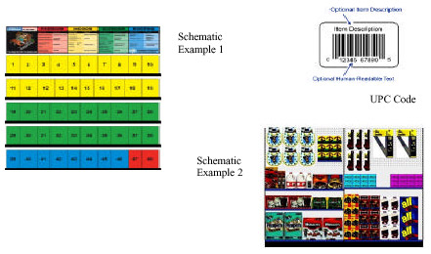

- SKU Listing or Line Listing — this is a listing of all the products that go on the planogram. It usually will start with the Loc ID that is on the schematic followed by the number of facings, the SKU (Stock Keeping Unit) number, the UPC number, the product description and other information about the placement of the items. The SKU listing or Line Listing will give you information to identify the product.
- UPC Code or Universal Product Code — the UPC code is a sequence of numbers with a bar code on the back of each product. It is the standard set of numbers used to identify a product.
Setting a Planogram
Before you start:
- Discuss the entire project with the MOD before beginning. This will enable you to work according to the MOD’s needs.

- Ask the MOD to print pricing labels.

- Before you start setting the planogram, make sure you have all the necessary supplies and materials (including cleaning supplies, labels, any new fixtures, or fixture accessories such as new shelves, peg hooks).

- Locate the new product to put on shelves.
- Check with store personnel about obtaining containers to store discontinued and back-stocked items. Verify what you need to do with these items.
- Section size can vary by store; insure that you will be working from the correct planogram. Count the shelves already in place. Make sure you have the correct size shelving before you start removing product. Typically the shelf part number will be on the cover or schematic page. Verify with MOD that the planogram you are about to use is the correct one (i.e. left-facing, right-facing, assortment).
- Always have the correct number of Peg Hooks/J-hooks and holders before you start. Hooks come in many shapes and sizes. Make sure you have the correct sized hooks. Typically the part number of the fixture accessory will be on the cover page or schematic page.
- Find out if there is Point of Purchase (POP) needed for this planogram. Typically the POP material or any additional signing needs will be listed on the cover page or schematic page.

Setting 4ft sections vs. the entire POG - Setting a planogram during store hours can be a challenging task. In most cases you will have customers making purchases off the planogram that you are working on; therefore it is best to keep the area as shoppable as possible. Many stores will want you to work in 4ft sections vs. resetting the entire POG at one time. If you are resetting the POG after store closing it may be easier to set all sections at the same time.
Concept of Lead In — Many planograms will have an arrow on the lower left hand corner of the schematic that shows which direction a planogram should be set. This arrow is called the lead in arrow. Setting a planogram with a lead in can get a little tricky so understanding the concepts are very important.
When setting a planogram with a lead in arrow you will need to be aware of the location of the gondola in relation to the main aisle. It is important to ask store personnel where the main aisles are.
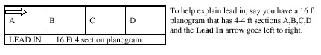
Some companies will give you x and y measurements from left to right or right to left to help you set a planogram, some will give you measurements only for setting a planogram left to right and you will have to extrapolate the measurements to set the planogram correctly right to left.
Planogram reset vs. Revision — Knowing the difference between a Planogram reset and a Planogram revision will save you lots of time. A revision means you will only remove certain products and replace them with new ones. You will always change the shelf labels. It also means you will not have to take down the entire Planogram and rebuild it saving valuable time. Study your instructions, it will tell you if the change is a reset or a revision.
Removing the old Planogram
- If discontinued product has not already been pulled by store personnel, pull it and place it in the designated container.
- Remove all product that will remain with the planogram reset and group it on the side of the aisle.
- Always clean shelves and shelf tag channels as needed. Remove stickers, price tags and POP materials (be sure you do not destroy any POP materials that may reused).
- Remember to keep product, cleaning supplies and additional shelving out of the main aisles and away from customers. It is your responsibility to keep the work area safe and shoppable.
- Most planograms will tell you where to set the shelves height above the base either by inches or notches along the side. You will need to count these to set the shelf correctly. Usually the height indicated is the top of the shelf.
- Place one product for each facing listed on the planogram to insure that SKU will fit. If the product doesn’t fit, you need to adjust the shelves.
- Work each section separately. Start on bottom shelf and work up one shelf at a time. Please remember line item numbers start on the left and move right.
- When setting a planogram with peghooks, take the time to count the holes on the pegboard correctly. The peg holes will either appear on the schematic or measurements will appear on the line listing that give you inches up from the base and inches over from the lead in.
- If you are setting a combination shelf/peghook planogram, set the shelves first from the bottom up and then set the peghooks from the top down. Adjust where needed. There are a variety of peghooks (J-Hooks, Skyhooks, etc.). Make sure you have the correct peghooks for the planogram.
Resetting the new Planogram
- Place one unit of each product on the shelf or peg hook based on the schematic and line listing. Ensure that all product fits on the shelves and peg hooks that you have placed on the POG.
- If there are issues with fit, have the store personnel make adjustments to ensure the fit of each product.
- Before filling in the POG with product, place all the point of purchase materials or additional signing on the POG.
- After all changes have been made and all product are placed on the shelf, place labels correctly according to the planogram. Decide what labels are missing and ask store personnel for new labels. Labels are usually placed under the left hand edge of the product.
- Once all products, labels and POP materials fit, it is time to fill in the planogram with stock. Any excess product should be put into containers to go to the stock room. If there is product missing from the POG you can have store personnel bring additional product from the stock areas to fill in. Break down boxes as you go. Ask store personnel where to take boxes.

Finishing Up
- If applicable, have the lead person of your merchandising team check your finished planogram. Make any necessary adjustments.
- Clean up — Make sure you leave nothing behind. Check that debris and supplies have been removed from the aisle.
- Return any cleaning materials supplied by the store.
- Throw away any trash; put back any unused shelves, pegs, etc.
- Discontinued, damaged and outdated merchandise has to be brought to the attention of store management for disposition. Never take any product home with you.
- If damaged goods or returns are being handled, be certain to follow the store’s specific procedures on where to put the merchandise and how it should be boxed.
- Inform the store manager that you have finished your work and ask them to review the completed display.
- Sign out of the CLA binder and store vendor log before leaving the store.
- Follow up with any necessary paperwork, computer reports, etc. within 24 hours of the completed visit.

Multiple Fixtures:
Most planograms are set on gondolas varying in sizes from 2ft to over 40 ft. However, there are other types of fixtures that will also use planograms to show the placement of product. Some other types are 4-ways, Spinners, Greeting Card Fixtures, Promo tables, Endcaps, and Walls.
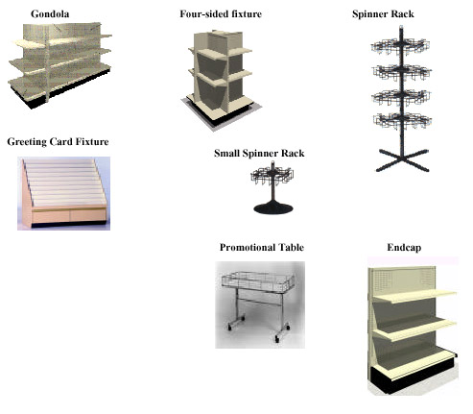

Source: NARMS Merchandising Proficiency Training Program (www.NARMS.com)

ANSWERING YOUR PROJECT/SPECIAL SERVICE OBJECTIVES

In order to better manage project and special service reporting, CLA has established uniform wording within the project objective questions. This will allow CLA to provide quantifiable reports that better determine execution and make it easier for accounting to verify billing.

PROJECT = time allocated in addition to the regular service time

SPECIAL SERVICE = time allocated within the regular service time

Each set of objectives will be classified accordingly by the Kronos screen display on the first page.

Kronos Project Example:

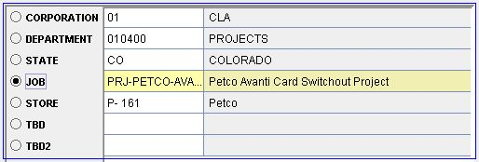

Kronos Special Service Example:

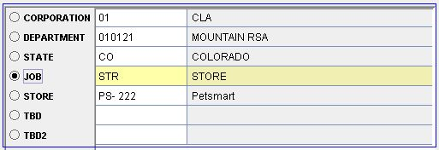

The first four questions of the project or special service objectives are called “Focus Questions”. The Focus Questions are designed to collect information necessary to determine whether or not the project or service has been completed. Any questions following the Focus Questions are used to collect specialized information for that particular project or service.

Focus Questions may be similar to the ones below:

- Is this store on the select store list?
- Yes
- No – End Report

This question will appear in all objectives regardless of whether a full store list or a limited selection of stores is being utilized. If the answer is NO, the report ends. If all stores will be performing this task, only YES will be listed as an option to answer. It is important to reference the select store list before answering this question. Reports incorrectly entered will be deleted.

- Is this project (or service) complete?
- Project complete
- MOD would not allow, use comment button to explain
- Project incomplete, use comment button to explain

The answer to this question is very important, since it will determine the execution or completion status of the project.

PROJECT COMPLETE = “Yes, it is done”

PROJECT INCOMPLETE = “No, it is not done”

MOD WOULD NOT ALLOW is considered final; requiring no return visit.
Here are situational examples for this question:

A project or service is considered PROJECT COMPLETE when:

- It has been completed in its entirety by either CLA or the store. When a project has been completed by the store, an audit should be performed by CLA.

- CLA has completed the project or service in its entirety but the store manager has made adjustments during the implementation.

- The project or service is finalized as far as the CLA can proceed. One example would be that the project is complete but the manager did not have time to make shelf or price labels and has assured CLA that he/she will do this. Follow-up by CLA, however, would be necessary on the next visit (see question #4).

A project or service is considered PROJECT INCOMPLETE when:

- The project or service was not completed in its entirety due to missing or damaged materials (i.e. racks, product. Comments are required in this situation.

- CLA will complete the project or special service on the next visit. Comments are required in this situation.

- The project or service was not completed in its entirety because manager did not have time to make shelf or price labels but expects CLA to place these labels. Comments are required in this situation.

A project or service is considered MOD WOULD NOT ALLOW when:

- The store is closing, moving or remodeling and could not be completed. Comments are required in this situation.

- The manager did not want the product moved or wanted it to be placed somewhere other than where specified in the instructions. Comments are required in this situation.

- How long did this process take to complete?
- 30 minutes (audit only)
- 30 minutes
- 1 hour
- 1 ½ hour

These time periods are set in increments according to time studies or estimated measurements. The “Audit Only” answer will always be included and is to be used when only an audit has been performed. Time entries should be rounded to the closest available choice.

- Does this project (service) require follow-up to be complete?
- Yes
- No

If it is necessary to complete this project on your next visit, the answer will be “Yes”.

➔This concludes the clarification for the “Focus Questions”.⬅

The balance of the objectives would be customized according to the individual project or special service.

An example for question 5 might be:

- What materials are missing or damaged in order to complete this project (service)?
- Rack (entire)
- Product
- Rack and product
- Rack parts missing

IMPORTANT NOTE:
Please be sure to include any applicable comments throughout the report. CLA is dependent upon these detailed comments to assist in determining the needs of the project and to better inform the vendor of the project status.

CLA TOP MANUFACTURERS

CLA represents several manufacturers in the pet industry. Among them are:


PetSafe (RADIO SYSTEMS CORPORATION)
Location: Knoxville, TN
Product Line(s): pet containment, remote training, bark control, pet doors, automatic feeders, pet wellness beds
Brand Names: PetSafe, Guardian, Sport Dog
Website: www.petsafe.net

Location: Kansas City, MO
Product Line(s): dental health treats, toys, grooming
Brand Names: Greenies, Smart Chew
Website: www.greenies.com

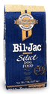


Bil-Jac
Location: Medina, OH
Product Line(s): pet foods, treats
Brand Names: Bil-Jac
Website: www.biljac.com

BRAMTON
Location: Dallas, TX
Product Line(s): stain & odor, grooming, training, first aid, lawn repair, pet beds
Brand Names: Simple Solution, Outright, Sleep Right
Website: www.bramton.com


FLEXI
Location: Cincinnati, OH
Product Line(s): retractable leashes
Brand Names: Flexi
Website: www.flexiusa.com
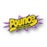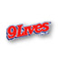
DELMONTE
Location: Pittsburgh, PA
Product Line(s): pet foods, treats
Brand Names: 9-Lives, Pounce, Kibbles & Bits, Pupperoni, Snausages, Canine Carry-Outs, Milkbone, and Nature’s Recipe.
Website: www.delmonte.com or www.naturesrecipe.com or www.milkbone.com


VIRBAC
Location: Fort Worth, TX
Product Line(s): vitamins, supplements, aquatic and avian medications, dental health
Brand Names: Mardel, Petrodex, Petromalt, Zema Francodex, St. Jon’s and Pet Tabs
Website: www.virbaccorp.com

COASTAL
Location: Alliance, OH
Product Line(s): collars, leashes, harnesses
Brand Names: Coastal
Website: www.coastalpet.com

HARTZ
Location: New Jersey
Product Line(s): flea & tick, grooming, toys, treats, dental health, aquatic foods
Brand Names: Hartz
Website: www.hartz.com
This concludes the Project Assistant Certification Training. To complete the Project Assistant Certification Test, go to http://www.quia.com/quiz/812532.html.

CLA also offers additional training opportunities for its associates through



Latham University is a web-based training program. Current modules offered through Latham University include Sales 101, Customer Service, and product knowledge training for Petsafe, Greenies, Virbac, Bramton, & Flexi. To access Latham University, visit www.clareps.com.

