Name: period:

DIMENSIONAL ANALYSIS ONLINE INTERACTIVE

A. go to: http://nlvm.usu.edu/en/nav/category_g_3_t_4.html or, go to my website and follow the link that reads: 30. the dimensional analysis interactive is HERE

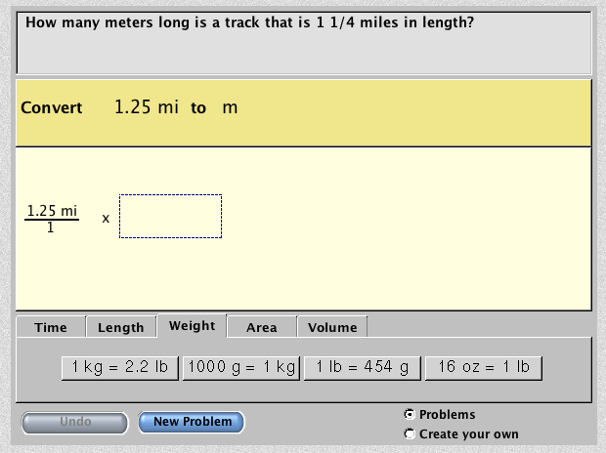
B. click on the 2nd link from the top: “converting units”. You should see a screen similar to as shown below.

C. You will be presented with a problem, stated in the gray and dark tan boxes at the top. Solve the problem using the following procedure:

1. By clicking on the gray tabs below the tan workspace, you can select dimensional analysis conversion factors to help you to work towards a solution.

If you do not see a helpful conversion factor under one gray tab (such as “weight”, as shown above) try a different gray tab (such as “length”).

2. using the procedure illustrated in the “fun with dimensional analysis” notepacket that we reviewed in class, attempt to select the best conversion factor by selecting a gray button that has units that can cancel out the fraction on the screen, and clicking that button. Then, choose the correct fractional form of the factor (shown in blue boxes), and drag it into the dashed box in the problem.
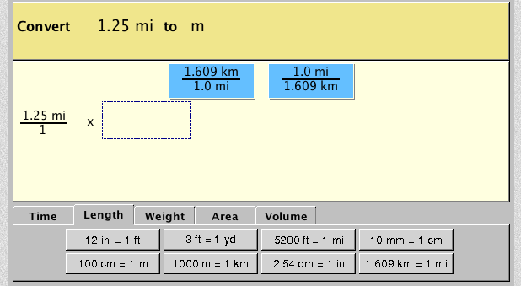

If you are correct, you will see something similar to this, with the conversion you selected and a cancellation:
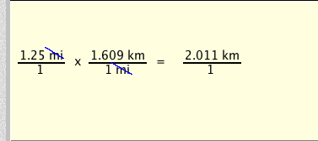

3. repeat the procedure, until you see a screen similar to this, indicating success:

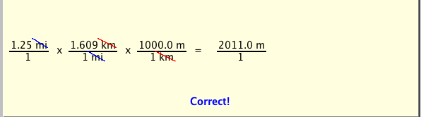

4. see the back of this sheet for the assignment problems.
Problems: Part 1:

Solve 4 problems using the interactive. After solving one problem, click the “New Problem” button for the next problem. Work on the problem until you get it correct, and then show all work in the spaces below. YOU MUST WORK ON PROBLEMS THAT DO NOT HAVE EXPONENTS (cm³, mi² ETC.)

YOU MAY SKIP ANY AREA AND VOLUME PROBLEMS (they have exponents - cm³, mi²) by clicking the “New Problem” BUTTON UNTIL YOU GET A PROBLEM WITHOUT EXPONENTS.

Problem 1:

Problem 2:

Problem 3:

Problem 4:

Part 2: Now, click the check box entitled “Create Your Own” in the bottom right hand corner of the interactive. Follow the directions, and create and solve 6 problems. Each problem MUST include a conversion between English and Metric Units. YOU MUST INCLUDE AT LEAST ONE PROBLEM OF THE FOLLOWING TYPE: Time , Length, Weight. Show your work below.

Problem 5:

Problem 6:

Problem 7:

Problem 8:

Problem 9:

Problem 10:

