NAME: PER:

***PLATE TECTONICS WEB UNIT***

1. Go to the following site: http://scign.jpl.nasa.gov/learn/index.htm

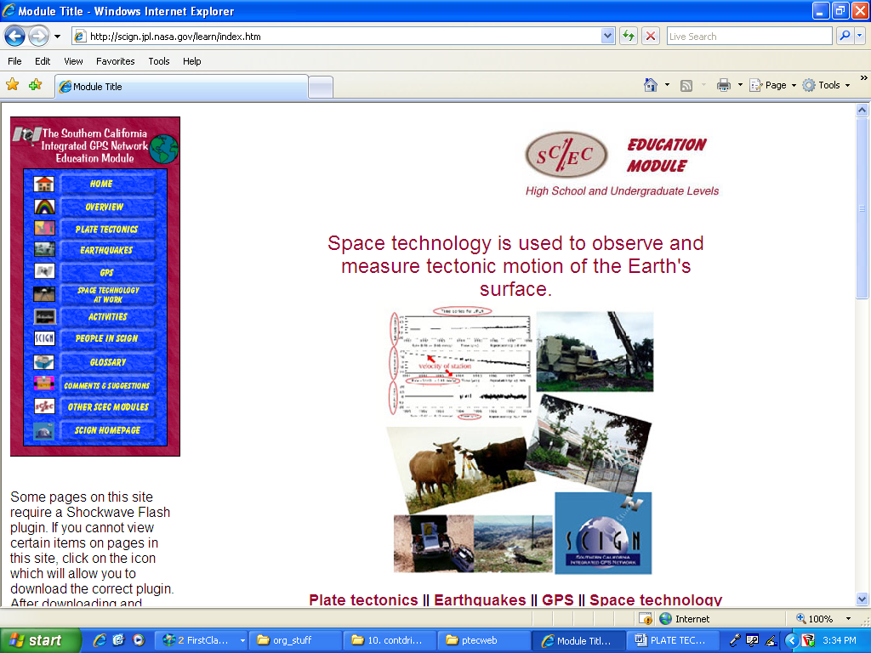
The home page appears as follows:

2. Click on the “Plate Tectonics” tab located
in the upper left corner of the page.

3. An animation of a textbook will appear.
Click on the textbook, and then on the
“Structure of the Earth” bullet.

I. STRUCTURES OF THE EARTH – BRIEFLY COMPLETE THE FOLLOWING:

A. Click on the green button to view the graphic of the Earth’s interior, and then indicate the thickness of each of the following sections:

crust: __________ mantle: __________

outer core: __________ inner core: __________

B. After viewing the diagram of the cross section of the earth, click play on the animation that follows, then answer the question below.

What is shown circulating through the mantle in the animation?

_______________ ______________

C. click on the yellow button to learn about the core. After viewing the animation of the structure of the cores, complete the following:

layer solid or liquid?

Outer core _____________

Inner core _____________

D. Define “lithosphere” (click the green link):

E. Define “asthenosphere” (click the green link):

4. Click on the “Plates” link at the bottom of the page.

II. PLATES- BRIEFLY COMPLETE THE FOLLOWING:

A. Plate tectonic theory is based on what 3 assumptions about tectonic processes? (you’ll find the answer in one of the first 4 paragraphs.)

1.

2.

3.

5. Click on the “Plate Boundaries” link at the bottom of the page.

III. PLATE BOUNDARIES- BRIEFLY COMPLETE THE FOLLOWING: (CLICK THE GREEN LINKS TO VIEW DEFINITIONS)

A. What happens at divergent boundaries?

B. Where are most divergent boundaries found (ocean floor or land)?

C. Click “play” to view the first animation. Describe what the first animation shows (focus on the colors)

D. Read the 1st paragraph after the first animation, then click “play” to view the second animation.

Describe how convection cells affect how plates move:

E. The answers below are found in one of the paragraphs after the second animation, and before the third animation.

_________________________ is another name for convergent boundaries.

F. What happens at convergent boundaries?

G. Click “play” to view the third animation, then describe what the third animation shows:

H. What 3 landforms are shown (in the 2 maps that follow the third animation) as examples of the types of landforms that can be created at convergent boundaries?

1.__________________________ 2._________________________ 3

I. Click “play” to view the fourth animation, then describe what the fourth animation show about conservative or transform boundaries:

