SIM CITY BUTTONS AND THEIR FUNCTIONS
God Mode
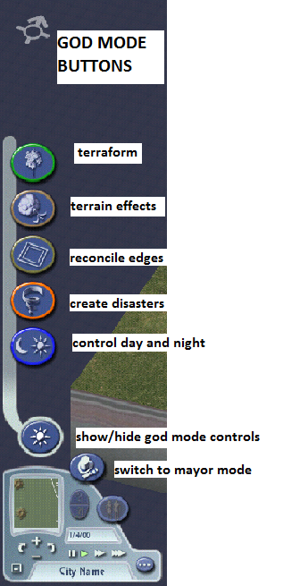
1ST LEVEL BUTTONS 2ND LEVEL BUTTONS THAT YOU WILL BE
ALLOWED TO USE

Under “terraform”:
- Make mountains
- Gouge valleys
- Level terrain
- Seed forests

Under “terrain effects”:
- Erode
- Smooth
- Raise terrain level
- Lower terrain level

A FLAT TERRAIN IS BEST. YOU MAY INCLUDE WATER, BUT ONLY IN A SMALL CORNER OF YOUR AREA – HAVING ENOUGH LAND AREA FOR A GROWING CITY IS KEY!!!

IMPORTANT NOTE:
Terraforming is free in God Mode – once you switch to Mayor Mode, EVERY CHANGE YOU MAKE TO THE LANDSCAPE COSTS MONEY, so make your terraforming decisions wisely and carefully in God Mode!

See back for Mayor Mode Buttons
Mayor Mode
1ST LEVEL BUTTONS 2ND & 3rd LEVEL BUTTONS THAT YOU WILL BE
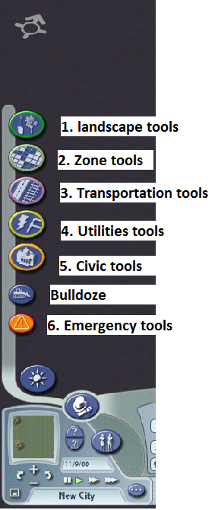
ALLOWED TO USE

Under “1. landscape tools”:
- You will only use these buttons to:
- Plant trees b. Correct terraforming mistakes

Under “2. Zone tools”:
- Zone residential areas: a. low density b. medium density
c. high density d. rezone
- Zone commercial areas: a. low density b. medium density
c. high density d. rezone
- Zone industrial areas: a. agriculture b. medium density ind.
c. high density ind. d. rezone

Under “3. Transportation tools”:
1. Build roads: a. roads b. one way roads c. avenues d. streets

Under “4. Utilities tools”:
- Build power systems: a. power lines b. wind power plants c. natural gas power plants d. coal power plants e. oil power plants
- Build water systems: a. water pipes b. water tower c. water pump d. large water pump
e. water treatment plant
- Build sanitation systems: a. landfill zone b. recycling center c. waste-to-energy power plant
d. Dezone (from landfill zone to another type of zone)

Under “5. Civic tools”:
- Build police stations and jails: a. police kiosk b. small police station c. large police station d. city jail
- Build fire stations: a. small fire station b. large fire station
- Build educational systems: various buttons for large and small elementary schools, high schools, libraries, and colleges/universities
- Build hospitals and clinics: a. medical clinic (small) b. large medical center c. disease research center
- Build parks: there are various options for parks, gardens, greenways, athletic fields, etc

**BULLDOZE BUTTON IS FOR DESTROYING STRUCTURES YOU BUILT BY MISTAKE – FOR LARGE MISTAKES, REZONE**

Under “6. Emergency tools”:
- Police car dispatch
- Fire (truck) dispatch
- Go to disaster (takes you directly to disaster site)

