ANSWER KEY: TIME / TEMPERATURE GRAPH OF 2 SUBSTANCES

A – F: SEE GRAPH KEY
G: SHOWN ON GRAPH KEY

QUESTIONS:

1. No, the graphs represent different substances; since each of the 2 lines has different melting/freezing and vaporization/condensation points, the substances must be different.

2. -10⁰C 3. 20⁰C 4. 60⁰C 5. 100⁰C

6. if had more of each substance (greater volume)plateaus would be longer (more time to melt more ice, for example). THE TEMPERATURE OF THE PLATEAUS WOULD NOT CHANGE!
( a lot of ice still melts at 0⁰C)

7. The freezing point would be lower – see graph key (think – road salt melts ice, even though the air temperature may be below freezing – therefore, the melting point of “salty ice” is lower)

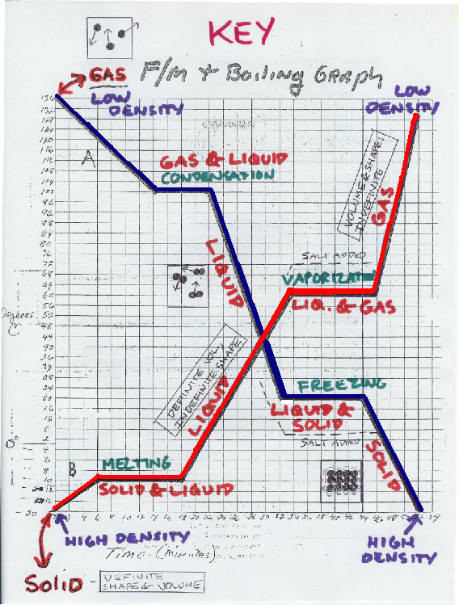
8. The boiling point would be higher – see graph key (salt crystals help to “get in the way” and prevent water molecules from breaking free from each other; therefore, the boiling point of “salty water” is higher)

