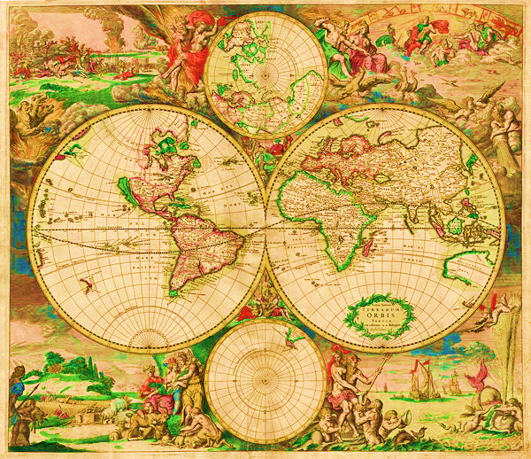

**Atomic scientists & their discoveries**

**&**

NAMES: PERIOD:



440 BC

1800