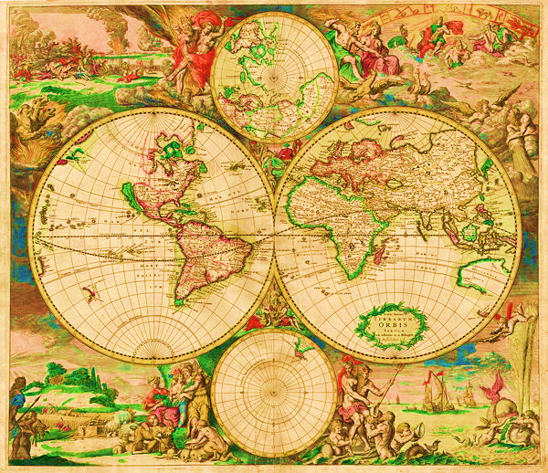

NAMES: PERIOD:



1860

1830