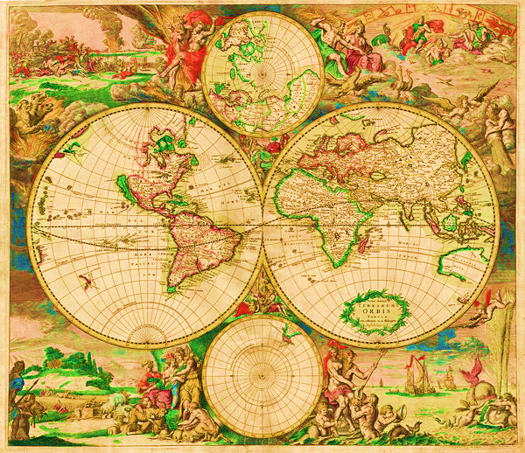

NAMES: PERIOD:



1920

1890