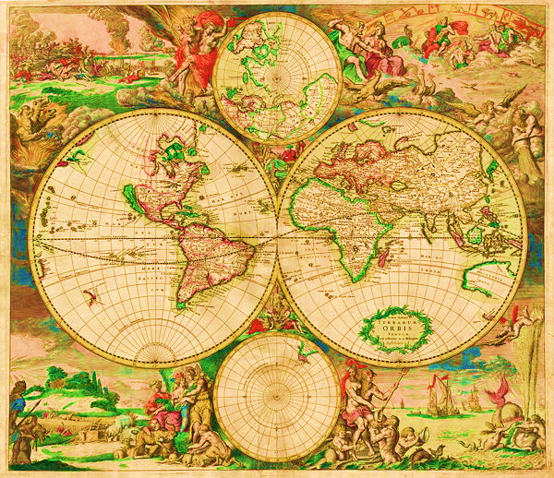

NAMES: PERIOD:



2012

1980

1950