Graphing on Excel: Plotting your Temperature/Time Graphs for the “Boiling Point of Two Liquids” Lab

Now that you have completed your “Boiling Point of Two Liquids Lab”, you are going to use Excel to create a graph of your data for each liquid that you boiled. You will use these graphs to answer the graphing analysis questions in your lab packet.

Follow the directions, and refer to the accompanying screenshots.

1. Open up Microsoft Excel and enter the data from your data tables for each liquid as shown below.

Column A = Time Column B = Temperature for water Column C = Temperature for alcohol.

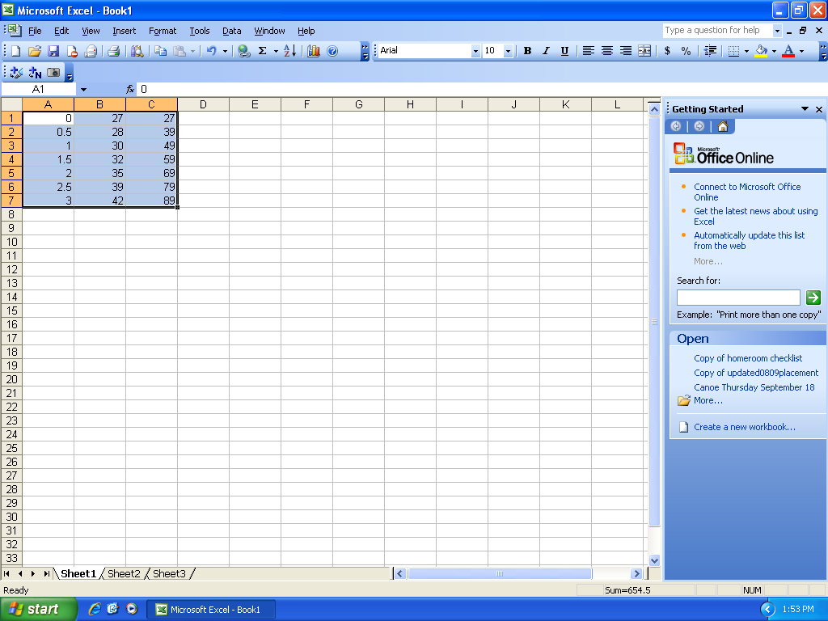

2. Highlight Data and then press the bar graph icon, located below “help” in the toolbar. (this is the “Chart Wizard” icon)

3. Choose “XY (Scatter)” from the list on the left, and then “scatter with data points connected by lines” to the right. See the screenshot below.

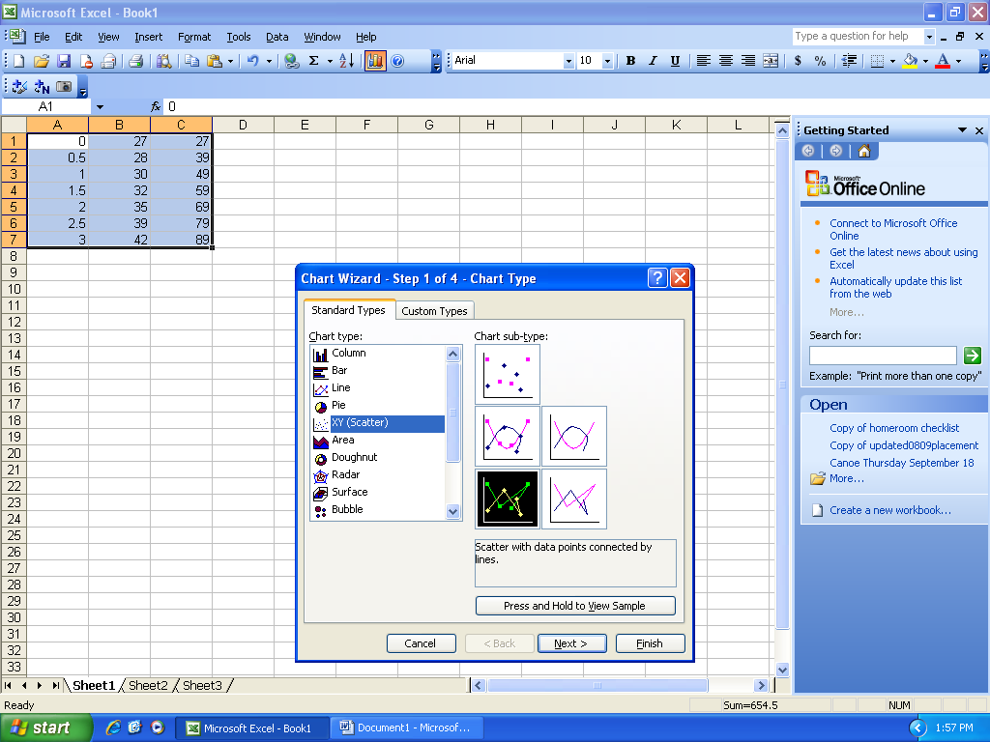
4. Click “Next”. Click “Next” again, then click on the “Titles” tab. Enter the Chart title and a title for each axis in the appropriate boxes on the left.

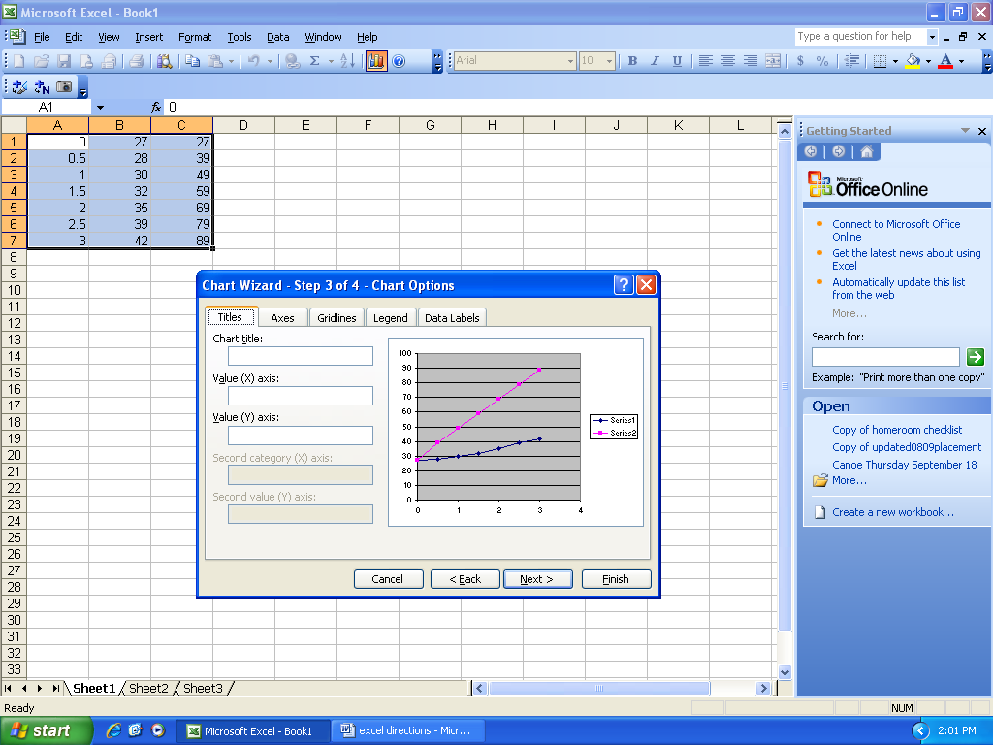

5. Click Finish. Then Click: “View” – “Toolbars”, then click “Chart”. (This will bring you to a chart box where you can scale your axis.

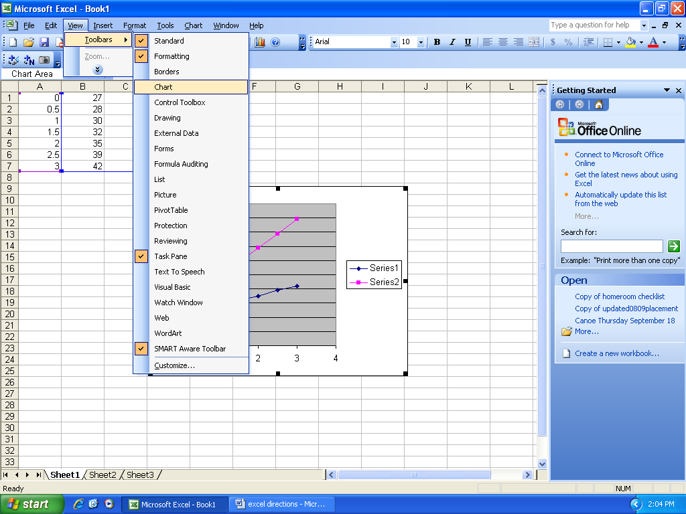

6. Choose the Value (Y)-axis from the “Chart Area” drop down menu.
Click “Format Axis” button to right of chart area drop down menu.

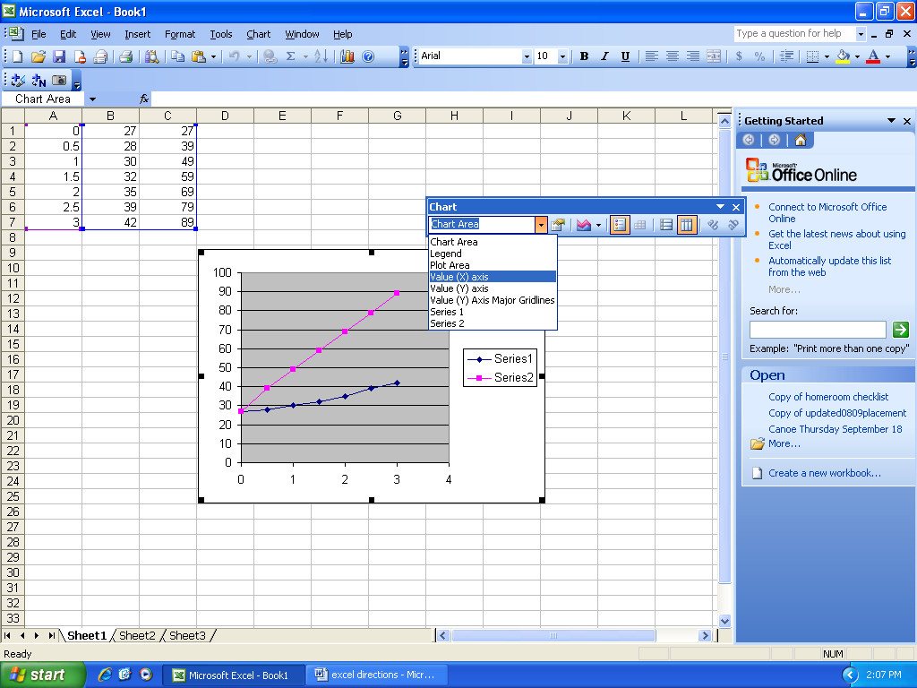

7. Click “Scale” tab. Complete maximum and minimum values for the Y axis. Be sure that your maximum Y value is a little higher than the highest temperature that you recorded for either liquid. A screenshot of the y axis is below.

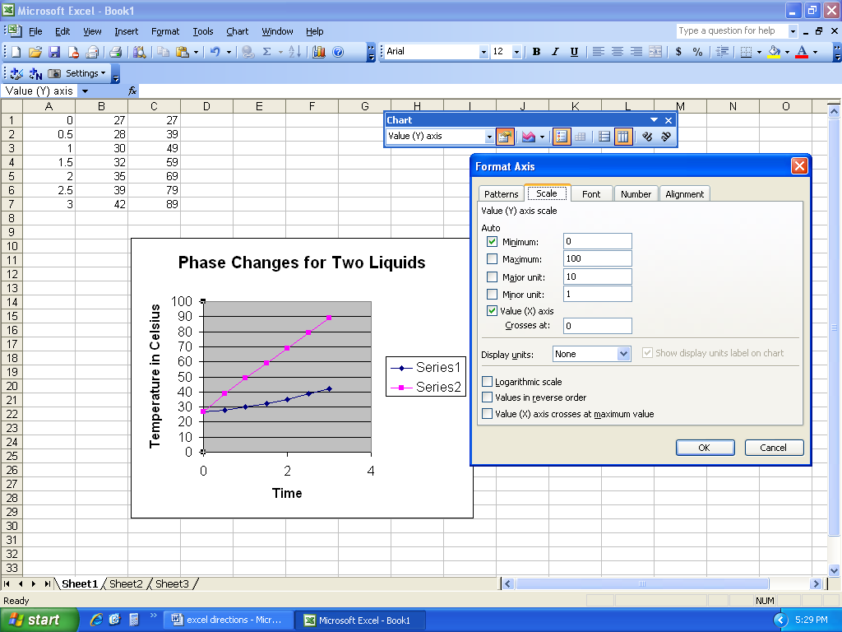

8. Click “Ok”, then Choose the Value (X)-axis axis from “chart area” dropdown. Click the “Format Axis” button to right of chart area drop down.

9. Click “Scale” tab. Complete maximum and minimum values, increment values for the X axis. Be sure that your maximum X value is a little higher than the longest time that you recorded for either liquid. Set the major unit to 1, and the minor unit to 0.5. See the screenshot below. Click “OK”.

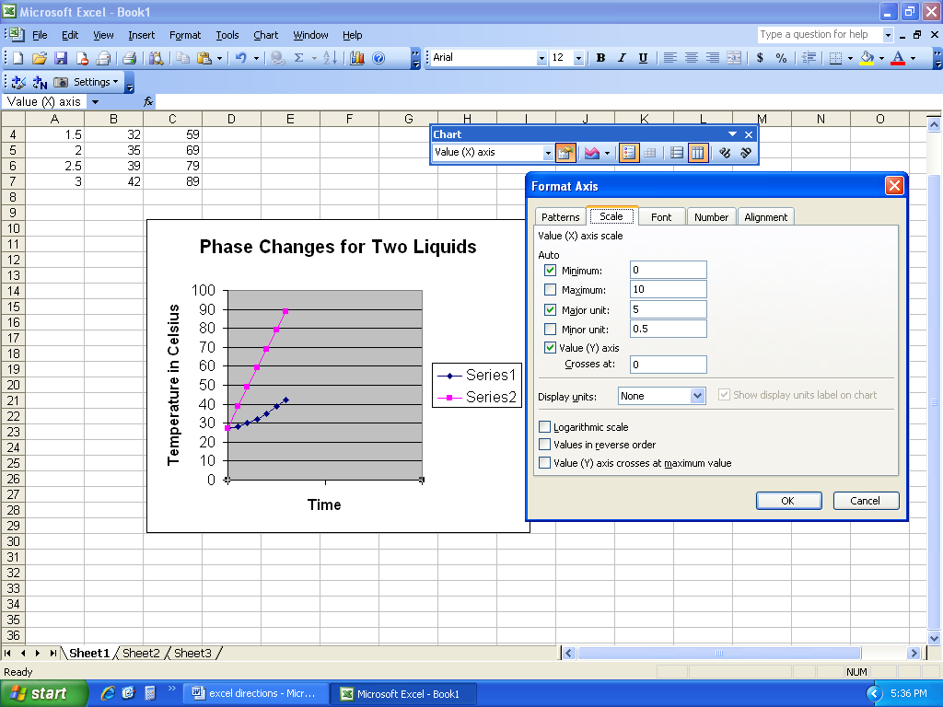

10. Place your cursor on a number on the x axis, right click, and select “format axis”. Click on the “patterns” tab. Select “outside” under the heading “minor tick mark type” and select “low” under “tick mark labels”. Then click “OK”.

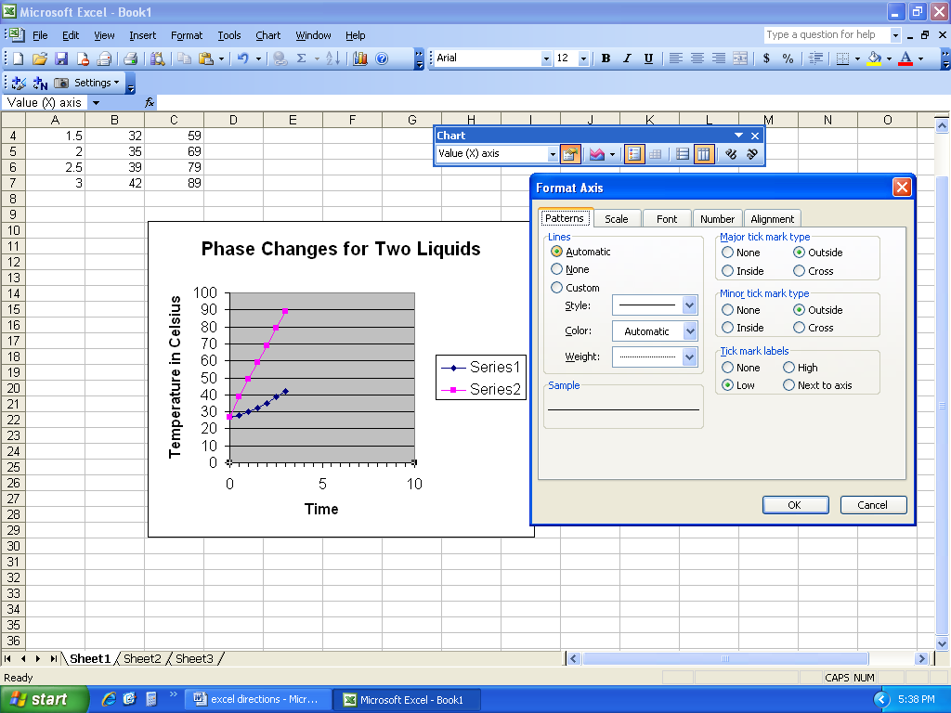
11. Now we’ll format our graph so that vertical gridlines are shown. Click anywhere in the gray space between the gridlines on the graph. Then right click, and select “chart options” from the dropdown as shown below.

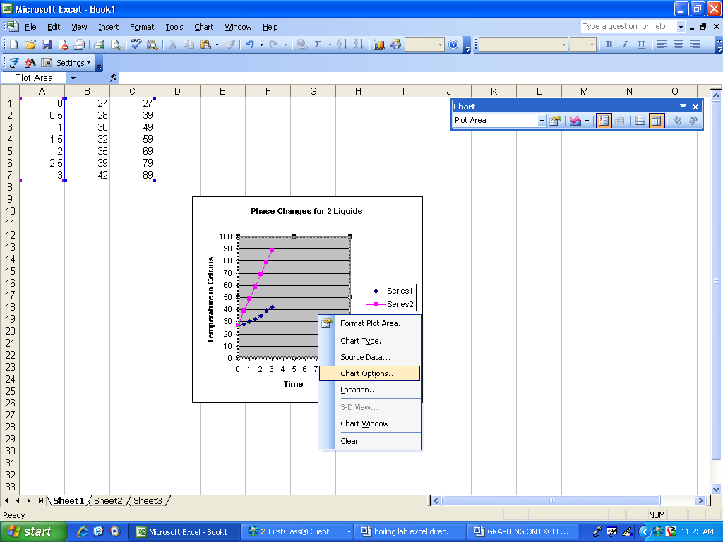

12. Now, click on the “gridlines” tab, and click to fill in the following checkboxes:
Under “Value (x) axis: both “major gridlines” and “minor gridlines”
Under “Value (y) axis: “major gridlines” only. Then click “OK”.

See screenshot below.

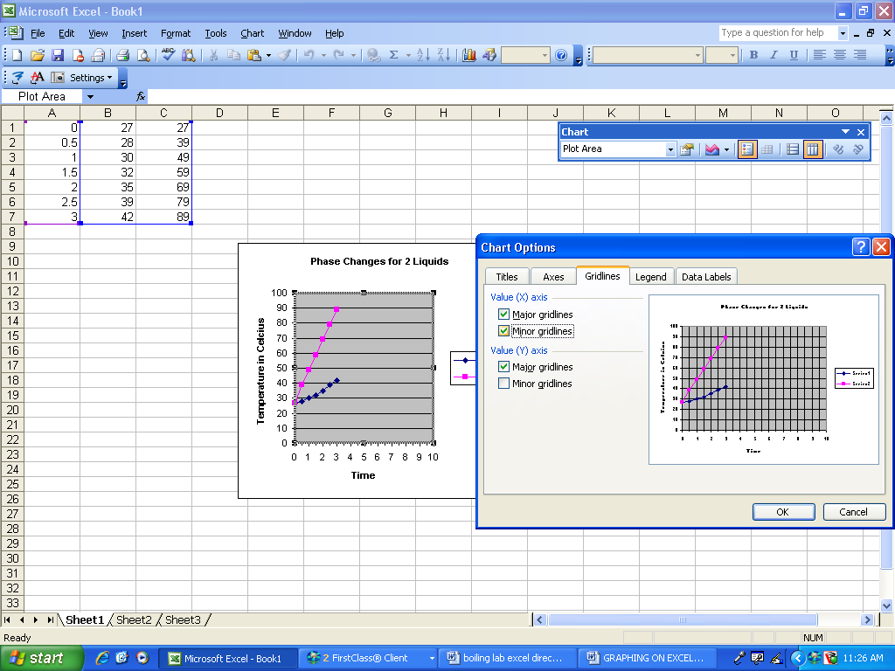

13. Let’s change the labels in our graph legend, which is located to the right of the graph. We will replace “series 1” with “WATER” and “series 2” with “ALCOHOL.” Click the chart wizard button again, then “next”, then select the “series” tab, as shown below:

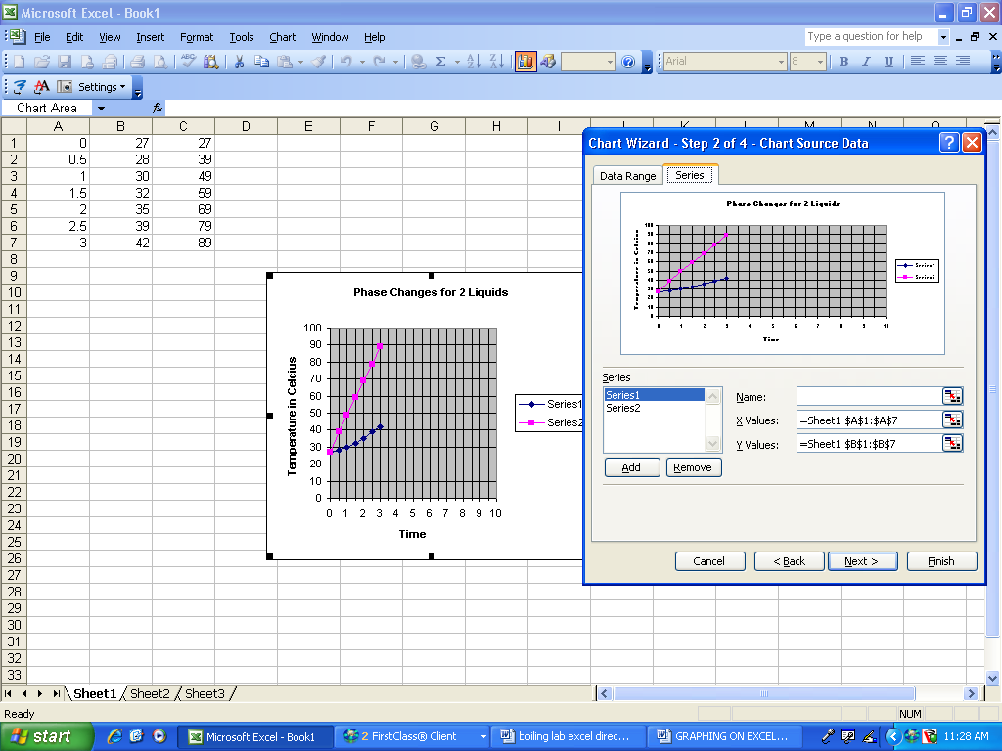

14. Click on “series 1” in the menu to the left, and type “WATER” into the “name” text box. Repeat for “series 2”, replacing it with the title “ALCOHOL.” CLICK “Finish”.

15. CLICK FILE – PRINT, AND SELECT “SELECTED CHART” under the “print what” heading. Print your final graph – it should be formatted similar to the graph below, but your lines should be different.

16. You now have a professional looking graph of your lab data! Include this graph in your lab report packet, after the data table sheet, and before your graphing analysis questions.

