SOLUBILITY – HOW DISSOLVING OCCURS

NaCl & H2O: SALT DISSOLVING IN WATER
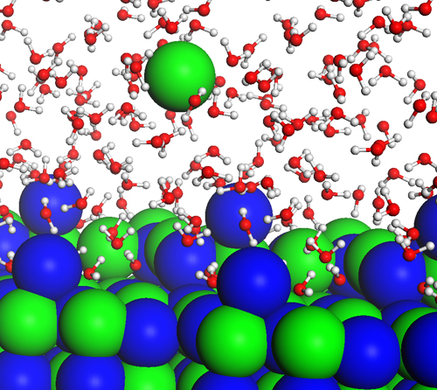

the diagram above shows how water molecules ( red = oxygen + 2 white = hydrogen) are pulling chlorine atoms (green) and sodium atoms (blue above, purple below) away from each other ( remember that sodium chloride is salt). This occurs because of the POLARITY of the molecules – that is, because both water and salt have magnetic poles – positive and negative ends. The positive side of a water molecule (white hydrogen atoms) is attracted to the negative side of the salt molecule (green chlorine atom), and pulls the atom from the molecule. THIS IS HOW DISSOLVING OCCURS!!!
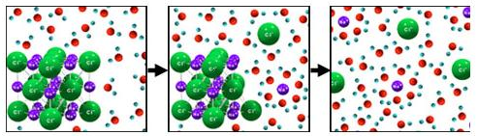

The diagram sequence above shows how this process leads to the total dissolution, or “dissolving” of salt in water to form a SOLUTION. To the human eye, the salt appears to have disappeared, but it is really evenly distributed throughout the water.

The video linked below animates this process. Hold the control button, and click on it to view the video AFTER READING THE TEXT BELOW.

Like the diagrams above, the positively charged, white hydrogen ends of the water molecules are attracted to the negatively charged, green chlorine atoms (Cl⁻) in the salt. In this animation, the positively charged sodium atoms (Na+) are shown as large white atoms – in the diagrams above, they are purple or blue. Notice how in both the animation and the diagrams, the red, negative oxygen is attracted to the sodium atoms, and the white, positive hydrogen atoms are attracted to the green, negative chlorine.

http://www.youtube.com/watch?v=EBfGcTAJF4o&feature=related

