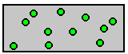

A

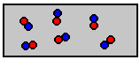

B

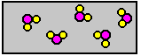

C

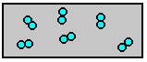

D

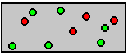

E

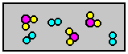

F

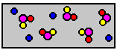

G

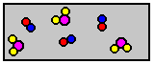

H

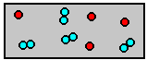

I

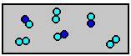

J

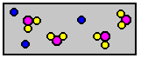

K

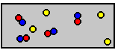

L

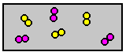

M

