Representatives

1st District

Robert Wittman
Took Office: Dec 13, 2007
Party: Republican
Caroline County, King and Queen ...
View District Map


2nd District

Edward “Scott” Rigell
Took Office: Jan 5, 2011
Party: Republican
Accomack County, Northampton County, Virginia ...
View District Map

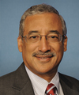
3rd District

Robert “Bobby” Scott
Took Office: Jan 5, 1993
Party: Democrat
Surry County, Charles City County, ...
View District Map

4th District

Randy Forbes
Took Office: Jun 26, 2001
Party: Republican
Southampton County, Dinwiddie County, Sussex ...
View District Map


5th District

Robert Hurt
Took Office: Jan 5, 2011
Party: Republican
Pittsylvania County, Halifax County, Albemarle ...
View District Map
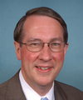
6th District

Bob Goodlatte
Took Office: Jan 5, 1993
Party: Republican
Augusta County, Rockingham County, Rockbridge ...
View District Map

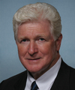
8th District

James “Jim” Moran Jr.
Took Office: Jan 3, 1991
Party: Democrat
Arlington County, Arlington, Mason Neck, ...
View District Map


9th District

Morgan Griffith
Took Office: Jan 5, 2011
Party: Republican
Washington County, Scott County, Tazewell ...
View District Map
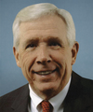
10th District

Frank Wolf
Took Office: Jan 5, 1981
Party: Republican
Loudoun County, Frederick County, Clarke ...
View District Map
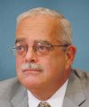
11th District Gerald Connolly
Took Office: Jan 6, 2009
Party: Democrat
Reston, Cherry Hill, Marumsco, Fairfax ...
View District Map

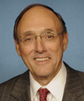
1st District

David “Phil” Roe
Took Office: Jan 6, 2009
Party: Republican
Greene County, Sevier County, Hawkins ...
View District Map

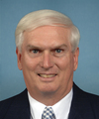
2nd District

John “Jimmy” Duncan Jr.
Took Office: Nov 8, 1988
Party: Republican
Blount County, Knox County, Claiborne ...
View District Map

3rd District

Charles “Chuck” Fleischmann
Took Office: Jan 5, 2011
Party: Republican
Monroe County, Hamilton County, Scott ...
View District Map

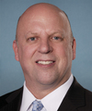
4th District

Scott DesJarlais
Took Office: Jan 5, 2011
Party: Republican
Rutherford County, Franklin County, Lincoln ...
View District Map

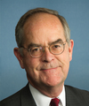
5th District

Jim Cooper
Took Office: Jan 7, 2003
Party: Democrat
Davidson County, Nashville-Davidson metropolitan government ...
View District Map
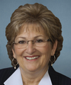
6th District

Diane Black
Took Office: Jan 5, 2011
Party: Republican
Cumberland County, Wilson County, Sumner ...
View District Map


7th District

Marsha Blackburn
Took Office: Jan 7, 2003
Party: Republican
Wayne County, Hardeman County, Lawrence ...
View District Map

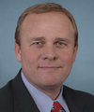
8th District

Stephen Fincher
Took Office: Jan 5, 2011
Party: Republican
Fayette County, Gibson County, Carroll ...
View District Map
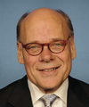
9th District

Steve Cohen
Took Office: Jan 4, 2007
Party: Democrat
White Haven-Coro Lake, Parkway Village-Oakhaven, ...
View District Map

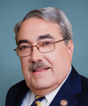
1st District

George “G.K.” Butterfield Jr.
Took Office: Jul 21, 2004
Party: Democrat
Bertie County, Halifax County, Northampton ...
View District Map


2nd District

Renee Ellmers
Took Office: Jan 5, 2011
Party: Republican
Moore County, Lee County and ...
View District Map

3rd District

Walter Jones Jr.
Took Office: Jan 4, 1995
Party: Republican
Dare County, Hyde County, Carteret ...
View District Map

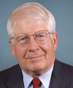
4th District

David Price
Took Office: Jan 7, 1997
Party: Democrat
Parts of Northeast, Raleigh, Orange ...
View District Map

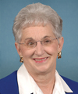
5th District

Virginia Foxx
Took Office: Jan 4, 2005
Party: Republican
Wilkes County, Ashe County, Yadkin ...
View District Map
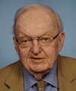
6th District

Howard Coble
Took Office: Jan 3, 1985
Party: Republican
Rockingham County, Surry County, Stokes ...
View District Map


7th District

Mike McIntyre
Took Office: Jan 7, 1997
Party: Democrat
Brunswick County, Sampson County, Columbus ...
View District Map


8th District

Richard Hudson
Took Office: Jan 3, 2013
Party: Republican
Anson County, Montgomery County, Richmond ...
View District Map
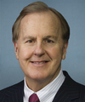
9th District

Robert Pittenger
Took Office: Jan 3, 2013
Party: Republican
Huntersville, Mint Hill, Mooresville and ...
View District Map

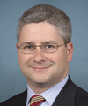
10th District

Patrick McHenry
Took Office: Jan 4, 2005
Party: Republican
Rutherford County, Cleveland County, Gaston ...
View District Map

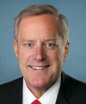
11th District

Mark Meadows
Took Office: Jan 3, 2013
Party: Republican
Haywood County, Swain County, Macon ...
View District Map

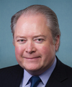
13th District

George Holding
Took Office: Jan 3, 2013
Party: Republican
Parts of Wayne County, Wilson ...
View District Map

Senators

Junior Senator

Rand Paul
Took Office: Jan 5, 2011
Next Election: 2016
Party: Republican

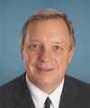
Senior Senator

Richard Durbin
Took Office: Jan 7, 1997
Next Election: 2014
Party: Democrat

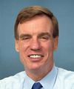
Senior Senator

Mark Warner
Took Office: Jan 6, 2009
Next Election: 2014
Party: Democrat

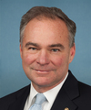
Junior Senator

Timothy Kaine
Took Office: Jan 3, 2013
Next Election: 2018
Party: Democrat

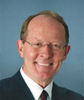
Senior Senator

Lamar Alexander
Took Office: Jan 7, 2003
Next Election: 2014
Party: Republican

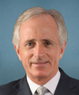
Junior Senator

Bob Corker
Took Office: Jan 4, 2007
Next Election: 2018
Party: Republican

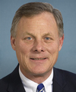
Senior Senator

Richard Burr
Took Office: Jan 4, 2005
Next Election: 2016
Party: Republican
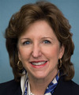
Junior Senator

Kay Hagan
Took Office: Jan 6, 2009
Next Election: 2014
Party: Democrat

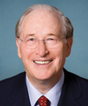
Senior Senator

John “Jay” Rockefeller IV
Took Office: Jan 3, 1985
Next Election: 2014
Party: Democrat

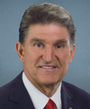
Junior Senator

Joe Manchin III
Took Office: Nov 15, 2010
Next Election: 2018
Party: Democrat

