Chapter 11 Study Guide and Review for Test Form 2A and 2B
Chapter 11, Lesson 2: “Histograms” (problems 1 – 3)
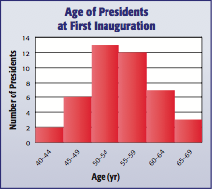
-How do you determine the value of each bar in the histogram to the left?

-How would you find out how many Presidents were at least 50 years old?

-How would you find out how many Presidents were less than 60 years old?

Chapter 11, Lesson 3: “Circle Graphs” (problems 4 - 5)
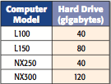
-Describe how you would determine what percent of the data is represented by
the gigabytes an L150 has?

-Describe how to determine the amount of degrees the gigabytes from the NX300
computer would represent on a circle graph:

Chapter 11, Lesson 4: “Measures of Central Tendency and Range” (problems 6 - 9)
- Describe how you would determine the following from a set of data:
Mean Median Mode Range

Chapter 11, Lesson 5: “Measures of Variation” (problems 10 - 12)
- Describe how you would determine the following from a set of data:
Upper or Lower Quartile Interquartile Range Outliers

Chapter 11, Lesson 6: “Box and Whisker Plots” (problems 15 - 17)
-How would you find the interquartile range?
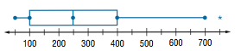

-How do you find the least & greatest piece of data?

-What percent of data is found between each “dot”?

Chapter 11, Lesson 7: “Stem & Leaf Plots” (problem 18)
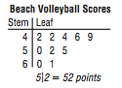
The data 42, 42, 44, 46, 49, 50, 52, 55, 60, 61 is shown in the Stem & Leaf Plot to the left.
-In the data above which numbers make up the stem?
-In the data above which numbers make up the leaves?
-Considering the digits 0-9, which are not used as leaves?
Chapter 11, Lesson 8 : “Select An Appropriate Display” (problems 13 & 14)
Write 1 or 2 words that represent clues to the type of graph to use for certain types of data:
Bar Graph Box & Whisker Circle Graph Histogram Line Graph Line Plot Stem & Leaf

